

MMS®

APPLICATION
FEATURES.

MMS

Merchandise Management System™

Revised 9/4/98

Copyright© 1997 by JDA Software Group, Inc. All rights reserved. These materials are protected by the Copyright Act of 1976, as amended, as an unpublished work and the foregoing notice and legend shall not be deemed to constitute publication or an intent to publish thereunder. These materials are proprietary and confidential information of JDA Software Group, Inc., and may be disclosed and used only as authorized in the License Agreement and Confidentiality Agreement controlling such disclosure and use.
JDA reserves the right, at any time and without notice, to change these materials or any of the functions, features or specifications of any of the software described herein. JDA SHALL HAVE NO WARRANTY OBLIGATION WITH RESPECT TO THESE MATERIALS OR THE SOFTWARE DESCRIBED HEREIN, EXCEPT AS PROVIDED IN JDA’S SOFTWARE LICENSE AGREEMENT WITH AN AUTHORIZED LICENSEE.

Contents
Executive Summary 1
About JDA Software Group, Inc. 2
Enterprise-Wide Applications 3
MMS Application Features 5
General System Features 5
Database/Master Files 7
Category Management 9
Executive Information System 10
Inventory Control 11
Inventory Stock Analyzers 13
Purchase Order Management/Allocation 14
PO Style Worksheet 17
Merchandise Receiving 18
Transfer Management/Return-To-Vendor 20
Sales Analysis 21
Price Event Management 23
Cost Management 25
Landed Cost 26
Vendor Rebate Management 28
Automated Replenishment 29
Warehouse/Distribution Center Management 31
Merchandise Planning/Open-To-Buy 33
Arthur Enterprise Suite 34
Accounts Payable 37
General Ledger/Budget 39
Sales Audit/Cash Balancing 41
Accounts Receivable 42
Customer Profile Analysis 43
Sales Commissions 44
Store Data Interchange/Advanced Logging 45
EDI 46
Wholesale Order Entry 47
Menu Management 49
Program Development and Object Control 50
Technological Advantage 52
Putting a relational database to work 52
Programs designed for the future 53
Built with the User in Mind 54
Ongoing commitment 56
Enterprise ViewerTM 58
IBM AS/400 Overview 60

Executive Summary
Merchandise Management System: Comprehensive Functionality in an AS/400 Solution
For many retailers, the answer to a globally expanding retail industry is an AS/400-based corporate merchandising, distribution and financial system that can do more than keep up with growth – it can help facilitate it. The system is the functionally robust JDA Merchandise Management SystemTM (MMS®).
Today, in fact, MMS is licensed to more than 300 retailers in over 30 countries. It has clearly become the choice for retailers who want a successful and reliable implementation.
Fully integrated, MMS gives you the tools to manage your entire retail cycle –from planning, buying and receiving . . . to transferring, distributing and selling of goods . . . to performance analysis and revised pricing . . . then back to planning for the next season.
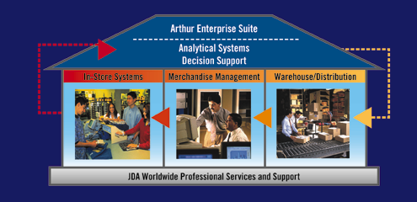
MMS was designed specifically to give you competitive advantages. The open gateway processes links MMS to JDA’s in-store systems, Distributed Store System™ and Distributed Store System for Windows®, to enhance the speed and efficiency of communication to and from your stores. This enables you to track, store, analyze and report data with greater efficiency and accuracy. The closed-loop architecture also is integrated with Retail IDEAS, JDA’s data warehouse system, to distribute data throughout your retailing enterprise. This enables management to make more informed and timely decisions, respond rapidly to changes in the competitive environment, monitor store-level activity and achieve operational efficiencies. And, MMS is available with either a windows look & feel or character-based desktop presentations.

About JDA Software Group, Inc.
JDA Software Group, Inc. (NASDAQ:JDAS) is a global provider of integrated retail software products and professional services for more than 600 clients worldwide. Designed to Optimize the Retail Enterprise, JDA offers a comprehensive, integrated ERP solution that addresses the requirements for the entire retail supply chain: from the corporate level with merchandising, merchandise planning and allocation, decision support and financial systems; to the distribution level with warehouse management and logistics systems; and finally to the store level with point-of-sale and back-office applications. Founded in 1985, JDA employs more than 1,000 associates operating from 22 offices. With headquarters in Phoenix, Arizona, the company has offices in major cities throughout the United States as well as internationally in Canada, the United Kingdom, France, Germany, Mexico, Brazil, Chile, South Africa, Singapore, and Australia. For more information, refer to JDA's Web site at http://www.jda.com.

Enterprise-Wide Applications
Merchandising
Financial Control

Distribution
Store Operations

Allowances
- Rebates
Invoice
Matching
Sales
Commission
Report
Writer
Budgeting
Accounts
Receivable
General
Ledger
Accounts
Payable
Customer
Analysis
Customer
Analysis
Auto Item
Movement
Wholesale
Orders
Carton
Manifesting
Picking
-
Letdown
Physical
Inventory
Shipping
Receiving
Putaway
-
Flowthru
Inventory
Control
Transfer
Orders
Mail Order
Processing
Cost & Price Management
Inventory
Stock
Ledger
Promotion Planning
Point-
of-Sale
Sales
Audit
Open Gateway /
Store Data
Interchange
Back
Office
Sales
Analysis
Merchandise
Analysis
Retail
IDEAS
Vendor
Analysis
Transfer
&
Allocation
Return to
Vendor
Inventory
Control
Automated
Replenishment
Purchase
Order
Mgmt.
E D I
Store
Host
Arthur
Enterprise
Suite
ASN /
Appointment
Scheduling

MMS Application Features
General System Features
MMS Combines Functionality with Ease of Use
Effectively manages all your operations
- Increases control of inventory management with tracking and reporting capabilities at all levels of the merchandising and organizational hierarchy.
- Features sophisticated analysis tools to provide effective inventory control, sales tracking, merchandise analysis, financial management and business planning.
- Helps you offer the right product at the right store location at the right time and at the right price and right quantity.
Achieve better margin percentages
- Reduces inventory and carrying costs in stores, and increases the accuracy of orders by automating the reordering process based on projected sales algorithms.
- Provides access to better buying information, inventory availability and promotional pricing, thus improving operating margins through lower cost of sales.
- Gives you the ability to enter permanent markdowns/clearance or temporary markdowns using a worksheet approach that supports financial impact analysis and managerial authorization prior to implementing price changes.
- Enables you to obtain better return on investment by giving you access to merchandising history so that you can plan and create markdowns based on prior performance.
Proven, reliable technology
- Features a single database enabling you to share resources, reduce duplication and streamline efforts.
- Fully integrates with in-store and data warehouse products designed by JDA or third parties, as well as such external tools as EDI, ticketing, shelf planning, merchandise planning and inventory counts services.
- Provides menu-driven, easy-to-use file maintenance procedures through a windows look and feel or character based presentation, intuitive online help screens, consistency of command keys and input across all application modules.
Leverages information for a competitive advantage
- Enables you to react quickly to your competitors’ price changes by featuring comprehensive price and markdown management capabilities.
- Improves customer service by providing your associates the information and analysis tools needed to determine the availability of products at any of your other locations.
- Enhances the effectiveness of your marketing activities by enabling you to track and report pertinent customer information such as buying habits and demographics.
- Fully integrates with the JDA advanced analysis tool, Retail IDEAS, a multi-platform, client/server data warehouse system.
No organizational or international requirements are too complex
- Supports multiple languages and multiple currency with a zero decimal to support inflationary currencies.
- Supports VAT/GST tax management to a location level.
- Provides Import/Export order status tracking.
- JDA is an international company, supporting Retailers worldwide.

Database/Master Files
Database/Master Files provides a common repository that is shared by all MMS modules. Within this module, you can establish the company and merchandise hierarchies and set merchandise and financial calendars. In addition, you can group and define organizational and merchandise attributes through associated databases.

Features and Functionality
- Establishes the primary store operations reporting hierarchy:
- Chain
- Region
- District
- Store
- Establishes the primary merchandising hierarchy:
- Department
- Sub-Department
- Class
- Sub-Class
- Provides merchandising calendar maintenance capability, along with a separate financial calendar.
- Easy addition and maintenance of the system’s underlying data structures.
- Maintenance of the system’s status master and table files.
- Provides searches and listings of master file entries.
- User-defined searches of item master file based on user-defined attributes.
- Item imaging capabilities.
- 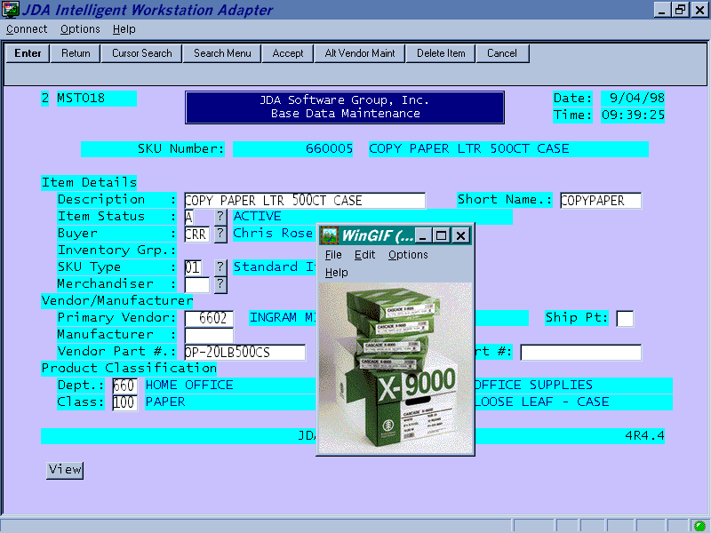Buttons available, for any GUI screen, to access product images

- Facilitates stores to be associated in groupings that cut across the organizational hierarchy:
- Pricing zones
- Replenishment zones
- Store groups
- Inventory groups
- Definition of externalized tables of product attributes such as:
- Vendors
- Buyers and merchandisers
- Units of measure
- Sizes
- Colors
- Merchandise groups
- Definition of user-definable product groupings for summary and comparative analysis.

Category Management
Category Management is an executive analysis tool that enables users to track sales and inventory movement by category, department, product, and vendor.

Features and Functionality
- Margin visibility of regular and promotional sales.
- Drill-down capability from department to item level.
- Chain-wide and store-level measurements.
- Exception and ranking views.
- Standard and user-defined inquiry formats.
- Graphic representation of key performance data.
- Flexible time frames can be specified.
- Item performance summarized at dynamic category levels.
- User-defined merchandise groups (Hotlists) to track specific items.
- Merchandise Analyzer for flexible product groupings based on common selection factors.
- User-defined
- Drill down to item
- Ranking and filtering
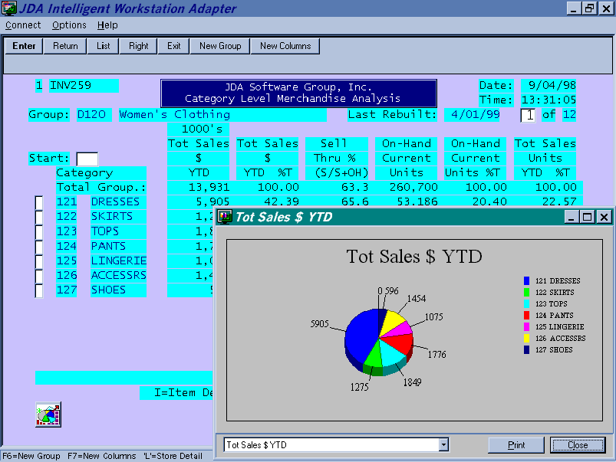
- Closed-loop process to create price changes or transfers
Executive Information System
Executive Information System provides the ability for Executives and Managers to extract data in a flexible and meaningful manner.

Features and Functionality
- A Graphical User Interface with charting capabilities
- Dynamic Exception Reporting.
- Customizable screens and graphics.
- Real-time drill downs into location and product databases.
- Closed-loop architecture to react to user-defined exceptions in allocating product, transferring product and price management.
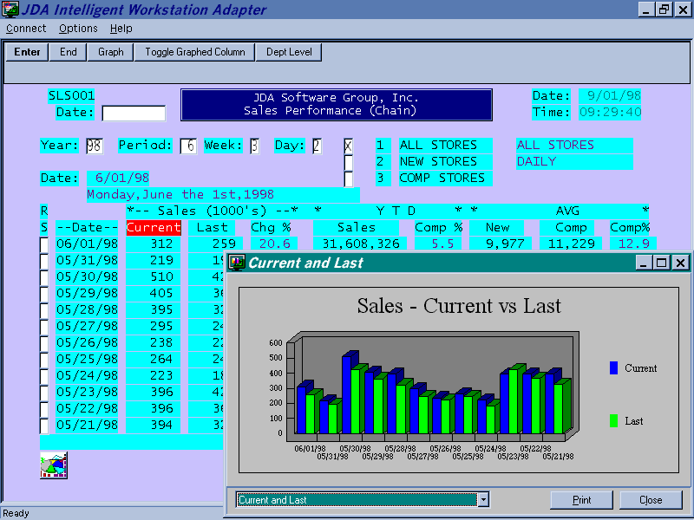

Inventory Control
Inventory Control provides the ability to accurately track and report the movement of inventory at all of a your locations. With multiple inventory costing/valuation methods, you’ll have flexible analysis and reporting of perpetual inventory levels. You’ll also be able to perform physical inventory counts, audit trail tracking and interfaces to additional merchandise modules.

Features and Functionality
- Maintains accurate perpetual inventory at the warehouse, chain and store level, with optional in-transit tracking.
- Provides the focal point of interfaces from other JDA modules. Tracks movement for:
- Regular and ad sales | - Returns
- Receipts | - Transfers in and out
- Returns to vendor | - Adjustments
- Physical adjustments
- Extensive detail and summary level inquiries into status of inventory.
- Extensive analysis and exception reports on:
- Stock status | - Item velocity
- Inventory movement | - Out of stock
- Inventory valuation | - Over stock
- Extensive audit trails of processed inventory transaction activity.
- User-defined attributes can be assigned to groups of items. Tools are available to analyze by these attributes either individually or collectively.
- Handles both Cost and Retail methods of accounting.
- Supports the following inventory costing/valuation methods:
- Average Cost | - Current Cost
- Chain Average Cost | - Associated Warehouse Cost
- Enables the maintenance and adjustment to the average unit cost of an item.
- Provides for manual inventory adjustments.
- Inventory adjustments are available for store use that capture reason codes and interface to the General Ledger module.
- Maintains an audit trail of all inventory adjustments by location.
- Provides the ability to freeze inventory values for physical inventory (cycle and full).
- Prints physical inventory count sheets.
- Reporting available on actual physical inventory count and valuation by item and location within store.
- Accepts input of physical inventory count via manual entry and portable data terminal interface.
- Produces discrepancy reports between system inventory balances and physical inventory counts.
- Provides the ability to track and report by SKU and store as well as on all stock adjustment transactions related to transfers, receipts, sales, etc.
- On-line inquiries of on-hand inventory by chain and location.
- Enables users to inquire on average inventory position by item, store and period.
- Provides the ability to report on inventory position based on such exception conditions as out of stock and excess stock.
- Merchandising activity summarized and passed to the General Ledger module.
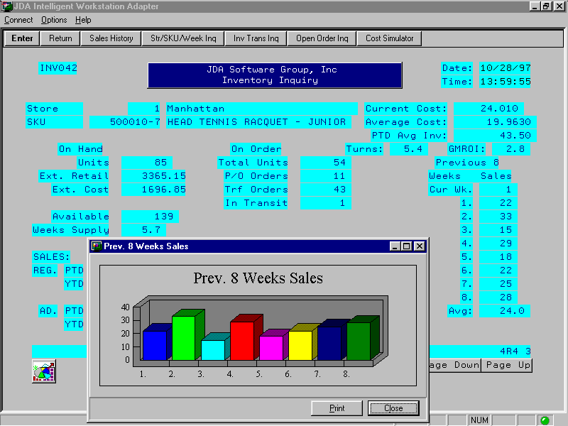
Inventory Stock Analyzers
Inventory Stock Analyzer offers flexible inquiry and reporting capabilities on monetary and unit information at your corporate, region, district and store levels. You can also report by inventory hierarchy levels, as well as by current and past time periods including year-to-date, period-to-date and week-to-date.

Features and Functionality
- Provides ad hoc analysis within traditional merchandising boundaries.
- Reduces need to create queries for custom reporting requirements.
- Provides flexible user-definable inquiries and reports of more than just sales results.
- Includes the Inventory Stock Ledger which permits users to define their own customized stock ledger and report on information at the following levels:
- Monetary results
- Company, region, district and store
- All products, department, sub-department, class and sub-class
- Year-to-date, period-to-date and week-to-date (current and past years)
- Includes the Stock Analyzer which enables users to report on both monetary and unit information. They can analyze merchandise down to the style/color/size (SKU) level and report on information at the following levels:
- Company, region, district, store group and store
- All products, department, sub-department, class and sub-class
- Style/color/size (SKU)
- Year-to-date, period-to-date and week-to-date (current and past years)
- Permits custom formulas to be developed and added to the system-supplied factors available for analysis.

Purchase Order Management/Allocation
Purchase Order Management enables you to enter multiple purchase orders and allocate based on a variety of distribution methods. This allows receiving at a central location for flowthru processing to other locations. Purchase Orders will also be created as an end result of our sophisticated Automated Replenishment Module.

Features and Functionality
- Multiple purchase order types and distribution methods:
- Single location order
- Drop-ship to multiple locations with one order per location
- Single order pre-distribution to multiple locations after receipt
- PO Style Worksheet with multiple vendors, multiple styles, per worksheet
- Direct Store Delivery (DSD)
- EDI Orders
- Copy an existing PO
- Store level from the Point of Sale (POS)
- Restrict entry by Department / Sub-Department
- Manual or system PO number generation.
- Unlimited line items per purchase order.
- Uses standard vendor defaults such as prices, terms and lead times when creating a purchase order.
- Provides the ability to override standard vendor terms such as lead times and costs.
- Maintains the following dates for each PO:
- Entry
- Last change
- Scheduled receipt dates (supports multiple receipt dates at PO and item level)
- Receipt (maintained by system)
- Cancel
- Expected payment
- Provides a “memo” field for special instructions to be printed on the purchase order or receiving authorization.
- Prepare and print “pro forma” purchase order worksheets.
- Print POs at the store and centrally.
- Ability to amend and reissue a purchase order.
- Ability to cancel an entire order or to cancel by individual items on the order.
- Allows for definition of allowances and discounts calculated as amount or percent off, with effective dates at any of the following levels:
- Vendor | - Class
- Department | - Sub-Class
- Sub-Department | - SKU
- Automatically retrieves applicable allowances when POs are written with the ability to override or amend allowances.
- Enables store-level item order quantities for pre-distributed or drop-ship orders can be determined using any of the following methods:
- Allocate using pre-defined model store rankings (assigned at store or store/product classification level)
- Allocate using a dynamic distribution table created by sales ranking functions
- Allocate to a number of weeks of supply calculated based on recent sales history
- Enter order quantities manually
- Ability to age open orders by:
- Item (SKU)
- Department
- Store
- Vendor
- Projected cash requirements reporting based on the expected receipt and payment dates of open POs.
- Ability to report on open POs by:
- Item (SKU) | - Department
- Store | - Buyer
- Vendor number | - Vendor name
- Purchase order number | - Scheduled receipt date
- Shares common vendor master file with the Accounts Payable module.
- Multiple delivery dates, landed cost factors, vendor rebate factors, and cost simulation per item.
- Comparison of order totals against vendor minimum, as expressed in one of the following measurements:
- Cost
- Weight
- Units
- Cases
- Provides for multiple receipts against a single PO
- Visibility to Open-To-Buy.
- Creation of SKU or style without exiting the PO
- Inventory balance visibility of SKU or style without exiting the purchase order.
- User control of PO approval process through system option setting with intuitive alert capability for order review/release.
- Provides inquiries and reports for tracking status, order quantities and amounts.
- Allows you to apply vendor allowances, rebate factors, landed costs factors and miscellaneous charges at the total PO level or at each individual line item level.
- Provides an interface to the Open -To-Buy and Electronic Data Interchange (EDI) modules.
PO Style Worksheet
Style Worksheet lets you create pre-packs that contain predetermined quantities of inventory by color/size/ dimension, thus enabling you to order from the “top down”.
Or you can create order quantities using a “bottom up” approach based on a percentage of color/size/dimension ratios.

Features and Functionality
- Create purchase orders for Softlines using a worksheet approach.
- Styles with Color/Size/Dimension
- Styles using Pre-packs
- Styles with Location Allocations
- Create and order by pre-defined grids (Pre-packs).
- Commonly used Color/Size combinations
- Vendor specific Pre-packs with standard quantities
- Multiple combinations with a variety of allocation components
- Order quantities generated by Top-Down or Bottom-Up process.
- Allocations based on ratios, percentages or quantities
- Work a complete season on one worksheet.
- Multiple vendors and styles
- Monitors workflow by color/size/dimensions/locations
- Creates a separate PO for each vendor on worksheet

Merchandise Receiving
Merchandise Receiving ensures comprehensive control and tracking at the receipt of merchandise ordered from a vendor through a PO or direct store delivery invoice. The module records the receipt of merchandise at the store, distribution center or warehouse and can be used to print price labels for the received merchandise. Over receipts, under receipts and damaged merchandise is tracked for later credit memo processing in Accounts Payable. The Distribution Center can schedule appointments for the receipt of merchandise by purchase order or transfer.

Features and Functionality
- Manages merchandise receiving functions:
- Receipt scheduling
- Check-in
- Piece count
- Putaway
- Automatically assigns receiver numbers.
- Produces receiving documents to use as turnaround documents.
- Enables receiving at stores or warehouses by Radio Frequency (RF).
- On-line receipt of merchandise against a displayed PO
- Merchandise can be received by line item or entire PO
- Provides the ability to post multiple receipts against an individual PO
- Scheduling of receiving based on Advanced Ship Notice (ASN).
- Allows receipt of over-shipped merchandise.
- Additional items can be added to order at receipt.
- Allows changes to pre-distributed quantities.
- Distributions can be built at time of receipt, or anytime prior to receipt.
- Produces receipts journal.
- Allows receipt of merchandise transferred from a store or warehouse.
- Maintains vendor delivery performance history.
- Merchandising tickets can be produced upon receipt of goods based on quantity received.
- Integrated with the Inventory Control and Reporting module, immediately updating on-hand balances for items received.
- Captures discrepancies and reason codes for communication to Accounts Payable. Credit memos attached to receipt automatically link to invoice when 3-way match is preformed.
- Allows entry of receipt adjustments after receipt has been posted.
- Manages the receipt of product into one or more slot locations at a distribution center.
- Generates transfer orders upon processing of receipt of a pre-distributed order.

Direct Store Delivery (DSD) Receiving
- Allows multiple methods of Data Capture:
- AS/400 MMS terminal or hand held in store
- AS/400 MMS terminal at corporate office
- 3rd party DSD receiving application
- Captures DSD header data.
- Vendor
- Invoice number
- Invoice amount
- Quantity invoiced
- If paid by store
- Provides the ability to identify and verify item by:
- SKU
- UPC
- Vendor Part Number
- Unit of Measure
- Quantity received
- Retail price
- Allows user to determine how to apply Cost of Goods Sold.
- Updates:
- PO/Receiver history
- Inventory balances
- Accounts Payable invoices
Transfer Management/Return-To-Vendor
Transfer Management/Allocation lets you initiate, manage and track multiple transfers of product from store to store, store to warehouse, warehouse to store and warehouse to warehouse. Transfers are tracked from creation and approval (allocation for warehouse orders) to shipping and receiving. This module also supports centrally initiated transfers, store initiated transfers, forced distributions, predistributed purchase orders and automated replenishment transfer orders.

Return to Vendor allows you to track the return of merchandise from stores and warehouses back to the vendor. You can identify and report on returned products using user-defined return codes.

Recall merchandise utilizing user-defined product groups for the purpose of tracking each store’s compliance with the return.

Features and Functionality
- Manages and tracks the movement of product between locations with optional in-transit tracking.
- Supports processing of transfers initiated from multiple sources:
- Centrally initiated, manually entered
- Store-initiated (entered manually or through automated interface)
- Receipt of pre-distributed purchase order
- Post-distribution of warehouse on-hand inventory
- Automated replenishment suggested transfer orders
- Merchandise Analyzer allows closed loop analysis to initiate transfers
- Accommodates the following types of transfers:
- Warehouse to store | - Warehouse to warehouse
- Store to warehouse | - Store to store
- Supports multiple warehouses and is integrated to the warehouse/distribution center picking process.
- Produces merchandise in-transit report by item and transfer shipment.
- Provides flexibility by transfer type to handle receipt quantities.
- Enables assumed received when shipped or receipt acknowledgment required.
- Provides the ability to identify and report on transfer receipt discrepancies.
- Accommodates returns-to-vendors.
- Tracks and provides reporting on damaged goods returned to vendor by item, store and vendor.
- Unshipped – Unreceived reporting capabilities.
- Link and track transfers by associated PO number for pre-distributed POs and by user-defined reference number.

Sales Analysis
Sales Analysis enables you to report on a variety of sales history information and identify trends at all levels of your organization and merchandising hierarchy. This includes reporting on sales and profitability for new stores and comparative store analysis; performing prior year sales comparisons by store; reviewing ad event versus regular price sales and graphing capabilities.

Features and Functionality
- Inquiry and reporting capabilities in standard formats and on an ad hoc basis.
- Standard inquiries by day, week, period or year-to-date.
- Comparison of a day, week or period to the same day, week or period in the previous year.
- Provides the ability to graph relevant columns of data.
- Ability to reassign a store to a different region or district and move its corresponding sales history.
- Provides pre-defined sales history inquiry and reporting capability for the following merchandise and company organization levels:
- Department | - Chain
- Sub-Department | - Region
- Class | - District
- Sub-Class | - Store
- Style | - Store Group
- SKU
- Sales history inquiry and reporting capability for:
- Day | - Year
- Week | - User-specified time period
- Period
- Provides sales and profitability information for new stores and comp stores.
- Allows users to establish groups of items to be summarized and reported individually and collectively for:
- Retail sales | - Sales units
- Gross margin percent | - Gross margin amount
- Sales per customer | - Sales per payroll hour
- Sales per square foot
- Regular versus advertised sales analysis.
- Ability to report sales performance on an exception basis according to the following input criteria:
- Top percentage of items in a criteria
- Bottom percentage of items in a criteria
- Top number of items
- Bottom number of items
- Ability to produce sales analysis reports at various levels of detail through user-controlled parameters.
- Sale analysis ranking by user-selected criteria, such as units and retail amount, for a user-defined time frame and groupings of stores.
- Allows a store-relative ranking to be saved and used as a guide for product distribution quantity decisions when creating POs and transfers.
- Provides ranked item (SKU) level reporting for fast sellers and slow sellers.
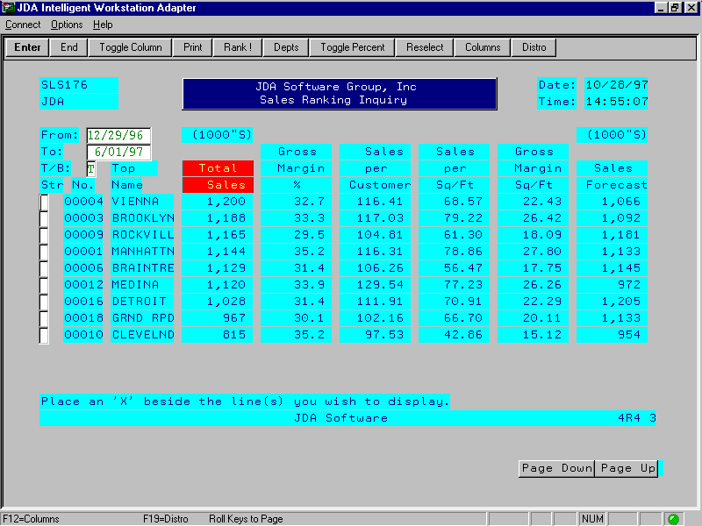
Price Event Management
Price Event Management creates and tracks promotional events and permanent markups and markdowns on items. Used in conjunction with Store Data Interchange (SDI), this module tracks sales and maintains the correct prices on items included in an active price event. You can assign multiple pricing methods, including Quantity Ends, Buy One Get One Free, Multiple Dates, Quantity Breaks, Mix/Match and Color/Size/Dimension Overrides, to any item in a price event.

Features and Functionality
- Manages price changes by control number.
- Provides the ability to maintain item prices:
- Chain-wide
- By price zone
- By store
- Allows users to select items for an event by:
- Vendor
- Product Classification
- Price Points
- Specific SKUs
- Previous price event
- Combination of above
- Cost event
- Closed loop design allows Merchandise Analyzer tool to save analyzed data and create price events from this information.
- Allows user to set prices for events by:
- Specific retail price
- Percent off regular price
- Amount difference
- Target gross margin percent
- Multiple dates
- Quantity ends
- Quantity breaks
- Mix/Match
- Price multiple
- Provides the ability to duplicate above criteria for groups of SKUs.
- Supports user-defined reason codes for price changes.
- Provides capability to specify date on which a price change will become effective and send notification to the stores.
- Rounds prices according to user-defined rules.
- Maintains detail performance information by SKU, including:
- Store promoting the SKU
- Event price
- Forecasted unit sales for the SKU during the event effective dates by selling location
- Ad space per SKU
- User-defined advertising code
- Units sold first 7 days and total for event
- Total Cost, Retail, and achieved Margins
- On-line creation, update and deletion of summary descriptive information for a specified event number.
- On-line entry, update and deletion from an event of detailed SKU information for a specific event.
- On-line inquiry into summary and detail information for a specific event.
- Creates sales price tags and labels for SKUs in the event.
- Tracks history by SKU and store, as well as, a total for the event in units, retail and cost.
- Maintains history for an event based on user-specified flags.
- Allows users to comment on item performance.
- Visibility of price history and forward price plans.
- Updates host system price files and manages POS interface price data.
- Provides price change simulation and “what if” analysis capability.
- Competitive price management available.
- Provides Point-of-Sale pricing support:
- Centralized control and transmission to store systems
- Mix/match price groups
- Multiples and per pricing (3 for $1)
- Free goods pricing (buy 3 get 1 free)
- UPC-level pricing (pre-marked merchandise)
- Unit pricing (.79 cents per pound)
- Deal Pricing – ability to mix products within mix/match price groups and multiples per pricing.

Cost Management
Cost Management creates and tracks temporary and permanent cost changes for a primary or alternate vendor at the chain, cost zone and store.

Features and Functionality
- Improves management of all facets of vendor cost changes.
- Allows the user to evaluate the financial impact of cost changes.
- Allows the user to react quickly to vendor price changes.
- Supports on-line definition and maintenance of cost changes at the chain, cost zone and store level.
- Allows the user to select items for cost changes by:
- Vendor
- Department
- Sub-Department
- Class
- Sub-Class
- SKU
- Allows the user to set new costs using any of the following methods:
- Percentage of cost change
- Amount of cost change
- Specific new cost
- Allows the user to set store level costs that override the chain-wide cost.
- Supports user-defined reason codes for cost change.
- Allows individual costs to be set for specific items.
- Automatically updates item files on the effective date.
- Suggests optional retail prices for items, allowing the gross margin or the difference between Cost/Retail to be preserved while automatically creating new retail price event.
Landed Cost
Landed Cost enables you to define and track multiple cost factors which contribute to the actual cost of an item, such as inland freight, import freight, taxes and insurance. The module can also calculate true cost and margin data for key cost analysis levels, including chain, vendor, product classification and SKU. Landed Cost is integrated with the Purchase Order Management, Merchandise Receiving and General Ledger modules.

Features and Functionality
- Allows for user-defined cost factors, such as:
- Freight
- Insurance
- Shrink
- Duties
- Enables the user to determine if cost affects:
- Cost of Goods Sold
- Purchase Orders
- Transfer Orders
- Includes the following allocation methods:
- Amount per cubic foot
- Weight times a rate
- Amount per cost dollar
- Percent of cost dollar
- Amount per unit
- Allows for total split at order time by:
- Cost
- Units
- Weight
- Length
- Enables factors to be assigned by various combinations of:
- Product
- Classification
- Vendor
- Location
- Country of Origin
- Chain Wide
- Provides a Cost Simulator that incorporates the effect of:
- Purchase Cost
- Rebates
- Allowances
- Landed Cost factors
- Enables simulated cost to be used when making decisions for:
- Purchasing/Receiving
- Transfers
- Pricing
- Inquiries
- Interfaces to Accounts Payable and General Ledger.
Vendor Rebate Management
Vendor Rebates establishes and tracks rebates for vendors offering billback moneys in exchange for ordering and/or selling products normally purchased from the vendor. You can perform inquiries and report on detailed rebate information, including lump-sum rebates, item rebates and volume rebates. The module interfaces to the Accounts Payable and Accounts Receivable modules.

Features and Functionality
- Multiple types of rebates:
- Lump Sum rebate
- Rebate based on quantities sold
- Rebate based on quantities purchased
- Provides for rebates to impact either Accounts Payable or Accounts Receivable.
- Allows for location exceptions.
- Allocation of Lump Sum rebate by:
- Product Classification level
- SKU level
- Associated with a promotional event
- Ability to allocate by location
- Definition of accrual types of rebates by product and location.
- Provides user to base vendor rebate rules on:
- Units or weights
- Amount or percentage
- Negotiated timeframe
- Supports volume agreements at rebate or override to item level.
- Allows the user to determine if rebates affect the Cost of Goods Sold.
Automated Replenishment
Automated Replenishment automates the process of achieving appropriate inventory levels for each store or warehouse. By selecting one of four different algorithms—Model Stock, Statistical, Dynamic Sales and Seasonal Re-buys—you can determine when products should be replenished. Or create flexible replenishment schedules for each location and/or product.

Features and Functionality
- Provides flexible methodologies for generating suggested orders:
- Seasonally adjusted stock level (min/max)
- Sales forecasting
- Average weekly sales
- Seasonal re-buy
- Provides the ability to establish parameters used by calculation algorithms:
- Model stock quantity
- Order at quantity
- Season trending
- Calculation method
- Distribution method
- Minimum order quantities
- Safety Stock based on user-defined percentages, or sales dollars, sales units, gross margin
- Allows parameters to be maintained at any level of the product hierarchy down to the SKU level for any grouping of stores or chain-wide.
- Replenishes stock at stores and warehouses.
- Produced suggested orders based on quantity on-hand or on-order.
- Enables suggested orders to be fulfilled by:
- Single location purchase order
- Pre-distributed purchase order
- Transfer from warehouse
- Suggested orders may be modified prior to releasing. Quantities can be adjusted and items can be added to or deleted from the order.
- Provides the ability to identify a group of merchandise from which items can be ordered to make up a vendor minimum order quantity.
- Provides the ability to identify:
- Out of stock items
- Over stocked items
- Low stock defined by a parameter
- Integrated with Purchase Order Management and Inventory Control and Reporting modules.
- Calculates seasonal profile curves based on up to three years actual SKU/store-level sales history.
- Provides the ability to determine trends based on actual sales history.
- Provides the ability to enter adjustments to sales history for replenishment considerations.
- Provides the ability to include or exclude the effect of promotional sales on seasonal profile and trend calculations.
- Provides the ability to create multiple POs for seasonal merchandise, basing the order quantities on previous seasons’ sales adjusted by a change factor.
- Provides on-line simulation capability to allow for “what if” analysis of parameter maintenance.
- Provides flexible replenishment scheduling capabilities to manage the complete supply chain.

Warehouse/Distribution Center Management
Warehouse Management enables you to plan, execute and manage the storage and flow of merchandise throughout one or more warehouses. This module provides functions needed to create and maintain a warehouse; receive, reserve or hold merchandise at the warehouse; and move merchandise between locations via picking, putaway, letdown or manually. You can also ship merchandise to a receiving location and perform a full physical inventory or a cycle count of the warehouse. The module also supports radio frequency for picking, receiving, putaway, letdown and shipping.

Features and Functionality
- Provides inventory tracking:
- At the SKU level
- By slot
- For the entire warehouse/distribution center (DC)
- Manages allocation and reservation of available inventory.
- Accommodates multiple warehouses.
- Groups slot locations into warehouse zones.
- Supports multiple slot locations per items and multiple items per slot.
- Provides high degree of control over warehousing and distribution functions:
- Receiving | - Cross docking
- Putaway | - Picking
- Letdown | - Shipping
- Cycle Counting | - Physical Inventory
- Provides standard control functions to manage all types of warehouse movement.
- Includes Advanced Warehouse/Distribution Center Management capabilities:
- Advanced Shipping Notice
- Creates Booking (Inbound Manifest)
- Builds receipt against expected ASN
- Allows multiple open receipts per PO
- Appointment Scheduling
- Input from Advance Shipping Notice
- Creates appointment
- Activity
- Detail resource
- Time frame
- Allows for user-defined Automatic Item Movement rules
- Assign to slots
- Assign to products
- Control priority of movement through facility
- Provides for Economic Picking
- Allows preview of volumes
- Allows pick by group
- Creates pick work in packs by zone
- Ability to utilize Radio Frequency technology throughout DC
- Ability to use Carton Manifesting
- Creates loads
- Assign store
- Load pallets
- Load carton
- Ship load
- Prints shipping manifest
- Allows items to be picked in slot location sequence based on user definition.
- Provides the ability to maintain each, case pack, inner pack, and pallet quantities by item.
- Manages picking of warehouse-to-store transfers.
- Produces a receiving log of daily receipts.
- Maintains shipment history by item by month.
- Accommodates damaged merchandise returns from the stores.
- Produces carton labels, packing slips and bills of lading.
- Supports automated distribution.
- Provides cross-docking capability.
- Accommodates pre-distribution.
- Allows for post-distribution of on-hand merchandise. Supports the following methods of determining store-level item distribution quantity:
- Manual entry
- Allocate using pre-defined model store rankings (assigned at store or store-product classification level)
- Allocate using dynamic distribution table created by sales ranking functions
- Calculate weeks of supply required based on recent sales history
- Allows full warehouse physical inventories and cycle counts for selected zones or a selected vendor’s products.
- Provides key performance measures:
- Work volumes
- Capacity utilization
- Inventory aging
- Fill rates
- Shipment history
- Capable of stand-alone Warehouse/DC functionality with common interface points.
Merchandise Planning/Open-To-Buy
Merchandise Planning/Open-To-Buy enables you to develop various merchandise plans to help determine how much merchandise is needed for each period.

Features and Functionality
- Provides the ability to maintain 12 or 13 period merchandise plans by period at the following levels:
- Department | - Chain
- Sub-Department | - Region
- Class | - District
- Sub-Class | - Store
- Accommodates planning in retail or cost values.
- Supports multiple planning seasons.
- Integrated with the Sales Analysis module and uses sales history as a planning basis.
- Ability to specify which season’s history is to be used as a planning basis.
- Provides for up to six user-defined retail reduction types. Examples include:
- Shrinkage | - Promotional markdowns
- Employee discounts | - Permanent markdowns
- Provides the ability to adjust the following variables on-line:
- BOM inventory | - Reductions
- EOM inventory | - Inventory turns
- Sales | - Purchases / Receipts
- Provides the ability to adjust planning variables independent of one another.
- Automatic recalculation of all dependent variables when a selected variable is changed.
- Open-to-buy report based on the merchandise plan.
- Allows summarization of actual to plan variances for each planning variable by amount and percent.
Arthur Enterprise Suite
The Arthur Enterprise Suite provides you with a detailed step-by-step methodology for navigating the complex process of managing the merchandise cycle.
Features and Functionality
- Arthur Performance Analysis
- Arthur Performance Analysis gives you access to the fundamentals of the business, putting true decision support directly in your hands.
- Examine trends over the years, or zoom in to the sales of a particular style across all stores in a given week.
- Review the key factors that contributed to success or failure.
- Chart receipts against sales.
- Measure price action against unit volume.
- Check inventory against sales on a store-by-store basis.
- Visibility of the business through dynamic exception highlighting, agent technology, and automatic alerts.
- Trends emerge quickly, and the facts to support your next decision become clear.
- Arthur Planning
- Quickly build detailed merchandise and location scenarios, then fine-tune them at any level.
- Push goals down to lower levels of detail, or work from the bottom up to a summary level.
- Identify and reconcile gaps easily.
- Review the impact of changes in receipts, markdowns, or promotions.
- Arthur Planning’s powerful “Opportunity Planning” capability takes each location’s requirements into account turning the theory of “Micro-marketing” into successful business practice.

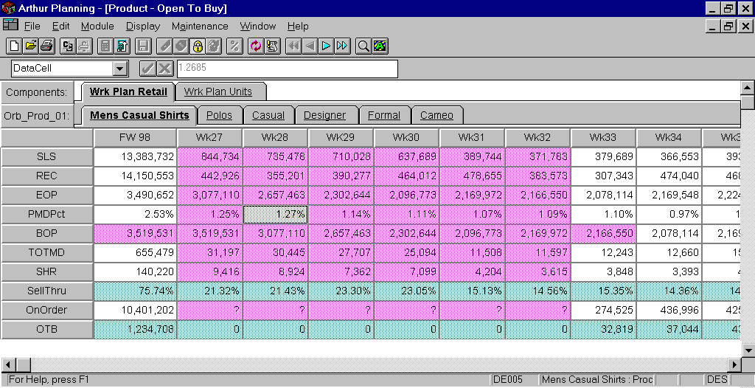
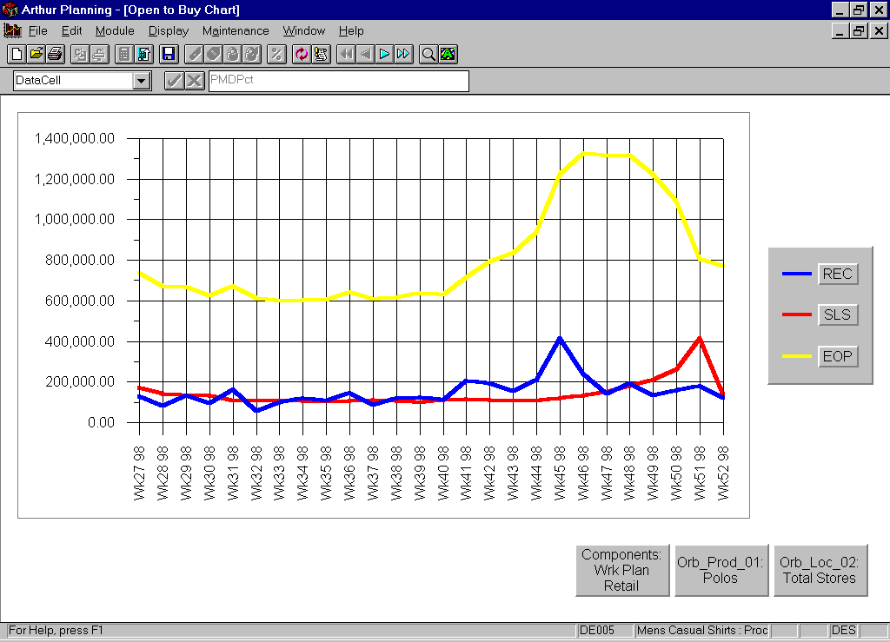
In Season Open to Buy

- Arthur Assortment Planning
- Arthur Assortment Planning helps you optimize merchandise selection, bridging the gap between plan and purchase order.
- Review planned assortments from every angle, for each product and store characteristic.
- Build collections, factor in existing items and space details, and view consolidations.
- Target profiles, calculation methods, charts, and automation features help buyers work productively at this low level of detail to achieve the optimum merchandise mix.
- Quickly determine if the planned assortment is in line with the company goals, and take action where necessary.
- The assortment is fact-based and focused.
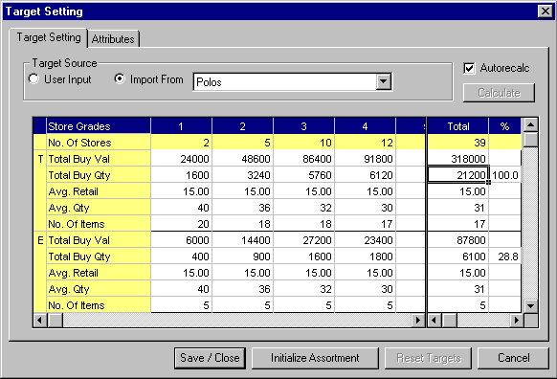

- Arthur Allocation
- Quickly assess which stores will perform best with each product.
- Use your plans, or combine them with current performance, to optimize product distribution.
- Quick work of distributing a collection of products to the right stores at the right time, in a single number of allocation methods based on ‘Best Practice’ methodology, or use expertise from within your own organization.
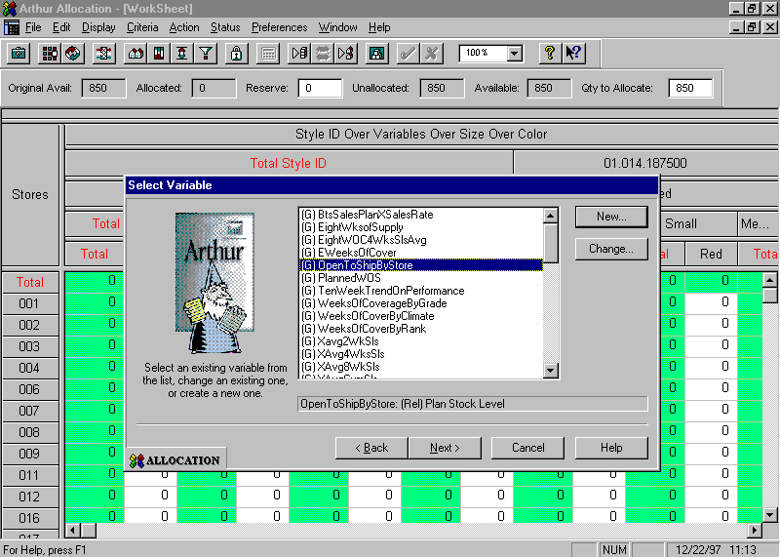
Accounts Payable
Accounts Payable gives you the capabilities to enter and track trade, expense and freight invoices, as well as reconcile outstanding checks. Three-way matching is provided based on vendor-established tolerances. Payments are processed based on flexible selection criteria and discounts can be automatically taken. Electronic Funds Transfer is available for user-specified vendors, as is interface to EDI invoices.

Features and Functionality
- Supports multiple fiscal companies.
- Integrated with JDA’s General Ledger module.
- Extensive vendor file that is used by other MMS modules.
- Alpha search capabilities on a vendor file wherever a vendor number is required.
- Allows invoice entry by EDI or on-line.
- Batch controls to ensure invoice entry accuracy.
- Supports miscellaneous, non-recurring vendors.
- Maintains freight, expense and trade payables.
- Automatically controls posting to the Accounts Payable, General Ledger, bank and cash discount accounts.
- Provides a comprehensive terms code management system.
- Provides holdback management by invoice and percentage to prevent payment to selected vendors.
- Unmatched invoice and receiver reporting for trade payables.
- Inquiries available on unmatched, open, cancelled, voided and paid invoices.
- Extensive vendor payables status and history inquiries.
- Provides a freight invoice reporting sub-system.
- Validates vendor, Purchase Order, and General Ledger account numbers upon invoice entry.
- Allows an invoice to be posted against multiple General Ledger accounts.
- Produces a General Ledger account distribution summary.
- Three-way matching of POs and receivers and vendor invoices at the invoice or line item level.
- Ability to automatically post to the General Ledger based on matched POs receivers and invoices.
- Automatically determines the due date for earning discounts based on a vendor’s standard terms or special terms entered at invoice entry or retrieved from a PO with user override capabilities.
- Ability to produce a Cash Requirements report by date, based on open invoices and terms.
- Ability to process multiple types of debit memos and vendor credit memos.
- Ability to report on debit/credit memos by vendor.
- Allows multiple POs to be paid on a single invoice.
- Ability to cross-reference a debit memo to a vendor credit memo as well as by PO number.
- Allows for on-line vendor maintenance.
- Prevents duplicate payments.
- Allows for extensive check selection criteria at the invoice level:
- Due dates
- Discount dates
- Vendor specific dates
- Separate check runs can be performed for freight, expense and trade vendors.
- Allows for entry of manual checks.
- Ability to summarize discounts taken and print on the remittance advice.
- Ability to summarize all payments due in a specified period to a vendor and issue a single check for payments selected.
- Ability to void checks.
- Produces checks for multiple bank accounts.
- Produces summary and detailed check registers.
- Provides check reconciliation capability.
- Produces open payables reports by vendor.
- Produces vendor payment history reports.
- Allows selection programs and check registers to be run any number of times until the desired result is produced. Files are not updated until the user is satisfied with the printed check run.
- Provides the ability to inquire into open/closed payables by:
- Vendor
- Invoice number
- Purchase order number
- Check number
- Date
- Produces a purchase journal.
- Defaults invoices to the currency at time of entry assigned to a vendor (can be overridden).
- Allows exchange rate differences between home and foreign currencies to be booked to a specified liability account.
- Allows value for minimum check amount to be entered for a check run.
General Ledger/Budget
General Ledger is a comprehensive financial control and reporting module that helps you effectively manage your financial operations. It includes a flexible account structure and Report Writer with user-defined reporting capabilities. It automates your recurring journal entries. It also supports the retail method of accounting, allowing you to compute the inventory cost of sales at the department or sub-department level. Additionally, it supports multiple budgets and 12 or 13 periods per year with user-defined period-end dates within a financial calendar.

Features and Functionality
- Supports multiple fiscal companies.
- Interfaces consistently with other MMS modules, checking for program-detectable exceptions.
- Allows entry of manual journal entries:
- One-time entries
- Recurring entries
- Provides flexible Chart of Accounts maintenance.
- Allows posting to any open period.
- Supports 12 or 13 periods per year, with user-defined period-end dates.
- Supports the retail method of accounting.
- Extracts a subset of General Ledger account activity to calculate a Retail Stock Ledger.
- Keeps transaction detail for current period, current year and last year.
- Provides user-defined automatic journal entries.
- Supports batch entry of journal transactions. Batches remain suspended until all balancing and editing is completed at which time they may then be posted.
- Allows use of account numbers of up to 14 digits in length in the form WWW-XXX-YYY-ZZZZZ where:
- WWW = Company
- XXX = Major account (Department or Sub-Department)
- YYY = Minor account
- ZZZZZ = Location (Store)
- Supports statistical accounts.
- Edits all account numbers on-line for validity.
- Provides for establishment of a budget by account.
- Supports multiple budgets.
- Budget revision capability.
- Provides financial report statement Report Writer.
- Produces a budget variance report by area of responsibility.
- Produces comparative reports that show performance versus Budget and last year.
- Provides for on-line General Ledger inquiry.
- Provides the ability to automatically reverse journal entries in the next period.
- Produces chart of accounts listing.
- Prevents single-sided journal entries.
- Maintains complete audit trails of all transactions.
- Provides the ability to produce financial statements by:
- Store or groups of stores
- Company
- Consolidated or individual store
- Produces trial balances.
- Provides the ability to define allocation formulas such as allocation of corporate level expenses to store level accounts.
- Supports grouping of accounts and associated balances for various purposes:
- Area of responsibility inquiries and reports
- Report writer
- Allocation formulas
- Users can create custom reports using the Report Writer programs without the aid of a programmer.
- Allows creation of an unlimited number of user-defined report headings with columns chosen from among a wide selection of available columns, such as:
Current | Year-To-Date
Actual | Actual
Budget | Budget
Last Year | Last Year
Variance | Variance
- Supports variances from budget or last year expressed as a number or percentage.
- The user controls which account’s or groups of accounts’ balance is printed on each line of the report.
- Values may be expressed as a percentage of another total.
- Frequently run groups of reports may be saved for easy selection.
Sales Audit/Cash Balancing
Sales Audit validates, accumulates, updates, balances and creates journal entries for sales transactions uploaded from your in-store systems via the store polling process. It ensures that accurate sales information is quickly accepted and available to those responsible for purchasing and pricing. You can quickly view all errors, correct the error and accept the sales to be posted into the General Ledger.

Features and Functionality
- Reconstructs POS data retrieved from the registers at the stores.
- Provides the ability to flag exception transactions.
- Provides the ability to adjust exception transactions on-line.
- Accepts manual entry of sales transactions.
- Updates sales history and inventory files with adjustments generated during register balancing.
- Supports POS capture of cash deposits by register.
- Supports POS capture of coupons and/or discounts used by item.
- Provides the ability to automatically compute markdown amounts based upon standard price and selling price.
- Produces an over/short register report.
- Provides the ability to post detail, summary and exception data after exception conditions have been corrected.
- Provides price variance reporting.
- Allows for user definition of summary categories and cash balancing equation.
- Provides for flexible posting to the General Ledger, associating summary categories to appropriate General Ledger account.
- Provides audit ability at Register or Till level.
- Provides Gift Certificate and Merchandise Credit tracking.
- Provides the ability to reconcile bank deposits by store/date.
- Allows for error exception tolerance checking for automatic approval.
Accounts Receivable
Accounts Receivable maintains customer credit information and transaction history for charge purchases and payments. It captures charge transactions, cash receipts and cash returns from each store’s POS terminals. Debit transactions on balance-forward accounts are automatically applied to outstanding credits; payments are applied to outstanding invoices. All receivable entries are posted to the General Ledger. The module accommodates multiple independent Accounts Receivable systems.
Features and Functionality
- Manages receivables and receipts.
- Produces client statements.
- Prints receivable invoices.
- Tracks client credit history.
- Applies payments to open items or to account balance.
- Dynamically ages account balances.
- Manages service charges.
- Generates letters to accompany statements for past due invoices.
Customer Profile Analysis
Customer Profile Analysis is fully integrated with your in-store system, enabling you to report and track customer information such as buying preferences, sizes and birthdays. The information will increase the effectiveness of your micro-marketing activities.

Features and Functionality
- Enables the management and analysis of detail customer information and activity:
- Frequent buyer programs
- Database marketing
- Demographic research
- Allows user-defined criterion for type of customer information to be tracked.
- Integrated with JDA’s, or interfaced to third-party POS systems.
- Checks for duplication of customer information on the inbound process.
- Distributes information globally out to locations.
- Supports micro-marketing capabilities and the printing of mailing labels for selected customers based on user-defined criteria.
Sales Commissions
Sales Commissions enables you to assign and track commissions awarded to your salespeople. You can establish commissions at levels ranging from an individual item to a merchandise category. Commissions may be a flat amount or a percentage of cost, retail or gross margin. You can even set SPIFFS in this module.

Features and Functionality
- Provides methods for assigning commissions to salespeople.
- SKU level for entire chain or a location
- Product level
- Chain level
- Allows for split payment to multiple salespeople.
- Allows for payment according to a wide range of plans.
- Gross margin range
- Commission rates can be set at varying percentage amounts for each level of gross margin achieved
- Established to pay a percentage of the gross margin or a flat amount
- Standard plan
- Percentage of the cost or a flat amount
- Percentage of the gross margin with a penalty assigned for any sale falling below a defined percentage
- Percentage of the retail or a flat amount
- Percentage of the retail with a penalty assigned for any sale falling a specified amount below the retail price
- Use of special commission scale for SPIFFS.
- Flat amount
- Percentage based on gross margin, retail or cost of the item
- Allows overrides at SKU level with or without an assigned time period.
Store Data Interchange/Advanced Logging
Store Data Interchange (Open Gateway), another member of the family of products, processes data sent to and from the stores. Integrated with JDA or interfaced to third-party polling software packages, SDI handles complex polling environments, such as multiple polling events per location per business day; validates data integrity prior to files updates; and logs both successful and failed events. Programs are available which correct errors and resubmit the data for processing. Supports both simple (Price Look Up) and complex (Back Office transactions) store downloads.

Advanced Logging incorporates user controlled tracking at file/field level.

Features and Functionality
- Store Data Interchange:
- Manages the data received from or sent to MMS modules
- POS
- Back Office
- Financials
- Warehouse
- Planning
- Incorporates step-by-step process control, which validates data integrity prior to updates
- Error logging and correction processing
- Provides the ability to perform “trickle” polling operations
- Advanced Logging:
- Tracks data changes, records and routes to appropriate modules for updates
- File/Field level logging with before and after images
- Activity logging with audit reporting and inquiries

EDI
Electronic Data Interchange (EDI) provides a means to communicate data electronically. The electronic communication of data (versus manual methods) increases speed and efficiency of operations, as well as reducing overhead and paperwork.

Features and Functionality
- Information created in VICS (Voluntary Inter-Industry Communications Standard) formats for all outgoing and incoming transaction types.
- Types currently supported and growing:
- VICS 810 – Accounts Payable Invoices
- VICS 850 – Purchase Orders
- VICS 856 – Advanced Shipping Notices
- VICS 860 – Purchase Order Changes
- Outgoing data is created from the Purchase Order module.
- Incoming invoice data is processed into the Accounts Payable module and the ASNs to the Distribution Center appointment scheduling.
- Provides a full circle of electronic communication without a paperwork link.
- Communication software required to transmit (send/receive) data.
Wholesale Order Entry
Wholesale Order Entry allows you to create, maintain and track orders from your wholesale customers through wholesale, phone-order, catalog, special and membership orders. You can pick and ship orders from the warehouse, prepare and print invoices for wholesale customers, handle customer returns and enter adjustments to customer accounts.

Features and Functionality
- Integrates with Inventory Control and Reporting, Warehouse/DC Management and Accounts Receivable modules.
- Allows for Customer file options such as:
- Required prepayment for all orders
- Freight prepayment
- Standard notes
- Allow substitutes
- Allow promotional prices
- Price group
- Provides for sales representative number, name and type.
- Controls allocation of inventory of selected products for wholesale orders at time of order entry.
- Allows for the creation of new customer accounts and maintenance of existing customer account information during the order entry process.
- Provides for the maintenance of wholesale prices.
- Support for promotional pricing for wholesale orders by percent off retail or the actual price to wholesale customers. This can be maintained during entry of the actual promotional event.
- Allocates item or SKU quantity requested by customers against the quantity available in the warehouse. Allocation can be restricted to a maximum number of units for any item or reserved for particular reasons.
- Provides for item substitution (based on rules) for discontinued and out of stock items, substitute products and specials.
- Provides a real time summary on the order entry screen.
- Ability to view and change previously entered items.
- Ability to enter items by SKU, vendor number or code along with the vendor product number.
- Price overrides between promotional price, regular price, or price group in effect for the customer.
- Allows changes to the order after it has been entered and up until the time a picking document has been printed.
- Order hold flags, by SKU or credit limit allows for review and completion by order.
- Ability to enter any prepayments for deposits received with the order.
- On-line access to detailed customer history for the credit department.
- Provides the following inquiries on wholesale orders:
- Status of a selected order
- Status of all orders by customer
- All orders having a selected status
- Allows for warehouse personnel to perform on-line review of all orders available for picking by a variety of warehouse status codes.
- Provides for printing of shipping carton labels and packing slips.
- Provides for a listing by carrier of all orders available for shipping and a manifest of actual orders shipped by carrier each day.
- Ability to generate back-orders if inventory cannot be allocated.
- Provides for the ability to review all back-orders in the system for inventory allocation and release.
- Provides for invoices to be printed once the order is picked.
- Provides a listing and an on-line inquiry showing all orders available for invoicing.
- Automatically determines whether a freight charge should be added to the invoice.
- Accounts Receivable module provides a detailed history of all transactions against the customer account.
- Ability to record returns from wholesale customers including a receiving function that updates warehouse on-hand, returns sales history and customer accounts receivable.
- Provides for wholesale order history and reporting by customer, date, sales representative and item.
Menu Management
Menu Management allows you to customize menus and define menu level option security for each of your MMS users. Online utilities or report listings to assist with menu maintenance. Applications include: Menu Maintenance, Menu Listings, Menu Comparison Reports and Menu Security.

Features and Functionality
- Allows menus to be changed without affecting current users.
- Creates custom menus, grouping all tasks users are allowed to perform on a minimum number of menus.
- Enforces standardization of menu presentation.
- Simplifies security through sign-on and menu level passwords.
- Logs selection of sensitive menu options.
- Provides “file driven” menus by a set of programs.
- Enables menus to be easily changed without programming.
- Enables menus to be changed even while they are being used.
- Allows help text for each menu option to be easily created and changed.
- Enables users to easily display help text.
- Menus’ layouts can be printed, with the user specifying whether or not to print:
- The programs that each menu runs, and the parameters passed
- The associated help text for each menu item
- Menu printing can print all menus, or printing can start at a particular menu, and include only the menus that are called from or below that menu.
- The initial menu for each user is maintained in their user profile. Users can access only the functions available on their initial menu or any menus accessed from that menu.

Program Development and Object Control
JDA developed a tool kit for MMS that provides a standard approach for designing and maintaining application modules. Program development tools interface to IBM utilities. Object control tools track modifications to software modules through a version control process. Tools are also provided to migrate software changes from development, quality assurance and production environments.

Features and Functionality
- Provides tools to improve programming efficiency.
- Contains the following editing utilities:
- Edit and compile commands for RPG, DSPF, CLP, PF, and LF source types
- Default source file members
- Rule-directed object placement
- Enforces programming standards while eliminating the need for redundant programming tasks.
- Provides program and file documentation for analysis.
- Provides security for changing source code.
- Controls movement of source code to prohibit overlaying.
- Enforces the proper movement from development to test and from test to production.
- Provides an audit trail of source changes.
- Expedites analysis of changes.
- Tools can be used from a menu, command entry screen, or a PDM screen.
- JDA pass-thru module allows JDA staff access to client machines. This allows source code to be quickly exchanged between JDA and client systems.
- Contains source utilities to:
- Compare two source files
- Match source file to objects
- Indent an RPG listing to match constructs
- Print a source member as a document
- Print record layouts
- Copy source files by prefix
- Scan source for RPG statement
- External source changes documentation
- Compile utilities allow users to compile:
- A group of members
- All members of a source file
- Members by prefix
- All logical files
- All physical files
- Contains object utilities for:
- Program to file cross reference
- File to program cross reference
- Program calls cross reference
- Options file to program cross reference
- Menu calls cross reference
- Provides object control:
- Copy latest version into development environment
- Migration path from development to test environment
- Migration path from test to development environment
Technological Advantage
JDA Software designed Merchandise Management System (MMS) to be a technically superior product. We’ve developed MMS to include a comprehensive suite of powerful modules and uniquely applied the AS/400 hardware and software. As a result of JDA’s ongoing commitment to the AS/400, retailers around the world can take full advantage of a proven, reliable system to efficiently manage their operations and streamline their business processes.

Putting a relational database to work
The relational database DB2/400 is an integrated part of the AS/400's operating system. All the widely accepted advantages of a relational database system over other approaches to data management are realized by MMS:
- Increased programmer productivity because the definition of the data is external to the application programs.
- Easier access to information for ad hoc reporting. The database provides for multiple views of the data so creating special reports using the native RPG/400 language or a query tool is simple.
- Excellent data integrity and minimal data redundancy. This saves storage space and reduces the risk that different versions of the same data are stored in the system.
Of all the popular and commercially available retail packages on the market, only MMS is specifically designed to take full advantage of the AS/400's relational database. JDA developed a number of strategies in the use of the database and the design of the system's data files and applications that sets us apart:
- Normalized design: A well-designed file allows the data to be independent of the file's structure. That’s why most of MMS’ files are normalized to at least third normal form. MMS' design allows for future flexibility because your data is not squeezed into a pre-determined number of "buckets". As a result, the MMS database will accommodate your needs as the business grows and conditions change.
- Occurrence-based record creation: MMS creates relationships as they occur rather than defining records in advance. For example, an inventory record is created the first time an item is received at a store. This saves disk space until it is needed and has the overall effect of minimizing disk storage requirements.
- Summary data storage: Using carefully thought-out data structures and efficient summarization techniques, MMS builds summary files that provide quick on-line access to information at user-defined levels. These structures lend themselves well to interactive manipulation of data and better serve users than other time-consuming, paper intensive report-oriented systems.
Programs designed for the future
JDA's customers demand a product that can handle a growing number of diverse tasks. Over time as the business changes, so too does the application needs. MMS provides the structure and tools for rapid development of software enhancements at a low cost.
- Development standards: JDA uses a comprehensive set of tools that provide a standard approach to designing and developing applications. Tools such as "shell" programs ensure consistently constructed, easily maintainable programs.
- Modular design of application functions: JDA makes use of reusable blocks of code, or "subprograms” to perform frequently executed logic, such as retrieving a price or searching for a vendor. By using such an object-oriented approach, the number of programs affected by the need to change a process is minimized. Also, such building blocks can easily be used in multiple situations. For example, a standalone inventory inquiry to be accessed from the menu can also be accessed from the purchasing, price management and replenishment modules.
- Field Reference file: Underlying the files that define the MMS database is a set of standard definitions of the file elements. The use of a field reference file minimizes the effort to change the length of a database field. Programs are built to make best use of these global field descriptions so they do not have to be rewritten when the files change.
- Soft-coded system options: MMS gives users the ability to make many choices about how the system will work. The choices can be made without having to change programs in the system. Examples: Method of assigning POs – Auto or Manual, Validate SKU/Vendor relationship – if set to No, any item can be ordered from any vendor.
- Born to run: MMS employs a number of techniques to get the job done quickly. Another benefit of the modular design is that it breaks down jobs to manageable-sized tasks, allowing the multi-tasking capabilities of the AS/400 operating system to efficiently handle the workload. With this approach, JDA has been able to poll hundreds of stores a night, updating sales and inventory for the earlier stores while continuing to poll the later stores.
- Performance Manager: JDA has designed specific areas within MMS to take advantage of IBM’s new AS/400e multi-processor computers. The workload is distributed to multiple processors to achieve maximum performance from the new 64 bit RISC processors. The use of Data Queues and Timed Member updates achieves greater throughput.
Built with the User in Mind
All of the technological advantages built into the system directly benefit the users. The system's focus is access to information, both operational and analytical. Another important factor is the presentation to the user. MMS adheres to strict standards that let the user be in control:
- Easy to learn, easy to use: The software is driven entirely by a set of menus, which are easily tailored to give each user a clearly-defined set of functions so they can effectively manage their work and process flow while providing applied security. Within all the applications, search capabilities keep the right data at the users' fingertips so they do not have to memorize tables or refer to bulky printouts.
- Looks good, too: To give the screens a useful appearance, JDA makes use of windows and colors. Windows pop up in applications as part of search functions or to allow a quick check of some relevant facts without interrupting the work at hand. JDA uses standard colors to guide the user to exception conditions and help point out how the screen is used, such as, which fields accept input.
- Management by exception: From both a maintenance and analytical point of view, this philosophy is inherent. The system allows users to assign product level attributes at a summary level, then by exception, override those styles or SKUs that differ from the rest in the group. In analyzing operational performance, many tools in the system provide ranking capabilities or the capacity to drill down from summary to detail level.
- Interactive Alerts: The Alert System has been devised to address several retailer needs. These are broken down into four basic categories.
- The first category is directed at assisting information flow for purchasing products. This category is very significant from both a cost and inventory point of view. As a consequence, all activities related to the purchasing/receiving process have an alert capability built in.
- The second category is related to margin management. Managing prices and costs in a very competitive environment is essential.
- The third category is related to inventory flows between locations and suppliers. This is essential for accurate inventory tracking purposes.
- The final category addresses overall system issues. These would include batch job failures and changes to databases that would unpredictably affect system operations.
- User-initiated functionality: Users can determine manageable workloads through the use of user-defined schedules and parameter-driven choices. This results in more efficient processing because the programs only access that subset of the data that was requested. In addition to the control and security, this capability also reduces the reliance on IT personnel.
- User-defined structures: JDA provides hierarchies to provide the structure of the organization and the merchandise to the system. Users also have the choice to define structures that cut across these traditional hierarchies and the analysis tools to create their own ad hoc inquiries and reports.
- On-line Documentation: JDA University has begun offering documentation in an on-line format. Regardless of what tool is used to create the documents, standard product documentation will be available in the Portable Document Format (PDF).
Using Adobe Acrobat Reader, a PDF file can be viewed or printed as it appears in hardcopy. The Reader can be freely distributed and may be sent with a PDF file or downloaded from various Internet sites.
There are many benefits to the PDF that outweigh traditional hardcopy, including:
- Electronic format is more portable
- PDFs can be searched for key words
- PDFs can offer a table of contents with point and click bookmarks to access topics
- A hardcopy manual, or a portion of a manual, can be printed from the PDF as often as necessary
Naturally, the copyright restrictions JDA applies to hardcopy documentation apply to PDFs.
Ongoing commitment
JDA is enthusiastic about the future of both the AS/400 and our product. IBM continues to invest heavily in further development, building on their impressive track record since the AS/400 was introduced. To keep pace with the constant improvements in performance and functions and the new technology that tends to appear rapidly on the AS/400, JDA is working closely with IBM:
“As a longtime vendor to Global Retailers, our responsibility is to shoulder the risks of evaluating new technologies for our clients and enhance our product offerings with those that meet today’s and tomorrow’s retail demands.”
Jim Armstrong
Co-Chairman of the Board
- Store Data Interchange (Open Gateway) processes data sent to and from the stores. Working with both JDA polling exclusive relationship with IBM in Rochester, Minnesota, where the AS/400 is designed and manufactured. JDA is involved in the development of advanced technologies such as parallel processing, imaging, and Fax processing. We continue to help IBM find new applications for these and other technologies, as they become available.
- RISC AS/400 and AS/400e: MMS operates on IBM’s RISC AS/400 and As/400e series, allowing retailers to choose the hardware platform that provides the best solution to their needs.
- Technology award: JDA has been presented with an award by IBM recognizing our ongoing commitment to technical excellence.
- e-Business:
Our Goal: “e-Business” or doing business on the Internet, presents a great opportunity for our retail clients to supplement, expand and enrich their operations. For example, they can increase sales by reaching new customers on the World Wide Web, improve productivity and communications with an Intranet, or reduce supply chain costs with an Extranet.
We want JDA to become the leading e-Business solution provider for retailers. This clearly fits with our mission to supply value-added products and services to help our clients ‘Optimize the Retail Enterprise.’ We believe that our special focus on the retail industry will allow us to provide e-Business solutions that are a cut above those available from Internet generalists.
e-Business is Here: Doing business on the Internet is now a fact of everyday life, and many of our clients already have a web presence. This ranges from having a home page to running integrated order-entry and supply chain management applications. To make the best use of these new business channels, our clients must separate the hype from the strategies that work. That’s where we can help.
Our Plan: As the Internet continues to evolve into a consumer marketplace and commercial zone, JDA will be there. We want to help our retail clients understand and implement the best methods and tools available to improve their bottom lines using e-Business. By integrating the strengths of our enterprise systems with the benefits of e-Business, we can help them build the solutions that will take them profitably into the next millennium!
- Internet Browser: With the continued expansion and acceptance of the Internet, JDA believes that providing Internet deployment of enterprise applications is a key ingredient for clients’ to “optimize the retail enterprise”. With this new deployment option, MMS customers can expand access of essential information “beyond the four walls” of the conventional information infrastructure. This means that a clients’ personnel can access information anywhere in the world, at any time, night or day. This can include store personnel, or the executive away from the office. With the provision to access enterprise applications via a single gateway, the multiplicity of issues surrounding distributed software environments is greatly mitigated. The client no longer has to worry about software distribution and seat licensing, viruses, or the myriad headaches surrounding client/server environments.
- NT Application on the AS400: With the myriad of products available for the personal computer based desktop, the need for departmental file servers continues unabated. IBM has realized the significance of this need and has offered an extraordinary solution – Internal Personal Computer Server on the AS/400. What is remarkable about this solution is the ability to share disk space on the AS/400 while still allowing independent operating system functions. This eliminates the need to have a plethora of standalone NT servers, and the consequent headache of separate management and back ups. From a management perspective, this is an excellent means to control costs, provide superior reliability, while still fulfilling the needs of the user community.
- Java: JAVA is a programming language developed by SUN Microsystems. The language was originally designed for extremely small microprocessors with limited storage and memory capabilities. As the Internet exploded on the scene, SUN realized that the ability to download small, efficient groups of code fit quite well in this new and evolving environment. The most significant aspect of this programming environment is the ability of the code to be loaded on any platform that has a JAVA virtual machine. Because JAVA is a true object oriented programming language, developers could experience several beneficial results. Without a long dissertation on these benefits, the key advantages are rapid development of applications, cross platform portability, and protection of software investment.
- SFO Project: The San Francisco project is an IBM project to establish common business frameworks using the JAVA programming language. Conceptually, the San Francisco frameworks was designed to assist software developers by creating a common set of objects that most applications use. The principle intent is to eliminate the need for developers to “re-invent the wheel” every time they develop or enhance an application. Rather then focus on developing these “application common” objects, the developer could focus on their core competencies such as retail or manufacturing. By following “standard” development methodologies, applications developed by different software vendors would appear transparent to the end user. The obvious advantage to the customer is the ability to acquire best of breed software from different vendors, while maintaining a consistent and standard user interface for all applications.

Enterprise ViewerTM
Imagine the power of bringing the opportunities of the Web and control of the retail enterprise together into a single, business-relevant medium. Many organizations have already bridged these two worlds by using a Web-enabled infrastructure to leverage investments in existing enterprise systems. Security, productivity and manageability are key factors to consider in these implementations. The JDA Enterprise Viewer™ addresses these factors.
The JDA Enterprise Viewer™ web application server platform provides an easy way to deliver Intranet, Extranet and Internet business solutions by providing the foundation for Web-enabling our Merchandise Management System (MMS™) enterprise solution. With Enterprise Viewer™, JDA is delivering both internal and external content to employees, vendors, and executives in an organized, managed, business-relevant way, through any browser. Enterprise Viewer uses our existing MMS™ enterprise computing system as the foundation for realizing new and powerful Internet-driven business opportunities. This scalable, Web application server-based solution delivers the top-line benefits and bottom-line efficiencies you need for an aggressive, competitive strategy and enduring business advantage.
- Enterprise Viewer™ is dynamic. This means that if the MMS application is modified or enhanced, the Enterprise Viewer will dynamically adapt to the application changes without programmer intervention. Enterprise Viewer also provides Web-based administration and management, centralized system controls, and domain security.
Possible retail scenarios would include:
- Providing store personnel access to inventory and sales information
- Providing executives access to sales and performance information
- Providing traveling merchants the ability to maintain orders and review inventory information.
- Providing all authorized employees access to price and promotion information.

- The JDA Enterprise Viewer™ also provides Web-based information publishing capabilities. Many organizations have discovered that Web-based distribution of business information and intelligence increases employee productivity, improves customer service, and strengthens business relationships. Retailers have already begun to implement network centric solutions to optimize their enterprises. Corporate Intranets are being used to deliver timely inventory and sales analyses, documents, and employee training. Value added Extranets are being used to distribute just-in-time inventory information and orders to vendors. Public Internet sites allow customers and prospects to purchase products, request service, and gather information around the clock, seven days a week.
The JDA Enterprise Viewer™ InfoPublisher is the Web-based enterprise publishing solution that makes it easy to provide secure access to database reports and queries, OLAP (Online Analytical Processing) cubes and documents. The InfoPublisher transforms Web browsers into a universal data access tool that can be deployed throughout the enterprise without additional application development, administration, or end-user training costs.
For example, a retailer can use the Enterprise Viewer™ InfoPublisher to create the following distribution channels:
- An executive information channel that automatically delivers daily sales information, industry, competitive and wire articles, and stock information to senior executives
- A company retail bulletin board channel that distributes human resource information, new job postings, benefits updates, retirement fund information, company press releases and retail industry news to employees
- A sales training channel that distributes associate sales training materials on products and policies to store managers and employees
- A customer newsletter channel offering special sales promotions, information about product updates and customer support tips to preferred customers
- In summary, retailers using the JDA Enterprise Viewer will be able to provide:
- Immediate access to MMS using any browser and thin client technology.
- An effective way to standardize desktops.
- The ability to web-enable other enterprise applications
- Web-based information publishing.
- Rapid reduction of administration and management costs.

MMS & ENTERPRISE VIEWER

MMS Merchandise Policies Benefits Investments
Analyzer Procedures Info Info (401K)
AS/400
DB2/400
HR Intranet
HR Intranet
WWW
Enterprise
Viewer
Host
Enterprise
Viewer
Data
Enterprise
Viewer
Channels
Enterprise Viewer Server
3rd Party Web Server
Delivery securely through an
Intranet, Extranet or Internet
HTML
Any Browser
Corporate
Any Browser
Store
Any Client
Corporate
Any Client
Store

IBM AS/400 Overview
The innovative AS/400e series provides companies around the world with the power, reliability, security and support needed to manage sophisticated applications in the ever-changing commercial environment. Now with the new functionality in OS/400, these benefits can be delivered to your e-Business-computing environment as well.

With a scaleable architecture supporting up to a terabyte of disk, quadrupled performance, leading security, and extended integration to the Web, the AS/400e series is also a cost effective server for retailers. For example, a retailer can get up to 70 percent more performance for the same price with some of these AS/400e series models.

Index

A
Accounts Payable, 3, 15, 18, 19, 27, 28, 37, 46
Accounts Receivable, 3, 28, 42, 47, 48
Advanced Logging, 3, 45
Allocation, 3, 14, 36
Arthur Enterprise Suite, 3, 34
AS/400, 60
Assortment Planning, 35
Automated Replenishment, 3, 14, 29
C
Category Management, 3, 9
Cost Management, 3, 25
Customer Profile Analysis, 3, 43
D
Database, 3, 7
Distribution Center Management, 3, 31
E
e-Business, 4, 56
Electronic Data Interchange, 3, 5, 14, 16, 37, 46
Enterprise ViewerTM, 4, 58
Executive Information, 3, 10
F
Future, 4, 56
G
General Ledger, 3, 39
I
IBM, 4, 60
InfoPublisher, 4, 58
Internet, 4, 57, 58
Inventory Control, 3, 11, 18, 29, 47
Inventory Stock Analyzers, 3, 13
J
Java, 57
L
Landed Cost, 3, 26
M
Master Files, 3, 7
Menu Management, 3, 49
Merchandise Planning, 3, 33, 34
O
Object Control, 3, 50
Open-To-Buy, 3, 33, 34
Overview, 3, 5
P
Planning, 33, 34
Price Event Management, 3, 23
Program Development, 3, 50
Purchase Order – Style Worksheet, 3, 14, 17
Purchase Order Management, 3, 14
R
Receiving, 3, 18, 26
Relational Database, 4, 52
Return-To-Vendor, 3, 20
S
Sales Analysis, 3, 21, 33
Sales Audit, 3, 41
Sales Commissions, 3, 44
Store Data Interchange, 3, 45
System Design, 4, 53
T
Transfer Management, 3, 20
U
Usability, 4, 54
V
Vendor Rebate Management, 3, 28
W
Warehouse Management, 3, 31
Web, 4, 57, 58
Wholesale Order Entry, 3, 47

