

`

TOM Integration
Interface Specification
On
Future Dated Subclass Reclassification Update from ORMS to CRDB

[S090]

Project BEN Code: | W60416
Author: | Shajitha Mohammed
Date: | 17/05/2007
Version: | 0.5
Status: | Draft
Modified By:
Reviewed By: | Andrew Barker

Change Record

Author | Date | Version | Change Reference, description
Shajitha Mohammed | 17-05-2007 | 0.1 | Draft
Shajitha Mohammed | 21-05-2007 | 0.2 | Draft
Shajitha Mohammed | 18-06-2007 | 0.3 | Draft
Nitin Singhai | 26-07-2007 | 0.4 | RMS is providing data at Style Item level. Updated the document to get data at SKUITEM details using IDS Common Form Services for each Style Item.
Nitin Singhai | 31-07-2007 | 0.5 | Corrected the Architecture Diagram on Pg 6 to include IDS.

Reviewers

Name | Date | Version | Position
Andrew Barker |  | 0.2 | Engagement Architect

At least one reviewer is required.

Sign-Off

By signing this form, I understand and agree with the contents of this document.

Business Owner/Customer | Andrew Barker
Position | Engagement Architect
Signature | <Physical signature or via email approval>
Date | dd/mm/yyyy (<version signed off>)

Distribution List

Name | Date of Issue | Version
Andrew Barker
John Cowper
Jon Braggs
David Onyett
Venkateswara Rao

Document Source
DocShare: UK IT/TOM Integration/Shared Documents

Related Documents

A complete interface specification requires three documents- an Interface Specification, an Information Architecture Context diagram, and a Mapping spreadsheet. This section identifies these documents plus other documents as appropriate.

Mapping spreadsheet
S090-FutureDatedSubClassReclassification(ORMStoCRDB) Mappings.xls

Other Reference Documents
Table of Contents
1 Introduction 3
1.1 Purpose of Document 3
1.2 Background 3
1.3 Scope 3
2 Description and Requirements for the End-to-End Interface 3
2.1 Description of the End-to-End Interface 3
2.2 Architecture 3
2.3 Requirements of the End-to-End Interface 3
2.4 Non-Functional Requirements of the End-to-End Interface 3
3 Processing Required in the Extract Stage of the Interface 3
3.1 Scope 3
3.2 Source Message Schema 3
3.3 Message Transport Details 3
4 Processing Required in the SSIS Stage of the Interface 3
4.1 Scope 3
4.2 Package Overview 3
4.3 Data Validation 3
4.4 Filtering 3
4.5 Mapping 3
4.6 Target Message Schema 3
4.7 Message Transport Details 3
4.8 Naming and Configuration 3
4.9 Environment and Security Context 3
4.10 Non-Functional Requirements 3
5 Testing Deliverables 3
6 Deployment 3
7 Assumptions and Outstanding Issues 3
7.1 Assumptions 3
7.2 Outstanding Issues 3
Appendix A Volumes 3
Appendix B Glossary 3
Appendix C Document Control 3

Introduction

Purpose of Document
The purpose of this document is to describe the interfacing requirements to transfer the details of how the products are classified now and how it would be reclassified in future. This interface would transfer this information from ORMS to CRDB. ORMS provides data at Style Item level. IDS Common Form Web Services will be called to get the SKUItem Details for each Style Item from IDS. The document is of a sufficiently technical nature to allow a developer to build an actual interface. Additionally the document contains detail that might sit logically within a Technical System Design (TSD) document, but is contained here for expediency. There is therefore no associated TSD for this interface.

This interface is for both US and Turkey Implementation.

Background
As part of Tesco Operating Model program, there is requirement to bridge the functionalities of enterprise applications including ORMS and CRDB. To achieve this functionality, high level process flow architecture has been designed and approved by Tesco’s Enterprise Architecture team. As part of this process flow architecture there is a set of interfaces that has been identified to be developed to transfer information’s across ORMS and CRDB. S090 is one such interface used to transfer the future dated product classification information to CRDB.

Scope
The Interface Specification covers:

- audit requirements across the interface
- security requirements across the interface
- timing/frequency requirements or constraints
- support requirements
- archiving
- the data format to be used for the interface at each stage (e.g. xml messages)
- the normal processing required at each stage
- recovery from failure required at each stage
- volumes.

Note that it is Tesco strategy to avoid placing any business logic in integration layer processing.

Description and Requirements for the End-to-End Interface

Description of the End-to-End Interface
This interface extracts Product reclassification details at StyleItem level from a flat file in ORMS; The Interface then extracts the SKUItem Number (from IDS via Common Form Services) associated with each StyleItem provided by RMS and sends the Product reclassification details at SKUItem level to the CRDB system as a positional Flat file via integration layer.

Architecture

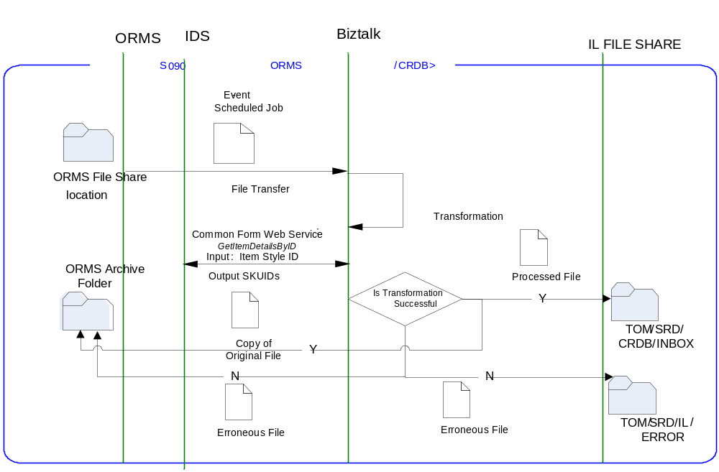

Requirements of the End-to-End Interface
The interface will run once a day and consists of a BizTalk package that extracts data from the ORMS shared location. It is accessed via CIFS file share through RTI file adapter in BizTalk. ORMS provide Product reclassification details at StyleItem level. Style Item ID is used to fetch SKUItem Number from IDS using the common form services. Product reclassification details are then passed at SKUItem level and formats into the target file format. The extracted file is kept in a shared folder in the integration layer. The CRDB system would pick the files from the windows shared location. Once the file is read, it will be moved to the archive directory of the integration layer.

The interface will make use of the audit and traceability components that are being developed as part of the Operational Framework stream. These components will be pluggable, and will be useable from BizTalk, RTI, and SSIS. At the time of writing (2007-01-20) the components are in design. Although not ready for use, they are included on the Information Architecture Context diagram where their functionality is required. Developers should put a ‘placeholder’ in their code / configurations as appropriate.

Non-Functional Requirements of the End-to-End Interface

Audit Requirements | The interface will use the components provided by the Operational Framework to satisfy audit requirements.
Security Requirements | The interface executes within a secure private domain. There is no additional security considerations required.
Timing/Cut-off Constraints | To be finalised.
Performance Requirements | The interface should be capable of extracting data from CRDB flat file, delivering the resulting data to CRDB in form of Flat file before the identified cut-off time. The interface should run on scheduled batch basis.
Reliability and Availability Requirements | The interface-run should be non atomic in nature. Appropriate mechanisms should be in place to raise/alert appropriate parties.
Scalability Requirements | No Scalability requirement. The requirement is to deliver a single extract. It is anticipated that the volume of data transferred will continue to remain within the capability provided by this implementation.
Operational Support Requirements | The scheduled start of the extract job and/or the completion of the target table update should be defined as IMOF events.
Likelihood of Change Requirements | There is no such requirement
Cultural/Global Consideration Requirements | Although multi-byte character set support is not required for US or Turkey, the interface will support multi-byte character sets through integration.
Legal Requirements | N/A
Compliance To Standards Requirements | No compliance exceptions.

Processing Required in the Extract Stage of the Interface

Scope
This section describes the data sources required by this interface and the services used to access the data.
Once the file appears in the shared location of ORMS, Biztalk extracts the required information from ORMS and IDS (via Common Form Services) and creates a required data-set as a flat file to a shared location in the integration layer. The data is also transformed to the required format within biz-talk package

Source Message Schema
The data for this interface resides in the ORMS shared folder. Biz-talk package is invoked to extract the reclassified product details.

Seq No | Field Name | Field Description | Data Format
1 | item | Item (Style Item) | Varchar2 (25)
2 | Filler | File delimiter containing the ‘|’ character | Varchar2 (1)
3 | reclass_no | Reclassification number | Number (4)
4 | Filler | File delimiter containing the ‘|’ character | Varchar2 (1)
5 | reclass_desc | Description of why the SKUs in the reclass_item table are being reclassified | Varchar2 (120)
6 | filler | File delimiter containing the ‘|’ character | Varchar2 (1)
7 | reclass_date | The effective date for the reclassification | Date
8 | filler | File delimiter containing the ‘|’ character | Varchar2 (1)
9 | dept | The current department the item belongs to. | Number (4)
10 | filler | File delimiter containing the ‘|’ character | Varchar2 (1)
11 | class | The current class the item belongs to. | Number (4)
12 | filler | File delimiter containing the ‘|’ character | Varchar2 (1)
13 | subclass | The current subclass the item belongs to. | Number (4)
14 | filler | File delimiter containing the ‘|’ character | Varchar2 (1)
15 | to_dept | The department that the SKUs should now belong to on the reclass_date. | Number (4)
16 | filler | File delimiter containing the ‘|’ character | Varchar2 (1)
17 | to_class | The class that the SKUs should now belong to on the reclass_date. | Number (4)
18 | filler | File delimiter containing the ‘|’ character | Varchar2 (1)
19 | to_subclass | The subclass that the SKUs should now belong to on the reclass_date. | Number (4)

IDS Common Form Web Service: GetItemDetailsByID web service is used to fetch the below details for each Style Item ID (1 Style Item:* SKU ID) from IDS.

Seq No | Field Name | Field Description | Data Format
1 | SKUID | Unique alphanumeric value that identifies the item. | Varchar(25)

Message Transport Details

Feature | Specification | Additional Information
Source System Name | ORMS
Source Platform / OS | Unix AIX
Source Physical Location | Shared Folder which can be accessed using CIFS using RTI file adapter (Configurable)
Source Underlying Data Storage Technology | File System
Target System Name | Biztalk
Target Platform / OS | Windows 2003 Server
Target Physical Location | In memory
Target Underlying Data Storage Technology | File Share
Transfer Function | HTTP (Put/Post) □  HTTPS (Put/Post) □  Message Queue □  FTP □  File Drop(Windows) □  (XCOM) □  RTI File Adapter ☑
Data Format. | XML □  Delimited □  Positional ☑  RDBMS □
Decryption/Encryption | No
Decompression/Compression | No
Transmission Mode | Synchronous □  Asynchronous ☑  Bulk Data □
Real-time/Scheduled Batch | Not yet decided
Archiving | There is no requirement to archive the messages.
Logging | Log via the Operational Framework.
Error Handling | Not yet decided  Processing should prevent sending of duplicate messages, unless this occurs during recovery from failure.

Processing Required in the SSIS Stage of the Interface

Scope
BizTalk monitors the shared location at ORMS shared folder for every new file. Once received, BizTalk picks up the file from the source, extracts SKUItem details from IDS and passes on to the shared location within the integration server after carrying out the necessary transformation. Since ORMS is under UNIX environment, the ORMS shared folder will be mounted in Windows environment at BizTalk end using CIFS and is accessed using RTI file adapter.

The file will be created with a temporary name and then it will be renamed once the file creation is complete.

Package Overview
The interface extracts the product reclassified details from ORMS and is formatted as per the target CRDB systems file structure and uploaded same into the integration layer shared directory.

Data Validation
N/A

Filtering
There is no filtering requirement.

Mapping
Mapping document will be provided subsequently.

Target Message Schema
Header Record
Column Name | Type | Length | Description
Record Type | Alphanumeric | 2 | Set to '00' for the header record.
Date/Time File Created | Alphanumeric | 14 | File Creation Date
Sequence number | Alphanumeric | 6 | Set to '000000'
Date | Alphanumeric | 8 | System date
File Id | Alphanumeric | 3 | Set to '000'
Filler | Alphanumeric | 150 | Set to spaces
Detail Record
Column Name | Type | Length | Description
Record Type | Alphanumeric | 2 | Set to ‘01’
Item | Alphanumeric | 25 | SKU Item ID
Reclass_no | Numeric | 4
Reclass_desc | Alphanumeric | 120
Reclass_date | Date | 8 | YYYYMMDD
Dept | Numeric | 4
Class | Numeric | 4
Subclass | Numeric | 4
To_dept | Numeric | 4
To_class | Numeric | 4
To_subclass | Numeric | 4
Trailer Record
Column Name | Type | Length | Description
Record Type | Alphanumeric | 2 | Set to '99' for the footer records
Record Count | Alphanumeric | 10 | Number of records (Excluding header & trailer)
Filler | Alphanumeric | 171 | Spaces

Message Transport Details
For messages destined for CRDB system, the following applies.

Feature | Specification | Additional Information
Source System Name | Biztalk
Source Platform / OS | Windows 2003 server
Source Physical Location | In memory
Source Underlying Data Storage Technology | File Based
Target System Name | CRDB
Target Platform / OS | Windows
Target Physical Location | TOM/SRD/CRDB/INBOX
Target Underlying Data Storage Technology | File-Based
Transfer Function | HTTP (Put/Post □  HTTPS (Put/Post) □  Message Queue □  FTP □  File Drop (Windows) □  (XCOM) □  RTI File Adapter □  RTI File Adopter ☑
Data Format | XML □  Delimited □  Positional ☑  RDBMS □
Decryption/Encryption | No
Decompression/Compression | No
Transmission Mode | Synchronous □  Asynchronous ☑  Bulk Data □
Real-time/Scheduled Batch | RDBMS extract
Archiving | There is no archiving requirement
Logging  Should logs be kept of all actions? For how long should these be stored? | Logging should occur, such that the message can be recreated if necessary.
Error Handling | On fail move the file to the failed transmissions location. The file drop failure will be tracked through IMOF functionality and will be done through a change request.

Naming and Configuration
BizTalk
Instruction Name: TOM.S090.ORMStoCRDB.FutureDatedProductReclassificationUpdate
Instruction Details
Description | To be determined
Enabled | Activate
Type
Operational Window
Schedule | N/A
Enabled | False
Host Details
Account | To be determined
Operational Details
Worker Threads
Priority
Batch Size
Period
Retry Attempts | 4
Timeout | 15
Require Data Send
Exception Management
Treat Fatal Adapter Exception As
Treat Unhandled Exceptions As

Environment and Security Context
Account details will be included here once we have visibility of the environments.

Non-Functional Requirements
On successful delivery of the data to the target system, the audit log should be updated via the Operational Framework pipeline component or adapter (to be determined).

In the event of a failure of transformation of data should be written to the failed log database, and an alert should be raised.

Testing Deliverables
This section should contain a list of discrete deliverables. The following table is an illustrative template only. The exact deliverables will depend on the technologies employed in the interface.

Deliverable | Description
TBD <stored proc name> | Common Form Stored Procedure
TBD <stored proc name> | Common Form Stored Procedure
TBD <service name> | Common Form Web Service
TBD <SSIS package name> | Package
TBD <RTI configuration file> | Xml configuration file exported from RTI. For testing, this should contain the configuration required to support this interface only.  For production, configuration should be documented under section 7 Deployment.
TBD <script name> | Unit Test Scripts. Scripts should be provided to:  - create databases (including stored procedures).  - populate with the minimum set of test data to satisfy functional requirements  - notes showing how to use scripts and describing the functions tested.
<installer> | Installers as appropriate to the technology being used.

Deployment

Assumptions and Outstanding Issues

Assumptions
ID | Assumption
1 | CIFS will provide link to Windows system for talking to UNIX system and vice-versa.

Outstanding Issues
ID | Issue | To be addressed by
1 | Source and Destination Shared location to be confirmed
2 | Error handling to be confirmed with respect to archiving process

- Volumes
- Glossary

Acronym | Term | Description
EAI | Enterprise Application Integration | The process of meeting the data requirements of applications by providing a message based transport from disparate data sources across all forms of enterprise technology.
EAI Layer | Enterprise Application Integration Layer | Refers to the integration services provided to implement EAI. In contrast to the EIA Layer for data services. See below.
EIA | Enterprise Information Architecture | Creation of a strategic single view of data across the enterprise.
Interface | Interface | Many definitions exist for 'interface'. In general, 'interface' refers to the link between a data source and a data target. And there are properties of the interface in this context. However more specifically 'interface' refers to one end of a data link, hence the terms source interface and target interface, and both the source interface and the target interface will have specific properties of their own.
RMS | Retek Merchandising System | Retek Merchandising System is getting installed for TESCO Merchandising operations in US. This system will governs the Merchandising operations; Receive base Master & Transaction data and from other systems and Provide data to next level of operation system as part of Retail systems chain.
IDS | Information Data Store | A store of data, logically residing in the EIA layer, that provides an authoritative single view of a discrete data component specific to the enterprise. Eg: Product, Store, etc. IDS's reside in the EIA Layer, and are accessed through the EAI Layer.
IMOF | Integration Management Operational Framework | IMOF is a framework which is pluggable to any Biztalk, RTI and SSIS for alerting, exception handling, defining rules, scheduling etc

- Document Control
Change Record

Author | Date | Version | Change Reference, description
Shajitha Mohammed | 17-05-2007 | 0.1 | Draft
Shajitha Mohammed | 21-05-2007 | 0.2 | Draft
Shajitha Mohammed | 18-06-2007 | 0.3 | Draft
Nitin Singhai | 26-07-2007 | 0.4 | RMS is providing data at Style Item level. Updated the document to get data at SKUITEM details using IDS Common Form Services for each Style Item.
Nitin Singhai | 31-07-2007 | 0.5 | Corrected the Architecture Diagram on Pg 6 to include IDS.

Related Documents

Author | Date | Version | Title

Distribution

Name | Position | Approver/Contributor/Other
Andrew Barker | Engagement Architect
John Cowper | Solution Architect
Jon Braggs | Enterprise Architect
David Onyett | Project Lead
Venkateswara Rao | Delivery Manager

