**LS command:**

Ls command is commonly used in daily linux operations. Command is used in listing content inside a directory.

**LS:**  ls without any options list files in plain format without information of permission, type, date etc.

**Options:**

**Ls -a:** returns the whole list of the current directory including hidden files.

**Ls -l:** returns the list in long list format.

**Ls -lh:** returns file sizes in human readable format.

**Ls -lhs:** returns files in descending order according to their size.

**Ls -d*/:** used to return display only sub directory.

**Ls -li:** print the index number if the file is in the first column.

**Ls -p:** used to identify directory by marking (/) line sign.

**Ls -r:**  print list in reverse order.

**Ls -R:** print content of sub directory also.

**Mkdir command:**

Mkdir stands for make directory. With help of this we can create a new directory wherever we want in our system.

**Mkdir <dir name>**

Mkdir file1 file2 file3 … fileN.

**Rmdir command:**

Rmdir stands for remove directory. With help of this we can remove the directory.

**Rmdir <dir name>**

Rmdir file1

**Pwd command:**

It is used to display the location of the current working directory.

**Pwd**

**Cd command:**

Cd command is used to change the current directory.

**Cd <dir name>**

Cd Desktop

**Touch command:**

It is used to create empty files.

**Touch <file1> <file2> …**

**Cat command:**

It is used to create file, display content. It is used for multi-purpose.

**Cat [option] []file]**

**Rm command:**

Rm command used to remove a file.

**Rm <file name>**

**Cp command:**

Cp command is used to copy a file or directory.

**Cp <existing file name> <new file name>**

**Mv command:**

Mv command is used to move a file or directory from one location to another location.

**Mv <file name> <directory path>**

**Rename command:**

Rename command is used to rename files. It is used to rename a large group of files.

Example: convert all text files into pdf files.

**Rename ‘s/\.txt$/\.pdf’*.txt**

**Linux user commands:**

**Su command:**

Su command is used to give/provide admin access to another user.

**Su <username>**

**Id command:**

Id command is used to display user id and group id.

**Id**

**Useradd command:**

Useradd command is used to add or remove a user.

**Useradd <username>**

**Passwd command:**

The passwd command is used to create and change the password for a user.

**Passwd <username>**

**Groupadd command:**

The groupadd command is used to create a user group.

**Groupadd <group name>**

**How to change directory permission in Linux:**

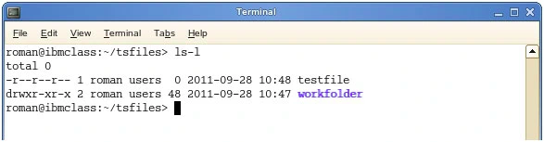

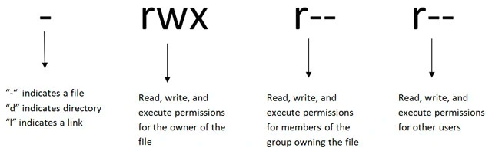

To change directory permission in linux, use the following:

**Chmod + rwx** filename to add permissions

**Chmod -rwx**  directoryname to remove permissions.

**Chmod +x** filename to allow executable permissions.

**Chmod -wx filename** to take out write and executable permissions.

**How to change groups of files and directories in linux:**

**Chgrp groupname filename**

**Chgrp groupname foldername**

**How to change ownership in linux:**

**Chown name filename**

**Chown name foldername**

These commands will give ownership to someone, but all sub files and directories still belong to the original owner.

**How to change permissions in numeric code in linux.**

0: No permission

1: Execute

2: Write

3: Read

Permission number are:

0: -

1: -x

2: -w-

3: -wx

4: r-

5: r-x

6: rw-

7: rwx

For example:

**Chmod 777 foldername:** will give read, write and execute permissions for everyone.

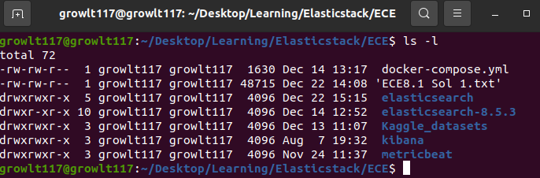

**Field Explanation:**

-: normal file

D: directory

S: socket file

L : link file

Field 1 - file permission: Next 9 char specifies file permission. Every 3 char specifies read, write, execute permission for user(root), group and others respectively in order.

Field 2 - Number of links: It specifies the number of links for that file.

Field 3 - Owner: specifies owner of the file.

Filed 4 - Group: specifies group of the file.

Field 5 - Size: specifies size of files in bytes.

Field 6 - Last modified data & time: specifies date and time of last modification.

Field 7 - File name: name of the file.