Mouse Framework - Project Report

AI Task Delegation Framework for Human-AI Collaboration

Executive Summary
Mouse Framework is an interactive web application designed to teach users the principles of effective human-AI collaboration. The application focuses on helping users understand when to delegate tasks to AI agents and when human judgment is required, with emphasis on stakes-based decision making, reversibility, and maintaining user control.Live Repository: https://github.com/growingpenguin/mouse-framework

Problem Statement
As AI agents become increasingly capable of executing complex tasks, users face a critical challenge: determining which tasks can be safely delegated to AI and which require human oversight. Poor delegation decisions can lead to:
- Irreversible actions taken without proper review
- Sensitive data exposed to automated systems
- Legal, financial, or security risks from AI-made decisions
- Loss of user control over critical processes

Solution: The Mouse Framework
The Mouse Framework provides an educational, interactive interface that:
- Visualizes task decomposition - Breaks complex requests into individual task nodes
- Classifies stakes levels - Identifies high-stakes vs low-stakes tasks
- Teaches delegation principles - Shows which tasks are safe to delegate
- Emphasizes reversibility - Demonstrates undo, rollback, and preview controls
- Reinforces learning - Summarizes key takeaways for user retention

Application Flow
The application consists of 5 connected screens:

Screen 1: Task Input & Decomposition

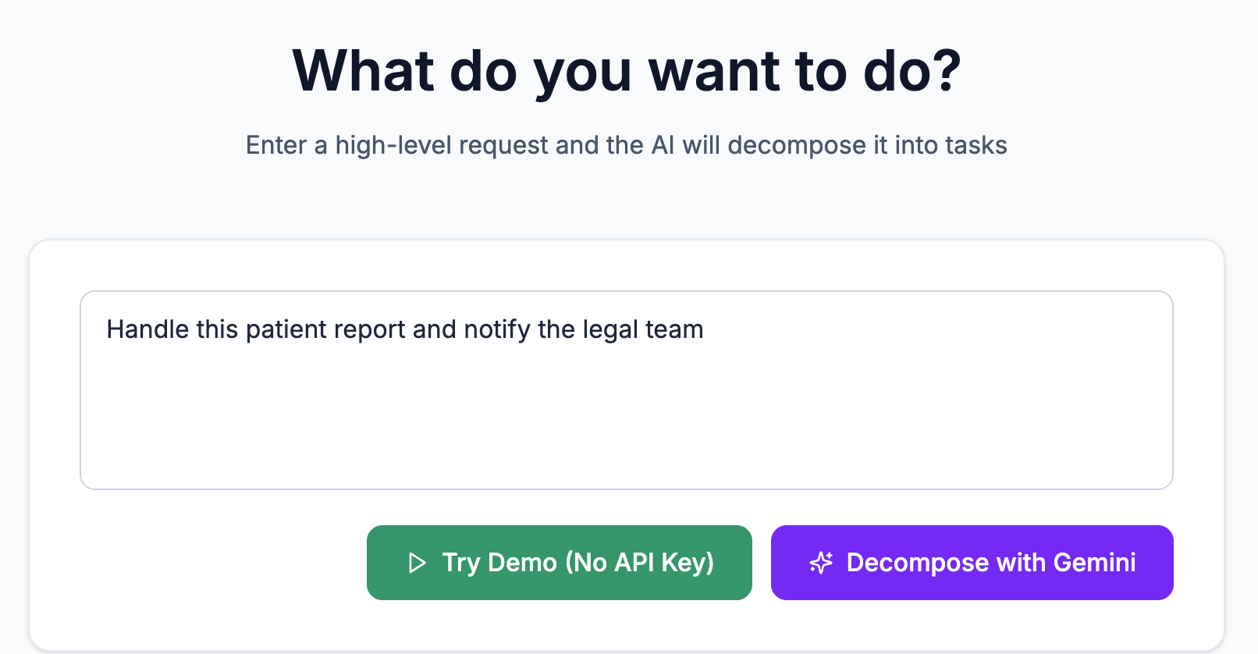
"What do you want to do?"Users enter a high-level request (e.g., "Handle this patient report and notify the legal team"). The system decomposes this into individual task nodes displayed as a visual framework:
- Green nodes = Low-stakes (reversible, informational)
- Red nodes = High-stakes (irreversible, sensitive, critical)
Key message: "High-stakes tasks should not be delegated to AI."

Screen 2: Framework View (Editable Process)

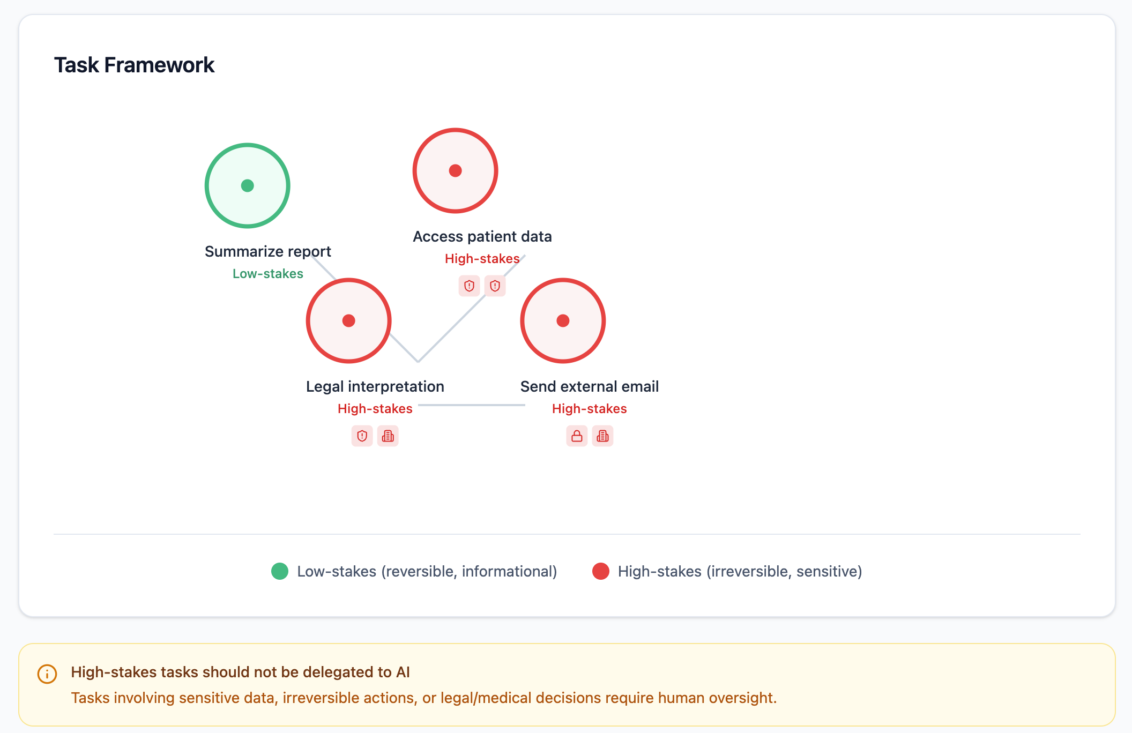
"Your process framework"
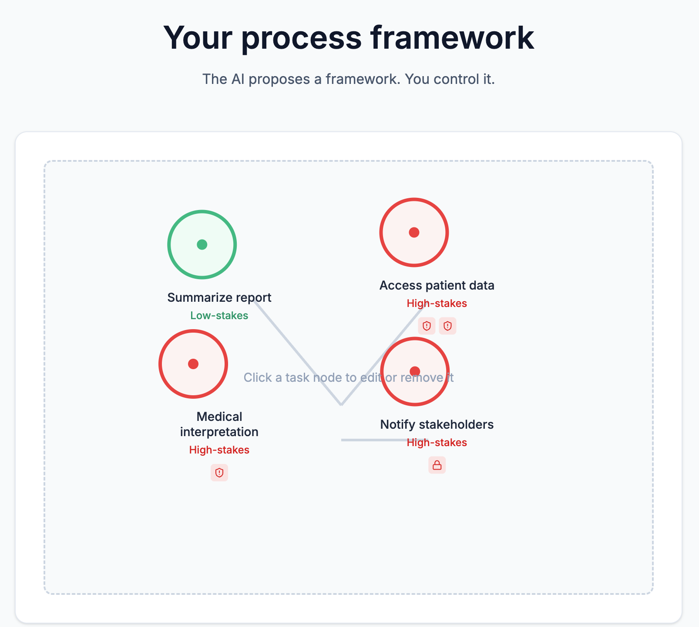
Users can interact with the task framework:
- Click nodes to select them
- Remove tasks from the workflow
- Edit descriptions
- Merge or split tasks
Key message: "The AI proposes a framework. You control it."

Screen 3: Delegation & Stakes Rules
"Who should handle each part?"
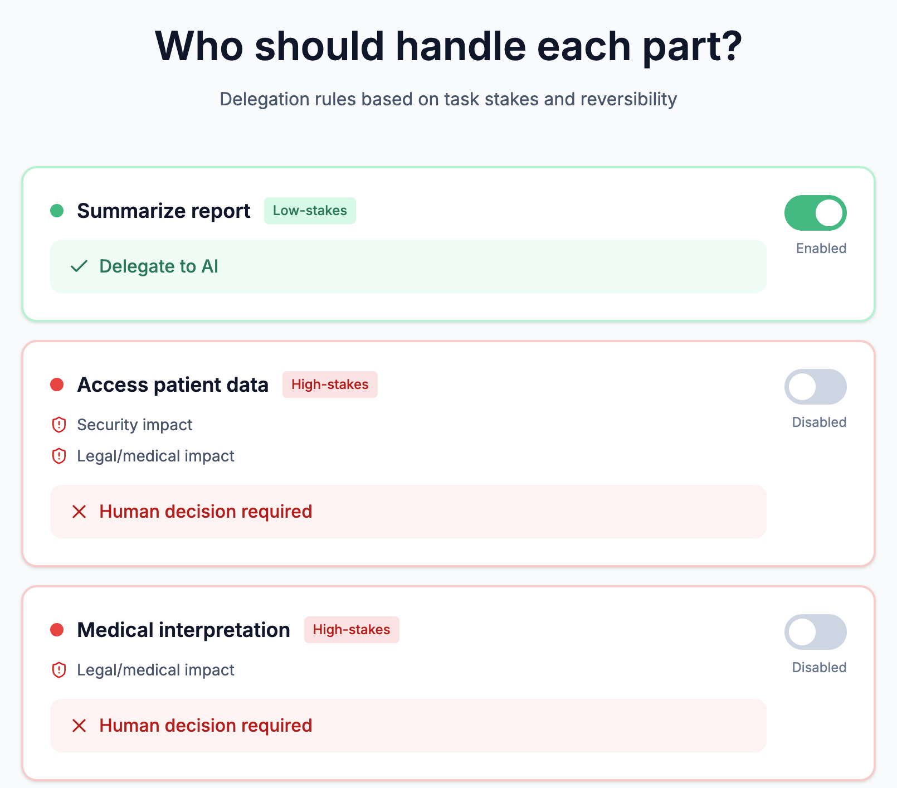
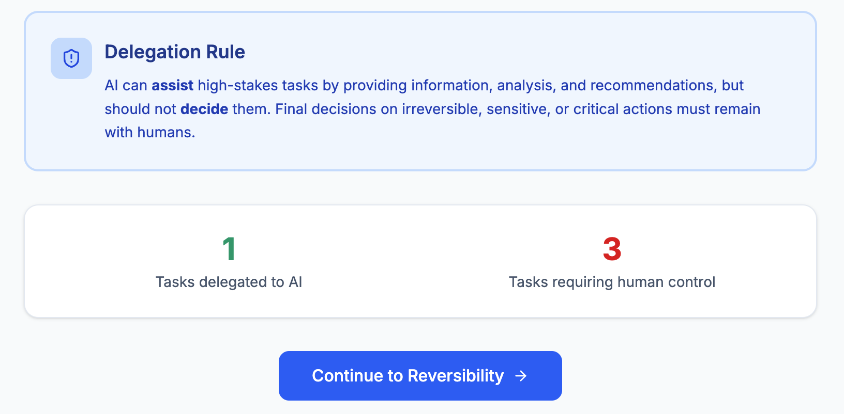

Each task displays its delegation status:
- ✅ Low-stakes → "Delegate to AI" (enabled)
- ❌ High-stakes → "Human decision required" (disabled)
Risk types are clearly shown:
- 🔒 Irreversible action
- ⚖️ Legal/medical/security impact
- 🏢 Company-wide risk
Key message: "AI can assist high-stakes tasks, but should not decide them."

Screen 4: Reversibility & Checkpoints
"Control & safety"

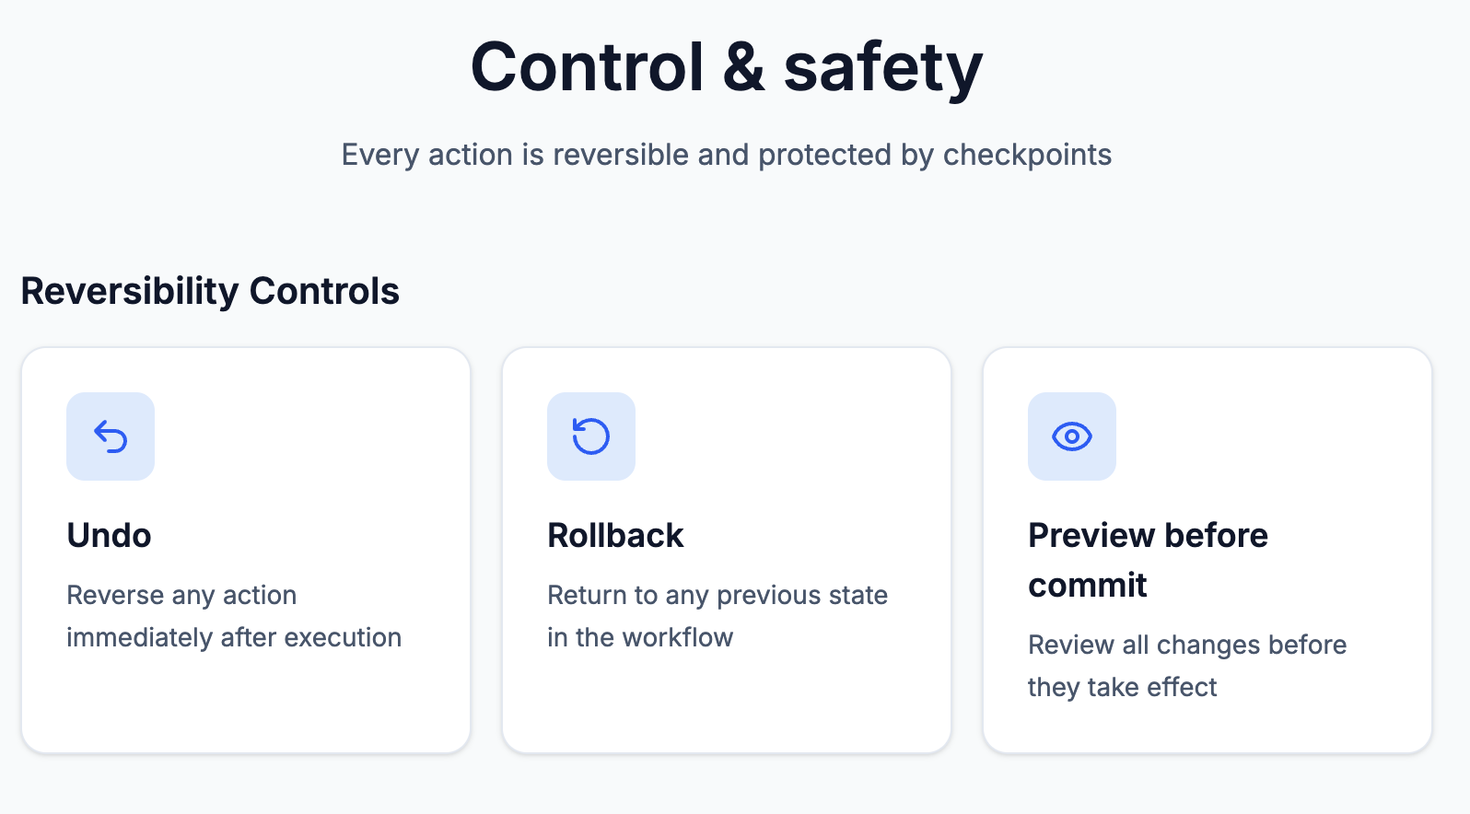

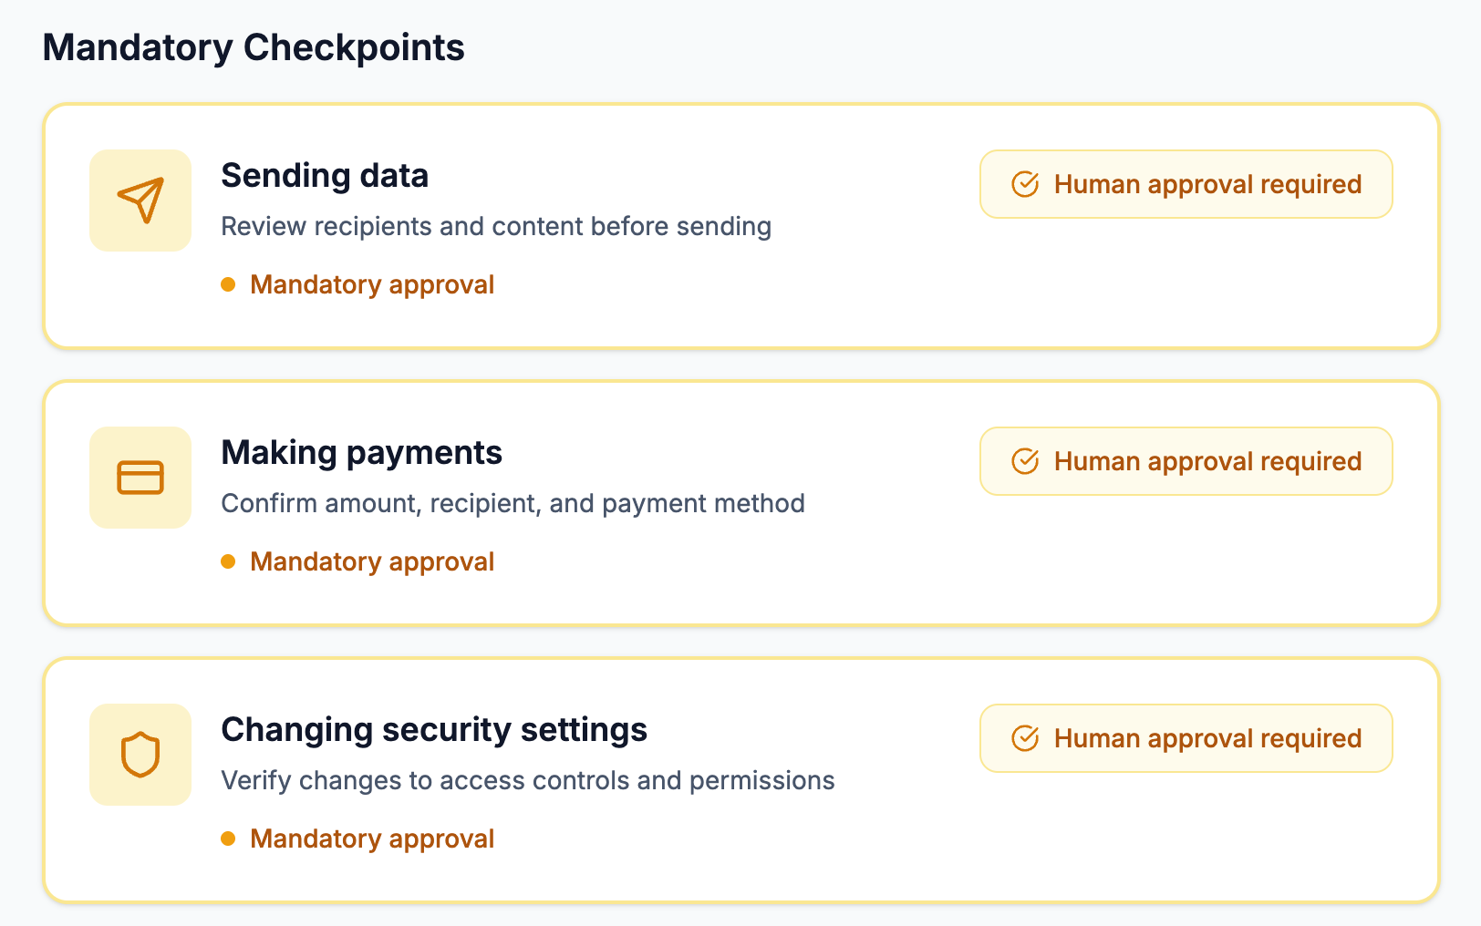

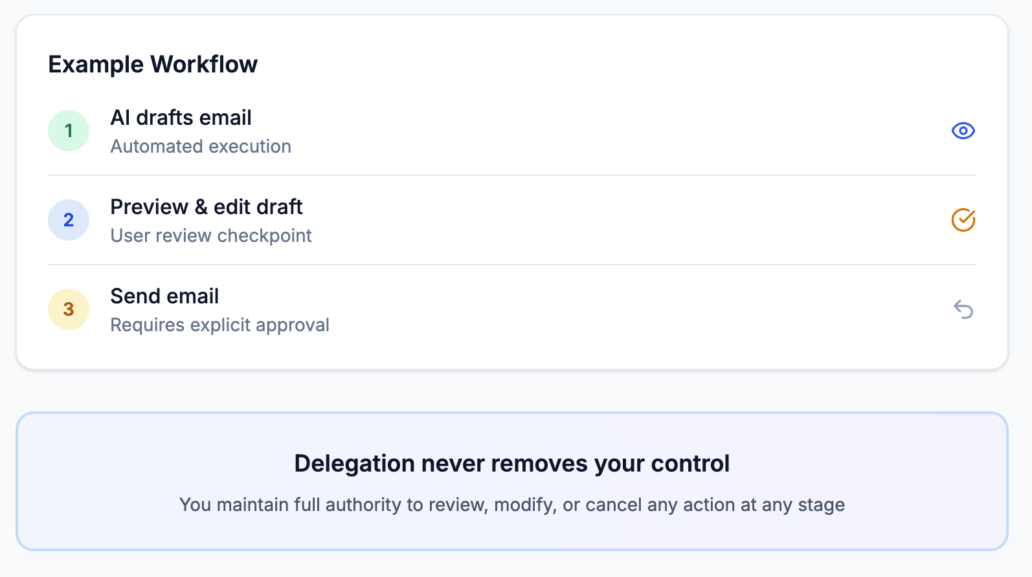
Demonstrates safety controls:
- Undo - Reverse any action immediately
- Rollback - Return to any previous state
- Preview - Review changes before commit
Mandatory checkpoints before:
- Sending data externally
- Making payments
- Changing security settings
Key message: "Delegation never removes your control."

Screen 5: Learning & User Improvement
"What you learned"
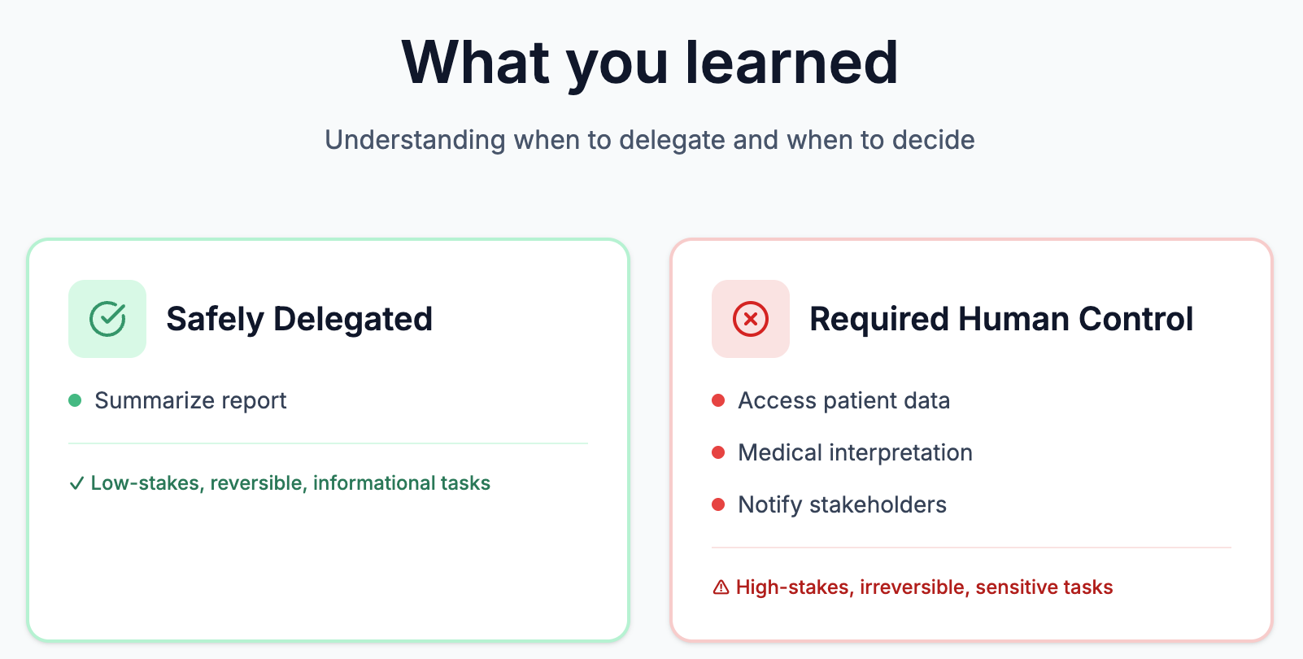
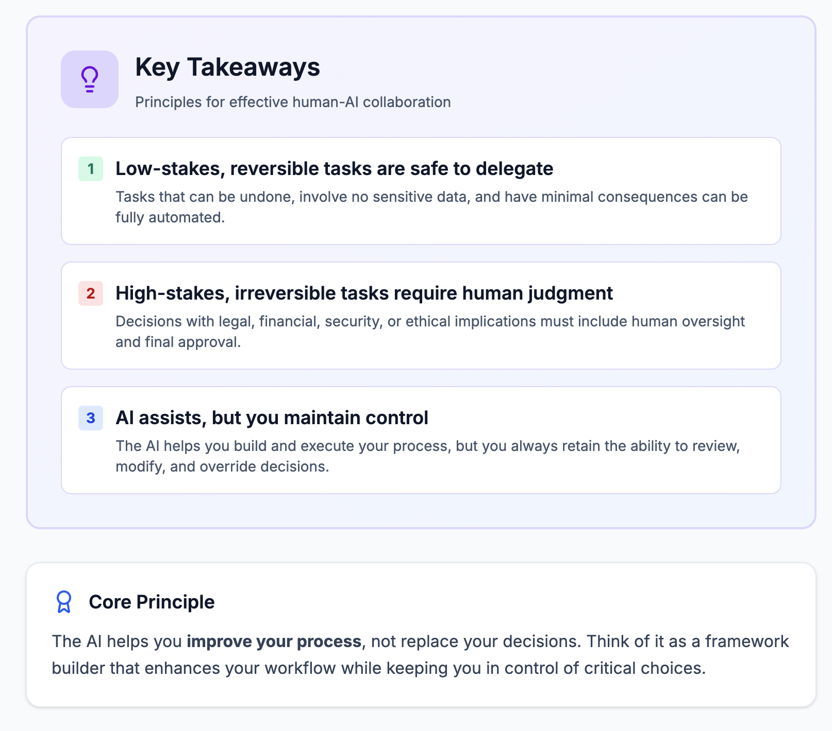
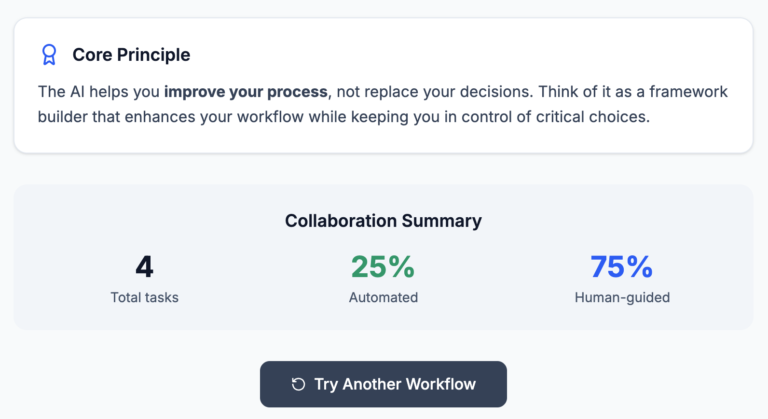

Summarizes the session:
- Tasks safely delegated to AI
- Tasks requiring human control
- Collaboration statistics (% automated vs human-guided)
Key takeaways:
- Low-stakes, reversible tasks are safe to delegate
- High-stakes, irreversible tasks require human judgment
- AI assists, but you maintain control
Core principle: "The AI helps you improve your process, not replace your decisions."

Technical Implementation

Technology Stack
Technology | Purpose
React 18 | UI framework
TypeScript | Type safety
Vite | Build tool & dev server
Tailwind CSS 4 | Styling
Google Gemini AI | Task decomposition
Lucide React | Icons
Radix UI | Accessible UI primitives

AI Integration
The application integrates Google Gemini AI (gemini-1.5-flash model) for intelligent task decomposition:
- Free tier usage: 15 requests/minute, 1,500 requests/day, 1M tokens/month
- Smart fallback: Works without API key using keyword-based task generation
- Demo mode: Pre-built example for immediate exploration

Project Structure
mouse-framework/
├── src/
│ ├── components/
│ │ ├── TaskNode.tsx # Visual task nodes
│ │ ├── TaskInput.tsx # Screen 1
│ │ ├── FrameworkView.tsx # Screen 2
│ │ ├── DelegationRules.tsx # Screen 3
│ │ ├── ReversibilityCheckpoints.tsx # Screen 4
│ │ └── LearningOutcome.tsx # Screen 5
│ ├── lib/
│ │ └── gemini.ts # AI integration
│ └── styles/
├── .env.example # API key template
├── package.json
└── README.md

Design Principles
Principle | Implementation
Visual Stakes | Green (safe) vs Red (danger) color coding
User Control | Editable framework, not fixed rules
Reversibility | Undo, rollback, preview at every step
Education | Teaching users over time, not just blocking
Enterprise-grade | Professional, calm, instructional UI
Accessibility | Keyboard navigation, clear visual hierarchy

Installation & Usage

Quick Start (Demo Mode)

git clone https://github.com/growingpenguin/mouse-framework.git

cd mouse-framework

npm install

npm run dev
Open http://localhost:5173 and click "Try Demo (No API Key)" to explore.

Full Setup (With AI)

git clone https://github.com/growingpenguin/mouse-framework.git

cd mouse-framework

npm install

cp .env.example .env

# Add your Gemini API key to .env

npm run dev
Get a free API key at: https://aistudio.google.com/app/apikey

Key Features
- No API Key Required - Demo mode allows instant exploration
- Gemini AI Integration - Intelligent task decomposition (free tier)
- Interactive Visualization - Node-based task framework
- Stakes Classification - Automatic high/low stakes detection
- Risk Type Identification - Security, legal, irreversibility flags
- Educational Flow - 5 screens teaching delegation principles
- Responsive Design - Works on desktop browsers
- Modern UI - Clean, professional enterprise aesthetic

Learning Outcomes
Users who complete the Mouse Framework experience will understand:
- When to delegate to AI:
- Reversible actions
- Informational tasks
- Low-consequence decisions
- Internal drafts and analysis
- When human judgment is required:
- Irreversible actions
- Sensitive data access
- Legal/medical/financial decisions
- Security-impacting changes
- External communications
- How to maintain control:
- Review before commit
- Undo capabilities
- Checkpoint approvals
- Editable frameworks

Future Enhancements
Potential areas for expansion:
- User authentication and saved workflows
- Custom task templates
- Team collaboration features
- Integration with real AI agent systems
- Analytics and learning progress tracking
- Mobile-responsive design

Conclusion
The Mouse Framework demonstrates that effective human-AI collaboration requires clear boundaries, visual feedback, and educational reinforcement. By treating AI as a "framework builder" rather than a decision-maker, users maintain control while benefiting from AI assistance.The application successfully teaches the core principle: AI helps improve your process, not replace your decisions.

