**PiperNet**

Version 0.5.0

User Guide

# Table of Contents

Table of Contents 1

About Document 2

1 Software Overview 3

2 Data Import 4

3 Data Visualization in 3D 6

4 Data Processing 7

Section 1 Modify statics in data sheets 7

Section 2 Selection 9

Section 3 Cluster 10

Section 4 Search 10

Section 5 Add and delete nodes or edges 10

Section 6 Merge Cluster 11

Section 7 3D plane separation 11

5 Graph Option 12

Section 1 Nodes 12

Section 2 Edges 13

Section 3 Labels 13

Section 4 Clusters 14

6 Export Data 15

# About Document

Intended users

This software is intended to be used by scientists who are working in data analysis. This document will be used in concert with the software to generate graphs from the research datasets, figure out some hidden information and modify the datasets when analyzing the graph.

Additional documents

For general instructions to install this software, see install instructions for PiperNet.

For sample datasets, see input data format and samples.

For system requirements of this software, see system requirements.

All documents are available at <https://yuewu0526.github.io/PiperNet-Docs/>.

# 1 Software Overview

This software is a desktop visual analytics application developed to aid the interpretation of complex datasets.

This software supports visualization from various input data formats to 3D graphs. After the graph is created, this software offers detailed information of nodes and edges. A table of statics is provided to modify data for updating the graph. Changes such as color the nodes through attributes and merge or separate nodes groups can be done in this software assisting data research. A fixed dataset will be export in GEXF and CSV format at the end of data analysis.

# 2 Data Import

You can import data to the start scene. The acceptable data formats are Comma Separated Values and Graph Exchange XML Format. To bring data to this application, click **Graph** pop-up menu on the bar above and choose **Import from CSV…** or **Import from GEXF…** according to the data format. An import dialog is displayed.

If you **import CSV files**, there are two options which are import **only edges file** or **both nodes and edge file**.

To import only edges file, choose **only edges file** and **Browse** to select the folder in which the edges file you want to import is located.

If you want to import both nodes and edges file, choose **both nodes and edges file** and click **Browse** to select the folder in which the matching nodes and edges file you want to import are located.

Choose the appropriate delimiter in **Selected Delimiter** then the data will be previewed in the correct format. By default, the first nine rows of data will be shown below, where you can choose whether to **hasHeaders** to include header attribute or not. Select the Source Node ID column and Target Node ID Column in edges files. Select Node ID column if the nodes file is chosen. Click **Import** when all settings are done.

If you want to **import GEXF files**, in the dialog, click **Browse** to select files on your disk and click **Import**.

After importing data, you are able to see a **3-dimensional** **non-directed** Graph base on the imported datasets.

# 3 Data Visualization in 3D

View graph

To view the graph from different angle and size, the following operations can be applied:

* Rotate:

hold the left mouse

* Pan:

hold the right mouse

* Zoom:

mouse wheel

To start or resume the **graph animation**, switch on or switch off to control automatic animation.

View node details

For more details of a certain node, the mouse **hover** can show a label of the node ID with the node in red color. The edges link to this node will be highlighted in red. Detailed information of the node such as node ID and other attributes will be displayed in a **table** on the right-top side of the software.

**Left click** the node, the **table** on the right-top will display the node details.

The node attributes are editable through the table by choose and double click the cell in the table.

# 4 Data Processing

Section 1 Modify statics in data sheets

Node Data Sheet

To update the scope of data to be visualized halfway, do the following:

Click **Tools** pop-up menu and choose **Node DataSheet** from this menu, a data sheet dialog will be displayed.

If you want to plot the graph with certain range of data, you need to select data by turn on or turn off the switch button is “**Show**” column. If the switch button is on, this row of data will be displayed in the graph. By contrast, the data will not be displayed in the graph is the switch button is off.

If you want to delete nodes, click **Delete** at the front of the row. A dialog will be displayed with all node attributes. Click **Cancel** if you do not want to delete the node. Press **Confirm Delete** button to delete the node.

文本

To change the properties of the data, select and double click the cell that you intended to change and type in the modified value.

If you want to add nodes, click **Add Node** and a dialog will pop-up. Enter the new node id and other attributes. Only a new node with unique id will be added after validation check. Click **confirm** then the new node is added to the bottom of the data sheet. If you do not want to add nodes, close this dialog.

If the data sheet is not updated with new nodes, click **Refresh** to update the node sheet. A new graph will be generated by clicking **Refresh**.

If you find difficulty in finding nodes, **Search any Node…** can aid you. Type the value of node id, the node whose id contains the value will be demonstrated in the table below.



Edge Data Sheet

To update the relationship between nodes, do the following:

Click **Tools** pop-up menu and choose **Edge DataSheet** from this menu, a data sheet dialog is displayed.

If you want to delete edges, click **Delete** at the front of the row. A dialog will be displayed with source node id and target node id. Click **Cancel** if you do not want to delete this edge. Press **Confirm Delete** button to delete the edge.

文本

If you want to add edges, click **Add Edge** and a dialog will be displayed. Choose the source node id and target node id for the edge. Validation check will check whether the source node is the same as target node or the edge already exists. Only passes the validation check, the new edge is able to be added. Click **confirm** then the new edge is added to the bottom of the data sheet. Otherwise, click **Cancel** to quit.

If the data sheet is not updated with new edges, click **Refresh** to update the edge data sheet. A new graph will be generated by clicking **Refresh**.

To find certain edges, **Search any Source or Target of an Edge…** helps. Type the value of node id, edges connect to the nodes containing the value in node id will be displayed below in the table.



Section 2 Selection

Multiple Selection

Hold **Control** or **Shift** and **left click** the node, multi-select the nodes. When the nodes are selected, they will be painted to yellow by default. The corresponding information of these nodes will be displayed at bottom of the scene. All properties of the nodes are included in this table.

To deselect the nodes, hold **Control** or **Shift** and **left click** the node. When the color of nodes turns into the previous one, the nodes are unselected. When the nodes are not selected, the details of the nodes will not be shown in the table.

Rectangular Marquee Selection

Section 3 Cluster

Cluster by attributes

To choose the attribute for cluster, do the following:

Choose **Clustered by** at the top of the scene. All attributes of the nodes will be shown in the menu. By default, the cluster is none and no cluster is formed. When a new attribute is selected for cluster, the graph will be refreshed. Nodes in different clusters will be packed by **spheres** in different colors. Change other attributes for cluster or choose non-cluster during data analysis.

User defined cluster

To add clusters to the graph when no attributes are selected, do the followings:

First, use multi-selection which is mentioned in the selection section earlier in this document.

Section 4 Search

To look up for a certain node, do the followings:

Type in **node id** in this search box, all nodes with id containing the value typed in will pop-up in a list. Click the node id, the camera will focus on this node and the corresponding node details will be displayed at the top-right table.

To search nodes through attributes, type in **‘attr:’** with **‘attribute names:’** and the **value**, for example, attr: type: person. After the search conditions are typed in, a list of nodes will be displayed above the search box. Click the node id, the camera will focus on this node and the corresponding node details will be displayed at the top-right table.

Section 5 Add and delete nodes or edges

To add nodes on the graph, first, **right-click** the background and a menu with **Add Node** will be pop-up. Then click Add Node and a dialog will be displayed. Type in Node ID and it will automatically check its validation. If the validation check of the new node ID is passed, the new node can be created with other possible attributes. When the node is generated and displayed in the graph, hold and drag the node to adjust its location.

To delete nodes, first, right-click the node and a menu will be displayed. Click **Delete Node** in the menu, then the node will be deleted. If the node is linked to other nodes, the edges between them will be cut off. The other nodes will remain in the graph after animation automatically.

To delete edges, first, right-click the node and a menu will be displayed. Click **Delete Edge** in the menu, then a table with all edges linked to this node will be displayed. The node id which the edge linked to will be showed in the table. Hover the row of edge, the edge will be highlighted in the graph and Click **Delete** and this edge will be cut off.

Section 6 Merge Cluster

Section 7 3D plane separation

# 5 Graph Option

The top-left menu provides options in visualizing the graph in different strategies. Click the unfold button to spread the menu.

Section 1 Nodes

To modify the styles of nodes, do the followings:

Click **Nodes** and node **Color**, **Size** and **Shape** can be changed in this menu.

Unfold **Color** Collapse component to set color of nodes as user defined. Click the color selection box at the right of the Collapse component. In this way, the **Default Color**, **Selected Color** and **Highlight Color** can be changed.

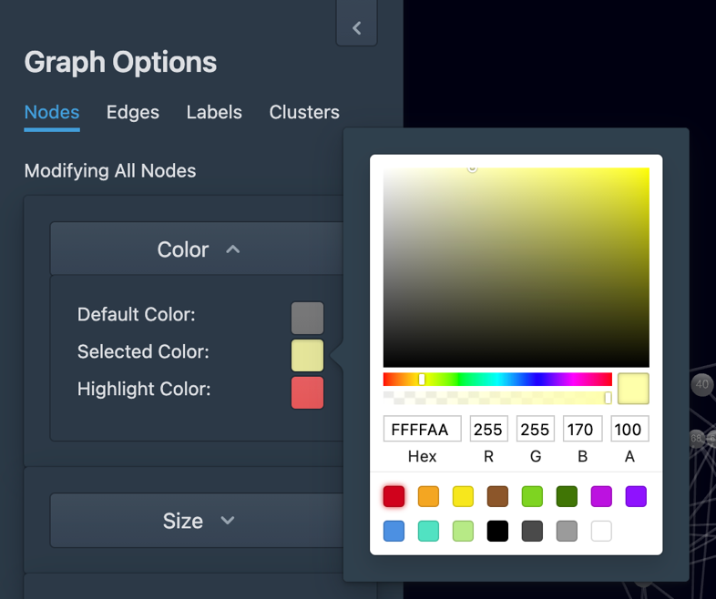

To modify the **Size** of nodes, unfold Size Collapse component. Then hold the value chooser and drag in the slider to change the size of nodes which can be ranged from 1 to 20. The size of nodes displayed in the graph will be modified along fixing the value of node size in the slider.

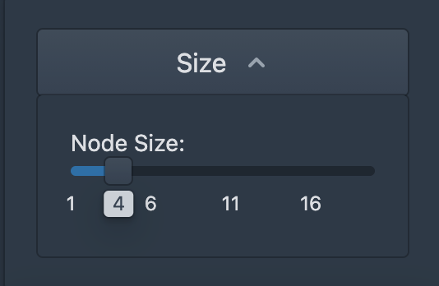

The Shape of nodes can be altered in the unfolded **Shape** Collapse component by changing the value of node resolution. Hold the value chooser and drag it in the slider. The value of node resolution is ranging from 2 to 20. The node’s shape is more likely to be a sphere when the node resolution is close to 20.

Section 2 Edges

To modify the styles of edges, do the followings:

Click **Edges** and edge **Color** can be changed in this menu.

Unfold **Color** Collapse component to set color of edges. Click the color selection box at the right of the Collapse component. In this way, the **Default Color**, **Selected Color** and **Highlight Color** can be changed. When nodes are selected or highlighted, the color will alter to the color as user set in this component.

Section 3 Labels

To modify the styles of labels, follow the steps below:

**Show Node Label** is used to control the display of labels. Switch on to display the labels, otherwise, switch off to hide the node labels. The node label contains information about node id.

To alter the size of labels, hold and drag the value chooser to change the size in the slider from 1 to 10. Choose the appropriate size for labels as indistinction might be cause when the label is larger than node.

Click the color selection box at the right-bottom of the menu. In this way, the font color of labels will be modified.

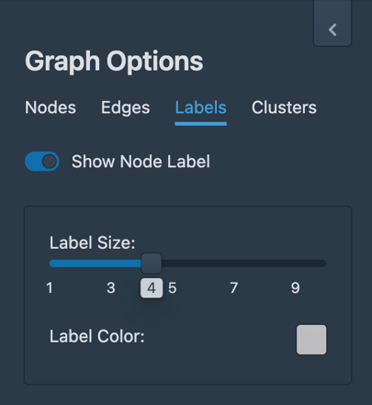

Section 4 Clusters

To modify the styles of clusters, follow the instructions:

The **Cluster Force Distance** and **Normal Force Distance** can be modified in the slider by holding and dragging the value chooser from the minimum value 0 to maximum value 100. The former controls the whole cluster connection. The nodes in a cluster will link tightly when a higher value is chosen in the slider3. The latter controls the edges between nodes. With higher normal force distance, the edges will loosely organized.

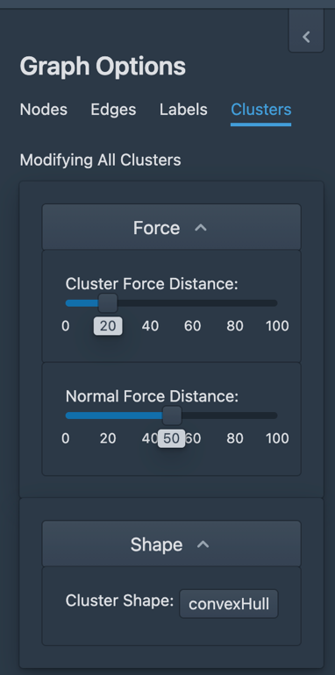

The **Shape** of clusters have two options which are convex Hull and sphere. Users are allowed to choose which shape the cluster is. If sphere is chosen, cluster resolution can be modified by hold and drag the value chooser in the slider from 2 to 20. The higher cluster resolution will makes the cluster tend to be a sphere.

\

# 6 Export Data

Use the Export command to compile the data into a **CSV** or **GEXF** file that can be used in data analysis later. The entire contents of the modified data are included in the export file. To export data, do the following:

Click **Graph** pop-up menu and choose **Export Graph**. An Export Graph dialog is displayed.

To export to a **GEXF** file, click **Download GEXF File** to download the GEXF file containing all data values to your disk.

To export in **CSV** format, click **Download Node File** to select the location to store the file of node attributes. Click **Download Node File** to download the file of edges’ information to the default location.