**PiperNet**

Version 1.0.0

User Guide

# Table of Contents

Table of Contents 1

About Document 2

1 Software Overview 3

2 Data Import 4

3 Data Visualization in 3D 7

4 Data Processing 8

Section 1 Modify statics in data sheets 8

Section 2 Search 10

Section 3 Selection 11

Section 4 Cluster 11

Section 5 Add and delete nodes or edges 12

Section 6 Merge Cluster 13

Section 7 Split Clusters 14

5 Graph Option 15

Section 1 Nodes 15

Section 2 Edges 16

Section 3 Labels 17

Section 4 Clusters 17

6 Export Data 19

# About Document

Intended users

This software is intended to be used by scientists who are working in data analysis. This document will be used in concert with the software to generate graphs from the research datasets, figure out some hidden information and modify the datasets when analyzing the graph.

Additional documents

For general instructions to install this software, refer to install instructions for PiperNet.

For sample datasets, see input data format and samples.

For system requirements of this software, see system requirements.

All documents are available at <https://grp202004.github.io/PiperNet-Docs/>.

# 1 Software Overview

This software is a desktop visual analytics application developed to aid the interpretation of complex datasets.

This software supports visualization from various input data formats to 3D graphs. After the graph is created, this software offers detailed information of nodes and edges. A table of statics is provided to modify data for updating the graph. Changes such as color the nodes through attributes, merge or separate nodes groups can be done in this software assisting data research. A fixed dataset will be export in GEXF and CSV format at the end of data analysis.

# 2 Data Import

You can import data in the start scene. The acceptable data formats are Comma Separated Values and Graph Exchange XML Format. To bring data to this application, click **Graph** pop-up menu on the bar above and choose **Import from CSV** or **Open GEXF** according to the data format. An import dialog is displayed.

If you wish to **import CSV files**, the edge file is required. First, click **Browse** to select the folder in which the edges file you want to import is located. Choose the appropriate delimiter in **Selected Delimiter** then the data will be previewed in the correct format. By default, the top nine rows of data will be shown below, where you can choose whether to **hasHeaders** to include header attribute or not. Select the Source Node ID column and Target Node ID Column in edges files. Click **Next** and the dialog gives instructions about whether to import node files or not. **Switch on** **I want to import node file** to Import node file in the next step, otherwise, no node files will be imported in the next step. The message will help you to decide whether to import node files or not. Click **Next** and click **Browse** to select the folder in which the nodes file you want to import is located. By default, the top nine rows of data will be shown below, where you can choose whether to **hasHeaders** to include header attribute or not. Select the Node ID column in nodes files. Click **Import** when all settings are done. Users are allowed to Click **Back** or Click the left steps to rollback and change the previous settings.

If you want to **Open GEXF files**, in this dialog, click **Browse** to select files on your disk and click **Import**.

After importing data, you are able to see a **3-dimensional** **non-directed** Graph base on the imported datasets.

# 3 Data Visualization in 3D

View graph

To view the graph from different angle and size, the following operations can be applied:

* Rotate:

hold the left mouse

* Pan:

hold the right mouse

* Zoom:

mouse wheel

To start or resume the **graph animation**, switch on or switch off to control automatic animation.

View node details

For more details of a certain node, the mouse **hover** can show a label of the node ID while the node turns red. The edges link to this node will be highlighted in red. Detailed information of the node such as node ID and other attributes will be displayed in a **table** on the right-top side of the software.

**Left click** the node and the respective information will be displayed at bottom table.

# 4 Data Processing

To aid data processing, there are four mode for different usage. **Normal mode** is used when basic operations, for example, add and delete single node in one time; **Node Selection** mode is used in selecting nodes and dispatch processing; **Cluster Selection** mode is applied in merge cluster and release a whole cluster while **Cluster Splitting** mode is utilized in sperate nodes in one cluster. Selection modes have hint dialogs displayed at the bottom. A small guidance can be seen by hovering each mode.



Section 1 Modify statics in data sheets

Node Data Sheet

To update the scope of data to be visualized halfway, do the following:

Click **Tools** pop-up menu and choose **Node DataSheet** from this menu, a data sheet dialog will be displayed.

If you want to delete nodes, click **Delete** at the front of the row. A dialog will be displayed with confirmation message including all node attributes. Click **Cancel** if you do not want to delete the node. Press **Confirm Delete** button to delete the node.

文本

To change the properties of the data, select and double click the cell that you intended to change and type in the modified value. Node ID as the unique identifier cannot be modified.

If you want to add nodes, click **Add Node** and a dialog will pop-up. Enter the new node id and other attributes. Only a new node with unique id will be added after validation check. Click **confirm** then the new node is added to the bottom of the data sheet. If you do not want to add nodes, close this dialog.

If the data sheet did not update users on new nodes, click **Refresh** to update the node sheet. A new graph will be generated by clicking **Refresh**.

If you find difficulty in finding nodes, **Search any Node…** can aid you. Type the value of node id, the node whose id contains the value will be demonstrated in the table below.



Edge Data Sheet

To update the relationships between nodes, do the following:

Click **Tools** pop-up menu and choose **Edge DataSheet** from this menu, a data sheet dialog is displayed.

If you want to delete edges, click **Delete** at the front of the row. A dialog will be displayed with confirmation message containing the value of source node id and target node id. Click **Cancel** if you do not want to delete this edge. Press **Confirm Delete** button to delete the edge.

文本

If you want to add edges, click **Add Edge** and a dialog will be displayed. Choose the source node id and target node id for the edge. Validation inspection will check whether the source node is the same as target node or the edge already exists. Only passes the validation check, the new edge is able to be added. Click **confirm** then the new edge is added to the bottom of the data sheet. Otherwise, click **Cancel** to quit.

If the data sheet did not update users on new edges, click **Refresh** to update the edge data sheet. A new graph will be generated by clicking **Refresh**.

To find certain edges, **Search any Source or Target of an Edge…** helps. Type the value of node id, edges connect to the nodes containing the value in node id will be displayed below in the table.



Section 2 Search

To look up for a certain node, do the followings:

Type in **node id** in this search box, all nodes with id containing the value typed in will pop-up in a list. Click the node id, the camera will focus on this node and the corresponding node details will be displayed at the top-right table.

To search nodes through **attributes**, click the left filter menu to choose the target attribute. Then type the value of the properties in target nodes. A list of nodes matching the conditions will be displayed. Click the node id, the camera will focus on this node and the corresponding node details will be displayed at the top-right table.

Section 3 Multi-Selection

To multi-select nodes, the following two methods can help you:

Clicking Selection

**Left click** the nodes to multi-select the nodes in **Node Selection** Mode. When the nodes are selected, they will be painted to yellow by default. The corresponding information of these nodes will be displayed at bottom of the scene. All properties of the nodes are included in this table.

To unselect the nodes, **click** the background or choose **Cancel Selection** in the context menu. When the colors of nodes turn into the previous color, the nodes are unselected. When the nodes are not selected, the details of the nodes will not be shown in the table.

Box Selection

Choose **Use Box-Selection** and **hold** the mouse to draw a rectangle, the nodes inside the rectangle will be highlighted. These nodes details will be displayed at the table at the bottom. The unselecting operations are the same as that in multi-selection by clicking.

Section 4 Cluster

Cluster by attributes

To choose the attribute for cluster, do the following:

Choose **Clustered by** at the top-right of the scene. All attributes of the nodes will be shown in the menu. By default, the cluster is none and no cluster is formed. When a new attribute is picked for cluster, the graph will be refreshed. Nodes in different clusters will be packed by **spheres** or **3D convex hulls** in different colors. Change other attributes for cluster or choose non-cluster during data analysis.

User defined cluster

To add clusters to the graph when no attributes are selected, do the followings:

First, use **multi-selection** which is mentioned in the selection section earlier in this document. After the nodes selected are displayed in the table at bottom, **right-click** the node and choose **Form a new cluster** in the menu popped-up. A new cluster group containing the selected will be formed. The attribute of Clustered by will turn into **new-cluster**. The node attribute will be modified and can be seen in Node DataSheet.

To release certain nodes from one cluster, first select the target node(s), then click **Release from Cluster** in the context menu.

Section 5 Add and delete nodes or edges

To add nodes on the graph, first, **right-click** the background and a menu containing **Add Node** will be pop-up. Then click Add Node and a dialog will be displayed. Type in Node ID and it will automatically check its validation. If the validation check of the new node ID is passed, the new node can be created with other possible attributes. When the node is generated and displayed in the graph, hold and drag the node to adjust its location.

To delete node, primarily, right-click the node and a context menu with the node ID will be displayed. Click **Delete Node** in the menu, then the node will be deleted. If the node has edges linked to other nodes, these edges will be cut off. The other nodes will remain in the graph after animation automatically.

To delete nodes in dispatch, click **Delete Selected Nodes** in the context menu after multi-selection on target nodes. All selected nodes will be deleted at one time.

To delete edges, first, right-click the node and a context menu with the node ID will be displayed. Click **Delete Edge** in the menu, then a table with all edges linked to this node will be displayed. The node id which the edge linked to will be showed in the table. Hover the row of edge, the edge will be highlighted in the graph and Click **Delete** and this edge will be cut off.

To add edges, first, right-click the node and a context menu with the node ID will be displayed. Click **Add Edge** in the menu, then a dialog will be displayed. Select the source node ID and target node ID for the new edge. After validation check of the new edge, the new edge will be displayed on the graph.

Section 6 Merge Cluster

To merge several clusters into one cluster, follow the steps below:

Initially, change the mode to Cluster Selection. When cluster is already formed, click cluster spheres or 3D convex hull. The clusters are selected when they are highlighted. **Right-click** the clusters, a menu will pop-up providing **Merge Cluster** option. Click merge cluster, the selected clusters will be conflated to a new cluster while other clusters will be remained. At the top-right of the software, the **Clustered by** attribute will be changed into **_merge-cluster**.

Section 7 Release Cluster

To release a cluster, follow the steps below:

Initially, change the mode to Cluster Selection. When cluster is already formed, click cluster spheres or 3D convex hull. The clusters are selected when they are highlighted. **Right-click** the clusters, a menu will pop-up providing **Release Cluster** option. Click release cluster, all nodes in this cluster will be released. The fixed data can be seen in the Node DataSheet.

Section 8 Split Clusters

To split a cluster into several clusters, follow the steps below:

Initially, change the mode to **Cluster Splitting**. The instructions will be show next to the mode. When cluster is already formed, click cluster spheres or 3D convex hull. Choose to **Draw a Freehand (Curved) Line** or **Draw a Straight Line**. Then hold the mouse to draw a line. Nodes located at the top or right side of the line will be highlighted. Click **confirm** to split the clusters. A new graph will be generated. The values stored in cluster attributes will be modified which can be seen in Node Datasheet. Close this stack panel if you do not want to sperate nodes in one cluster or turn back to redraw a new line.

# 5 Graph Option

The top-left menu provides options in visualizing the graph in different strategies. Click the unfold button to spread the menu.

Section 1 Nodes

To modify the styles of nodes, do the followings:

Click **Nodes** and node **Color**, **Size** and **Shape** can be changed in this menu.

Unfold **Color** Collapse component to set color of nodes as user defined. Click the color selection box at the right of the Collapse component. Set color in the color selection component. In this way, the **Default Color**, **Selected Color** and **Highlight Color** of nodes can be changed. When nodes are selected or highlighted, the color will alter to the color as user set in this component.

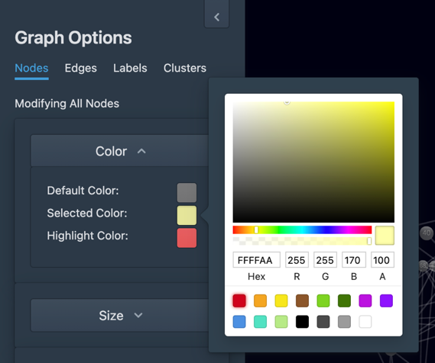

To modify the **Size** of nodes, unfold Size Collapse component. Then hold the value chooser and drag in the slider to change the size of nodes which is ranging from 1 to 20. The size of nodes displayed in the graph will be modified along changing the value of node size in the slider.

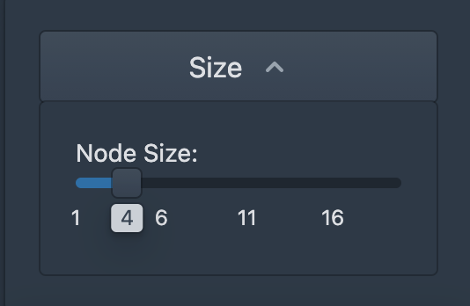

The Shape of nodes can be altered in the unfolded **Shape** Collapse component by changing the value of node resolution. Hold the value chooser and drag it in the slider. The value of node resolution is ranging from 2 to 20. The node’s shape is more likely to be a sphere when the node resolution is closer to 20.

Section 2 Edges

To modify the styles of edges, the instructions below can aid you:

Click **Edges** and edge **Color** can be changed in this menu.

Unfold **Color** Collapse component to set color of edges. Click the color selection box at the right of the Collapse component. Set color in the color selection component. In this way, the **Default Color**, **Selected Color** and **Highlight Color** of edges can be changed. When edges are selected or highlighted, the color will alter to the color as user set in this component.

Section 3 Labels

To modify the styles of labels, follow the steps below:

**Show Node Label** is used to control the display of labels. Switch on to display the labels, otherwise, switch off to hide the node labels. The node label contains information about node id.

To alter the size of labels, hold and drag the value chooser to change the size in the slider from 1 to 10. Choose the appropriate size for labels as indistinction might happens when the label is larger than node.

Click the color selection box at the right-bottom of the menu. In this way, the font color of labels will be modified.

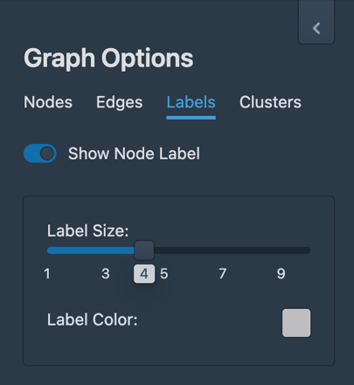

Section 4 Clusters

To modify the styles of clusters, follow the instructions below:

The **Cluster Force Distance** and **Normal Force Distance** can be modified in the slider by holding and dragging the value chooser from the minimum value 0 to maximum value 100. The former controls the whole cluster connection. The nodes in a cluster will link tightly when a higher value is chosen in the slider. The latter controls the edges between nodes. With higher normal force distance, the edges will loosely organized.

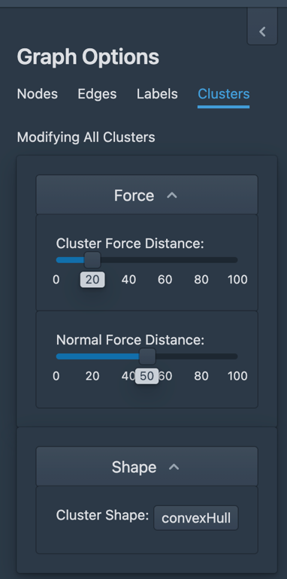

The **Shape** of clusters have two options which are convex Hull and sphere. Users are allowed to choose which shape the cluster is in. If sphere is chosen, cluster resolution can be modified by hold and drag the value chooser in the slider from 2 to 20. The higher cluster resolution will make the cluster tend to be in the shape of sphere.

\

# 6 Export Data

Use the Export command to compile the data into a **CSV** or **GEXF** file that can be used in data analysis later. The entire contents of the modified data are included in the export file. To export data, do the following:

Click **Graph** pop-up menu and choose **Export Graph**. An Export Graph dialog is displayed.

To export to a **GEXF** file, click **Download GEXF File** to download the GEXF file containing all data values to your disk.

To export in **CSV** format, click **Download Node File** to select the location to store the file of node attributes. Click **Download Node File** to download the file of edges’ information to the default location.