# Project 2 PageRank Performance Analysis on Academic Cloud

# Introduction

Academic Cloud provides a great environment to run applications with higher availability to students and researchers. In this assignment, you will hand in a performance analysis report. The MPIPageRank program runs in two different mode — bare metal and Eucalyptus VM on multiple nodes using FutureGrid. Please reuse your MPIPageRank program developed in Project #1 for this project. This document provides detailed instructions on how to access FutureGrid.

You must have your FutureGrid account and the your generated ssh private key ready for this project. If you haven’t applied one, please sign up at [FutureGrid Portal](http://portal.futuregrid.org) [1] as soon as possible.

## Access to FutureGrid

You will need to login to IU-india with using the following command:

ssh –i [ssh private key] [username]@india.futuregrid.org

Enter passphrase for key 'ssh_id_rsa':

[johnny@i136 ~]$

Here, “i136” is the headnode (first login node) of IU-india cluster. You will need to obtain a bare metal node and a Eucalyptus VM from this node, and **DO NOT** run your mpi program on the “i136” headnode.

## FutureGrid Bare Metal

For the bare metal test, you need to obtain an independent node from the headnode:

[johnny@i136 ~]$ qsub –I   
qsub: waiting for job 43809.i136 to start  
qsub: job 43809.i136 ready

[johnny@i55 ~]$

Here “i55” is the assigned node number, then load the openmpi module. If you are using MPJ Express, please installed the package under your home directory and set the environment yourself.

[johnny@i55 ~]$ module load openmpi  
Intel compiler suite version 11.1/072 loaded  
OpenMPI version 1.4.2 loaded

## Setup MPI cluster environment on Bare Metal mode

First, get a set of work nodes with using the following command:

command: qsub -I -l nodes=[numOfNode]:ppn=[CpuPerNode],walltime=[hh]:[mm]:[ss]

[johnny@i136 ~]$ qsub -I -l nodes=2:ppn=8,walltime=12:00:00  
qsub: waiting for job 44418.i136 to start  
qsub: job 44420.i136 ready

[johnny@i55 ~]$ echo $PBS_NODEFILE

i55  
i55  
i55  
i55  
i55  
i55  
i55  
i55  
i56  
i56  
i56  
i56  
i56  
i56  
i56  
i56

Here, “i55” and “i56” are the assigned nodes. Then, load the openmpi module and run the program, please see the detail optional argument for running in a cluster mode (add argument “-hostfile $PBS_NODEFILE”) in “MPI_README.txt”:

[johnny@i55 ~]$ module load openmpi  
[johnny@i55 ~]$ mpirun -hostfile $PBS_NODEFILE -np 6 mpi_main -i pagerank.input -n 10 -t 0.000001  
  
max_iterations=10, threshold=0.000001000  
 ->cur_iteration=0 delta=0.042619476  
 ->cur_iteration=1 delta=0.008099583  
 ->cur_iteration=2 delta=0.002703766  
 ->cur_iteration=3 delta=0.001191630  
 ->cur_iteration=4 delta=0.000519276

## FutureGrid Eucalyptus

## Prepare for FutureGrid Eucalyptus

Several steps need to be finished before obtaining a Eucalyptus VM:

1. Apply for a eucalyptus account with your FutureGrid user name: <https://eucalyptus.india.futuregrid.org:8443/#apply>

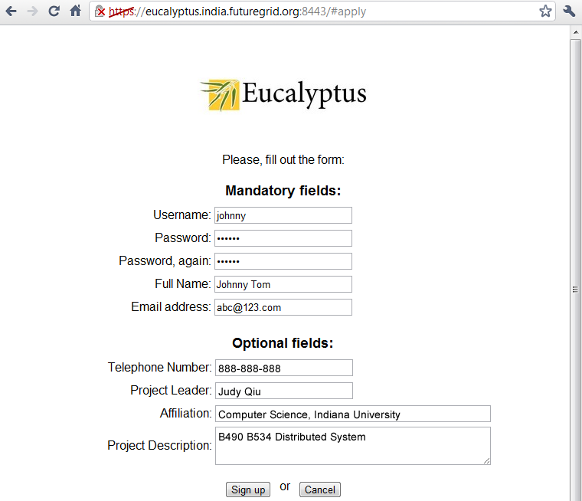

1. Login to the [india-eucalyptus website](https://eucalyptus.india.futuregrid.org:8443/), download your credentials zip file (euca2-[username]-x509.zip).

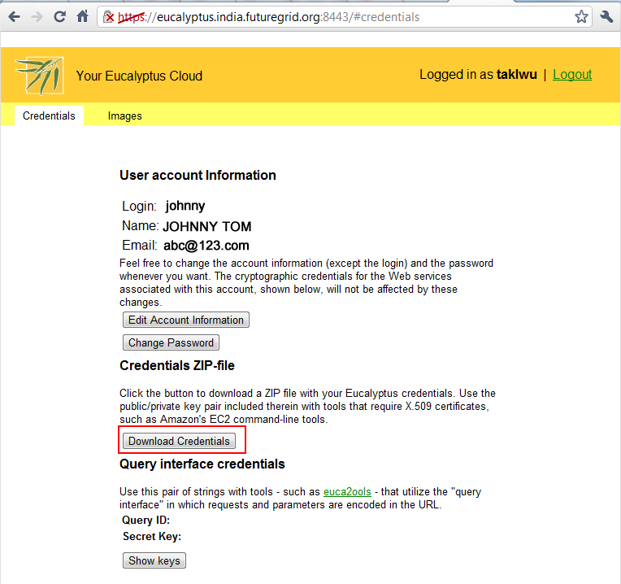

1. Upload credentials back to your FutureGrid India home directory.

[johnny@i136 ~]$ ls -l  
-rwxr-xr-x 1 johnny users 5133 Feb 20 22:30 euca2-johnny-x509.zip

1. Unzip the credentials.

[johnny@i136 ~]$ mkdir johnny-euca

[johnny@i136 ~]$ unzip euca2-johnny-x509.zip –d johnny-euca

1. Load the euca2ools module and setup the environment.

[johnny@i136 ~]$ cd johnny-euca

[johnny@i136 johnny-euca]$ module load euca2ools

[johnny@i136 johnny-euca]$ source eucarc

1. Test the euca2ools :

[johnny@i136 johnny-euca]$ euca-describe-availability-zones

AVAILABILITYZONE india 149.165.146.135

## Setup the VM keypair and allow ssh access to VM:

After tested the euca2ools, you need to add a keypair for future access to the VM:

Command: euca-add-keypair [new public key name]> [new private key name]

[johnny@i136 johnny-euca]$ euca-add-keypair johnny > johnny.private

[johnny@i136 johnny-euca]$ chmod 600 johnny.private

Then, create a security group to allow SSH access to the VM:

[johnny@i136 johnny-euca]$ euca-authorize -P tcp -p 22 –s 0.0.0.0/0 default [johnny@i136 johnny-euca]$ euca-describe-groups

GROUP johnny default default group

PERMISSION johnny default ALLOWS tcp 22 22 FROM CIDR 0.0.0.0/0

## Start and login to a Eucalyptus VM

Finally, start a Eucalyptus VM. For MPI, please use image “emi-A89A14B0”. For MPJ, please use image “emi-4A051306”.

command: euca-run-instances -k [public key] -t [instance class] [image emi #]

[johnny@i136 johnny-euca]$ euca-run-instances -k johnny -t c1.medium emi-A89A14B0

RESERVATION r-45F607A9 johnny johnny-default

INSTANCE i-55CE091E emi-A89A14B0 0.0.0.0 0.0.0.0 pending johnny 2011-02-20T03:59:20.572Z eki-78EF12D2 eri-5BB61255

Here, please refer to [FutureGrid Eucalyptus tutorial](https://portal.futuregrid.org/tutorials/euca-hadoop) [2-3] for details about the available instance class. Please check and wait the instance status become “running”.

[johnny@i136 johnny-euca]$ euca-describe-instances

RESERVATION r-442E080F johnny default

INSTANCE i-46B007AE emi-A89A14B0 149.165.146.207 10.0.5.66 running johnny 0 c1.medium 2011-02-18T22:37:36.772Z india eki-78EF12D2 eri-5BB61255

Above, “149.165.146.207” is the assigned public IP to your VM. At the end, you can login as root user with your created ssh private key (i.e. johnny.private).

[johnny@i136 johnny-euca]$ ssh -i johnny.private [root@149.165.146.207](mailto:root@149.165.146.207)

Warning: Permanently added '149.165.146.207' (RSA) to the list of known hosts.

Linux localhost 2.6.27.21-0.1-xen #1 SMP 2009-03-31 14:50:44 +0200 x86_64 GNU/Linux

Ubuntu 10.04 LTS

Welcome to Ubuntu!

* Documentation: https://help.ubuntu.com/

The programs included with the Ubuntu system are free software;

the exact distribution terms for each program are described in the

individual files in /usr/share/doc/*/copyright.

Ubuntu comes with ABSOLUTELY NO WARRANTY, to the extent permitted by

applicable law.

root@localhost:~#

## Setup MPI cluster environment on Eucalyptus VMs

Before running the MPI PageRank in multiple nodes environment on FutureGrid Eucalyptus, you need to make sure the Eucalyptus ssh private key and the MPI program are uploaded to each of the created VM. **Do Not copy the Eucalyptus ssh key and MPI program to each node in Bare Metal mode.**

[johnny@i136 johnny-euca]$ scp -i johnny.private johnny.private [root@149.165.146.207](mailto:root@149.165.146.207):~/.ssh/id_rsa

[johnny@i136 johnny-euca]$ scp -i johnny.private MpiPageRank.zip [root@149.165.146.207](mailto:root@149.165.146.207):~/

On the headnode of your Eucalyptus VM or bare metal node (i.e. 149.165.146.207), create a file includes all the **internal IP** address of each worker (use the IP started with 10.x.x.x).

[johnny@i136 johnny-euca]$ euca-describe-instances

RESERVATION r-4356080F johnny default

INSTANCE i-44600903 emi-4A051306 149.165.146.207 10.0.5.67 running johnny 0 c1.medium 2011-02-18T22:38:35.181Z india eki-78EF12D2 eri-5BB61255

RESERVATION r-45F607A9 johnny default

INSTANCE i-55CE091E emi-A89A14B0 149.165.146.195 10.0.5.68 running johnny 0 c1.medium 2011-02-21T03:59:20.572Z india eki-78EF12D2 eri-5BB61255

[johnny@i136 johnny-euca]$ ssh -i johnny.private [root@149.165.146.207](mailto:root@149.165.146.207)

Linux localhost 2.6.27.21-0.1-xen #1 SMP 2009-03-31 14:50:44 +0200 x86_64 GNU/Linux

Ubuntu 10.04 LTS

Welcome to Ubuntu!

* Documentation: https://help.ubuntu.com/

Last login: Mon Feb 21 20:12:52 2011 from i136r.idp.iu.futuregrid.org

root@localhost:~# vi nodes

10.0.5.67

10.0.5.68

When running your MPIPagerank program on the headnode, simply add an optional argument “-hostfile” to run as a cluster mode. (For MPJ, please use the optional argument “-dev nodes”, see the detail for [MPJ Cluster Configuration](http://mpj-express.org/docs/guides/linuxguide.pdf) [4])

root@localhost:~# mpirun -hostfile nodes -np 6 mpi_main -i pagerank.input -n 10 -t 0.000001

## Important notes:

1. Upload ssh key and MPIPagerank program to each worker VM correctly, unzip the program at the same location on each VM
2. Make a node file include all the internal IP addresses on your headnode VM.
3. Run the program with argument “-hostfile [nodes IP addresses file]”

# PageRank Dataset Generation

We have provided a java class “PageRankDataGen.java” in order to generate a larger dataset (i.e. more than 10000 urls) to run the performance test, please compile and execute this generator as following:

[johnny@i136 ~]$ javac PageRankDataGen.java

[johnny@i136 ~]$ java PageRankDataGen pagerank.lginput 10000 1

[johnny@i136 ~]$ ls –l

-rw-r--r-- 1 johnny users 240160 Feb 20 16:56 pagerank.lginput0

# Run MPIPageRank under these environment

At this point, you should be able to use FutureGrid as your test environment for this project. Simply copy your Project 1 back to these two environments, and then test MPIPagerank program on a small (old) dataset to make sure everything is working correctly. Finally, run the program with generated larger dataset (use PageRankDataGen.java) to analyze the performance. Please make notes on any interesting finding. A description and an explanation about your result are required. Please refer to the attached files “MPI_README.txt” and “MPJ_README.txt” to run the PageRank Program.

## Terminate your instance(s) after finish your task

Due to the FutureGrid Eucalyptus capacity, there are limited resource shares all a large amount of users. Therefore, please shut down the VM when finish running your test in order to let others run their test.

Command: euca-terminate-instances [instance ID]

[johnny@i136 johnny-euca]$ euca-describe-instances

RESERVATION r-4356080F johnny default

INSTANCE i-44600903 emi-4A051306 149.165.146.207 10.0.5.67 running johnny 0 c1.medium 2011-02-18T22:38:35.181Z india eki-78EF12D2 eri-5BB61255

[johnny@i136 johnny-euca]$ euca-terminate-instances i-44600903

INSTANCE i-44600903

# Deliverables (Due Mar. 21)

You are required to turn in a report to concourse with following items for this project. Please complete your B534 project #2 webpage at same due time.

1. Instance class, number of worker nodes, size of dataset (# of urls, # of groups), number of processes, threshold and iteration setting
2. A speed up performance analysis chart (graph) about your result
3. Finding, description and explanation about your result
4. Feedback about using FutureGrid Eucalyptus and Bare Metal

# Acknowledgement

FutureGrid is a national scale, NSF funded project which provides a capability that makes it possible for researchers to tackle complex research challenges in computer science related to the use and security of grids and clouds.

# References

1. <http://portal.futuregrid.org>
2. <https://portal.futuregrid.org/tutorials/euca-hadoop>
3. <http://salsahpc.indiana.edu/b649/slides/b649-eucalyptus-hadoop.pdf>
4. <http://mpj-express.org/docs/guides/linuxguide.pdf>
5. <http://en.wikipedia.org/wiki/PageRank>