
SWAPI — The Star Wars API
API Guide
Version 1.0

API Overview
SWAPI (Star Wars API) is an open REST API that provides data from the Star Wars universe. It requires no authentication. All responses return as JSON. The API supports GET requests only.

API Properties
Property | Value
Base URL | https://swapi.py4e.com/api
Version | 1.0
Protocol | HTTPS
Data Format | JSON
Supported Methods | GET only
Rate Limit | 10,000 requests per day per IP address
Authentication | None — open API

API Resources
Resource | Endpoint URL
people | https://swapi.py4e.com/api/people
films | https://swapi.py4e.com/api/films
planets | https://swapi.py4e.com/api/planets
species | https://swapi.py4e.com/api/species
starships | https://swapi.py4e.com/api/starships
vehicles | https://swapi.py4e.com/api/vehicles

Note: This document covers the People resource only. For all other resources, refer to the full SWAPI documentation at https://swapi.py4e.com/documentation.

People Resource
A People resource represents an individual character in the Star Wars universe. Each record contains biographical and physical attributes for that character.

Resource URL
https://swapi.py4e.com/api/people/

API References

GET /people/ — Retrieve All People Resources

Introduction
This endpoint returns a paginated list of all People resources in the SWAPI database. Each page returns up to 10 records. Use the next and previous URLs in the response to navigate between pages.

Curl Command
curl -X GET "https://swapi.py4e.com/api/people/" \
-H "Accept: application/json"

Request Properties
Property | Value
Base URL | https://swapi.py4e.com/api
Method | GET
Endpoint | /people/
Content-Type | application/json
Accept | application/json

Request URL
https://swapi.py4e.com/api/people/

Example URL
https://swapi.py4e.com/api/people/

Query Parameters
Parameter | Required / Optional | Value | Description
search | Optional |  | Filters results to records whose name contains this string. Case-insensitive.Example: Luke
page | Optional |  | Returns the specified page of paginated results. Default: 1.Example: 2

Note: The /people/ endpoint accepts optional query parameters to filter and paginate results.

Response Parameters
Parameter | Child Parameter | Data Type | Value | Description
count |  | Integer |  | Total number of People records in the database.
next |  | String |  | URL of the next page of results.
previous |  | String |  | URL of the previous page of results.
results |  | Array |  | Array of People resource objects. Returns up to 10 records per page.
 | name | String |  | Name of this person.
 | height | String |  | Height of this person in centimeters.
 | mass | String |  | Mass of this person in kilograms.
 | hair_color | String |  | Hair color of this person. Returns "unknown" if not known, or "n/a" if the person has no hair.
 | skin_color | String |  | Skin color of this person.
 | eye_color | String |  | Eye color of this person.
 | birth_year | String |  | Birth year in the in-universe standard. BBY = Before Battle of Yavin. ABY = After Battle of Yavin.
 | gender | String |  | Gender of this person. Values: "male", "female", "n/a", "unknown".
 | homeworld | String |  | URL of the Planet resource that is the homeworld of this person.
 | films | Array |  | Array of Film resource URLs in which this person appears.
 | species | Array |  | Array of Species resource URLs for this person.
 | vehicles | Array |  | Array of Vehicle resource URLs that this person has piloted.
 | starships | Array |  | Array of Starship resource URLs that this person has piloted.
 | created | String |  | Date and time this resource was created.
 | edited | String |  | Date and time this resource was last edited.
 | url | String |  | Hypermedia URL of this resource.

Example Response
{
"count": 82,
"next": "https://swapi.py4e.com/api/people/?page=2",
"previous": null,
"results": [
{
"name": "Luke Skywalker",
"height": "172",
"mass": "77",
"hair_color": "blond",
"skin_color": "fair",
"eye_color": "blue",
"birth_year": "19BBY",
"gender": "male",
"homeworld": "https://swapi.py4e.com/api/planets/1/",
"films": [
"https://swapi.py4e.com/api/films/1/",
"https://swapi.py4e.com/api/films/2/"
],
"species": ["https://swapi.py4e.com/api/species/1/"],
"vehicles": ["https://swapi.py4e.com/api/vehicles/14/"],
"starships": ["https://swapi.py4e.com/api/starships/12/"],
"created": "2014-12-09T13:50:51.644000Z",
"edited": "2014-12-20T21:17:56.891000Z",
"url": "https://swapi.py4e.com/api/people/1/"
}
]
}

Response Codes
HTTP Status Code | Status Text | Description
200 | OK | The request is successful. The response body contains the result.
404 | Not Found | The requested page does not exist. Verify the page number and retry.
429 | Too Many Requests | The IP address exceeds the rate limit of 10,000 requests per day.

Postman Screenshot
The screenshot below shows the Postman test result for GET /people/. HTTP 200 OK confirms the request is successful and the People resource is returned.

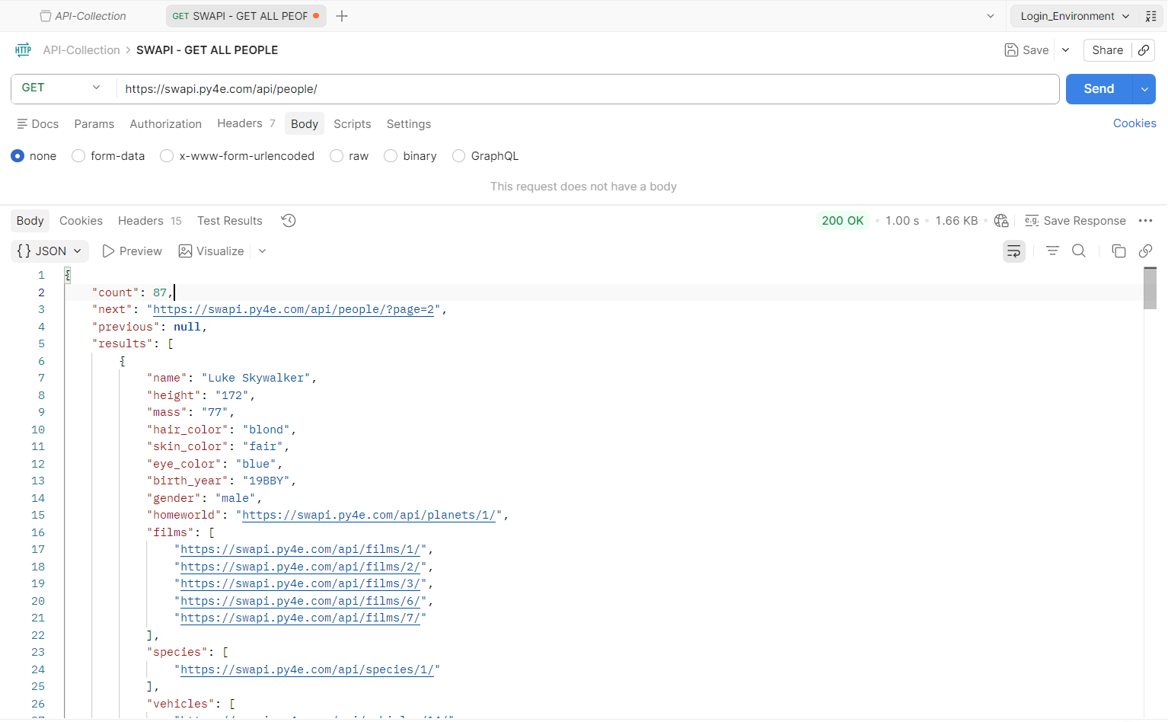

GET /people/:id/ — Retrieve a People Resource by ID

Introduction
This endpoint returns a single People resource identified by its unique integer ID. Pass the ID as a path parameter appended to the endpoint URL.

Curl Command
curl -X GET "https://swapi.py4e.com/api/people/1/" \
-H "Accept: application/json"

Request Properties
Property | Value
Base URL | https://swapi.py4e.com/api
Method | GET
Endpoint | /people/:id/
Path Parameter | id — Integer. Unique identifier of the People resource.
Content-Type | application/json
Accept | application/json

Request URL
https://swapi.py4e.com/api/people/:id/

Example URL
https://swapi.py4e.com/api/people/1/

Path Parameters
Parameter | Required / Optional | Value | Description
id * | Required |  | Unique integer identifier of the People resource to retrieve.Example: 1

Response Parameters
Parameter | Data Type | Value | Description
name | String |  | Name of this person.
height | String |  | Height of this person in centimeters.
mass | String |  | Mass of this person in kilograms.
hair_color | String |  | Hair color of this person. Returns "unknown" if not known, or "n/a" if the person has no hair.
skin_color | String |  | Skin color of this person.
eye_color | String |  | Eye color of this person. Returns "unknown" if not known, or "n/a" if the person has no eyes.
birth_year | String |  | Birth year in the in-universe standard. BBY = Before Battle of Yavin. ABY = After Battle of Yavin.
gender | String |  | Gender of this person. Values: "male", "female", "n/a", "unknown".
homeworld | String |  | URL of the Planet resource where this person was born or lives.
films | Array |  | Array of Film resource URLs in which this person appears.
species | Array |  | Array of Species resource URLs for this person.
vehicles | Array |  | Array of Vehicle resource URLs that this person has piloted.
starships | Array |  | Array of Starship resource URLs that this person has piloted.
created | String |  | ISO 8601 date and time this resource was created.
edited | String |  | ISO 8601 date and time this resource was last edited.
url | String |  | Hypermedia URL of this resource.

Example Response
{
"name": "Luke Skywalker",
"height": "172",
"mass": "77",
"hair_color": "blond",
"skin_color": "fair",
"eye_color": "blue",
"birth_year": "19BBY",
"gender": "male",
"homeworld": "https://swapi.py4e.com/api/planets/1/",
"films": [
"https://swapi.py4e.com/api/films/1/",
"https://swapi.py4e.com/api/films/2/"
],
"species": ["https://swapi.py4e.com/api/species/1/"],
"vehicles": [
"https://swapi.py4e.com/api/vehicles/14/",
"https://swapi.py4e.com/api/vehicles/30/"
],
"starships": [
"https://swapi.py4e.com/api/starships/12/",
"https://swapi.py4e.com/api/starships/22/"
],
"created": "2014-12-09T13:50:51.644000Z",
"edited": "2014-12-20T21:17:56.891000Z",
"url": "https://swapi.py4e.com/api/people/1/"
}

Response Codes
HTTP Status Code | Status Text | Description
200 | OK | The request is successful. The response body contains the result.
404 | Not Found | The requested resource does not exist. Verify the ID and retry.
429 | Too Many Requests | The IP address exceeds the rate limit of 10,000 requests per day.

Postman Screenshot
The screenshot below shows the Postman test result for GET /people/1/. HTTP 200 OK confirms the request is successful and a single People resource is returned.

