Troubleshooting Network Connectivity in a Peered VPC
Lab environment
The following diagram shows the lab scenario:
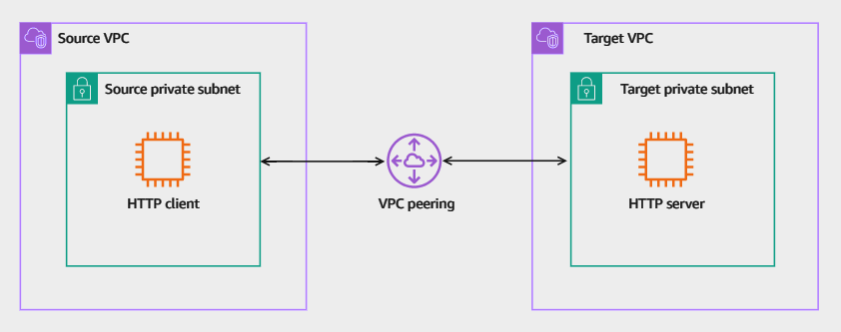
Image description: The following list details the major resources in the lab:
- Two VPCs named as Source VPC and Target VPC.
- Each VPC has one private subnet.
- The HTTP client instance resides in the source private subnet.
- The HTTP server instance resides in the source private subnet.
- A VPC peering connection between the two VPCs.

Task 1: Testing HTTP client-server connectivity
In this task, you test the HTTP connectivity between the client and server instances. You test the connectivity by initiating HTTP traffic from the HTTP client instance and observe the response.
Ensure that you completed the instructions in the Start lab section above and you have the AWS Management Console page open before you proceed to the next step.
- Copy the HTTPClientTerminal value that is listed to the left of these instructions. Paste the value into a new browser tab, and then press Enter to access the HTTP Client instance terminal.
Now, initiate an HTTP connection from the HTTP-Client to the HTTP-Server.
- Command: Run the following command on the HTTP-Client prompt after replacing the HTTPServerIPAddress string with its respective value listed to the left of these instructions.
wget http://HTTPServerIPAddress
Expected output: Your values might differ from what is seen below.
************************
**** EXAMPLE OUTPUT ****
************************

--2025-06-20 15:41:09-- http://10.2.2.139/
Connecting to 10.2.2.139:80... failed: Connection timed out.
Retrying.
The HTTP client attempts to initiate the connection but it fails after couple of minutes.
- Press CTRL-C to exit the connection retries.
The HTTP connection failed which verifies the reported issue.
Task complete: You successfully tested the HTTP connection between the client and server and verified the issue.

Task 2: Troubleshooting and remediating the issue
In this task, you identify the issues in the existing configuration and remediate the configuration to allow the HTTP traffic between the client and server via the VPC peering.
Now that have you confirmed the issue, you need to identify the services and resources which were misconfigured and remediate them.
You can navigate through the AWS Management Console of the VPC, EC2, or any other service you need to identify the issues in the current configuration and determine how to remediate them.
Consider: Here are few things to consider when you attempt remediating the issue:
- You have the permissions to use the Reachability Analyzer for troubleshooting.
- The httpd service is up and running on the HTTP-Server instance so you do not need to troubleshoot it.
- The HTTP service is running on the standard HTTP port (TCP port 80).
- You do not need to create new resources to resolve the issue. However, you can modify existing resources.
- You have the required AWS Identity and Access Management (IAM) permissions to remediate the issues.
Do it yourself
Hint: Here are some references to assist you in solving the issue:
- How Reachability Analyzer works.
- Troubleshoot a VPC peering connection.
Solution
Expand the Detailed instructions section below for the full solution.
Detailed instructions
First, here is a summary of the VPC configuration in the lab:
- The source VPC is named as Source-VPC.
- The Source-VPC has a private subnet named Source-Private-Subnet.
- The Source-Private-Subnet has a route table associated with it named Source-Private-RT.
- The Source-Private-Subnet has a network access control list (ACL) associated with it named Source-Private-Subnet-NACL.
- The HTTP client instance is named HTTP-Client and resides in the Source-Private-Subnet.
- The HTTP client instance has a security group named Source-Instance-SG applied to it.
- The target VPC is named as Target-VPC.
- The Target-VPC has a private subnet named Target-Private-Subnet.
- The Target-Private-Subnet has a route table associated with it named Target-Private-RT.
- The Target-Private-Subnet has a network ACL associated with it named Target-Private-Subnet-NACL.
- The HTTP server instance is named HTTP-Server and resides in the Target-Private-Subnet.
- The HTTP server instance has a security group named Target-Instance-SG applied to it.
- The VPC peering connecting the two VPCs is named Lab-Peering.
The lab also has VPC endpoints and other resources that are used to provide you and other resources with required connectivity. You do not need to check or modify the configuration of these resources.
You can navigate through the VPC configuration to explore and verify the existing VPC, subnets, VPC peering, route tables, security groups, and network ACLs configuration. You can also refer to the lab diagram in the Lab environment section.
Before you start troubleshooting, it it useful to summarize the requirements for connecting to a resource in a VPC from a resource in a peer VPC:
- For each resource in each VPC, verify that the route table for its subnet contains a route that sends traffic destined for the peer VPC via the VPC peering connection.
- For EC2 instances, verify that the security groups for the EC2 instances allow traffic from the peer VPC.
- For each resource in each VPC, verify that the network ACL for its subnet allows traffic from the peer VPC.
Now, you can check the existing configuration of each of the above requirements.
Using the Reachability Analyzer to troubleshoot the issue
Reachability Analyzer is a configuration analysis tool that enables you to perform connectivity testing between a source resource and a destination resource in your virtual private clouds (VPCs). When the destination is reachable, Reachability Analyzer produces hop-by-hop details of the virtual network path between the source and the destination. When the destination is not reachable, Reachability Analyzer identifies the blocking component.
- At the top of the AWS Management Console, in the search bar, search for and choose
Network Manager
from the Features section.
- In the navigation pane at the left of the page, under Monitoring and troubleshooting section, choose Reachability Analyzer.
To analyze a traffic path using the Reachability Analyzer, you create a path. The path emulates your scenario as follows:
  - The source is the HTTP-Client instance.
  - The traffic source port is TCP port 50000. This is one of the ports used by Amazon Linux instances as a source port when initiating traffic.
  - The traffic destination port is TCP port 80. This is the same port running on the HTTP server.
  - The destination is the HTTP-Server instance.
- On the Paths page, choose the Create and analyze path.
- On the Create and analyze path page, in the Path configuration section, for Name tag - optional, enter
VPC-peering-test
.
- In the Path Source section, configure the following:
  - For Source type, select Instances.
  - For Source, select HTTP-Client.
  - Expand the Additional packet header configurations at source - optional section.
  - For Source port, enter
50000
.
  - For Destination port, enter
80
.
- In the Path destination section, configure the following:
  - For Destination type, select Instances.
  - For Destination, select HTTP-Server.
- In the Protocol section, for Protocol, select TCP.
- Choose Create and analyze path.
A message banner is displayed at the top of the page indicating that the request to run an analysis succeeded.
You created a Reachability Analyzer path from the HTTP-Client instance to the HTTP-Server instance. The connection is attempted using TCP port 50000 as the source port and TCP port 80 as the destination port.
The console displays the created path with the Reachability status as pending. This is where the analyzer is attempting the connection and capturing the result at each point in the path.
- In the Analyses section, choose the to refresh the reachability status.
The Reachability status should display Not reachable. The analyzer provides details of where the connection failed. The Analysis explorer section provides summary of the attempted path between the source and destination instances. You can verify the instances IDs with HTTPClientInstanceId and HTTPServerInstanceId which are listed to the left of these instructions.
- In the Analysis explorer section, expand Packet header configurations at source and verify the source and destination ports used in the analysis.
- Scroll down to the Explanations section and observe the reason of failing the reachability.
The message reads None of the ingress rules in the following security groups apply: sg-xxxxxxxxxxxxxxxxx.
Now you need to determine which security group is blocking the traffic.
- Check the visual analysis under the Path details section.
The visual analysis gives a detailed hop-by-hop analysis of the traffic path. If you trace each hop in the path starting from the source, you can trace the exact traffic path. You can also see that the security group which is applied to the HTTP-Server instance does not have any ingress rules to allow the required traffic.
Consider: Here are few things to comprehend from the path details visual analysis:
  - You can expand the Output header under the HTTP-Client to check the source/destination IP addresses and port numbers used in the analysis.
  - The HTTP traffic from the client successfully traversed through the source instance security group, source subnet network ACL, private subnet route table, VPC peering connection, and target subnet network ACL before it was blocked by the target instance security group.
  - You can choose the the dashed underlined name of each hop in the analysis to display more information about each hop.
  - Each hop provides links to the related resources so you can easily navigate to these resources.
  - The icon of the hop blocking the traffic appears in a red color while all other icons appear in a gray color.
Now, remediate the security group which is blocking the traffic.
Remediating the target security group issue
- In the Path details visual analysis, locate the hop where the traffic is blocked. This is the elastic network interface (ENI) of the HTTP-Server instance where the security group is applied.
- Choose the sg-xxxxxxxxxxxxxxxxx link at the end of the None of the ingress rules in the following security groups apply: sg-xxxxxxxxxxxxxxxxx message.
The browser opens a new console tab with the Target-Instance-SG security group. Note that the inbound rules section does not have any rules. You need to add a rule allowing traffic from the source private subnet.
- In the Inbound rules tab, choose Edit inbound rules.
- Choose Add rule.
- In the new rule, configure the following:
  - For Type choose, Custom TCP.
  - For Port range, enter
80
.
  - For Source, enter
10.1.1.0/24
.
- Choose Save rules.
A message banner is displayed at the top of the page indicating that the inbound security group rules was successfully modified.
- Close the Target-Instance-SG console tab and return to the Reachability Analyzer path console tab.
Repeating the Reachability Analyzer path analysis
After remediating the security group issue, you repeat the analysis to verify the issue. You can re-run the analysis again using the same previously created path.
- On the Reachability Analyzer page, choose Analyze path.
- In the Analyze path pop-up window, choose Confirm.
A message banner is displayed at the top of the page indicating that the request to re-analyze path succeeded.
- In the Analyses section, choose the to refresh the reachability status.
The Reachability status for the latest run should display Not reachable. You can scroll down to the Explanations and Path details sections to find out why the status is still Not reachable
Note that the Path details visual analysis does not show any hop icon in a red color. This indicates that the traffic reached all the way to the destination. However, the issue might be in the return traffic.
- To examine the reverse path analysis, choose the View reverse path switch in the Path details section.
The reverse path analysis is displayed. Note that the Destination is now at the top of the analysis while the Source is at the bottom of the path.
Examine the hops which are blocking the traffic, you should note the following:
  - The Target-Private-RT route table does not have an applicable route to the Source-Private-Subnet via the VPC peering.
  - The Source-Private-Subnet-NACL does not allow inbound traffic from the Target-Private-Subnet.
Now remediate these two issues.
Remediating the target route table issue
- In the Path details visual analysis, locate the hop of the Target-Private-RT, then choose the rtb-xxxxxxxxxxxxxxxxx link at the end of the Route table rtb-xxxxxxxxxxxxxxxxx does not have an applicable route to pcx-xxxxxxxxxxxxxxxxx message.
The browser opens a new console tab with that route table displayed.
- Select the Target-Private-RT.
- On the Route tables page, choose the Routes tab.
- Choose Edit routes.
- Choose Add route, then configure the following:
  - For Destination, enter
10.1.1.0/24
.
  - For Target, select Peering Connection, then choose Lab-Peering.
- Choose Save changes.
A message banner is displayed at the top of the page indicating that the route table was successfully updated.
- Close the Target-Private-RT console tab and return to the Reachability Analyzer path console tab.
Remediating the source subnet network ACL issue
- In the Path details visual analysis, locate the hop of the Source-Private-Subnet-NACL, then choose the acl-xxxxxxxxxxxxxxxxx link at the end of the Network ACL acl-05c2686f13f610623 does not allow inbound traffic from acl-xxxxxxxxxxxxxxxxx to acl-xxxxxxxxxxxxxxxxx message.
The browser opens a new console tab with that network ACL displayed.
- Select the Source-Private-Subnet-NACL.
- On the Network ACLs page, choose the Inbound rules tab.
- Note that the only ingress rule configured allows HTTPS traffic from anywhere (0.0.0.0/0). You need to add another ingress rule to allow the return HTTP traffic from the Target-Private-Subnet IP range (10.2.2.0/24)
Knowledge check: What would be the port range to configure in the ingress rule that you need to add to the network ACL?
Answer
Now, remediate these two issues in the Source-Private-Subnet-NACL issue.
- Choose Edit inbound rules.
- Choose Add new rule, then configure the following:
  - For Rule number, enter
110
.
  - For Type, select Custom TCP.
  - For Port range, enter
1024-65535
.
  - For Source, enter
10.2.2.0/24
.
- Choose Save changes.
A message banner is displayed at the top of the page indicating that the acl inbound rules was successfully updated.
- Close the Network ACLs console tab and return to the Reachability Analyzer path console tab.
Re-evaluating the Reachability Analyzer path analysis
After remediating the route table and network ACL issues, you repeat the analysis to verify the issue. You can re-run the analysis again using the same previously created path.
- On the Reachability Analyzer page, choose Analyze path.
- In the Analyze path pop-up window, choose Confirm.
A message banner is displayed at the top of the page indicating that the request to re-analyze path succeeded.
- In the Analyses section, choose the to refresh the reachability status.
The Reachability status for the latest run should display Reachable. You can scroll down to the Explanations and Path details sections for the detailed analysis. Ensure that you verify that the reverse path as well.
Now, it is time to verify the HTTP client-server connectivity.

Verifying the solution
To verify that you resolved all the issues, you can simply re-initiate the HTTP traffic from the HTTP-Client instance to the HTTP-Server instance.
- Choose the HTTP-Client terminal session browser tab that you used in Task 1.
Note: If you do not have the terminal session still open, 1. copy the HTTPClientTerminal value that is listed to the left of these instructions. Paste the value into a new browser tab, and then press Enter to access the HTTP Client instance terminal.
Now, initiate an HTTP connection from the HTTP-Client to the HTTP-Server.
- Command: Run the following command on the HTTP-Client prompt after replacing the HTTPServerIPAddress string with its respective value listed to the left of these instructions.
wget http://HTTPServerIPAddress
Expected output: Your values might differ from what is seen below.
************************
**** EXAMPLE OUTPUT ****
************************

--2025-06-20 16:23:07-- http://10.2.2.139/
Connecting to 10.2.2.139:80... connected.
HTTP request sent, awaiting response... 200 OK
Length: 51 [text/html]
Saving to: ‘index.html’

100%[===================================================================================================================>] 51 --.-K/s in 0s

2025-06-20 16:23:07 (10.5 MB/s) - ‘index.html’ saved [51/51]
If you get a 200 response as above, then the connection is successful.
Consider: Here is a quick summary of the requirements for connecting to a resource in a VPC from a resource in a peer VPC:
  - For each resource in each VPC, verify that the route table for its subnet contains a route that sends traffic destined for the peer VPC via the VPC peering connection.
  - For EC2 instances, verify that the security groups for the EC2 instances allow traffic from the peer VPC.
  - For each resource in each VPC, verify that the network ACL for its subnet allows traffic from the peer VPC.
Task complete: You successfully identified the issues in the existing configuration and remediated the configuration to allow HTTP traffic between the client and server via the VPC peering.

Conclusion
You successfully did the following:
- Tested the HTTP connection between the client and server and verified the issue.
- Identified the issues in the existing configuration and remediated the configuration to allow HTTP traffic between the client and server via the VPC peering.
- Used the Reachability Analyzer to troubleshoot VPC connectivity issues.

Troubleshooting Website Reachability behind a Load Balancer
Lab environment
The following diagram shows the lab scenario:
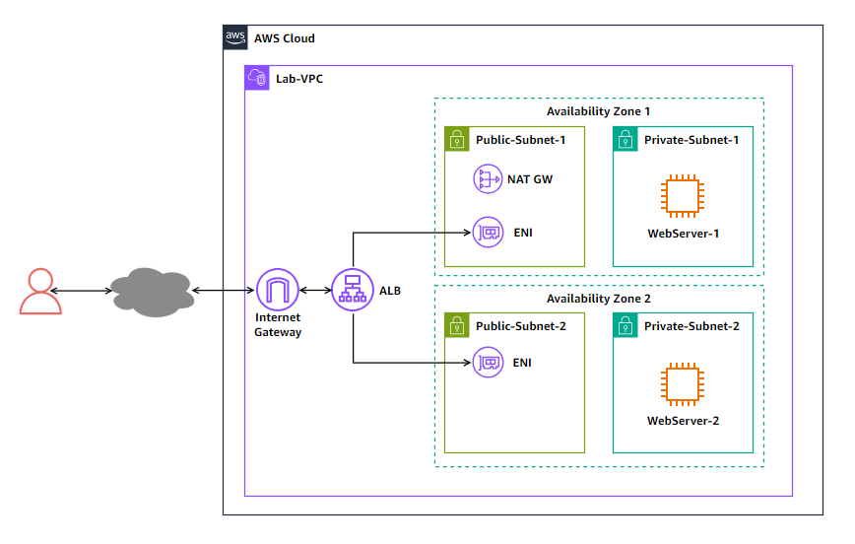
Image description: The following list details the major resources in the lab:
- A VPC hosting all the lab resources.
- The VPC has two public subnets and two private subnet across two availability zones.
- The VPC has an internet gateway allowing public access from the internet.
- A NAT gateway in one of the public subnets to provide outbound access from the private subnets.
- An Application Load Balancer (ALB) with an elastic network interface (ENI) in each of the public subnets.
- An EC2 instance in each of the private subnets to host the website.

Task 1: Testing the web server reachability from the internet
In this task, you test the web server reachability from the internet to verify the issue. Since the web server is in a private subnet behind the load balancer, you attempt reaching the web server using the load balancer DNS name.
- Copy the ALBDNSName value that is listed to the left of these instructions. Paste the value into a new browser tab, and then press Enter.
After couple of minutes, your browser page fails to connect to the web server and returns a message to indicate that the page cannot be reached. This verifies that the website is not reachable.
- Close the browser tab that you attempted to access the ALBDNSName with.
Task complete: You tested the website reachability from the internet and verified that it cannot be reached.

Task 2: Troubleshooting and remediating website reachability issues
In this task, you identify the issues in the existing configuration and remediate the configuration so the website can be accessed from the internet using the load balancer DNS name.
Now that have you confirmed the issue, you need to identify the services and resources which were misconfigured and remediate them.
You can navigate through the AWS Management Console of the EC2, VPC, or any other service you need to identify the issues in the current configuration and determine how to remediate them.
Consider: Here are few things to consider when you attempt remediating the issue:
- The HTTP service is up and running on both web server instances so you do not need to troubleshoot it.
- The website HTML files and settings are correctly configured on both web server instances so you do not need to troubleshoot it.
- The HTTP service on the web servers are running on the standard HTTP port (TCP port 80).
- You do not need to create new resources to resolve the issue. However, you can modify existing resources.
Resolve the website reachability - Do it yourself
Hint: Here are some references to assist you in solving the issue:
- Why can’t clients connect to my Elastic Load Balancing load balancer?
- Troubleshoot your Application Load Balancers
Solution
Expand the Detailed instructions section below for the full solution.
Detailed instructions
First, here is a summary of the lab scenario:
- The VPC used in the lab is named as Lab-VPC.
- The two public subnets are named Public-Subnet-1 and Public-Subnet-2.
- The load balancer is an Application Load Balancer named Lab-lb.
- The load balancer scheme is internet-facing and it has an elastic network interface in each of the public subnets.
- The two private subnets are named Private-Subnet-1 and Private-Subnet-2.
- Each of the two private subnets has an EC2 instance hosting the website.
- The two EC2 instances are named WebServer-1 and WebServer-2.
- The subnets are distributed equally across two availability zones.
- An internet gateway is attached to the VPC to provide internet access.
- A NAT gateway resides in Public-Subnet-1 to provide outbound access the instances in the private subnets.
- All routing is properly configured to allow traffic routing between the subnets, between public subnets and internet, and outbound traffic between the private subnets and internet.
You can navigate through the VPC and EC2 configuration to explore and verify the existing configuration. You can also refer to the lab diagram in the Lab environment section.
Here are some of the things you need to check when troubleshooting issues related to connecting to a website behind a load balancer:
- Load balancer listeners.
- Load balancer target groups.
- Security groups on the load balancer and target instances.
- Subnet network access control lists.
- Route tables.
Checking the load balancer listeners
An Application Load Balancer must have at least one listener. A listener is a process that checks for connection requests, using the protocol and port that you configure. The rules that you define for a listener determine how the load balancer routes requests to its registered targets.
- At the top of the AWS Management Console, in the search bar, search for and choose
EC2
.
- In the navigation pane at the left of the page, under Load Balancing section, choose Load Balancers.
- In the Load balancers section, choose the Lab-lb link.
- In the Lab-lb page, scroll down to the Listeners and rules section under the Listeners and rules tab.
Observe the listener under the Protocol:Port column. Note that the listener is configured as HTTP:8080 and it is Not reachable.
Recall that the HTTP service on the web servers are running on port 80. This is clearly misconfigured on the load balancer listener.
Remediating the load balancer listener
Now, remediate the listener port.
- Choose HTTP:8080 link.
The browser opens a new page for the HTTP:8080 listener.
- From the Actions menu, choose Edit listener.
- Under the Listener details section, modify the current value under Protocol:Port from 8080 to
80
.
- Choose Save changes.
A message banner indicates that the listener was successfully modified.
Checking the load balancer and instances security group
Now, check the security groups rules on both the load balancer and web servers instances.
- To navigate back to your load balancer’s page, select Lab-lb from the breadcrumb trail towards the top of the page.
- In the Lab-lb page, choose the Security tab.
Note that the security group attached to the load balancer is named ALB-SG.
- Choose the sg-xxxxxxxxxxxxxx link.
The browser opens a new page for the ALB-SG security group.
- Examine the rules under the Inbound rules tab.
Note that the existing inbound rule allows HTTP traffic on TCP port 80 from anywhere (0.0.0.0/0). This seems right. Now, check the outbound rules.
- Choose the Outbound rules tab.
Note that the existing outbound rule allows all traffic to anywhere (0.0.0.0/0). This also seems right.
- Close the current console tab and return to the Lab-lb console tab in your browser.
Now, web servers instances security groups.
- In the navigation pane at the left of the page, under Instances section, choose Instances.
The two instances used to host the website appear under the Instances section. The two instances are named WebServer-1 and WebServer-2. Each one of them is in one of the private subnets.
- Select the WebServer-1 instance.
- Choose the Security tab.
Note that the security group attached to the first web server instance is named WebServer-SG.
- Examine the rules under the Inbound rules section. Note that there are no ingress rules configured.
- Examine the rules under the Outbound rules section. Note that the existing outbound rule allows all traffic to anywhere (0.0.0.0/0). This seems correct.
So the inbound rules are missing and must be remediated.
Now, check if the same security group is applied on the second instance WebServer-2.
- In the navigation pane at the left of the page, under Instances section, choose Instances.
- In the list of instances, select the WebServer-2 instance.
- Under the instance details at the bottom of the page, choose the Security tab.
Note that the security group attached to the second web server instance is the same as the first instance.
Remediating the inbound rules in the instances security group
Now, remediate the WebServer-SG security group inbound rules. For security best practice, the ingress rule should allow HTTP traffic on TCP port 80 from the load balancer security group ALB-SG.
- In the navigation pane at the left of the page, under Network & Security section, choose Security Groups.
- In the list of security groups, select the WebServer-SG.
- Choose the Inbound rules tab.
- Choose Edit inbound rules.
- In the Edit inbound rules page, choose Add rule and configure the following:
- For Type, select HTTP.
- For Source, enter
sg
, then select the ALB-SG security group from the list.
- Choose Save rules.
A message banner indicates that the inbound security group rules was updated successfully.
Now, test to see if the website is reachable from the internet.
Verifying the website reachability
To verify that you resolved all the issues, you can simply attempt to access the website from your browser using the load balancer DNS name.
- Copy the ALBDNSName value that is listed to the left of these instructions. Paste the value into a new browser tab, and then press Enter.
The browser should return the website page which should include the web server instance name WebServer-1 where the website is hosted. The page also displays the EC2 instance ID for WebServer-1. You can verify this instance ID with the value of WebServer1InstanceID which is listed to the left of these instructions.
Note: It may take 1-2 minutes for the instance to become healthy before you can reach it via the load balancer DNS name.
- Close the browser tab of WebServer-1.
Task complete: You identified the issues in the existing configuration and remediated the configuration so the website can be accessed from the internet using the load balancer DNS name.

Task 3: Ensuring the solution is highly available
After remediating the website reachability issues, you need to improve the solution resiliency to mitigate against any potential failure in the instance hosting the website.
In this task, you make configure your solution to be highly available to ensure that the website is still reachable even if one instance is down.
First, you stop the instance currently hosting the website and check if the website is still reachable or not.
- In the navigation pane at the left of the page, under Instances section, choose Instances.
- In the list of instances, select the WebServer-1 instance.
- From the Instance state menu at the top of the page, select Stop instance.
- In the Stop instance popup window, choose Stop.
A message banner indicates that the instance was stopped successfully.
Now, check if you can still access the website.
- Copy the ALBDNSName value that is listed to the left of these instructions. Paste the value into a new browser tab, and then press Enter.
Your browser page fails to connect to the web server.
Even though you have a second instance WebServer-2 hosting the website, the website is not reachable when the first instance is down.
- Close the browser tab that you attempted to access the ALBDNSName with.
Resolve the single-point of failure issue - Do it yourself
Try to troubleshoot and remediate the issue so that website is still reachable even when the WebServer-1 instance is down.
If you are stuck, expand the Detailed instructions section below for the full solution.
Detailed instructions
Verifying the solution
To verify that your solution, attempt to access the website using the load balancer DNS name while the WebServer-1 instance is still down (stopped).
- Copy the ALBDNSName value that is listed to the left of these instructions. Paste the value into a new browser tab, and then press Enter.
The browser should return the website page which should include the web server instance name WebServer-2 where the website is hosted. The page also displays the EC2 instance ID for WebServer-2. You can verify this instance ID with the value of WebServer2InstanceID which is listed to the left of these instructions.
Now, start the WebServer-1 instance to verify that load balancing is working between the two instances.
- In the navigation pane at the left of the page, under Instances section, choose Instances.
- In the list of instances, select the WebServer-1 instance.
- From the Instance state menu at the top of the page, select Start instance.
A message banner indicates that the instance was started successfully.
Now, check the instance status in the target group.
- In the navigation pane at the left of the page, under Load Balancing section, choose Target Groups.
- In the Load balancers section, choose the Lab-lb link.
- In the list of target groups, select the Lab-WebServer-TargetGroup target group
- Choose the Targets tab to check the instances in the group.
Note that both the instances health status are now healthy.
Note: You may need to choose the refresh icon to refresh the health status of the target.
Return to the browser tab where you access the load balancer DNS name and refresh the browser multiple times. You note that the page alternates between the two instances as the indicated by the web server name and instance id displayed on each page.
Consider: Here is a quick recap of what you learned from troubleshooting the scenario:
- The load balancer listener must be configured with the correct protocol and port.
- The security groups on both the load balancer and instances must be configured to allow the desired traffic.
- The load balancer target group must have targets added and their health status as healthy for the load balancer to send traffic to the target.
Task complete: You configured your solution to be highly available to ensure that the website is still reachable even if one instance is down.

Conclusion
You have successfully done the following:
- Examined the current configuration of the Application Load Balancer and website running on EC2 instances behind the ALB.
- Troubleshooted and identified the issues in the existing configuration which are preventing users from accessing the website.
- Remediated the configuration to allow users to access the website behind the ALB and ensured the solution is highly available.

VPC Lattice Service
Lab Overview
As the DevSecOps and Network administrator for AnyCompany’s Parkezzapp, you are responsible for managing its infrastructure. Parkezzapp currently offers Parking, Payments, and Reservation features. AnyCompany has adopted a microservices architecture, with each service being developed and operated by independent teams within their respective VPCs. The current setup of Parkezzapp includes two main services:
- A Parking service is built using two micro-services running on EC2 - Rates (/rates) and Payments (/payments).
- A Reservation service is built using Lambda - Reservation (/reservation).
You are tasked with simplifying service-to-service communication, enforcing the necessary security controls, and having end-to-end visibility into service-to-service interactions within Parkezzapp. Currently, AnyCompany has these challenges below:
- Overlapping VPC CIDR addresses.
- Services with HTTP and HTTPS deployed.
- Using different compute services on AWS from instance-based AWS EC2 to serverless AWS Lambda.
- No network connectivity between the VPCs.
Lab environment
When you begin the lab, you see an environment containing the resources shown in the following diagram:
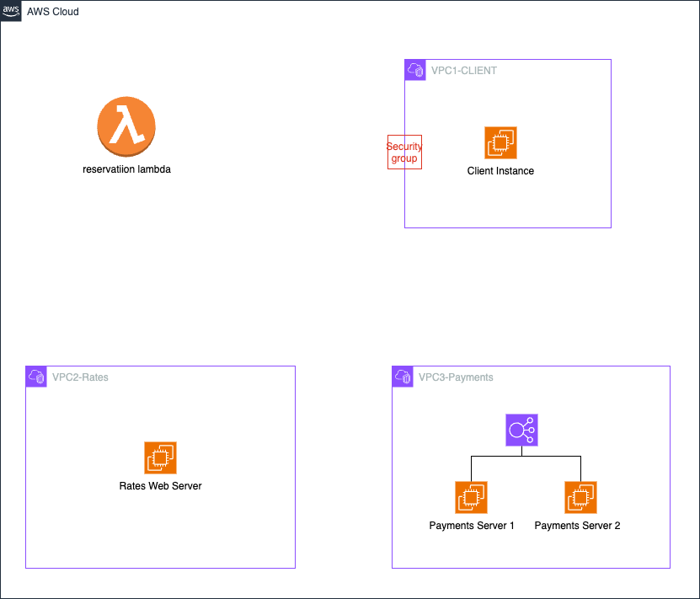
Image description: Three VPCs created: 1 with ALB and instance which handles payments service, 1 with Rates service running on EC2 instance, 1 with client machine used to access the services later in Task 4, and finally one Lambda which hosts reservation services.
By the end of the lab, you create the architecture shown in the following diagram:
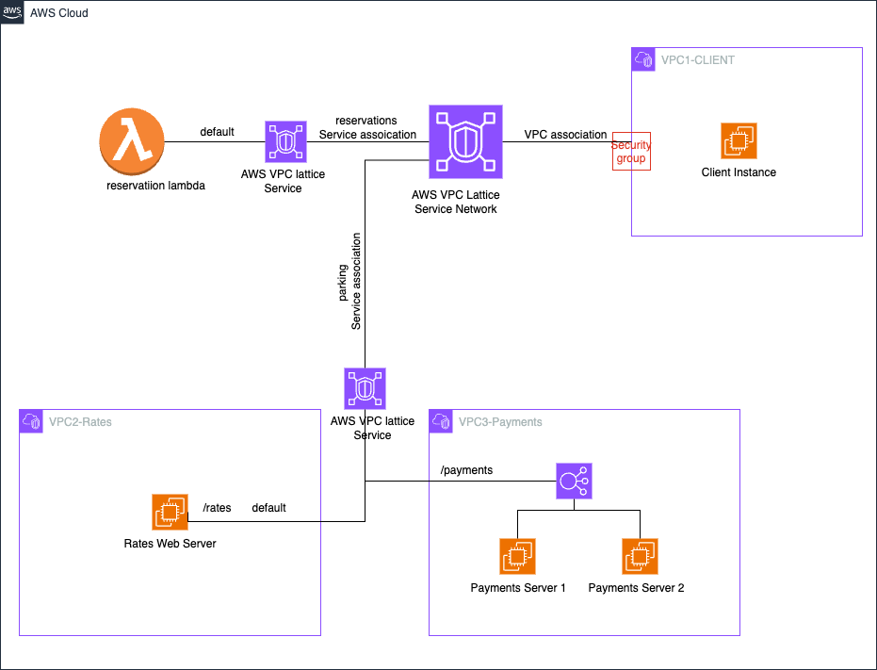
Image description: DevSecOps engineer builds VPC Lattice services and associates them to VPC Lattice service network. Parking service with two paths /payments and /rates, reservation parking service default path to Lambda. Client VPC is associated with VPC Lattice service with appropriate security group settings to access the VPC Lattice services.
Task 1: Create VPC Lattice Target Groups
In this task, you create target groups for VPC Lattice services.
- At the top of the AWS Management Console, in the search bar, search for and choose
VPC
.
- In the left navigation pane, under PrivateLink and Lattice, choose Target groups.
- Choose Create target group.
Create a target group for the Reservation service.
- For Specify group details:
  - For Choose a target type, select Lambda function.
  - For Target group name, enter
reservation-tg
(all lowercase).
  - Note: The target group name field is case-sensitive. Ensure to copy the value as listed.
- Choose Next.
- For Register targets:
  - For Lambda function, choose Select a Lambda function.
  - For the lambda function, select the drop-down menu and choose ParkingReservationFunction.
  - Choose Create target group.
Note: A success banner will appear validating the creation of target group:reservation-tg.
- Choose Lattice:Target groups to return to the target groups window.
- Choose Create target group.
Create a target group for the Rates service.
- For Specify group details:
  - For Choose a target type, select Instances.
  - For Target group name, enter
rates-tg
(all lowercase).
  - Note: The target group name field is case-sensitive. Ensure to copy the value as listed.
  - For Protocol, choose HTTP from the drop-down menu.
  - For VPC, select VPC2-Rates from the drop-down menu.
- Choose Next.
- On the Register targets window, select the instance.
- Choose Include as pending below.
- Choose Create target group.
Note: A success banner will appear validating the creation of target group:rates-tg.
- Choose Lattice:Target groups to return to the target groups window.
- Choose Create target group.
Create a target group for the Payments service.
- For Specify group details:
  - For Choose a target type, select Application Load Balancer.
  - For Target group name, enter
payments-tg
(all lowercase).
  - Note: The target group name field is case-sensitive. Ensure to copy the value as listed.
  - For Protocol, choose HTTP from the drop-down menu.
  - For VPC, select VPC3-Payments from the drop-down menu.
- Choose Next.
- On the Register targets window, from the Application Load Balancer drop-down menu, choose the listed application load balancer.
- Choose Create target group.
Note: A success banner will appear validating the creation of target group:payments-tg.
Task complete: You successfully configured the target groups for VPC Lattice services. You created target groups for a Lambda function (reservation-tg), EC2 instance (rates-tg), and an Application Load Balancer (payments-tg).
Task 2: Create VPC Lattice Services
In this task, you create the VPC Lattice services.
- At the top of the AWS Management Console, in the search bar, search for and choose
VPC
.
- In the left navigation pane, under PrivateLink and Lattice, choose Lattice Services.
- Choose Create service. Create the Parking service.
- For Create a VPC Lattice service:
- For Service name, enter
parking
.
- Choose Next.
- Choose Add listener.
- Configure the listener:
- Listener identifier: select Use protocol:port values as listener name.
- Protocol: choose HTTPS, and enter port
443
.
- Listener rules: Add 2 listener rules.
  - Configure Rule 1:
    - Choose Add rule.
    - Rule name: enter
rates
.
    - Rule conditions: choose Path condition.
    - Path match type: with Exact selected, for Exact path match enter
/rates
.
    - Rule action: with Forward to target group selected, for the Target group, choose rates-tg from the drop-down menu.
    - Choose Add rule.
  - Configure Rule 2:
    - Choose Add rule.
    - Rule name: enter
payments
.
    - Rule conditions: choose Path condition.
    - Path match type: with Exact selected, for Exact path match enter
/payments
.
    - Rule action: with Forward to target group selected, for the Target group, choose payments-tg from the drop-down menu.
    - Choose Add rule.
- Listener default action: with Forward to target group selected, from the Target group drop-down menu, choose
rates-tg
or
payments-tg
.
- Choose Skip to Review and create.
- Choose Create VPC Lattice service.
Note: A success banner will appear validating the creation of service:parking.
- Choose Lattice:Services to return to the Services window.
- Choose Create service. Create the Reservations service.
- For Create a VPC Lattice service:
- For Service name, enter
reservations
.
- Choose Next.
- Choose Add listener.
- Configure the listener:
- Listener identifier: select Use protocol:port values as listener name.
- Protocol: choose HTTPS, and enter port
443
.
- Listener default action: with Forward to target group selected, from the Target group drop-down menu, choose
reservation-tg
.
- Choose Skip to Review and create.
- Choose Create VPC Lattice service.
Note: A success banner will appear validating the creation of service:reservations.
Task complete: You successfully created VPC Lattice services for Parking and Reservations. The Parking service uses HTTP with path-based routing for rates and payments, while the Reservations service uses HTTPS with a Lambda function as the target.
Task 3: Create a VPC Lattice Service Network
In this final task, you create the service network and associate the services with the VPC network so the consumers in associated VPC can access the service without any network connectivity between the VPC.
- From the current window, select VPC to return to the VPC service dashboard.
- In the left navigation pane, under PrivateLink and Lattice, choose Service networks.
- Choose Create service network. Configure the service network.
- For Create service network:
- For Service network name, enter
appsvcnetwork
.
- Choose Create service network.
Note: A success banner will appear with Network created successfully.
- On the Service associations tab, choose Create service associations.
- On the Create service associations window, from the Services* drop-down menu, select parking and reservations.
- Choose Save changes. Associate the client VPC with the service network.
- On the VPC associations tab, choose Create VPC associations.
- Choose Add VPC association.
- For VPC, from the drop-down menu, select VPC1-Client.
- For Security groups, from the drop-down menu, select VPC1-Client-sg.
- Choose Save changes.
Task complete: You successfully created a VPC Lattice service network named ‘appsvcnetwork’. You associated the Parking and Reservations services with this network and linked the client VPC (VPC1-Client) to enable access without direct network connectivity.

Assessment Tasks
In this assessment task, you access the services from the consumer/client VPC that is associated with AWS VPC Lattice Service Network.
- From the current window, select VPC to return to the VPC service dashboard.
- In the left navigation pane, under PrivateLink and Lattice, choose Service networks.
- Choose appsvcnetwork.
- From the Service associations tab, copy the Domain name for both parking and reservations services to a text editor.
- At the top of the AWS Management Console, in the search bar, search for and choose
EC2
.
- In the left navigation pane, under Instances, choose Instances.
- Select the instance named Linux-Client-instance-VPC1.
- Choose Connect.
- On the Connect to instance window, select the Session Manager tab and choose Connect.
- Command: Edit the command replacing the domain-name-of-reservation-service placeholder with the domain name value copied earlier and paste it in the terminal to test the connectivity to the reservations service.
curl https://domain-name-of-reservation
Expected output:
Hello from Reservations
- Command: Edit the command replacing the domain-name-of-parking-service placeholder with the domain name value copied earlier and paste it in the terminal to test the connectivity to the rates service.
curl https://domain-name-of-parking-service/rates
Expected output:
Hello from Rates
- Command: Edit the command replacing the domain-name-of-parking-service placeholder with the domain name value copied earlier and paste it in the terminal to test the connectivity to the payments service.
curl https://domain-name-of-parking-service/payments
Expected output: The system displays one of the following responses.
Hello from Payments-Server1
OR
Hello from Payments-Server2
Task complete: You successfully tested connectivity to the VPC Lattice services from the client VPC. You verified access to the reservation service over HTTPS and to the rates and payments services over HTTP using their respective domain names.

Conclusion
You successfully did the following:
- Built VPC Lattice target groups.
- Built a VPC Lattice service network with a client VPC association.
- Built VPC Lattice services for parking and reservation.
- Associated VPC Lattice services with a VPC Lattice service network.
- Tested the connectivity between the VPC Lattice services from the client VPC.

Evolution of a website: Going from single server to serverless
Lab overview
AnyCompany Ice Cream hires you to create and maintain their website. In this lab, you follow the growth of the business and how it evolves their website’s infrastructure.
You start by creating the company’s static website hosted on Amazon Simple Storage Service (S3) that displays the ice cream flavors. The business starts to gain popularity among the locals and flavors start to sell out before the day is up. The business owners ask you to migrate to a server where they can have you push updates. They decide to migrate their static site to Amazon Elastic Compute Cloud (EC2) with a Linux, Apache, MySQL, PHP (LAMP) stack built on it.
This will allow the website to update and react dynamically. Demand for AnyCompany’s ice cream surges after a viral video and the infrastructure and maintenance becomes difficult to manage. To scale with demand, you suggest migrating sections of their LAMP stack to serverless services, starting with the MySQL database. The MySQL database will be replaced with Amazon DynamoDB serverless database.
Lab Environment
The application architecture uses the following services:
- Static site: Amazon S3 which contains HTML, CSS, and images.
- Dynamic site: Amazon EC2 Linux, Apache web server, MySQL database, and PHP (LAMP) stack will come pre installed. This will allow the owner or developer to update the flavors available for the day.
- Serverless: Amazon DynamoDB. This will replace the MySQL database and make the database portion serverless.
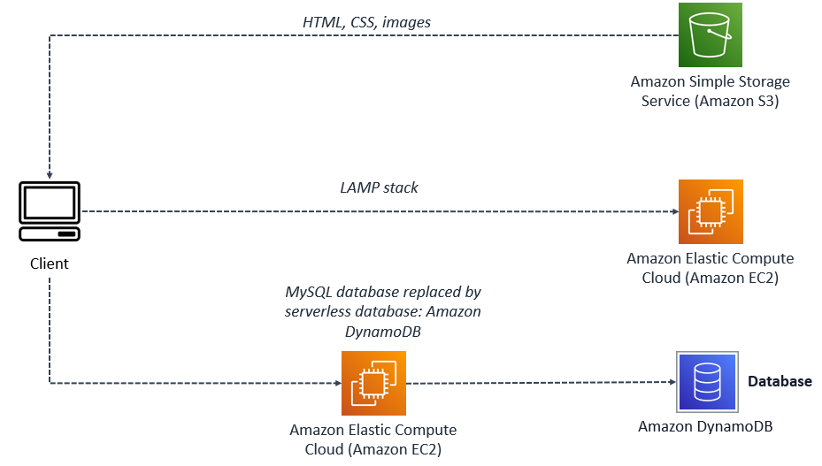
Image Description: The preceding architecture shows three different ways the client is accessing information. The client can access static content through Amazon S3 which holds the HTML, CSS, and image files. Dynamic content can be accessed through the dynamic site hosted on Amazon EC2. The site has a database, and is able to update content through its server. The last way to access this site is keeping the Amazon EC2 instance, and migrating the database to a serverless database, which is seen in this diagram.

Task 1: Upload files to Amazon S3
In this task, AnyCompany Ice Cream would like you to create a static website which displays their ice cream flavors. To help speed up this step, this task is already configured with an S3 bucket and the following actions have already been completed.
- The website hosting feature is enabled to allow this bucket to host a website.
- Additionally, a bucket policy was added to allow s3:GetObject permissions to this bucket and the files within the bucket.
- The index document property has been set to index.html in the root of the bucket. This is a file you just copied to the bucket.
The static website files have already been created including the index.html file, css folder, and an images folder. In this task, you download the zip file containing these necessary files. Then you will upload them to the s3htmlbucket to finish configuring the website hosted using an Amazon S3 bucket.
Task 1.1: Download the static-site.zip file
In this task you download the static website files to your local machine.
- Download the static-site.zip file containing the static website files to your local machine (Save link as…).
- Static-Site.zip
- Unzip the files to a temporary directory or the desktop.
Task 1.2: Upload the files to Amazon S3
In this task, you use the S3 management console to upload the static site files to the s3htmlbucket that will host your website.
- At the top of the AWS Management Console, in the search bar, search for and choose
S3
.
- Choose the text link for the bucket with s3htmlbucket in the name.
- Open the location where you unzipped the static website files to on your machine. Select all of the files and folders and drag them to the Files and folders area of the Object page.
- Choose Upload at the bottom of the page.
Expected service output:
Upload succeeded
- Choose the Close button.
- Your bucket listing should look similar to the example below:
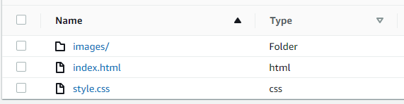
Image Description: The index.html document is in the root of the bucket. The images folder has the ice cream image inside of it and the css style sheet gives the index.html document colors, fonts, and size.
Task 1.3: Test the static S3 website
In this task, you test the static S3 website to ensure it works as expected.
- Choose the Objects tab located at the top of the page.
- Navigate to the static-site/index.html section, located at the end of the page.
- Copy and paste the object URL in a new browser tab to view the website.
Congratulations! You have successfully crated a static website for AnyCompany Ice Cream.

Task 2: Verify the dynamic website on Amazon EC2 is running
The business starts to grow, and customers want a feature on the website where they can see an updated flavor of the day, or when a flavor sells out. You suggest to migrate the server to an Amazon EC2 instance with LAMP installed on it. This allows the site to generate dynamic content using a database and allows you to update flavors as inventory is added or runs out.
In this task, you verify the new dynamic website is working and that data about the inventory for available ice cream flavors is returned from the database. You copy the IP address for the EC2 instance and paste it into a new browser tab to see if the website pulls up.
To help speed up this step, this task is already configured with a Amazon VPC and its networking resources, and an Amazon EC2 with a LAMP stack configured. The following actions have already been completed.
- The LAMP stack is installed as a web server to host AnyCompany’s dynamic website.
- Additionally, an IAM Policy is used to define the permissions for each service used.
- Flavors and prices are now updated through a MySQL database that dynamically updates the website.
Architecture Overview
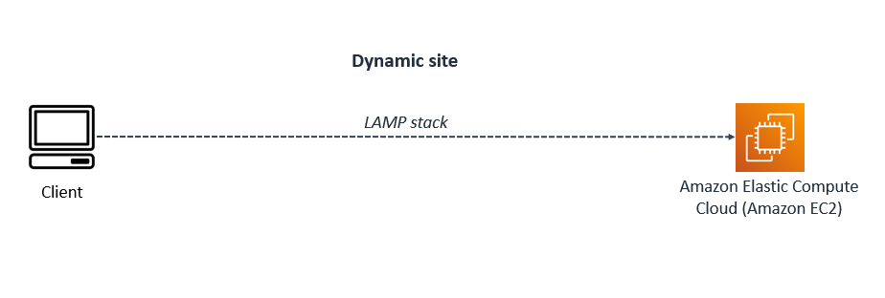
Image Description: In this architecture, the Operating System (OS) for this Amazon EC2 instance is Linux, the HTTP server is Apache, the MySQL database is MariaDB, and the scripting language used is PHP. All of these configured together, run the dynamic website you open shortly. A dynamic site is information or web pages that are generated in real time. With a LAMP stack, customers will be able to input orders, and submit them.
- At the top of the AWS Management Console, in the search bar, search for and choose
EC2
.
- Choose Instances from the left navigation pane.
- Check the box next to the instance with the name Ice Cream.
Note: A detailed notification box appears following the selected instance. Each tab gives you an overview of the instance such as its public or private IPv4 address, Public IPv4 DNS name, the VPC it is assigned to, security associations, status of the instance, and networking associations.
- In the Details tab, copy the Public IPv4 IP address value.
- Paste the Public IPv4 IP address into a new browser tab to see the dynamic website running on EC2. Leave this tab open for task 3.
Use HTTP and not HTTPS in the browser.
http://<PUBLIC IPv4 ADDRESS>
Expected website:
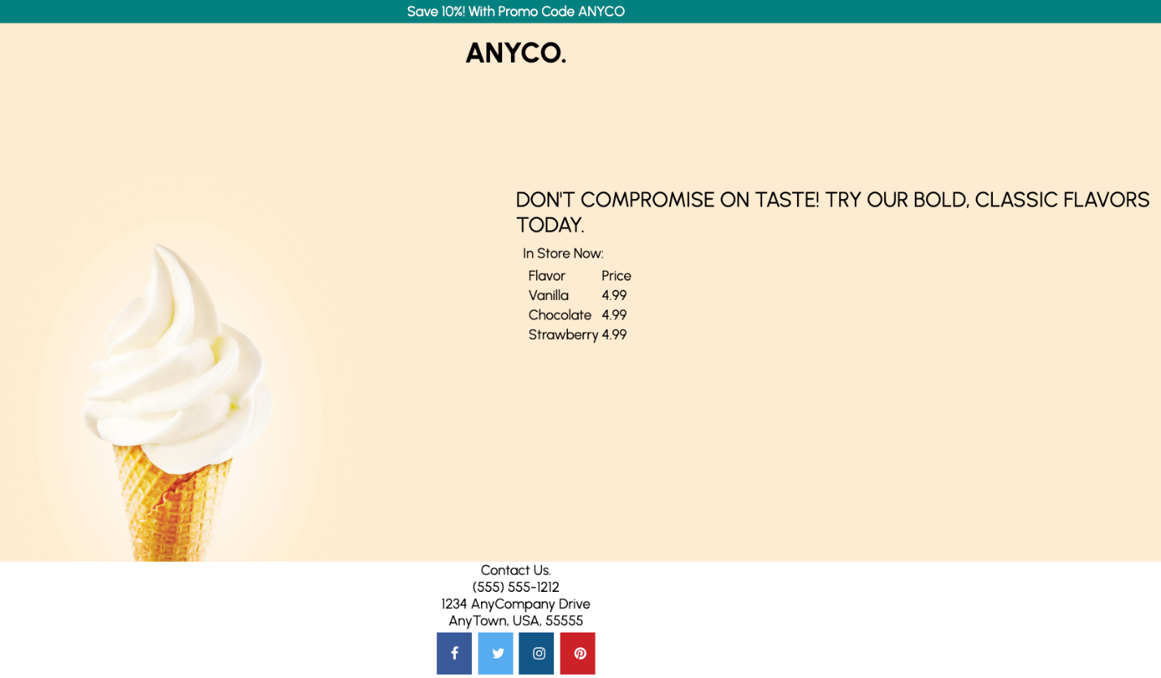
Image Description: Depicted is the home page for AnyCompany Ice Cream with the photo of a waffle cone filled with vanilla ice cream and a listing of available ice cream flavors and prices.
Congratulations! You have successfully verified the dynamic website using a MySQL database to show inventory of available ice cream flavors is working as expected.

Task 3: Update dynamic website to a serverless solution using DynamoDB for the MySQL database
Business has been steadily growing but with a recent video of a customer’s experience that has since gone viral, the AnyCompany Ice Cream website has experienced more web traffic than the current MySQL database server can keep up with. Unfortunately, customers are getting errors accessing the website. To remedy this, you are tasked with migrating the local MySQL database to Amazon DynamoDB since it can scale with the demands of customer web traffic to ensure customers continue to reach the AnyCompany Ice Cream website without interruptions.
Note: The Amazon DynamoDB database has already been created and the existing MySQL table has already been imported.
- The Amazon DynamoDB table is installed, however, the items in the table need to be created.
- A script is created to replace the old index.php with a new index.php.
- IAM user, and roles are adjusted to allow permissions to access Amazon DynamoDB.
Architecture Overview
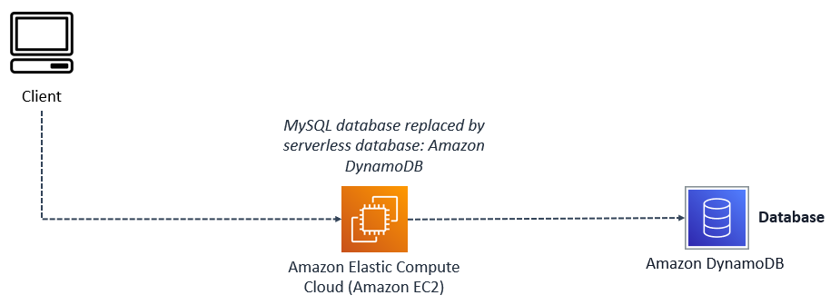
Image Description: In this architecture, the Operating System (OS) for this Amazon EC2 instance is Linux, the HTTP server is Apache, the MySQL database has been replaced with an Amazon DynamoDB serverless database, and the scripting language used is PHP. All of these configured together run the dynamic website you open shortly. A dynamic site is information or web pages that are generated in real time.
In this task, you complete the following steps:
- Update the database with a new flavor using the Amazon DynamoDB console.
- Update the index.php file to point to the Amazon DynamoDB database using a bash script.
- Refresh the website to see that it is now pulling in content from the Amazon DynamoDB database revealing the the new flavor you just added.
Task 3.1: Update the Amazon DynamoDB Products table with a new ice cream flavor
In this task, you create a new ice cream flavor in the Products table using the Amazon DynamoDB console.
- At the top of the AWS Management Console, in the search bar, search for and choose
DynamoDB
.
- In the left navigation pane, choose Tables.
- Choose the text link for the table named Products.
- Choose Explore table items .
- In the Items returned section, choose Create item and configure the following options:
- Attribute name: id - Partition key
- Value:
1
- Choose Add new attribute > String and then configure the following options:
- Attribute name:
ProductFlavor
- Value:
Cinnamon-spiced Chocolate
Note: You can put in any flavor name you want for the Value field.
- Choose Add new attribute > String and then configure the following options:
- Attribute name:
ProductPrice
- Value:
7.99
- Choose Create Item .
Task 3.2: Update the website to use Amazon DynamoDB
In this task, you connect to your EC2 instance using Session Manager and run a script to migrate the website from using the local MySQL database to using the serverless database Amazon DynamoDB.
- At the top of the AWS Management Console, in the search bar, search for and choose
EC2
.
- Choose Instances from the left navigation pane.
- Check the box next to the instance with the name Ice Cream.
- In the top section of the console, choose Connect .
- From the Connect to instance page, choose the Session Manager tab, then choose Connect .
- Command: From the terminal session copy and paste the following command to migrate the website from using the MySQL database to Amazon DynamoDB.
sudo /var/www/html/migrate-database.sh
Expected output:
******************************
**** This is OUTPUT ONLY. ****
******************************

Renaming index.php to compute-index.php
Renaming serverless-index.php to index.php
Restarting Apache
Task 3.3 Refresh website to see your new ice cream flavor
In this task, you refresh the browser to show the new ice cream flavor you added to the Amazon DynamoDB Products table.
- Switch back to the browser tab opened to the AnyCompany Ice Cream website and choose the refresh icon to update the website and see your new ice cream flavor.
Expected website:
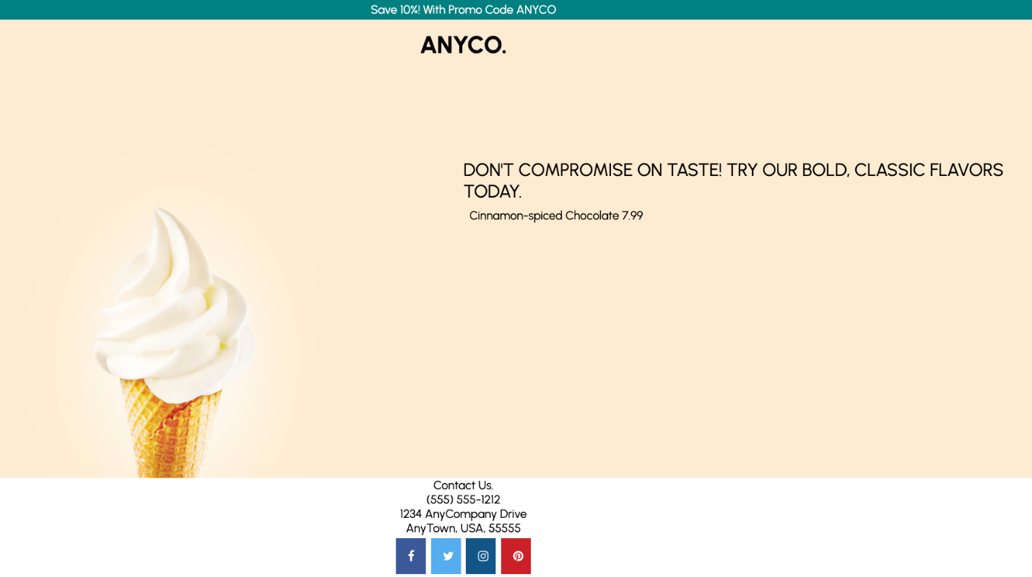
Image Description: The website is updated with the new flavor and price listed from the Amazon DynamoDB Products table that was just created.
Congratulations! You have successfully added a new ice cream flavor and price to the Amazon DynamoDB Products table, migrated the website to use Amazon DynamoDB instead of MySQL for the database, and refreshed the website to reveal your new ice cream flavor.
Congratulations! You now have successfully:
- Uploaded files to Amazon S3 to host a static website.
- Migrated the dynamic website hosted on EC2 from using a MySQL database to using Amazon DynamoDB.
- Updated the DynamoDB table with a new ice cream flavor.
- Refreshed the website to reveal your new ice cream flavor.

Introduction to Amazon API Gateway
Lab environment
Amazon API Gateway and AWS Lambda
A microservice using Amazon API Gateway consists of a defined resource and associated methods (GET, POST, PUT, etc.) in API Gateway as well as the backend target. In this lab, the backend target is an AWS Lambda function. However, the backend target could be any other HTTP endpoint (a third-party API or listening web server), an AWS service proxy or a mock integration to be used as a placeholder.
Services used in this lab
Amazon API Gateway
Amazon API Gateway is a managed service provided by AWS that makes creating, deploying and maintaining APIs easy.
Amazon API Gateway includes features to:
- Transform the body and headers of incoming API requests to match backend systems.
- Transform the body and headers of the outgoing API responses to match API requirements.
- Control API access via AWS Identity and Access Management.
- Create and apply API keys for third-party development.
- Enable Amazon CloudWatch integration for API monitoring.
- Cache API responses via Amazon CloudFront for faster response times.
- Deploy an API to multiple stages, allowing easy differentiation between development, test, production as well as versioning.
- Connect custom domains to an API.
- Define models to help standardize your API request and response transformations.
AWS Lambda
AWS Lambda is a serverless, event-driven compute service that lets you run code for virtually any type of application or backend service without provisioning or managing servers. You can trigger Lambda from over 200 AWS services and software as a service (SaaS) applications, and only pay for what you use. These events may include changes in state or an update, such as a user placing an item in a shopping cart on an e-commerce website. You can use AWS Lambda to extend other AWS services with custom logic, or create your own backend services that operate at AWS scale, performance, and security. AWS Lambda automatically runs code in response to multiple events, such as HTTP requests via Amazon API Gateway, modifications to objects in Amazon Simple Storage Service (Amazon S3) buckets, table updates in Amazon DynamoDB, and state transitions in AWS Step Functions.
AWS Lambda includes features to:
- Extend other AWS services with custom logic.
- Build custom backend services.
- Bring your own code.
- Completely automate administration.
- Built-in fault tolerance.
- Package and deploy functions as container images.
- Automatic scaling.
- Connect to relational databases.
- Fine-grain control over performance.
- Connect to shared file systems.
- Orchestrate multiple functions.
- Integrate security model with AWS Identity and Access Management (IAM).
- Utilize trust and integrity controls for code.
- Integrate Lambda with your favorite operational tools.
- Monitoring and observability.
Task 1: Create a Lambda Function
In this task, you use the AWS Lambda console to create a function with lab provided code, and finish configuring it to work with Amazon API Gateway.
Task 1.1: Create the initial Lambda Function
- At the top of the AWS Management Console, in the search bar, search for and choose
Lambda
.
- Choose Create a function.
Learn more: Blueprints are code templates for writing Lambda functions. Blueprints are provided for standard Lambda triggers such as creating Alexa skills and processing Amazon Kinesis Firehose streams. This lab provides you with a pre-written Lambda function to use.
- Select Author from scratch.
- In the Basic information section, configure the following:
- For Function name, enter
FAQ
.
- For Runtime, select Node.js 22.x.
- Expand Change default execution role.
- For Execution role, select Use an existing role.
- For Existing role, select lambda-basic-execution.
- Expand the Additional configurations section.
Note: To make this lab more secure, you must attach your function to a VPC, subnet, and security group that have been created for you. Conventionally, Lambda functions do not need to be attached to a VPC, but this lab will not let you create the function without the addition of defined networking.
- In the Additional configurations section:
- Choose VPC.
- For VPC, select the VPC with CIDR range 10.0.0.0/16.
- For Subnets, select both the subnets with CIDR range 10.0.1.0/24 and 10.0.2.0/24.
- For Security groups, select the security group with LambdaSecurityGroup in its name.
- Choose Create function.
- On the Getting started pop-up, choose Dismiss .
Note: Creating a VPC-attached Lambda function takes a few minutes. Wait until a banner at the top of the page displays Successfully created the function Create-Thumbnail. to proceed.
The Lambda console displays a page to configure your function.
Note: In case you get an error while creating the Lambda function, check the function name, the name should be FAQ.
- Choose the Code tab.
- In the Code source window, select (or double-click) on the index.js file.
- Delete the default content displayed under index.js tab.
- Copy the code shown below and paste it into the index.js tab.
var json = {
"service": "lambda",
"reference": "https://aws.amazon.com/lambda/faqs/",
"questions": [{
"q": "What is AWS Lambda?",
"a": "AWS Lambda lets you run code without provisioning or managing servers. You pay only for the compute time you consume - there is no charge when your code is not running. With Lambda, you can run code for virtually any type of application or backend service - all with zero administration. Just upload your code and Lambda takes care of everything required to run and scale your code with high availability. You can set up your code to automatically trigger from other AWS services or call it directly from any web or mobile app."
},{
"q":"What events can trigger an AWS Lambda function?",
"a":"You can use AWS Lambda to respond to table updates in Amazon DynamoDB, modifications to objects in Amazon S3 buckets, logs arriving in Amazon CloudWatch logs, incoming emails to Amazon Simple Email Service, notifications sent from Amazon SNS, messages arriving in an Amazon Kinesis stream, client data synchronization events in Amazon Cognito, and custom events from mobile applications, web applications, or other web services. You can also invoke a Lambda function on a defined schedule using the AWS Lambda console."
},{
"q":"When should I use AWS Lambda versus Amazon EC2?",
"a":"Amazon Web Services offers a set of compute services to meet a range of needs. Amazon EC2 offers flexibility, with a wide range of instance types and the option to customize the operating system, network and security settings, and the entire software stack, allowing you to easily move existing applications to the cloud. With Amazon EC2 you are responsible for provisioning capacity, monitoring fleet health and performance, and designing for fault tolerance and scalability. AWS Elastic Beanstalk offers an easy-to-use service for deploying and scaling web applications in which you retain ownership and full control over the underlying EC2 instances. Amazon Elastic Container Service is a scalable management service that supports Docker containers and allows you to easily run distributed applications on a managed cluster of Amazon EC2 instances. AWS Lambda makes it easy to execute code in response to events, such as changes to Amazon S3 buckets, updates to an Amazon DynamoDB table, or custom events generated by your applications or devices. With Lambda you do not have to provision your own instances; Lambda performs all the operational and administrative activities on your behalf, including capacity provisioning, monitoring fleet health, applying security patches to the underlying compute resources, deploying your code, running a web service front end, and monitoring and logging your code. AWS Lambda provides easy scaling and high availability to your code without additional effort on your part."
},{
"q":"What kind of code can run on AWS Lambda?",
"a":"AWS Lambda offers an easy way to accomplish many activities in the cloud. For example, you can use AWS Lambda to build mobile back-ends that retrieve and transform data from Amazon DynamoDB, handlers that compress or transform objects as they are uploaded to Amazon S3, auditing and reporting of API calls made to any Amazon Web Service, and server-less processing of streaming data using Amazon Kinesis."
},{
"q":"What languages does AWS Lambda support?",
"a":"AWS Lambda supports code written in Node.js (JavaScript), Python, and Java (Java 8 compatible). Your code can include existing libraries, even native ones. Lambda functions can easily launch processes using languages supported by Amazon Linux, including Bash, Go, and Ruby. Please read our documentation on using Node.js, Python and Java."
},{
"q":"Can I access the infrastructure that AWS Lambda runs on?",
"a":"No. AWS Lambda operates the compute infrastructure on your behalf, allowing it to perform health checks, apply security patches, and do other routine maintenance."
},{
"q":"How does AWS Lambda isolate my code?",
"a":"Each AWS Lambda function runs in its own isolated environment, with its own resources and file system view. AWS Lambda uses the same techniques as Amazon EC2 to provide security and separation at the infrastructure and execution levels."
},{
"q":"How does AWS Lambda secure my code?",
"a":"AWS Lambda stores code in Amazon S3 and encrypts it at rest. AWS Lambda performs additional integrity checks while your code is in use."
},{
"q":"What is an AWS Lambda function?",
"a":"The code you run on AWS Lambda is uploaded as a Lambda function. Each function has associated configuration information, such as its name, description, entry point, and resource requirements. The code must be written in a stateless style i.e. it should assume there is no affinity to the underlying compute infrastructure. Local file system access, child processes, and similar artifacts may not extend beyond the lifetime of the request, and any persistent state should be stored in Amazon S3, Amazon DynamoDB, or another Internet-available storage service. Lambda functions can include libraries, even native ones."
},{
"q":"Will AWS Lambda reuse function instances?",
"a":"To improve performance, AWS Lambda may choose to retain an instance of your function and reuse it to serve a subsequent request, rather than creating a new copy. Your code should not assume that this will always happen."
},{
"q":"What if I need scratch space on disk for my AWS Lambda function?",
"a":"Each Lambda function receives 500MB of non-persistent disk space in its own /tmp directory."
},{
"q":"Why must AWS Lambda functions be stateless?",
"a":"Keeping functions stateless enables AWS Lambda to rapidly launch as many copies of the function as needed to scale to the rate of incoming events. While AWS Lambda's programming model is stateless, your code can access stateful data by calling other web services, such as Amazon S3 or Amazon DynamoDB."
},{
"q":"Can I use threads and processes in my AWS Lambda function code?",
"a":"Yes. AWS Lambda allows you to use normal language and operating system features, such as creating additional threads and processes. Resources allocated to the Lambda function, including memory, execution time, disk, and network use, must be shared among all the threads/processes it uses. You can launch processes using any language supported by Amazon Linux."
},{
"q":"What restrictions apply to AWS Lambda function code?",
"a":"Lambda attempts to impose few restrictions on normal language and operating system activities, but there are a few activities that are disabled: Inbound network connections are managed by AWS Lambda, only TCP/IP sockets are supported, and ptrace (debugging) system calls are restricted. TCP port 25 traffic is also restricted as an anti-spam measure."
},{
"q":"How do I create an AWS Lambda function using the Lambda console?",
"a":"You can author the code for your function using the inline editor in the AWS Lambda console. You can also package the code (and any dependent libraries) as a ZIP and upload it using the AWS Lambda console from your local environment or specify an Amazon S3 location where the ZIP file is located. Uploads must be no larger than 50MB (compressed). You can use the AWS Eclipse plugin to author and deploy Lambda functions in Java and Node.js. If you are using Node.js, you can author the code for your function using the inline editor in the AWS Lambda console. Go to the console to get started."
},{
"q":"How do I create an AWS Lambda function using the Lambda CLI?",
"a":"You can package the code (and any dependent libraries) as a ZIP and upload it using the AWS CLI from your local environment, or specify an Amazon S3 location where the ZIP file is located. Uploads must be no larger than 50MB (compressed). Visit the Lambda Getting Started guide to get started."
},{
"q":"Which versions of Python are supported?",
"a":"Lambda provides a Python 2.7-compatible runtime to execute your Lambda functions. Lambda will include the latest AWS SDK for Python (boto3) by default."
},{
"q":"How do I compile my AWS Lambda function Java code?",
"a":"You can use standard tools like Maven or Gradle to compile your Lambda function. Your build process should mimic the same build process you would use to compile any Java code that depends on the AWS SDK. Run your Java compiler tool on your source files and include the AWS SDK 1.9 or later with transitive dependencies on your classpath. For more details, see our documentation."
},{
"q":"What is the JVM environment Lambda uses for execution of my function?",
"a":"Lambda provides the Amazon Linux build of openjdk 1.8."
}
]
}

export const handler = function(event, context) {
var rand = Math.floor(Math.random() * json.questions.length);
console.log("Quote selected: ", rand);

var response = {
body: JSON.stringify(json.questions[rand])
};
console.log(response);
context.succeed(response);
};
- Examine the code.
It performs the following steps:
- Defines a list of Frequently Asked Questions (FAQs).
- Returns a random FAQ.
- Choose Deploy.
Task complete: You have successfully created a AWS Lambda function and used the lab provided code.
Task 1.2: Create an API Gateway endpoint
Learn more: An API endpoint refers to a host name of the API. The API endpoint can be edge-optimized or regional, depending on where the majority of your API traffic originates from. You choose a specific endpoint type when creating an API.
- Choose the Configuration tab.
- Choose General configuration, then choose Edit.
- For Description, enter
Provide a random FAQ
.
- Choose Save.
AWS Lambda functions can be triggered automatically by activities such as data being received by Amazon Kinesis or data being updated in an Amazon DynamoDB database. For this lab, you trigger the Lambda function whenever a call is made to API Gateway.
- Locate the Function overview section, at the top of the console page.
- Choose Add trigger, then configure the following:
- For Select a source, select API Gateway.
- For Intent, select Create a new API.
- For API type, select REST API.
- For Security, select Open.
- Expand Additional settings.
- For API name, enter
FAQ-API
.
- For Deployment stage, enter
myDeployment
.
- Choose Add.
Task complete: You have successfully created the Lambda function and configured the settings. This has also created a new API Gateway REST endpoint, which is used to trigger the Lambda function.

Task 2: Test the Lambda function
In this task, you test the Lambda function and are presented with the FAQ Lambda function page when successful.
- In the Configuration tab, select Triggers from the navigation menu on the left.
- In the Triggers section, locate API Gateway, and expand Details to view the details of your API.
- Copy the API endpoint to your clipboard, then:
- In a new browser tab, paste the API endpoint.
- Press Enter to go to the URL.
A new browser tab opens.
A random FAQ entry for the Lambda code is displayed on the web page.
An example is text similar to:
q "What languages does AWS Lambda support?"
a "AWS Lambda supports code written in Node.js (JavaScript), Python, and Java (Java 8 compatible). Your code can include existing libraries, even native ones. Lambda functions can easily launch processes using languages supported by Amazon Linux, including Bash, Go, and Ruby. Please read our documentation on using Node.js, Python and Java."
The Lambda function can also be tested in isolation.
- Close the FAQ browser tab and return to the web browser tab showing the AWS Lambda Management Console.
- Select the Test tab and configure a new test event.
- In the Test event section, configure the following:
- For Event name, enter
BasicTest
.
- Delete the provided keys and values.
- Keep an empty {} to represent an empty JSON object:
{}
- Choose Save.
- Choose Test.
- In the Execution result: succeeded window, expand Details.
The output shows the FAQ entry wrapped inside a body parameter.
Below the Execution result are two columns. The Summary displays the total execution time for the AWS Lambda function and the resources consumed. The Log output displays logging information. This section contains any console logging as well as any error messages.
- Choose the Monitor tab.
- Choose View CloudWatch logs.
- Choose on one of the log streams.
You are presented with the same event data that was displayed in the AWS Lambda Management Console. Examine the contents of each line to review the log information.
Task complete: You have successfully tested that the AWS Lambda Function works and displays a FAQ page by making a request from the Amazon API Gateway endpoint… You also created a new test event for testing the function from within the AWS Lambda console. Finally, you learned how to locate and review the CloudWatch logs associated with the AWs Lambda function.

AWS Network Firewall Fundamentals
Lab overview
You are a Network Security Engineer at AnyCompany. You are responsible for setting up and deploying network firewall security across Amazon Virtual Private Cloud (Amazon VPC) in your Organization. Your company is concerned about network security and would like to standardize network configurations.
Your task is to set up a baseline configuration of AWS Network Firewall to ensure traffic is inspected and filtered as necessary.
This lab is designed to provide a hands-on walkthrough of setting up an AWS environment that properly utilizes AWS Network Firewall. In this lab, you walk through each step to learn the fine grained details of what it takes to have the proper networking infrastructure to route and block traffic with AWS Network Firewall. You start with a simple, single VPC and single firewall and build from there. After completing this lab, you end up with one VPC and up to three subnets. Multiple EC2 instances are used during the course of this lab to help test network connectivity.
Objectives
By the end of this lab, you should be able to do the following:
- Review the basic network architecture required to support the Network Firewall scenarios.
- Configure AWS Network Firewall.
- Configure and test routing configuration using a basic subnet architecture.
- Configure and test routing configuration using a more sophisticated architecture involving a NAT Gateway.

Lab environment

Services used in this lab

AWS Network Firewall
AWS Network Firewall can be configured as either stateful or stateless. It is a managed, network firewall and intrusion detection and prevention service for your virtual private cloud (VPC). Network Firewall enables you to filter traffic entering and exiting your VPC. This includes filtering traffic directed towards an internet gateway, NAT gateway, or even a VPN or AWS Direct Connect. Network Firewall uses the open source intrusion prevention system (IPS), Suricata, for stateful inspection.
Amazon EC2
Amazon Elastic Compute Cloud (Amazon EC2) provides scalable computing capacity in the Amazon Web Services (AWS) Cloud. Using Amazon EC2 eliminates your need to invest in hardware up front, so you can develop and deploy applications faster. You can use Amazon EC2 to launch as many or as few virtual servers as you need, configure security and networking, and manage storage. Amazon EC2 enables you to scale up or down to handle changes in requirements or spikes in popularity, reducing your need to forecast traffic.
AWS Systems Manager Session Manager
Session Manager is a fully managed AWS Systems Manager capability. With Session Manager, you can manage your Amazon Elastic Compute Cloud (Amazon EC2) instances, edge devices, on-premises servers, and virtual machines (VMs). You can use either an interactive one-click browser-based shell or the AWS Command Line Interface (AWS CLI). Session Manager provides secure and auditable node management without the need to open inbound ports, maintain bastion hosts, or manage SSH keys. Session Manager also allows you to comply with corporate policies that require controlled access to managed nodes, strict security practices, and fully auditable logs with node access details, while providing end users with simple one-click cross-platform access to your managed nodes.
Amazon VPC
With Amazon Virtual Private Cloud (Amazon VPC), you can launch AWS resources in a logically isolated virtual network that you’ve defined. This virtual network closely resembles a traditional network that you’d operate in your own data center, with the benefits of using the scalable infrastructure of AWS.
Task 1: Review the basic network architecture
In this task, you review the basic network architecture of the lab and test the connectivity for two Amazon EC2 instances. This basic infrastructure is used to support the Network Firewall scenarios in the later tasks.
Task 1.1: Review the lab VPC
In this task, you review the VPC and its related resources.
- At the top of the AWS Management Console, in the search bar, search for and choose
VPC
.
- In the navigation pane at the left of the page, choose Your VPCs.
Note: On Your VPCs page, you see two VPCs that are already created for this lab.
- In the Lab-VPC row, choose the VPC ID link to view its details.
On the Lab-VPC details page, you see additional details about the VPC, including but not limited to:
- VPC ID
- State
- IPv4 CIDR
- Tenancy
- On the Lab-VPC details page, choose the Resource map tab.
The resource map shows relationships between resources inside a VPC and how traffic flows from subnets to NAT gateways, internet gateway and gateway endpoints.
Learn more
Refer to Visualize the resources in your VPC in the Additional resources section for more information.
- Review the VPC resources, including the subnets, route tables and network connections.
Task 1.2: Review EC2 instances and test connectivity
In this task, you review the EC2 instances and test their connectivity.
- At the top of the AWS Management Console, in the search bar, search for and choose
EC2
.
- In the navigation pane, under Instances, choose Instances.
Note: On the Instances page, you see two EC2 instances that are already configured for this lab.
- Select Lab-PublicInstance.
- Choose Connect.
- On the Connect to instance page, choose the Session Manager tab.
- Choose Connect.
Expected output: After successful connection, you are redirected to a terminal session with a secured connection to the Lab-PublicInstance instance.
- Command: To confirm the connection from the public EC2 instance to a remote host, run the following command:
curl www.example.com
Expected output: The output should display the HTML code for the website address you entered, similar to this:
************************
**** EXAMPLE OUTPUT ****
************************

<!doctype html>
<html>
<head>
<title>Example Domain</title>

<meta charset="utf-8" />
<meta http-equiv="Content-type" content="text/html; charset=utf-8" />
<meta name="viewport" content="width=device-width, initial-scale=1" />
<style type="text/css">
body {
background-color: #f0f0f2;
margin: 0;
padding: 0;
font-family: -apple-system, system-ui, BlinkMacSystemFont, "Segoe UI", "Open Sans", "Helvetica Neue", Helvetica, Arial, sans-serif;

}
div {
width: 600px;
margin: 5em auto;
padding: 2em;
background-color: #fdfdff;
border-radius: 0.5em;
box-shadow: 2px 3px 7px 2px rgba(0,0,0,0.02);
}
a:link, a:visited {
color: #38488f;
text-decoration: none;
}
@media (max-width: 700px) {
div {
margin: 0 auto;
width: auto;
}
}
</style>
</head>

<body>
<div>
<h1>Example Domain</h1>
<p>This domain is for use in illustrative examples in documents. You may use this
domain in literature without prior coordination or asking for permission.</p>
<p><a href="https://www.iana.org/domains/example">More information...</a></p>
</div>
</body>
</html>
- Command: To test connectivity from the public instance to the private instance, run the following command:
- Replace the IP_ADDRESS placeholder value with the PrivateIP1 value that is listed to the left of these instructions.
ping -c 5 IP_ADDRESS
Note: PrivateIP1 is the private IP of the Lab-PrivateInstance instance.
Expected output: The output should display the successful transmission of five data packets to the Lab-PrivateInstance instance, similar to this:
************************
**** EXAMPLE OUTPUT ****
************************

PING XX.X.X.XXX (XX.X.X.XXX) 56(84) bytes of data.
64 bytes from XX.X.X.XXX: icmp_seq=1 ttl=255 time=0.403 ms
64 bytes from XX.X.X.XXX: icmp_seq=2 ttl=255 time=0.442 ms
64 bytes from XX.X.X.XXX: icmp_seq=3 ttl=255 time=0.462 ms
64 bytes from XX.X.X.XXX: icmp_seq=4 ttl=255 time=5.02 ms
64 bytes from XX.X.X.XXX: icmp_seq=5 ttl=255 time=0.410 ms

--- XX.X.X.XXX ping statistics ---
5 packets transmitted, 5 received, 0% packet loss, time 4074ms
rtt min/avg/max/mdev = 0.403/1.348/5.024/1.838 ms
- Close your AWS Systems Manager - Session Manager web browser tab.
- Return to your web browser tab with the AWS Management Console.
- At the top of the AWS Management Console, in the search bar, search for and choose
EC2
.
- In the navigation pane, choose Instances.
- Select Lab-PrivateInstance.
- Choose Connect.
- On the Connect to instance page, choose the Session Manager tab.
- Choose Connect.
Expected output: After successful connection, you are redirected to a terminal session with a secured connection to the Lab-PrivateInstance instance.
- Command: To confirm the connection from the private EC2 instance to the public EC2 instance, run the following command:
- Replace the IP_ADDRESS placeholder value with the PrivateIP2 value that is listed to the left of these instructions.
curl IP_ADDRESS
Expected output: The output should display a message, similar to this:
************************
**** EXAMPLE OUTPUT ****
************************

Hello from Public Instance!
- Command: To test connectivity from the private instance to the public instance, run the following command:
- Replace the IP_ADDRESS placeholder value with the PrivateIP2 value that is listed to the left of these instructions.
ping -c 5 IP_ADDRESS
Note: PrivateIP2 is the private IP of Lab-PublicInstance.
Expected output:
************************
**** EXAMPLE OUTPUT ****
************************

PING XX.X.X.X (XX.X.X.XX) 56(84) bytes of data.
64 bytes from XX.X.X.X: icmp_seq=1 ttl=255 time=0.392 ms
64 bytes from XX.X.X.X: icmp_seq=2 ttl=255 time=0.432 ms
64 bytes from XX.X.X.X: icmp_seq=3 ttl=255 time=0.398 ms
64 bytes from XX.X.X.X: icmp_seq=4 ttl=255 time=0.479 ms
64 bytes from XX.X.X.X: icmp_seq=5 ttl=255 time=0.447 ms

--- XX.X.X.X ping statistics ---
5 packets transmitted, 5 received, 0% packet loss, time 4085ms
rtt min/avg/max/mdev = 0.392/0.429/0.479/0.039 ms
- Close the AWS Systems Manager - Session Manager browser tab.
Task complete: You have successfully reviewed the basic network architecture for you lab, and tested the connectivity for two Amazon EC2 instances.

Task 2: Create a basic Network Firewall, configure routing and test the firewall
In this task, you deploy an AWS Network Firewall, change the routing configuration of your VPC to send traffic from the public subnet to the Network Firewall, and test your configuration using the EC2 instances already created for this lab.
Note: A firewall needs a dedicated subnet with a /28 or larger IP space. Hence, you create this dedicated subnet before creating the firewall.
- At the top of the AWS Management Console, in the search bar, search for and choose
VPC
.
- In the navigation pane, under Virtual private cloud, choose Subnets.
- Choose Create subnet.
On the Create subnet page, configure the following:
- For VPC ID, choose Lab-VPC.
- For Subnet name, enter
FirewallSubnet
.
- For Availability Zone, choose the value that matches with the value of LabAZ that is listed to the left of these instructions.
- For IPv4 subnet CIDR block, enter
10.0.2.0/28
.
- Choose Create subnet.
Expected output: A You have successfully created 1 subnet: subnet-xxxxxx message is displayed at the top of the page.
Task 2.1: Firewall setup
In this task, you create a firewall, some basic rule groups, and firewall policies. These resources are later used for testing the configuration of your AWS Network Firewall deployment.
An AWS Network Firewall rule group is a reusable set of criteria for inspecting and handling network traffic. You add one or more rule groups to a firewall policy as part of policy configuration.
Learn more
Refer to Rule groups in AWS Network Firewall in the Additional resources section for more information.
Create the Network Firewall rule groups
First, you create the following two stateful rule groups:
- A stateful rule group to address traffic to certain domains.
- A stateful rule group for ICMP traffic.
Note: A stateful rule group defines criteria for examining a packet in the context of traffic flow and of other traffic that’s related to the packet.
- In the navigation pane, under Network Firewall, choose Network Firewall rule groups.
- Choose Create rule group.
- On the Choose rule group type page, configure the following:
- For Rule group type, choose Stateful rule group.
- For Rule group format, choose Domain list.
- For Rule evaluation order, choose Action order.
- Choose Next.
- On the Describe rule group page, configure the following:
- For Name, enter
StatefulRuleGroupDomainList
.
- For Description - optional, enter
A stateful rule group specific to certain domains
.
- For Capacity, enter
1000
.
- Choose Next.
- On the Configure rules page, configure the following:
- For Domain names, enter the following domains, each on its own line:
  - www.example.com
  - www.facebook.com
- For CIDR ranges, choose Default.
- For Protocols, select HTTP and HTTPS.
- For Action, choose Allow.
- Choose Next.
- On the Configure advanced settings - optional page, keep the default settings, and choose Next.
- On the Add tags - optional page, choose Next.
- At the bottom of the Review and create page, choose Create rule group.
Expected output: A You’ve successfully created rule group StatefulRuleGroupDomainList message is displayed on top of the page.
- On the Rule groups page, choose Create rule group.
- On the Choose rule group type page, configure the following:
- For Rule group type, choose Stateful rule group.
- For Rule group format, choose Standard stateful rule.
- For Rule evaluation order, choose Action order.
- Choose Next.
- On the Describe rule group page, configure the following:
- For Name, enter
StatefulRuleGroupICMP
.
- For Description - optional, enter
A stateful rule group for ICMP traffic
.
- For Capacity, enter
1000
.
- Choose Next.
- On the Configure rules page, in the Standard stateful rules section, configure the following:
- For Protocol, choose ICMP.
- For Source, keep the default setting of Any.
- For Source port, keep the default setting of Any port.
- For Destination, keep the default setting of Any.
- For Destination port, keep the default setting of Any port.
- For Action, keep the default setting of Pass.
- Choose Add rule.
- Choose Next.
- On the Configure advanced settings - optional page, keep the default settings, and choose Next.
- On the Add tags - optional page, choose Next.
- At the bottom of the Review and create page, choose Create rule group.
Expected output: A You’ve successfully created rule group StatefulRuleGroupICMP message is displayed at the top of the page.
Next, you create one stateless rule group that allows all traffic.
Note: A stateless rule group defines standard network connection attributes for examining a packet on its own, with no additional context.
- On the Rule Groups page, choose Create rule group.
- On the Choose rule group type page, configure the following:
- For Rule group type, choose Stateless rule group.
- Choose Next.
- On the Describe rule group page, configure the following:
- For Name, enter
StatelessRuleGroup
.
- For Description-optional, enter
A stateless rule group that allows all traffic
.
- For Capacity, enter
1000
.
- Choose Next.
- On the Configure rules page, configure the following:
- For Priority, enter
10
.
- For Protocol, keep the default setting of All.
- For Source, choose Custom and then enter
10.0.0.0/16
in the textbox below the drop-down menu.
- For Destination, choose Custom and then enter
10.0.0.0/16
in the textbox below the drop-down menu.
- For Rule action, keep the default setting of Pass.
Note: In this lab environment, 10.0.0.0/16 is the IPv4 CIDR for Lab-VPC.
- Choose Add rule.
- Verify that the rule that you just added is visible in the Rules section.
- Choose Next.
- On the Configure advanced settings - optional page, keep the default settings, and choose Next.
- On the Add tags - optional page, choose Next.
- At the bottom of the Review and create page, choose Create rule group.
Expected output: A You’ve successfully created rule group StatelessRuleGroup message is displayed at the top of the page.
Create the Firewall Policy
An AWS Network Firewall firewall policy defines the monitoring and protection behavior for a firewall. The details of the behavior are defined in the rule groups that you add to your policy, and in some policy default settings. To use a firewall policy, you associate it with one or more firewalls.
Learn more
Refer to Firewall policies in AWS Network Firewall in the Additional resources section for more information.
- In the navigation pane, under Network Firewall, choose Firewall policies.
- On the Firewall policies page, choose Create firewall policy.
- On the Describe firewall policy page, configure the following:
- For Name, enter
FirewallLabPolicy
.
- For Description - optional, enter
Sample firewall policy for this lab
.
- For Stream exception policy, choose Drop.
- Choose Next.
- On the Add rule groups - optional page, in the Stateless default actions section, keep the default settings.
- In the Stateless rule group section, choose Add stateless rule groups.
- In the Add from existing rule groups pop-up window, select StatelessRuleGroup.
- Choose Add rule groups.
- In the Stateful rule evaluation order and default actions section, choose Action order.
- In the Stateful rule group section, choose Add stateful rule groups.
- In the Add from existing rule groups pop-up window, select StatefulRuleGroupDomainList and StatefulRuleGroupICMP.
- Choose Add rule groups.
- Choose Next.
- On the Configure advanced settings - optional page, choose Next.
- On the Add TLS inspection configuration - optional page, choose Next.
- On the Add tags-optional page, choose Next.
- At the bottom of the Review and create page, choose Create firewall policy.
Expected output: A You’ve successfully created firewall policy FirewallLabPolicy message is displayed at the top of the page.
Create Network Firewall
An AWS Network Firewall firewall connects a firewall policy, which defines network traffic monitoring and filtering behavior, to the VPC that you want to protect. The firewall configuration includes specifications for the Availability Zones and subnets where the firewall endpoints are placed. It also defines high-level settings like the firewall logging configuration and tagging on the AWS firewall resource.
Learn more
Refer to Firewalls in AWS Network Firewall in the Additional resources section for more information.
- In the navigation pane, under Network Firewall, choose Firewalls.
- On the AWS Network Firewall getting started page, choose Create firewall.
- On the Describe firewall page, configure the following:
- For Firewall name, enter
LabFirewall
.
- For Description - optional, enter
Lab Network Firewall
.
- Choose Next.
- On the Configure VPC and subnets page, configure the following:
- For VPC, choose Lab-VPC.
- Under Firewall subnets, configure the following:
  - For Availability Zone, choose the value that matches the value of LabAZ that is listed to the left of these instructions.
  - For Subnet, choose FirewallSubnet.
  - For IP address type, choose IPv4.
- Choose Next.
- On the Configure advanced settings - optional page, in the Protection against changes section, configure the following:
- For Delete protection, clear Enable.
- Choose Next.
- On the Associated firewall policy page, configure the following:
- For Firewall policy, choose Associate an existing firewall policy.
- For Choose firewall policy, choose FirewallLabPolicy.
- Choose Next.
- On the Add tags - optional page, choose Next.
- At the bottom of the Review and create page, choose Create firewall.
Expected output: A You’ve successfully created firewall LabFirewall message is displayed at the top of the page.
Note: The firewall provisioning takes approximately 5-10 minutes to complete. While it is being provisioned, you can continue to configure logging for your firewall.
- On the LabFirewall page, choose the Firewall details tab.
- In the Logging section, choose Edit.
- On the Edit firewall logging configuration page, configure the following:
- In the Log type section:
  - For Log type, select Alert and Flow.
- In the Alert log destination section:
  - For Log destination, choose CloudWatch log group.
  - For CloudWatch log group, search for and choose
/nfw/alert
.
- In the Flow log destinatio section:
  - For Log destination, choose CloudWatch log group.
  - For CloudWatch log group, search for and choose
/nfw/flow
.
Learn more
You can record alert logs and flow logs from your Network Firewall stateful engine.
- Alert logs report traffic that matches your stateful rules that have an action that sends an alert. A stateful rule sends alerts for the the following rule actions:
  - DROP
  - ALERT
  - REJECT
- Flow logs are standard network traffic flow logs. Each flow log record captures the network flow for a specific standard stateless rule group.
Refer to Logging network traffic from AWS Network Firewall in the Additional resources section for more information.
- Choose Save.
Expected output: A You’ve successfully updated the firewall LabFirewall message is displayed at the top of the page.
Refresh: Refresh the page until the Firewall status changes from Provisioning to Ready.
Task 2.2: Routing configuration
Before you begin testing your firewall rules, you need to adjust routing to send traffic through the firewall.
In this task, you create the following two route tables:
- Internet gateway (IGW) ingress route table.
- Firewall subnet route table.
Create IGW ingress route table
- In the navigation pane, under Virtual private cloud, choose Route tables.
- Choose Create route table.
- On the Create route table page, in the Route table settings section, configure the following:
- For Name - optional, enter
igw-ingress-route-table
.
- For VPC, choose Lab-VPC.
- Choose Create route table.
Expected output: A Route table rtb-xxxxxxx | igw-ingress-route-table was created successfully. message is displayed at the top of the page.
Create firewall subnet route table
- In the navigation pane, under Virtual private cloud, choose Route tables.
- Choose Create route table.
- On the Create route table page, in the Route table settings configure the following:
- For Name - optional, enter
firewall-subnet-route-table
.
- For VPC, choose Lab-VPC.
- Choose Create route table.
Expected output: A Route table rtb-xxxxxxx | igw-ingress-route-table was created successfully. message is displayed at the top of the page.
Configure the igw-ingress-route-table to direct incoming traffic to the Firewall
- In the navigation pane, under Virtual private cloud, choose Route tables.
- On the Route tables page, in the row for igw-ingress-route-table, choose the Route table ID link to view its details.
- On the igw-ingress-route-table details page, choose the Edge associations tab.
- Choose Edit edge associations.
- On the Edit edge associations page, select Internet gateway.
- Choose Save changes.
Expected output: A You have successfully updated edge associations for rtb-xxxxxxx / igw-ingress-route-table. message is displayed on top of the screen.
- Choose the Routes tab.
- Choose Edit routes.
- On the Edit routes page, choose Add route and configure the following:
- For Destination, enter
10.0.0.0/24
.
- For Target, choose Gateway Load Balancer Endpoint to search for the available endpoints, and then choose the VPC firewall endpoint that starts with vpce-.
Learn more
A firewall endpoint is similar to a PrivateLink VPC interface endpoint and it shows up as vpce-id in your VPC route table target selection.
Refer to What is AWS PrivateLink? in the Additional resources section for more information.
- Choose Save changes.
Expected output: A Updated routes for rtb-xxxxxxx / igw-ingress-route-table successfully message is displayed at the top of the page.
Configure the firewall-subnet-route-table to direct outgoing traffic to the Internet Gateway
- In the navigation pane, under Virtual private cloud choose Route tables.
- On the Route tables page, in the row for firewall-subnet-route-table, choose the Route table ID link to view its details.
- Choose the Routes tab.
- Choose Edit routes.
- On the Edit routes page, choose Add route and configure the following:
- For Destination, enter
0.0.0.0/0
.
- For Target, choose Internet Gateway , and then choose Lab-InternetGateway.
- Choose Save changes.
Expected output:
An Updated routes for rtb-xxxxxxx / firewall-subnet-route-table successfully message is displayed at the top of the page.
- Choose the Subnet associations tab.
- In the Explicit subnet associations section, choose Edit subnet associations.
- On the Edit subnet associations page, select FirewallSubnet.
- Choose Save associations.
Expected output: A You have successfully updated subnet associations for rtb-xxxxxxx / firewall-subnet-route-table. message is displayed at the top of the page.
Configure the Lab-PublicRouteTable to direct outgoing traffic to the firewall
- In the navigation pane, under Virtual private cloud, choose Route tables.
- On the Route tables page, in the row for Lab-PublicRouteTable, choose the Route table ID link to view its details.
- Choose the Routes tab.
- Choose Edit routes.
- On the Edit routes page, for the existing 0.0.0.0/0 destination, do the following:
- For Target, change the value to Gateway Load Balancer Endpoint, and then choose the VPC firewall endpoint that starts with vpce-.
- Choose Save changes.
Expected output: An Updated routes for rtb-xxxxxxx / Lab-PublicRouteTable successfully message is displayed at the top of the page.
You should now have three route tables as follows:
Lab-PublicRouteTable
Destination | Target
10.0.0.0/16 | local
0.0.0.0/0 | vpce-id
igw-ingress-route-table
Destination | Target
10.0.0.0/16 | local
10.0.0.0/24 | vpce-id
firewall-subnet-route-table
Destination | Target
10.0.0.0/16 | local
0.0.0.0/0 | igw-id
Task 2.3: Testing Firewall
In this task, you test the configuration of your AWS Network Firewall configuration.
Test internet access from your instance in the public subnet
- At the top of the AWS Management Console, in the search bar, search for and choose
EC2
.
- In the navigation pane, under Instances, choose Instances.
- Select Lab-PublicInstance.
- Choose Connect.
- On the Connect to instance page, choose the Session Manager tab.
- Choose Connect.
Expected output: You are redirected to a terminal session with a secured connection to the Lab-PublicInstance instance.
First, you use the curl command to connect to a public website.
Learn more
curl_ is a command-line tool and library used for transferring data to or from a server, using any of the supported protocols including but not limited to HTTP, HTTPS, FTP, SCP, SMTP, TELNET, and FILE.
Refer to curl in the Additional resources section for more information.
- Command: To confirm the connection from the public EC2 instance to a public website, run the following command:
curl -Iv www.example.com --max-time 5
Expected output: The following output confirms that you have access over port 80.
************************
**** EXAMPLE OUTPUT ****
************************

* Trying 93.184.216.34:80...
* Connected to www.example.com (93.184.216.34) port 80 (#0)
> HEAD / HTTP/1.1
> Host: www.example.com
> User-Agent: curl/8.0.1
> Accept: */*
>
< HTTP/1.1 200 OK
HTTP/1.1 200 OK
< Accept-Ranges: bytes
Accept-Ranges: bytes
< Age: 603858
Age: 603858
< Cache-Control: max-age=604800
Cache-Control: max-age=604800
< Content-Type: text/html; charset=UTF-8
Content-Type: text/html; charset=UTF-8
< Date: Fri, 07 Jul 2023 04:09:22 GMT
Date: Fri, 07 Jul 2023 04:09:22 GMT
< Etag: "3147526947"
Etag: "3147526947"
< Expires: Fri, 14 Jul 2023 04:09:22 GMT
Expires: Fri, 14 Jul 2023 04:09:22 GMT
< Last-Modified: Thu, 17 Oct 2019 07:18:26 GMT
Last-Modified: Thu, 17 Oct 2019 07:18:26 GMT
< Server: ECS (oxr/830F)
Server: ECS (oxr/830F)
< X-Cache: HIT
X-Cache: HIT
< Content-Length: 1256
Content-Length: 1256

<
* Connection #0 to host www.example.com left intact
Next, try the ping command to confirm if you are able to communicate over ICMP.
Learn more
ping is a networking utility tool used for testing reachability of a host on an Internet Protocol (IP) network.
Refer to ping (networking utility) in the Additional resources section for more information.
- Command: To confirm if you are able to communicate over ICMP, run the following command:
ping -c 5 8.8.8.8
Expected output: The following output confirms that you are able to communicate over ICMP.
************************
**** EXAMPLE OUTPUT ****
************************

PING 8.8.8.8 (8.8.8.8) 56(84) bytes of data.
64 bytes from 8.8.8.8: icmp_seq=1 ttl=97 time=10.2 ms
64 bytes from 8.8.8.8: icmp_seq=2 ttl=97 time=8.94 ms
64 bytes from 8.8.8.8: icmp_seq=3 ttl=97 time=9.05 ms
64 bytes from 8.8.8.8: icmp_seq=4 ttl=97 time=9.05 ms
64 bytes from 8.8.8.8: icmp_seq=5 ttl=97 time=9.02 ms

--- 8.8.8.8 ping statistics ---
5 packets transmitted, 5 received, 0% packet loss, time 4005ms
rtt min/avg/max/mdev = 8.947/9.258/10.205/0.486 ms
Now that you have tested internet access from your instance in the public subnet, you edit your rule groups so you can test if the firewall is working correctly.
Test the StatefulRuleGroupDomainList rule group
- Return to your web browser tab with the AWS Management Console.
- At the top of the AWS Management Console, in the search bar, search for and choose
VPC
.
- In the navigation pane, under Network Firewall, choose Network Firewall rule groups.
- Choose the StatefulRuleGroupDomainList link to view its details.
- On the StatefulRuleGroupDomainList details page, in the Traffic to inspect and action section, choose Edit.
- On the Edit rules page, for Action choose Deny.
- Choose Save rule group.
Now verify if the firewall is working correctly. Once again, use curl commands on two different domains to see if you can access them.
- Return to your web browser tab with the AWS Systems Manager - Session Manager session.
- Command: To confirm the connection from the public EC2 instance to the www.example.com domain, run the following command:
curl -Iv www.example.com --max-time 5
Expected output:
************************
**** EXAMPLE OUTPUT ****
************************

* Trying 93.184.216.34:80...
* Connected to www.example.com (93.184.216.34) port 80 (#0)
> HEAD / HTTP/1.1
> Host: www.example.com> User-Agent: curl/8.0.1
> Accept: */*
>
* Operation timed out after 5000 milliseconds with 0 bytes received
* Closing connection 0
curl: (28) Operation timed out after 5000 milliseconds with 0 bytes received
As you can see, the curl command times out after 5 seconds and you can no longer connect to the www.example.com domain.
Next, use the curl command on the www.facebook.com domain.
- Command: To confirm the connection from the public EC2 instance to a the www.facebook.com domain, run the following command:
curl -Iv www.facebook.com --max-time 5
Expected output:
************************
**** EXAMPLE OUTPUT ****
************************

* Trying 157.240.249.35:80...
* Connected to www.facebook.com (157.240.249.35) port 80 (#0)
> HEAD / HTTP/1.1
> Host: www.facebook.com
> User-Agent: curl/8.0.1
> Accept: */*
>
* Operation timed out after 5001 milliseconds with 0 bytes received
* Closing connection 0
curl: (28) Operation timed out after 5001 milliseconds with 0 bytes received
As you can see, the curl command again times out after 5 seconds and cannot connect to the www.facebook.com domain.
This confirms that the StatefulRuleGroupDomainList Network Firewall rule group is working as expected and traffic is denied to the www.example.com and www.facebook.com domains.
Knowledge check: Using the above example commands, try connecting to other domains to see if you are able to connect to them.
Test the StatefulRuleGroupICMP rule group
- Return to your web browser tab the AWS Management Console.
- In the navigation pane, under Network Firewall, choose Network Firewall rule groups.
- Choose the StatefulRuleGroupICMP link to view its details.
- On the StatefulRuleGroupICMP details page, in the Rules section, choose Edit.
- At the bottom of the Edit rules page, in the Rules section, choose the ICMP rule.
- Choose Edit.
- In the Edit rule pop-up window, for Action, choose Drop.
- Choose Save.
- Choose Save rule group.
Now verify that the firewall is working correctly. You use ping commands to see if you can communicate over ICMP.
- Return to your web browser tab with the AWS Systems Manager - Session Manager session.
- Command: To test connectivity to a public IP over ICMP, run the following command:
ping -c 5 8.8.8.8
Expected output:
************************
**** EXAMPLE OUTPUT ****
************************

PING 8.8.8.8 (8.8.8.8) 56(84) bytes of data.

--- 8.8.8.8 ping statistics ---
5 packets transmitted, 0 received, 100% packet loss, time 4088ms
As you can see, the ping command times out after 5 attempts and you cannot communicate to a public IP over ICMP.
Note: If the ping command still works, wait for a minute and try again. This temporary inconsistency can occur when you make changes to an existing firewall. Generally, any inconsistencies of this type last only a few seconds.
Next, use the ping command on the www.amazon.com domain.
- Command: To test connectivity to www.amazon.com domain over ICMP, run the following command:
ping -c 5 www.amazon.com
Expected output:
************************
**** EXAMPLE OUTPUT ****
************************

PING d3ag4hukkh62yn.cloudfront.net (3.163.28.135) 56(84) bytes of data.

--- d3ag4hukkh62yn.cloudfront.net ping statistics ---
5 packets transmitted, 0 received, 100% packet loss, time 4101ms
As you can see, the ping command times out again after 5 attempts and you cannot communicate with the www.amazon.com domain over ICMP.
This confirms that the StatefulRuleGroupICMP Network Firewall rule group is working as expected and ICMP traffic is being dropped.
- Close the AWS Systems Manager - Session Manager browser tab.
Task complete: You successfully deployed an AWS Network Firewall, changed the routing configuration of your VPC to send traffic from the public subnet to the Network Firewall, and tested your configuration using the EC2 instances already created for this lab.

Task 3: Modify the Network Firewall to include NAT capabilities
You can add a network address translation (NAT) gateway to your AWS Network Firewall architecture for the areas of your VPC where you need NAT capabilities.
In this task, you expand on what you have already deployed in the previous tasks by deploying a NAT Gateway. You then configure routes from your private subnet to route through your NAT Gateway and then through your firewall.
Task 3.1: Creating NAT Gateway
In this task, you create a new subnet to support the NAT Gateway. You then create a NAT Gateway.
Create a subnet to support NAT Gateway
- Return to your web browser tab with the AWS Management Console.
- At the top of the AWS Management Console, in the search bar, search for and choose
VPC
.
- In the navigation pane, under Virtual private cloud, choose Subnets.
- Choose Create subnet.
On the Create subnet page, configure the following:
- For VPC ID, select Lab-VPC from the dropdown menu.
- For Subnet name, enter
NATGWSubnet
.
- For Availability Zone, choose the value that matches the value of LabAZ listed to the left of these instructions.
- For IPv4 subnet CIDR block, enter
10.0.3.0/24
.
- Choose Create subnet.
Expected output: A You have successfully created 1 subnet: subnet-xxxxxx message is displayed at the top of the page.
Create a NAT Gateway
- In the navigation pane, under Virtual private cloud, choose NAT gateways.
- Choose Create NAT gateway.
- On the Create NAT gateway page, configure the following:
- For Name - optional, enter
NATGWForFirewall
.
- For Subnet, choose NATGWSubnet.
- For Connectivity type, leave Public selected.
- For Elastic IP allocation ID, choose Allocate Elastic IP to create a new EIP.
Important
Make sure that you see an Elastic IP address XX.XX.XXX.XXX (eipalloc-XXXXXXX) allocated. message displayed at the top of the page before proceeding further.
- Choose Create NAT gateway.
Expected output: A NAT gateway nat-xxxxxxx | NATGWForFirewall was created successfully. message is displayed at the top of the page.
Task 3.2: Configure routing
In this task, you create a route table for the NAT Gateway subnet and configure routing.
- In the navigation pane, under Virtual private cloud, choose Route tables.
- Choose Create route table.
1 On the Create route table page, in the Route table settings configure the following:
- For Name- optional, enter
nat-gateway-route-table
.
- For VPC, select Lab-VPC.
- Choose Create route table.
Expected output: A Route table rtb-xxxxxxx | nat-gateway-route-table was created successfully. message is displayed at the top of the page.
- Choose the Routes tab.
- Choose Edit routes.
- On the Edit routes page, choose Add route, and then configure the following:
- For Destination, enter
0.0.0.0/0
.
- For Target, choose Gateway Load Balancer Endpoint, and then select the VPC firewall endpoint that starts with vpce-.
- Choose Save changes.
Expected output: An Updated routes for rtb-xxxxxxx / nat-gateway-route-table successfully message is displayed at the top of the page.
- Choose the Subnet associations tab.
- In the Explicit subnet associations section, choose Edit subnet associations.
- On the Edit subnet associations page, select NATGWSubnet.
- Choose Save associations.
Expected output: A You have successfully updated subnet associations for rtb-xxxxxxx / nat-gateway-route-table. message is displayed at the top of the page.
Now you create a route table for the private subnet and add routes.
Task 3.3: Create a route table for the private subnet and add routes
- In the navigation pane, under Virtual private cloud, choose Route tables.
- Choose Create route table.
- On the Create route table page, in the Route table settings configure the following:
- For Name- optional, enter
private-subnet-route-table
.
- For VPC, choose Lab-VPC.
- Choose Create route table.
Expected output: A Route table rtb-xxxxxxx | private-subnet-route-table was created successfully. message is displayed at the top of the page.
- Choose the Routes tab.
- Choose Edit routes.
- On the Edit routes page, choose Add route, and then configure the following:
- For Destination, enter
0.0.0.0/0
.
- For Target, choose NAT Gateway, and then choose NATGWForFirewall.
- Choose Save changes.
Expected output: An Updated routes for rtb-xxxxxxx / private-subnet-route-table successfully message is displayed at the top of the page.
- Choose the Subnet associations tab.
- In the Explicit subnet associations section, choose Edit subnet associations.
- On the Edit subnet associations page, select Lab-PrivateSubnet.
- Choose Save associations.
Expected output: A You have successfully updated subnet associations for rtb-xxxxxxx / private-subnet-route-table. message is displayed on top of the screen.
Since you have new subnets, you have to change your route table that was created earlier for the Internet Gateway.
- In the navigation pane, under Virtual private cloud, choose Route tables.
- On the Route tables page, in the row for igw-ingress-route-table, choose the Route table ID link to view its details.
- Choose the Routes tab.
- Choose Edit routes.
- On the Edit routes page, choose Add route, and then configure the following:
- For Destination, enter
10.0.1.0/24
.
- For Target, select Gateway Load Balancer Endpoint, and then choose the VPC firewall endpoint that starts with vpce-.
- Choose Add route again, and then configure the following:
- For Destination, enter
10.0.3.0/24
.
- For Target, choose Gateway Load Balancer Endpoint, and then choose the VPC firewall endpoint that starts with vpce-.
- Choose Save changes.
Expected output: An Updated routes for rtb-xxxxxxx / igw-ingress-route-table successfully message is displayed on top of the screen.
Task complete: You successfully deployed a NAT Gateway and configured routes from your private subnet to route through your NAT Gateway and then through your firewall.

Task 4: Test the firewall and routing configuration with NAT capabilities
In this task, you test the firewall with NAT Gateway setup using the EC2 instance in the private subnet to confirm you have configured everything correctly.
- At the top of the AWS Management Console, in the search bar, search for and choose
EC2
.
- In the navigation pane, choose Instances.
- Select Lab-PrivateInstance.
- Choose Connect.
- On the Connect to instance page, choose the Session Manager tab.
- Choose Connect.
Expected output: You are redirected to a terminal session with a secured connection to the Lab-PrivateInstance instance.
You now test that your firewall rules from earlier tasks are still working.
- Command: To confirm the connection from the private EC2 instance to the www.example.com domain, run the following command:
curl -Iv www.example.com --max-time 5
Expected output:
************************
**** EXAMPLE OUTPUT ****
************************

* Trying 93.184.216.34:80...
* Connected to www.example.com (93.184.216.34) port 80 (#0)
> HEAD / HTTP/1.1
> Host: www.example.com> User-Agent: curl/8.0.1
> Accept: */*
>
* Operation timed out after 5000 milliseconds with 0 bytes received
* Closing connection 0
curl: (28) Operation timed out after 5000 milliseconds with 0 bytes received
As you can see, the curl command times out after 5 seconds and you cannot connect to the www.example.com domain.
Next, use the curl command on the www.facebook.com domain.
- Command: To confirm the connection from the public EC2 instance to a the www.facebook.com domain, run the following command:
curl -Iv www.facebook.com --max-time 5
Expected output:
************************
**** EXAMPLE OUTPUT ****
************************

* Trying 31.13.70.36:80...
* Connected to www.facebook.com (31.13.70.36) port 80 (#0)
> HEAD / HTTP/1.1
> Host: www.facebook.com
> User-Agent: curl/8.0.1
> Accept: */*
>
* Operation timed out after 5001 milliseconds with 0 bytes received
* Closing connection 0
curl: (28) Operation timed out after 5001 milliseconds with 0 bytes received
As you can see, the curl command again times out after 5 seconds and you cannot connect to the www.facebook.com domain.
This confirms that the StatefulRuleGroupDomainList Network Firewall rule group that was created earlier is still working as expected and traffic is denied to the www.example.com and www.facebook.com domains.
Finally, test the StatefulRuleGroupICMP rule group.
- Command: To test connectivity to a public IP over ICMP, run the following command:
ping -c 5 8.8.8.8
Expected output:
************************
**** EXAMPLE OUTPUT ****
************************

PING 8.8.8.8 (8.8.8.8) 56(84) bytes of data.

--- 8.8.8.8 ping statistics ---
5 packets transmitted, 0 received, 100% packet loss, time 4088ms
As you can see, the ping command times out after 5 attempts and you are not able to communicate to a public IP over ICMP.
Now use the ping command on the www.amazon.com domain.
- Command: To test connectivity to www.amazon.com domain over ICMP, run the following command:
ping -c 5 www.amazon.com
Expected output:
************************
**** EXAMPLE OUTPUT ****
************************

PING d3ag4hukkh62yn.cloudfront.net (3.163.28.135) 56(84) bytes of data.

--- d3ag4hukkh62yn.cloudfront.net ping statistics ---
5 packets transmitted, 0 received, 100% packet loss, time 4101ms
As you can see, the ping command times out again after 5 attempts and you are not able to communicate with www.amazon.com domain over ICMP.
This confirms that the StatefulRuleGroupICMP Network Firewall rule group that was created earlier is still working as expected and ICMP traffic is being dropped.
Knowledge check: Can you modify these rules to allow traffic and then verify that you are able to connect?
Consider: At this point you might want to try some scenarios that apply directly to your environment from both public and private instances. What is relevant to you?
Task complete: You have successfully tested the Firewall with NAT Gateway setup using the EC2 instance in a private subnet to confirm you have configured everything correctly.

Knowledge Check

This knowledge check is designed to gauge your understanding of the material covered.
Why this matters: Completing this knowledge check will help reinforce your grasp of the content and highlight any areas that may need further review.
Launch knowledge check

Conclusion
You have successfully done the following:
- Reviewed the basic infrastructure needed to support the Network Firewall scenarios.
- Configured AWS Network Firewall.
- Configured and tested routing configuration using a basic subnet architecture
- Configured and tested routing configuration using a more sophisticated architecture involving a NAT Gateway.

