Customer Default Identification Report

Project Overview
Credit One has recently seen an increase in the number of customers defaulting on their loans. The company is interested in understanding if it is possible to ensure customers will pay their loans and if so, what steps should be taken to promote positive loan payment behavior.

Dataset Details
Credit One provided a data set with 30,202 transactions and 25 features. After initial cleaning efforts, the dataset was cut down to 30,000 transactions (202 duplicates or unintentional rows were removed) and 24 features (the ID feature was discarded). After deeper analysis, high correlation between historic payment features was found, and eventually led to the removal of all historic payment features except PAY_0. This left only SEX, EDUCATION, MARRIAGE, AGE, PAY_0, LIMIT_BAL, and DEFAULT as the relevant features to consider. (For reference, a dictionary with all feature definitions is included at the end of the report.)

Regression and Classification Analysis
With a more concise dataset in hand, our data team set to work using regression and classification analysis to detect patterns that could help Credit One predict loan payment behavior.

Predicting Limit Balance by Regression
First, we considered the transactions in the dataset that did not result in default (DEFAULT = 0). These customers modeled positive loan payment behavior and could possibly give Credit One insight on how to determine loan balances most appropriately. Next, cross validation was used among three different regression methods to select the best method for predicting LIMIT_BAL based on SEX, EDUCATION, MARRIAGE, AGE, and PAY_0. The results were highly inaccurate models, with the best-case scenario having an R2 score of -0.02 (we want a positive R2 score at the least). Here is an example of one prediction.
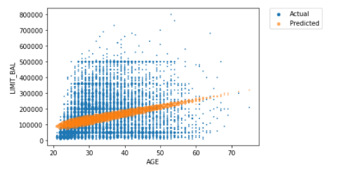 | A 2-dimensional example of the prediction produced using the Linear Support Vector Regression Method. The data is simply too spread out to predict.

Predicting Limit Balance by Classification
Next, we tried grouping our limit balance variable into 100k groups to predict the limit balance group using classification methods. Again, we employed cross validation among 3 different classification methods to pin down the best method. After that we tested, trained, and tuned the model, but we were only able to achieve a 43% accuracy.

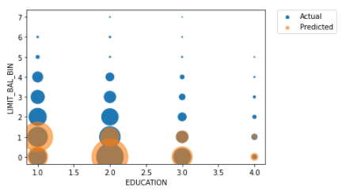 | A 2-dimensional example of the prediction of LIMIT_BAL_BIN produced using the Random Forest Classification method.  Note  LIMIT_BAL_BIN represents groupings of the limit balance (LIMIT_BAL) variable:  0 = 0 – 100k, 1 = 100k-200k, …, 7=700k-800k

Predicting Default Behavior by Classification
Finally, unable to find enough structure to the limit balance variable, we turned to predicting default behavior. One more time, we cross validated to choose a method and then trained, tested, and tuned our model. This time the model produced 82% accuracy in predicting whether a customer would default.
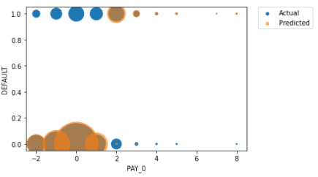 | A 2-dimensional example of the prediction for default behavior produced using the Decision Tree Classification method.

It should be noted that the PAY_0 variable by itself can produce a classification model with 82% accuracy. This indicates that a customer’s historic payment behavior is by and large the biggest predictor of future default behavior.

Conclusions and Recommendations
After rigorous testing, it seems clear that there is not enough structure to the dataset to try to predict the correct limit balance for a new customer. However, there is enough structure to predict with approximately 80% accuracy which customers will default. The most important predictor of default behavior is the customer’s historic payment behavior.

At the end of the day, approving customers with good payment history (PAY_0 between -2 and 2) is the best way to minimize default behavior. But even with that business rule, we would expect 20% of customers to default on their loan.

Feature Descriptions
LIMIT_BAL: Amount of the given credit (NT dollar): it includes both the individual consumer credit and his/her family (supplementary) credit.
SEX: (1 = male; 2 = female).
EDUCATION: (1 = graduate school; 2 = university; 3 = high school; 0, 4, 5, 6 = others).
MARRIAGE: (1 = married; 2 = single; 3 = divorce; 0=others).
AGE: (year).
PAY_0 – PAY_6: History of past payments. (-2: No consumption; -1: Paid in full; 0: The use of revolving credit; 1 = payment delay for one month; 2 = payment delay for two months; . . .; 8 = payment delay for eight months; 9 = payment delay for nine months and above.)
BILL_AMT1 – BILL_AMT6: Amount of bill statement (NT dollar).
PAY_AMT1- -PAY_AMT6: Amount of previous payments (NT dollar).
DEFAULT: Did the customer default on the loan (default, not default)

