Instructions for Creating the Labels for the Boxes of Sub-Assemblies

# Creating the Data for the Labels

To create the data for the labels open the file H:\MANUFACTURING\Labels\Sub-Assembly Labels\Labels.xlsm. You will be presented with this window.

## Product Details

### Please Select the Works Order Number

## Completion Date

Year Month Day

## Order Details

### How Many Parts are in the Box?

## Buttons

### Close

Clicking this button will close this window so that you can see the spreadsheet.

### Clear

Clicking this button will clear the data from the spreadsheet and reset this window.

### Print Labels

At the moment this button doesn’t do anything.

### Create Label Data

Clicking this button will create the data needed for the labels and add it to the spreadsheet. Check the data to make sure it’s what you expect. If it isn’t you may change your selections and press this button again to update the data.

Once you have checked the data and are happy with it please close this window and the spreadsheet. If you are asked whether or not you want to save it click Yes.

When the file opens you will be shown the following window:

Enter the product code

And click on the OK button.

The next window enables you to enter the works order number. Once you have entered it click on the OK button.

Keep entering the data requested, and clicking on the OK button when you are ready, for the following windows.

The week number should be on the paperwork for the job. If it isn’t, please ask your manager.

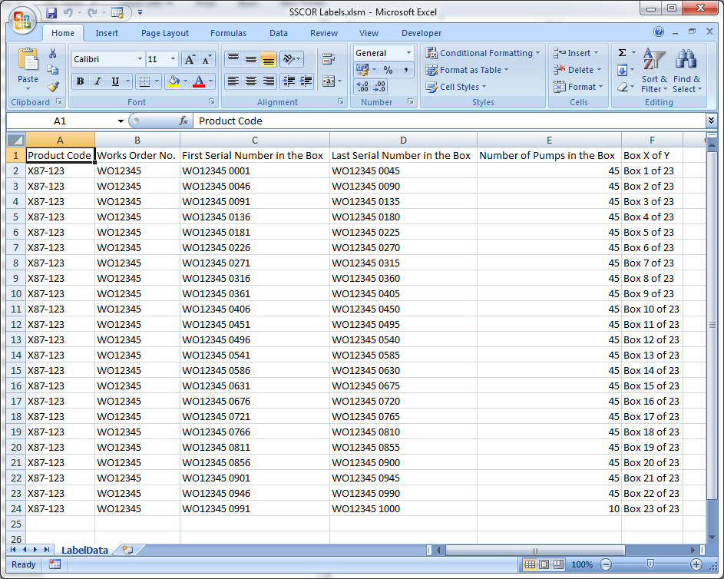

The data will be created in an Excel spreadsheet, as above.

# Creating the Labels

Open the file named SSCOR Labels.doc and click Yes on the window that opens.

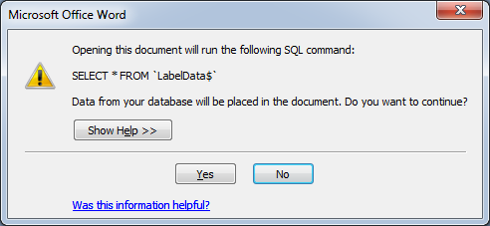

The document will open and you will see this:

Click on the Mailings tab and then on the button labelled Finish & Merge and then select Print Document.

A print dialog box will appear and you may select a printer and then print the labels.

If you have any problems please ask David Gibb for help.