Creating the Packing Labels
The files needed to generate the packing labels are contained in a compressed archive. Once opened you should have the following three files as below.

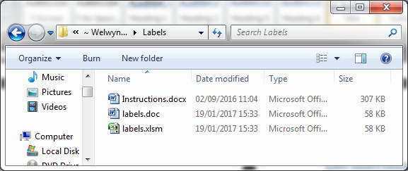

The Creating the Data for the Labels
Open the file named labels.xlsm. When the file opens you will be presented with the following window:
The number of the current week is selected for you, automatically. If you want to use a different week number change the seletion by clicking on the correct week.
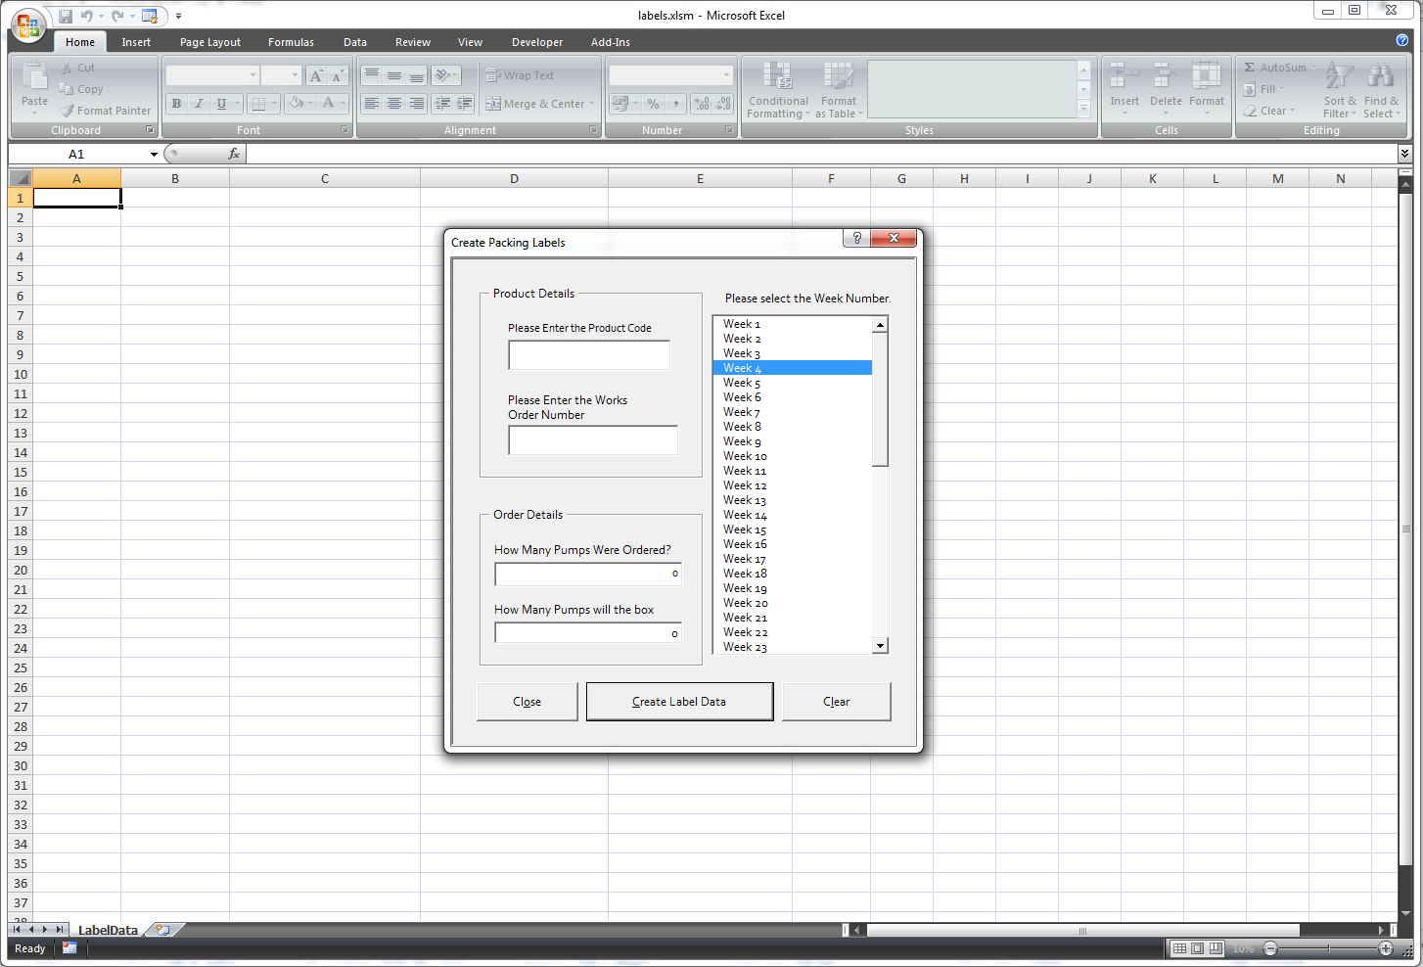
Enter the Product code in this box.
Enter the Works Order number in this box.
Enter the total number of pumps in the order.
Enter the number of pumps that that a packing box will hold.
Closes the dialog box so you can see the data.
Creates the data and adds it to the spreadsheet.
Clears all the data from the dialog box so that you may start again.

Product Details

Please select the Product Code.
Use the scroll bar to find the Product Code for the job you are packing and click on it once to select it. When selected it will be highlighted in Blue.

Please select the Works Order Number.
Use the scroll bar to find the Works Order for the job you are packing and click on it once to select it. When selected it will be highlighted in Blue.

Please select the Week Number.
Use the scroll bar to find the Week Number for the job you are packing and click on it once to select it. When selected it will be highlighted in Blue. The week number should be on the paperwork for the job. If it isn’t, please ask your manager.

Order Details

How Many Pumps Were Ordered?
Please enter the total number of pumps ordered (and that you are packing) in to this field.

How Many Pumps will the box hold?
Please enter the number of pumps the boxes, you are using, will hold when full in to this field.

Additional Information

Buttons

Close
Clicking this button will close this window so that you can see the spreadsheet.

Clear
Clicking this button will clear the data from the spreadsheet and reset this window.

Create Label Data
Clicking this button will create the data needed for the labels and add it to the spreadsheet. Check the data to make sure it’s what you expect. If it isn’t you may change your selections and press this button again to update the data.
Once you have checked the data and are happy with it please close this window and the spreadsheet. If you are asked whether or not you want to save it click Yes.

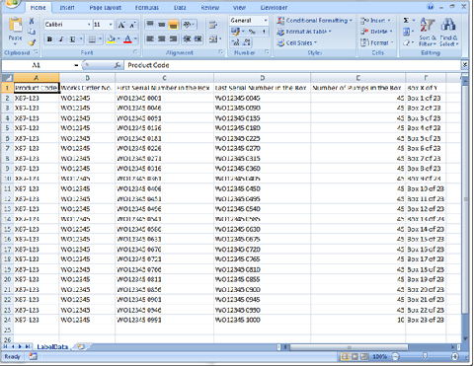
The data will be created in an Excel spreadsheet, as above.

Creating the Labels
In the same folder as the previous program (H:/MANUFACTURING/Labels/Packing Labels/) open the file named labels.doc.
You will be presented with this window; click on the Yes button.
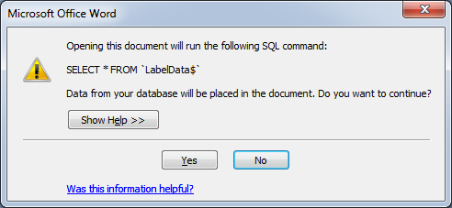
The document will open and you will see something similar to this, but with your data.
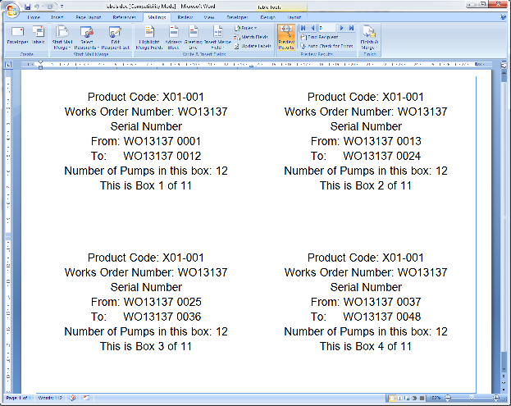Click on the Mailings tab and then on the button labelled Finish & Merge. You will be presented with three options.

Edit Individual Documents ...
The labels will be created in a new document and you will be able to check and edit them if need be.

Print Documents ...
The labels will be created and sent straight to the printer. A print dialog box will appear and you may select a printer and then print the labels.

Send E-mail Messages ...
Please do not use this option.
If you have any questions or problems please speak to your line manager.

