Instructions for creating the labels for the packing cases

Contents

Creating the Data for the Labels 2

Product Details 2

Please select the Product Code. 2

Please select the Works Order Number. 2

Please select the Week Number. 2

Order Details 3

How Many Pumps Were Ordered? 3

How Many Pumps will the box hold? 3

Additional Information 3

Product Code Suffix 3

Serial Number Suffix 3

Are These SSCOR Pumps? 3

Buttons 3

Close 3

Clear 3

Print Labels 3

Create Label Data 3

Creating the Labels 5

Edit Individual Documents ... 6

Print Documents ... 6

Send E-mail Messages ... 6

# Creating the Data for the Labels

Open the file named H:/MANUFACTURING/Labels/Packing Labels/labels.xlsm.

When the file opens you will be shown the following window:

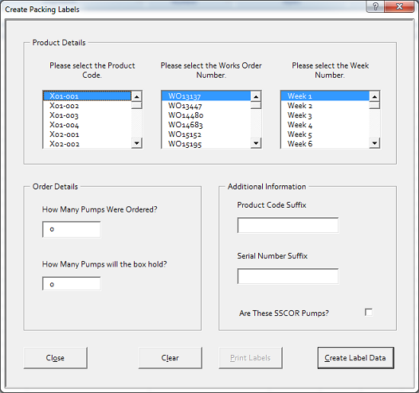

## Product Details

### Please select the Product Code.

Use the scroll bar to find the Product Code for the job you are packing and click on it once to select it. When selected it will be highlighted in Blue.

### Please select the Works Order Number.

Use the scroll bar to find the Works Order for the job you are packing and click on it once to select it. When selected it will be highlighted in Blue.

### Please select the Week Number.

Use the scroll bar to find the Week Number for the job you are packing and click on it once to select it. When selected it will be highlighted in Blue. The week number should be on the paperwork for the job. If it isn’t, please ask your manager.

## Order Details

### How Many Pumps Were Ordered?

Please enter the total number of pumps ordered (and that you are packing) in to this field.

### How Many Pumps will the box hold?

Please enter the number of pumps the boxes, you are using, will hold when full in to this field.

## Additional Information

### Product Code Suffix

If you want to add a suffix to the Product Code, enter it in to this field. It will be added **exactly** as entered, so, if you need spaces or punctuation you will need to enter them.

### Serial Number Suffix

If you want to add a suffix to the Serial Number, enter it in to this field. It will be added **exactly** as entered, so, if you need spaces or punctuation you will need to enter them.

### Are These SSCOR Pumps?

If you are packing SSCOR Pumps check this box, otherwise leave it blank.

## Buttons

### Close

Clicking this button will close this window so that you can see the spreadsheet.

### Clear

Clicking this button will clear the data from the spreadsheet and reset this window.

### Print Labels

At the moment this button doesn’t do anything.

### Create Label Data

Clicking this button will create the data needed for the labels and add it to the spreadsheet. Check the data to make sure it’s what you expect. If it isn’t you may change your selections and press this button again to update the data.

Once you have checked the data and are happy with it please close this window and the spreadsheet. If you are asked whether or not you want to save it click Yes.

### 

The data will be created in an Excel spreadsheet, as above.

# Creating the Labels

In the same folder as the previous program (H:/MANUFACTURING/Labels/Packing Labels/) open the file named labels.doc.

You will be presented with this window; click on the Yes button.

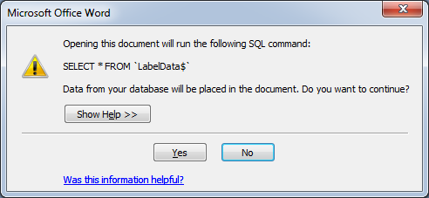

The document will open and you will see something similar to this, but with your data.

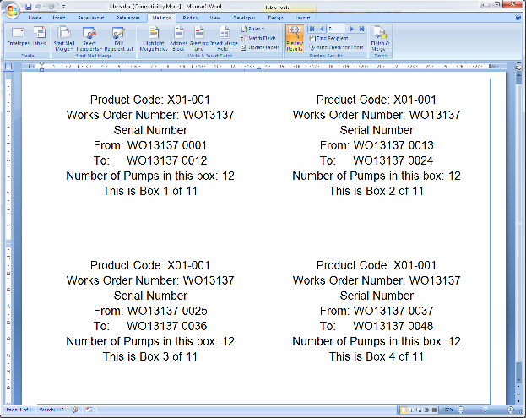

Click on the Mailings tab and then on the button labelled Finish & Merge. You will be presented with three options.

## Edit Individual Documents ...

The labels will be created in a new document and you will be able to check and edit them if need be.

## Print Documents ...

The labels will be created and sent straight to the printer. A print dialog box will appear and you may select a printer and then print the labels.

## Send E-mail Messages ...

**Please do not use this option.**

If you have any questions or problems please speak to your line manager.