Resume

Job position: web front-end developer

work experience

2014.07-2021.06 Company: vivo

Position: Front-end development engineer

2021.06-present Company: ByteDance

Position: Front-end development engineer

Project experience

2014-2015 Automatic Translation System

Extract the strings of all apps in the android system and match the translations in various languages. At the same time, it provides a web system for users to add, delete, check and modify strings, and import translation functions.

Responsible for part of the background development (using python scripts to parse android app strings and store them in the library, generate android app string xml files, and use nodejs to develop background services)

Use requirejs and angular1 to develop front-end pages

2015-2017 vivo mall pc, mobile version https://shop.vivo.com.cn/

Responsible for the development of some pages

Develop common components and abstract common styles

The mobile terminal uses the rem layout, adapts to various mobile phone screens, and can realize the size control of 1 physical pixel

● Use fis3 to build static resources, compress files, add hash values, etc.

2017-2018 vivo official website https://www.vivo.com.cn/

Responsible for technology selection, development of some pages, development of general components and abstract general styles

● Use lazy loading and other solutions to save traffic

Responsive pages are implemented using media queries, and the wap style uses rem layout to adapt to various mobile phone screens

● Use fis3 to build static resources, compress files, add hash values, etc.

2017-2019 vivo point system, vivo game forum, vivo game center, etc.

Hybrid SPA developed with vue

Using es6 syntax, compiling and building with webpack and babel

Implement the webp plugin of webpack and the webp command of vue by myself, intelligently identify whether the browser supports webp pictures and load them

2018-2019 vivo game activities

Using the visualization activities inside vivo to build a platform

Use vue to develop page components for visual assembly and configuration

Using es6 syntax, compiling and building with webpack and babel

2019 vivo Quick Game Center

Responsible for distributing quick games in the quick app market, I was responsible for the development and launch of the first two versions

2019-2020 vui component library https://github.com/grtan/vui

Vue component library serving department business

Compatible with PC and mobile

Support component loading on demand

Support custom skin

The style code is not redundant when there are nested references between components (this problem exists in element-ui)

Unified code specification, git collaboration specification, perfect documentation, CHANGELOG

Document demo supports online editing and preview

Two major versions have been iterated. The two versions contain a total of more than 40 components, instructions, and plug-ins, such as Button, Layer, Swiper, Picker, ImagePreviewer, Transition, etc. Currently, most components have not been migrated from v1 to v2

2019-2020 General Form Component https://github.com/grtan/form

By configuring the schema to generate a Vue visual form of arbitrary json data, it is currently widely used by the department management background.

● element-ui used by basic components

Compatible with JSON Schema

Support field linkage

Support field custom verification method

Support field custom UI

● Deployed an online editing preview site

To be implemented: schema visualization configuration

2020 unified operation background Vue

The portal website that integrates all the background projects of the department, unifies the background entrance, UI, interaction, authority control, etc., and provides a general visual configuration center, approval center and problem feedback center.

Unified background entry, UI, interaction and authority control

Visible general configuration center, configuration items no longer need to be developed to modify json directly, operations can be modified directly through the visual form, and can be approved

● Visualize the general approval center and provide common front-end components and server interfaces. Any project can be connected. The approval details page will display the visualized form before and after modification, and provide the effect of diff comparison

Integrate the online generation function of simple table pages in the background, no longer need local development and deployment

Announcement, problem feedback center

Compatible with jsp pages and single-page applications, and adopts a micro front-end solution, so that single-page sub-applications behave like a whole

2020 Vue background form page component https://github.com/grtan/form/blob/master/docs/component/list/index.md

Many pages in the background are crud table interfaces with a similar layout. The top is the condition query and new area; the middle is the content display table area, the left side of the content is the batch selection area, and the right side of the content is the edit, delete and other operation buttons; page area. Therefore, a background crud form page component is implemented by combining the general form component and the crud interface features.

● Support various types of tabular data through schema configuration

Each data in the form supports any legal json, and supports a visual form interface when adding and editing

It has been integrated into the unified operation background, providing functions of online configuration, preview, and generating simple background pages, eliminating the need for local development and deployment processes

Online generation can currently meet more than 60% of the background page needs of the department

● Various configuration items are provided. For example, when the content operation button is not a simple edit or delete button, you can customize the operation button, but at this time you need to use this component for local development and deployment, and it cannot be directly generated online

2020 Code Specification Unification Tool https://github.com/grtan/specification

A command-line tool developed, through the use of eslint, stylelint, husky, lint-staged, commitlint and other tools to realize the unified code specification of the project, standardize git commit information and other functions, has been widely used in the project.

Support js/ts, css/less/scss, vue/html files

Support specification selection on demand

With vscode, it supports error prompts and automatic formatting when saving

Support interception verification code specification and commit information specification when submitting with git

Built-in image compression function, which automatically compresses static images in the project when submitting codes, preventing students from uploading images without optimizing them

2021-byte Education Aladdin System React

This is an operational project that provides configuration capabilities through json schema developed by colleagues in other business lines. Configurable capabilities are abstracted into general capabilities, including editor and runtime. The editor runs in the management background and is used to render the schema to provide visual configuration capabilities; while the runtime runs in the business project and is used to render the configuration into a UI interface in real time. In the schema, you can specify which pages, which modules each page has, and which configuration items each module has, etc., and the modules point to the local modules of the project. When other systems need to use this general configuration capability, they need to develop their own management background and front-end projects, and access the editor and runtime.

2021-2022-byte education marketing campaign building system React + Node service + MongoDB

A visualized and configurable web activity building platform that fully leads the design and development, including being responsible for platform product and technical architecture design. Due to the adjustment of the organizational structure, the two colleagues I led quit after participating in a small part of the development. Later, I developed all the functions independently, including the front-end site, CLI and server.

The concept of the platform is that developers develop configurable business modules and upload them to the platform, and then developers or operators can configure web activities visually through the platform, and finally release static resources after compiling and building. The platform is mainly divided into three parts: front-end site, CLI and server:

Front-end site: build a platform site for all users, and can manage space, project templates, business modules, and activities

CLI: For developers, it can be used to initialize the development project of business modules or project templates, and provide commands issued to the platform, etc.

Server: a web service written by node+mongodb, which provides all the interfaces of the platform, and compiles thrift idl into a ts declaration file for joint debugging with the front end

At present, the following functions are mainly supported

Using the module federation of webpack5, business components can share modules with the host, such as react, mobx, etc.

Support workspace (i.e. line of business) management

Support customizing and managing activity C-end project templates, such as which pages in the project can be customized, and which built-in content is included in each page besides the visual construction part, etc.

Support custom and management business modules

Supports the selection of project templates + business modules to create visual configuration activities and manage them

Support layering to build any layout, which can be nested at will, and supports configuration at the application, page, and business component levels, and supports dynamic linkage

Layers and components support events and actions, and layers and components can interact with each other

Support local development and debugging functions

Support PC and mobile terminal style adaptation, the mobile terminal supports design drafts of any width, and can use px unit uniformly, no need for rem processing on the mobile terminal

Support overall undo and redo

2022-Byte Internationalized E-Commerce Merchants Direction Project React + PHP

In 22 years, the organizational structure was adjusted, and the education department was transferred to the international e-commerce department. The purpose of this project is to divert merchants from platforms such as shopify and woocommerce to tiktok shop. The part I am in charge of is woocommerce and other platforms. The woocommerce platform is a wordpress site, which needs to be developed with php. In the end, we developed a wordpress plug-in and realized the diversion function on our own web site.

The project involves many business lines, and it also needs to cooperate with colleagues in Beijing, Shanghai, and the United States. Communication across locations and time zones is the norm. As the front-end owner of the project, he actively communicates and collaborates with all parties during the project to ensure the smooth completion of the project.

2022-byte International e-commerce Forge platform React + Node service + MySQL

Forge is a mid- and back-end construction platform suitable for international business built on top of the company's mid- and back-end construction system SDK. As the initiator and owner of the project, he proposed and designed the front-end and back-end architecture of the entire system, and ensured the smooth completion of the entire platform. The platform has built-in processing of various cumbersome processes, which greatly improves the development efficiency of the middle and back office, and is currently being tested in the department.

professional skill

Proficient in html, css/css3, js, mobile terminal development, Hybrid development, etc., have a certain understanding of css

Familiar with engineering knowledge such as modularization, front-end compilation and construction tools, skilled use of es6, webpack, rollup, babel, fis3, gulp, nodejs, etc.

Proficient in using ts, jquery, vue, react, redux and mobx, etc., and have a certain understanding of its principles

Familiar with mysql, mongodb, understand the principle of concurrent processing, have the ability to develop node server and have practiced in the project

● Understand PWA, docker, etc.

Self-evaluation

● Serious and responsible work attitude, easy-going personality, strong team awareness

Strong learning ability, have the spirit of research, seek a deep understanding of knowledge, and like to learn new technologies

Keep an empty cup mentality at all times, expecting to communicate and learn with peers, and make progress together



Major: Internet of Things Engineering

Education: B.Eng.

Graduate school: Hunan University

Graduation time: 2014.06

Name: Xin Tan

Date of Birth: 1992.12

Contact number: 13611583069/

19962017913

Email: 710598788@qq.com

Language skills

Native language is Chinese, can read and write English, may sometimes need to use translation software. Able to communicate in English by text, but direct voice communication in English may not be very smooth, but I can try.

Work Experience

2014.07-2021.06 Company：vivo

Position：Web front-end development engineer

2021.06-present Company：Bytedance

Position：Web front-end development engineer

Project Experience

**2014-2015 Automatic Translation System**

Extract the strings of all apps in the android system and match the translations in various languages. At the same time, it provides a web system for users to add, delete, check and modify strings, and import translation.

* Responsible for part of the back end development (using python scripts to parse android app strings and store them in the database, generate android app string xml files after translated, and use nodejs to develop backend services)
* Use requirejs and angular1 to develop web pages

**2015-2017 [vivo mall of pc, mobile https://shop.vivo.com.cn/](https://shop.vivo.com.cn/)**

* Responsible for the development of some pages
* Develop common components and abstract common styles
* The mobile terminal uses the rem layout, adapts to various mobile phone screens, and can realize the size control of 1 physical pixel
* Use fis3 to build static resources, compress files, add hash values, etc.

**2017-2018 [vivo official website https://www.vivo.com.cn/](https://www.vivo.com.cn/)**

* Responsible for technology selection, development of some pages, development of general components and abstract general styles
* Use lazy loading and other solutions to save traffic
* Responsive pages are implemented using media queries, and the wap style uses rem layout to adapt to various mobile phone screens
* Use fis3 to build static resources, compress files, add hash values, etc.

**2017-2019 [vivo point system](https://pointh5.vivo.com.cn/)、[vivo game forum](https://gamebbsh5.vivo.com.cn/)、[vivo game center](https://game.vivo.com.cn/), etc**

* Hybrid SPA developed with vue
* Using es6 syntax, compiling and building with webpack and babel
* Implement the webp plugin of webpack and the webp command of vue by myself, intelligently identify whether the browser supports webp pictures and load them

**2018-2019 vivo game activities**

* Use the visualization activities building system inside vivo to build a activity
* Use vue to develop page components for visual assembly and configuration
* Use webpack and babel to compile and build es6 syntax

**2019 [vivo](https://game.vivo.com.cn/" \l "/index) quick game center**

The quick game market for distributing quick games, I was responsible for the development and launch of the first two versionssn学习新技术，时刻，对智商支持级联和非级联的形势

**2019-2020 [vui components lib https://github.com/grtan/vui](https://github.com/grtan/vui)**

* A vue component library serving for business department
* Compatible with PC and mobile
* Support component loading on demand
* Support custom skin
* The style code is not redundant when there are nested references between components (this problem exists in element-ui)
* Unified code specification, git collaboration specification, perfect documentation, CHANGELOG
* Document demo supports online editing and preview
* Two major versions have been iterated. The two versions contain a total of more than 40 components, directives, and plug-ins, such as Button, Layer, Swiper, Picker, ImagePreviewer, Transition, etc. Currently, most components have not been migrated from v1 to v2

**2019-2020[Common Form Component https://github.com/grtan/form](https://github.com/grtan/form)**

By configuring the schema to generate a Vue visual form of arbitrary json data, it is currently widely used by the admin website of department.

* element-ui used by basic components
* Compatible with JSON Schema
* Support field linkage
* Support field custom verification method
* Support field custom UI
* Deployed an online editing preview site
* To be implemented: schema visualization configuration

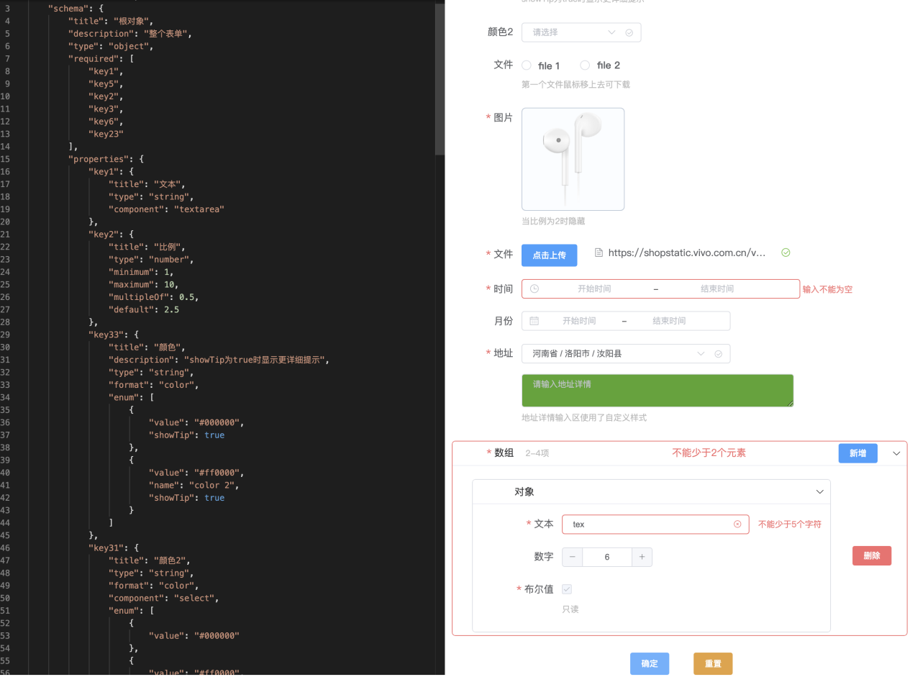

**2020 Admin Portal Vue**

The portal website that integrates all the admin projects of the department, unifies the entrance, UI, interaction, authority control, etc., and provides a general visual configuration center, approval center and problem feedback center.

* Unified entry, UI, interaction and authority control
* The general visualize configuration center, configuration items no longer need to be developer to modify json directly, operations can be modified directly through the visual form, and can be approved
* The general visualize approval center and provide common front-end components and server interfaces. Any project can be connected. The approval details page will display the visualized form before and after modification, and provide the effect of diff comparison
* Integrate the online generation function of simple table pages, no longer need local development and deployment
* Announcement, problem feedback center
* Compatible with jsp pages and single-page applications, and adopts the micro front-end solution, the single-page sub-application behaves like a whole

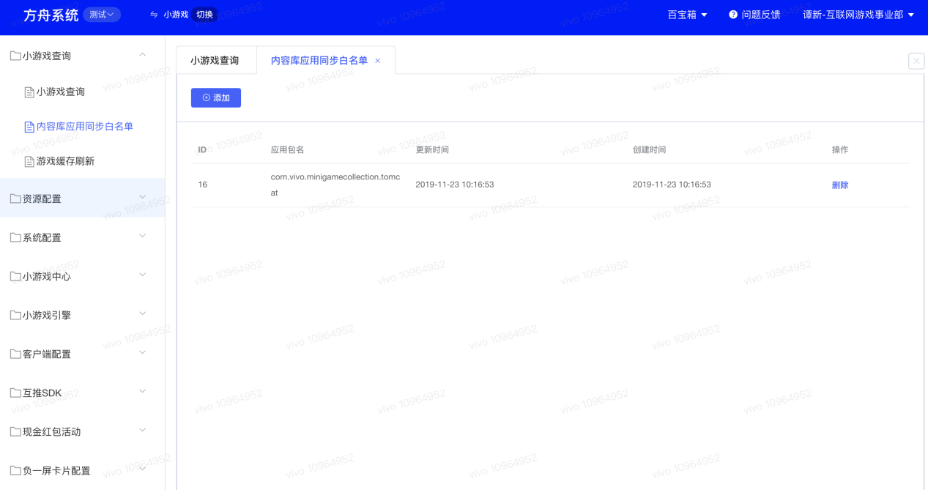

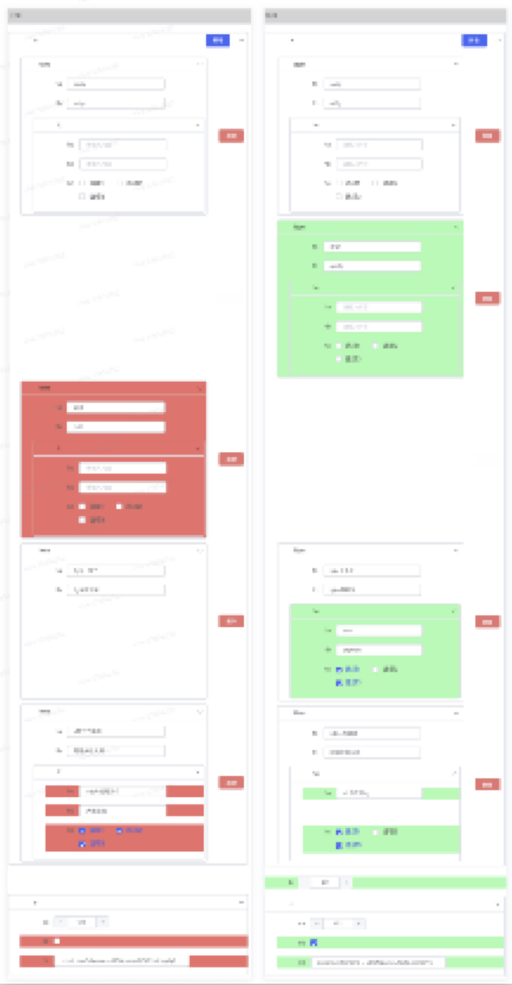

**2020 Vue [Table Page Component](https://github.com/grtan/form/blob/master/docs/component/list/index.md)**

**<https://github.com/grtan/form/blob/master/docs/component/list/index.md>**

Many pages in the admin are crud table ui with a similar layout. The top is the condition query and new operation area; the middle is the area to display table content, the left side of the content is the batch selection area, and the right side of the content is the edit, delete and other operation buttons; At the bottom is the pagination area. Therefore, a crud table page component is implemented by combining the general form component and the crud ui features.

* Support various types of table data through schema configuration
* Each data in the table supports any valid json, and supports a visual form interface when adding and editing
* It has been integrated into the admin portal, providing functions of online configuration, preview, and generating simple admin pages, can skip the processes of local development and deployment
* Online generation can currently meet more than 60% of the admin page needs of the department
* Various configuration items are provided. For example, when the content operation button is not a simple edit or delete button, you can customize the operation button, but at this time you need to use this component for local development and deployment, and it cannot be directly generated online

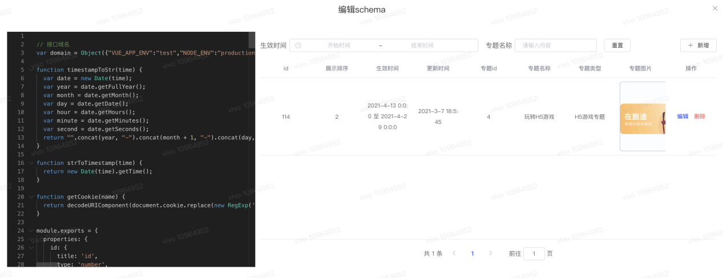

**2020 [Code standard unification tool https://github.com/grtan/specification](https://github.com/grtan/specification)**

开A command-line tool that through the use of eslint, stylelint, husky, lint-staged, commitlint and other tools to unify code specification of the project, standardize git commit information and other functions, has been widely used in the project.。

* Support js/ts, css/less/scss, vue/html files
* Support specification selection on demand
* With vscode, it supports error prompts and automatic formatting when saving
* Support to verify code specification and commit information specification when submitting with git
* Built-in image compression function, which automatically compresses static images in the project when submitting codes, preventing someone from uploading images without optimizing them

**2021-Bytedance Education Department Aladdin System React**

This is an operational project that provides configuration capabilities through json schema developed by colleagues in other business lines. Configurable capabilities are abstracted into general capabilities, including editor and runtime. The editor runs in the admin and is used to render the schema to provide visual configuration capabilities; while the runtime runs in the business project and is used to render the configuration into a UI interface in real time. In the schema, you can specify which pages, which modules each page has, and which configuration items each module has, etc., and the modules point to the local modules of the project. When other systems need to use this general configuration capability, they need to develop their own admin and front-end projects, and import the editor and runtime.

**2021-2022-Bytedance Education Department**

**Visual build system React + Node + MongoDB**

A visualized and configurable web activity building platform that fully leads the design and development, including being responsible for platform product and technical architecture design. Due to the adjustment of the organizational structure, the two colleagues I led quit after participating in a small part of the development. Later, I developed all the functions independently, including the front-end site, CLI and server.

The concept of the platform is that developers develop configurable business modules and upload them to the platform, and then developers or operators can configure web activities visually through the platform, and finally release static resources after compiling and building. The platform is mainly divided into three parts: front-end site, CLI and server：

Front-end site: admin for all users, and can manage space, project templates, business modules, and activities

CLI: For developers, it can be used to initialize the project of business component or project templates, and provide commands to publish to the platform, etc.

Server: a web service written by node+mongodb, which provides all the interfaces of the platform, and compiles thrift idl into a ts declaration file for joint debugging with the front end

At present, the following functions are supported

* Using the module federation of webpack5, business components can share modules with the host, such as react, mobx, etc.
* Support workspace (i.e. line of business) management
* Support customizing and managing activity project templates, such as which pages in the project can be customized, and which built-in content is included in each page besides the visual construction part, etc.
* Support custom and management business component
* Supports the selection of project templates + business component to create visual configuration activities and manage them
* Support layering to build any layout, which can be nested at will, and supports configuration at the application, page, and business component levels, and supports dynamic linkage
* Layers and components support events and actions, and layers and components can interact with each other
* Support local development and debugging
* Support PC and mobile terminal style adaptation, the mobile terminal supports design drafts of any width, and can use px unit uniformly, no need for rem processing on the mobile terminal
* Support overall undo and redo

1. **Bytedance Global e-commerce department**

**Merchant import project React + PHP**

In 2022, the organizational structure was adjusted, and the education department was transferred to the global e-commerce department. The purpose of this project is to import merchants from platforms such as shopify and woocommerce to tiktok shop. The part I am in charge of is woocommerce and other platforms. The woocommerce platform is a wordpress site, which needs to be developed with php. In the end, we developed a wordpress plug-in and realized the import function on our own web site.

The project involves many business lines, and it also needs to cooperate with colleagues in Beijing, Shanghai, and the United States. We often communicate across locations and time zones. As the front-end owner of the project, I actively communicates and collaborates with all parties during the project to ensure the smooth completion of the project.。

1. **Bytedance Global e-commerce department**

**Forge System React + Node + MySQL**

Forge is a visualized build platform suitable for international business built on top of the company's other visualized build system SDK. As the initiator and owner of the project, I proposed and designed the front-end and back-end architecture of the entire system, and ensured the smooth completion of the entire platform. The platform has built-in processing of various cumbersome processes, which greatly improves the development efficiency of the admin, and is currently being used in the department.

2022.11-present Byte Internationalized e-commerce M4B component library

Role: general development, responsible for the development and maintenance of six components

The M4B component library is a component library suitable for international e-commerce business packaged based on the Byte Arco Design component library. I am responsible for the development and maintenance of Upload, DatePicker, Image and other components

2023.02-present Byte Internationalized e-commerce code scanning routing impact detection tool

Role: technical owner, initiated and developed independently

By standardizing the react routing organization of the project, the detection tool analyzes which files and npm packages have been changed between the submitted branch code and the code of the master branch, and then analyzes the building module dependency graph through AST to finally determine which routes are affected by this modification page. Then provide the data to downstream e2e and code coverage testing, which can narrow the scope of QA testing and ensure the quality of testing.

Professional Skill

* Proficient in html, css/css3, js, mobile terminal development, Hybrid development, etc., have a certain understanding of css
* Familiar with engineering knowledge such as modularization, front-end compilation and build tools, skilled use of es6, webpack, rollup, babel, fis3, gulp, nodejs, etc.
* Proficient in using ts, jquery, vue, react, redux and mobx, etc., and have a certain understanding of its principles
* Familiar with mysql, mongodb, understand the principle of concurrent processing, have the ability to develop node server and have practiced in the project
* Understand PWA, docker, weggl, compilation principle, etc.

Self-evaluation

* Serious and responsible work attitude, easy-going personality, strong team awareness
* Strong learning ability, have the spirit of research, seek a deep understanding of knowledge, and like to learn new technologies
* Keep an empty cup mentality at all times, expecting to communicate and learn with peers, and make progress together