ElegAI Project Documentation

1. Document Information
Field | Value
Project | ElegAI — AI-Powered Bridal & Formal-Wear E-Commerce Platform
Date | October 12, 2026
Version | 1.0
Prepared by | ElegAI Development Team
Status | Active / Delivered (MVP)
Repository | github.com/grtxepp/ElegAI_Finale

2. Meetings Log
# | Date | Attendees | Agenda | Decisions / Action Items
1 | 2026-09-05 | Team, Adviser | Project kick-off, scope definition | Choose bridal & formal-wear niche; confirm MVP scope (no real payments)
2 | 2026-09-12 | Team | Requirements, target users, feature list | Finalize customer + admin feature sets; select tech stack
3 | 2026-09-19 | Team | System architecture & database design | Approve layered architecture (routes → controllers → repositories); schema draft
4 | 2026-09-26 | Team | AI feature design | AI Stylist with reasoned recommendations; body-positive rules
5 | 2026-10-03 | Team | Security review | Add Turnstile CAPTCHA, rate limiting, JWT hardening
6 | 2026-10-10 | Team | AI provider strategy | Adopt free-first provider ladder; add image generation fallbacks
7 | 2026-10-17 | Team | Deployment & documentation | Deploy via Back4app Containers; finalize docs

3. Problem
Bridal and formal-wear shopping has real friction on both sides of the market:
- Overwhelming choice — Customers face hundreds of gowns, suits, barongs, and
accessories and struggle to filter down to items that match their occasion, style,
color, fit, and budget.
- No guidance online — Traditional e-commerce returns a flat list of products with
no explanation of *why* an item suits the buyer. Physical boutiques provide a stylist;
online stores usually do not.
- Fit and body sensitivity — Sizing and fit are critical for formal wear, yet online
tools rarely account for measurements — and must do so without commenting on the
customer's body.
- Occasion-specific needs — Weddings, debuts, graduations, and corporate events each
demand different formality levels that generic filters do not capture.
- Boutique operations — Small boutiques lack affordable tooling to manage inventory,
orders, and customers online.
Goal: build an affordable, AI-assisted online formal-wear platform that guides
customers to the right products with clear reasons, while giving the boutique a full
management console.

4. Proposed Solutions
Problem | Proposed Solution
Overwhelming choice | AI Stylist chatbot that narrows the catalog through conversation
No guidance | AI recommendations with explicit reasons ("matches your Elegant style", "fits your A-Line preference")
Hard to visualize | Outfit image generation so customers can preview a look
Fit concerns | Measurement + preference profile feeding the recommendation engine (body-positive rules)
Occasion needs | Occasion-aware filtering (Wedding, Debut, Corporate, etc.)
Boutique operations | Admin console: products, inventory, orders, customers, dashboard
Reach | PWA + native React Native app for the same backend
Trust & abuse | JWT auth, bcrypt, CAPTCHA, rate limiting, Helmet, CORS

Core solution — the AI Stylist: the customer describes what they need (or uploads an
optional photo). The backend sends the preferences plus a live snapshot of the real
catalog to an LLM, which returns a strict JSON list of up to **6 real catalog products
with reasons**. Every recommendation is validated against the database, and the system
degrades gracefully to a deterministic rule-based engine if no AI provider is available.

5. Architecture & Diagram
ElegAI is a layered monolith — one small deployable application, not a fleet of
microservices. Responsibilities are separated so UI, API logic, and persistence can
change independently.
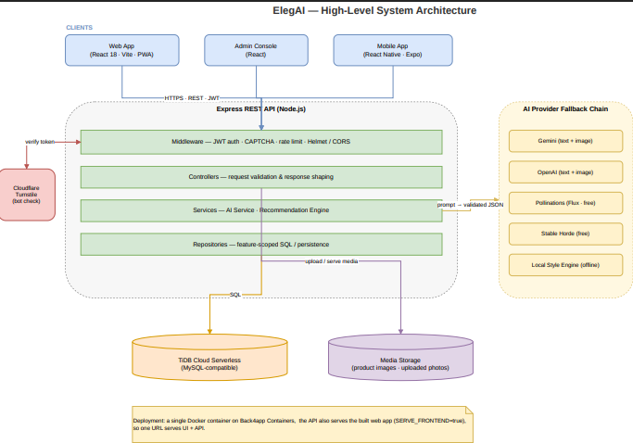
Request flow (example — AI recommendation):
sequenceDiagram
participant U as Customer (Web/Mobile)
participant A as Express API
participant S as AI Service
participant P as AI Provider
participant D as Database

U->>A: POST /api/stylist/recommend (prefs + optional photo)
A->>D: Load real product catalog snapshot
A->>S: buildRecommendationPrompt(prefs, catalog)
S->>P: Request strict JSON (≤6 items)
P-->>S: Candidate recommendations
S->>D: Validate product_ids exist
S-->>A: Verified recommendations (+ reasons)
A-->>U: JSON results (fallback engine on error)
Layer rules
- Frontend never touches the database and holds no secrets.
- routes/ declare endpoints · controllers/ handle HTTP · repositories/ own SQL ·
services/ hold cross-cutting logic (AI, recommendations).
- API keys (Gemini/OpenAI/Pollinations/Horde), JWT_SECRET, and the Turnstile secret
live only in backend environment variables.

6. Tech Stack
Layer | Technology
Frontend | React 18, Vite, Tailwind CSS, React Router, Axios, Lucide icons
Backend | Node.js (≥18), Express 4, REST API
Database | TiDB Cloud Serverless (MySQL-compatible); MySQL/MariaDB locally (mysql2)
Auth | JWT (jsonwebtoken), bcrypt (bcryptjs)
Security | Helmet, CORS, express-rate-limit, Cloudflare Turnstile CAPTCHA
AI — text | Google Gemini API (primary), OpenAI API (fallback)
AI — images | Gemini image → OpenAI gpt-image → Pollinations (Flux) → Stable Horde
Uploads | Multer (MIME + size validated)
Mobile | React Native + Expo (mobile/); installable PWA
Container | Single Dockerfile (Vite build + Express runtime, SERVE_FRONTEND=true)
Hosting | Back4app Containers (free tier)
Tooling | Git/GitHub, npm

7. Advantages and Disadvantages

Advantages
- Guided discovery — recommendations come with reasons, not just a product grid.
- Real, validated results — every suggested item exists in the actual catalog.
- Never breaks — provider fallback chain + offline rule-based engine keep it working
with zero API keys.
- Free-first AI — free image providers (Pollinations, Stable Horde) reduce cost.
- Body-positive by design — hard rule: never comment on the customer's body.
- Full-stack completeness — storefront, admin console, PWA, and native app.
- Clean architecture — layered, testable, easy to extend.
- Security conscious — hashed passwords, CAPTCHA, rate limits, no secrets in frontend.
- Single-container deploy — one URL, low RAM, cheap/free hosting.

Disadvantages
- AI cost/quota limits — real Gemini/OpenAI image generation is paid; free tiers are
rate-limited or blocked (limit: 0).
- Free image latency — Stable Horde can take ~1–2 minutes per image.
- No real payments — checkout is simulated (COD / GCash / Card demo).
- No virtual try-on — recommendations and generated looks, but no AR fitting.
- In-memory rate limiter — fine for one instance; needs Redis at scale.
- Password reset — dev mode returns the link (no mail server wired up).
- Single-instance DB limits — TiDB Serverless tier has connection/throughput caps.
- Content moderation — generated images may need filtering for production use.

8. Competitors and Uniqueness
Competitive landscape
Category | Examples | Gap ElegAI fills
Global fashion e-commerce | ASOS, Zalando, Zara | Generic filters; no formal-wear stylist, weak occasion logic
AI stylists | Stitch Fix, Zalando Assistant | Subscription/foreign-focused; not PH formal wear
Rental/try-on | Rent the Runway | Rental model; not a boutique storefront + admin suite
Marketplace (PH) | Shopee, Lazada | Vast, unfocused; no curated bridal/formal guidance
Local boutiques | Facebook/IG shops | No catalog system, AI, or order management

What makes ElegAI unique
- Niche focus — Philippine bridal & formal wear (gowns, suits, barongs, accessories).
- AI stylist + chatbot + generated outfit preview in one experience.
- Reasoned, catalog-validated recommendations — not generic "you may like".
- Occasion + measurement + style matching tailored to formal wear.
- Zero-cost resilience — works fully with no AI keys (deterministic engine).
- Boutique-in-a-box — storefront, admin console, PWA, and mobile app from one backend.

9. Strategy and Use of AI
AI strategy: "free-first, always-available, always-honest."
- Provider ladder for text — Gemini → OpenAI → local rule-based engine. The system
auto-detects which key is present and falls back on any failure, so the app never
returns an error to the customer.
- Provider ladder for images — Gemini image → OpenAI gpt-image → Pollinations
(Flux, free) → Stable Horde (free, no signup) → clean 503 only if all fail.
- Structured, verifiable output — the LLM is instructed to return strict JSON;
results are validated against real product_ids before being shown.
- Grounding — recommendations are constrained to a live snapshot of the actual
catalog, preventing hallucinated products.
- Ethical guardrails — hard rules forbid body comments; suggestions focus on the
garment and occasion.
- Cost control — expensive models are tried only when configured; free providers
keep the image feature working at no cost for demos and students.
- Graceful degradation — no key, quota exhausted, or provider outage all resolve to
a working experience (rule-based recommendations / free image renderers).
Where AI is used
- AI Stylist chat (/api/chatbot/*) — conversational shopping assistant.
- Recommendations (/api/stylist/recommend) — preference + optional photo → ranked,
reasoned products.
- Image generation — prompts built from the chosen outfit, rendered by the ladder.
- Preference parsing — free-text requests converted into structured preferences.

10. Deployment (summary)
- Container: single root Dockerfile builds the React site and runs the Express API
(SERVE_FRONTEND=true) on port 5000.
- Host: Back4app Containers (free, no credit card); auto-deploys on git push.
- Secrets: provided as environment variables in the host dashboard (never committed —
.env is git-ignored, .dockerignore excludes it from the image).
- Health check: GET /api/health → JSON ok.
- Recommended order: deploy with CAPTCHA_ENABLED=false, verify, then add the app
domain to the Cloudflare Turnstile allow-list and enable CAPTCHA.

