22AIE113

ECS-2

ASSIGNMENT-1

Guruprasath M R

CH.EN.U4AIE22015

1. Write and execute a hack assembly program for the following C statement

k=(a+b)-(c+d)

CODE:

// this code is to  evaluate k = (a+b)-(c+d)

//input

//@0 == a

//@1 == b

//@2 == c

//@3 == d

//step1

//@4 == sum1 = a+b

//@5 == sum2 = c+d

//step1

//@6 == k = sum1 - sum2

@0

D = M

@1

D = D + M

@4

M = D

@2

D = M

@3

D = D + M

@5

M = D

@4

D = M

@5

D = D - M

@6

M = D

Screen Shot

INPUT

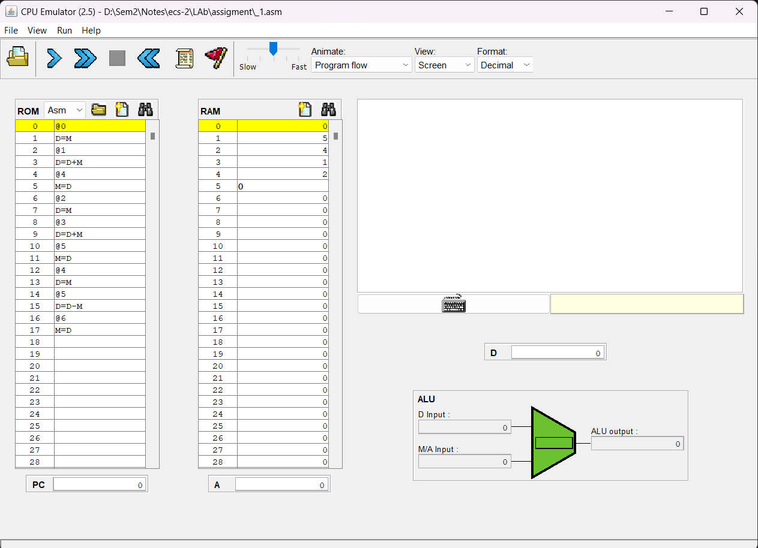

OUTPUT

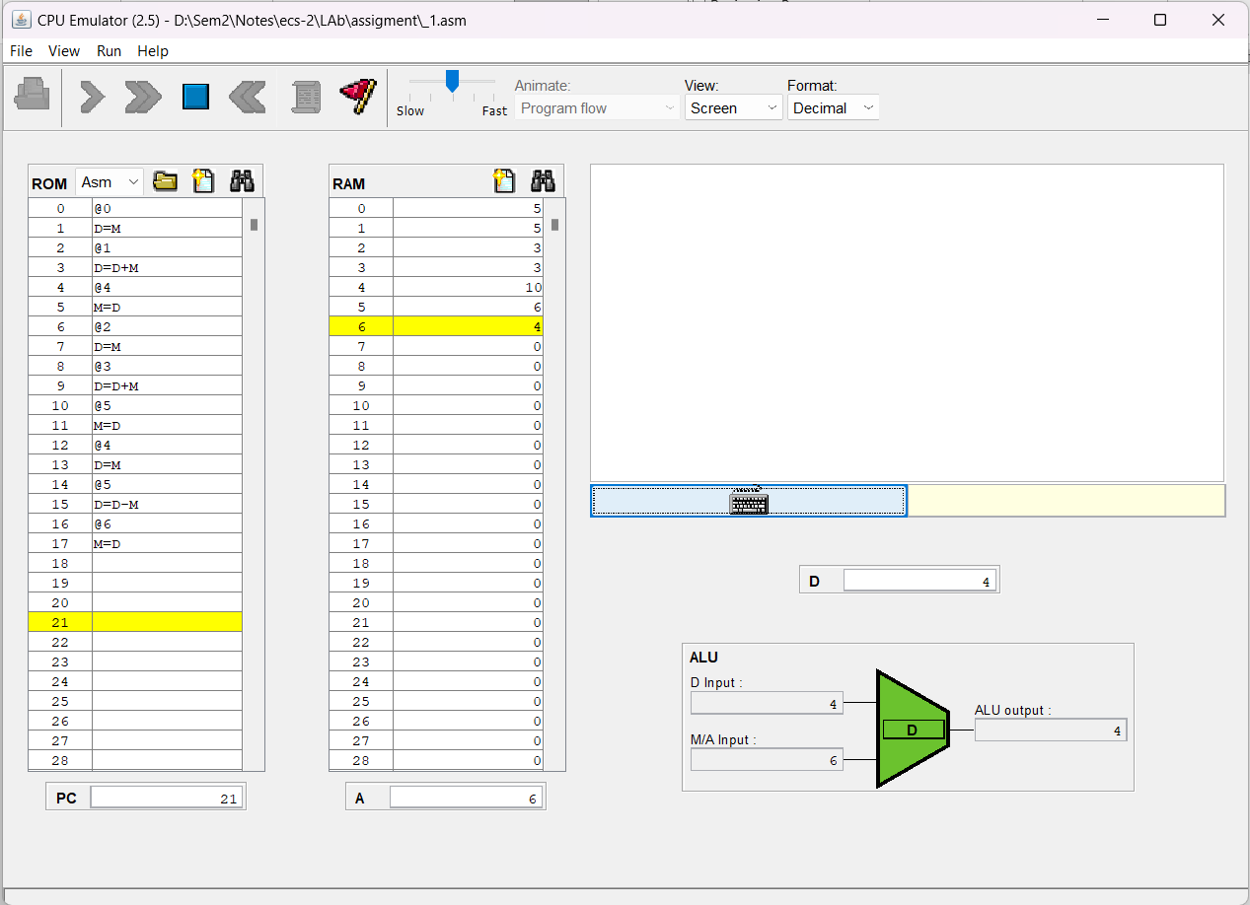

2.Write and execute a hack assembly program to swap two values.

Code:

// this code will swap 2 variable

//input

//@1 == var1

//@2 == var2

//extra

//@3 == tmp

//steps

// tmp = va1

// var1 = var2

// var2 = tmp

// tmp = 0

//1

@1

D = M

@3

M = D

//2

@2

D = M

@1

M = D

//3

@3

D = M

@2

M = D

//4

@3

M = 0

@END

0;JMP

(END)

    @END

    0;JMP

Screen Shot

INPUT

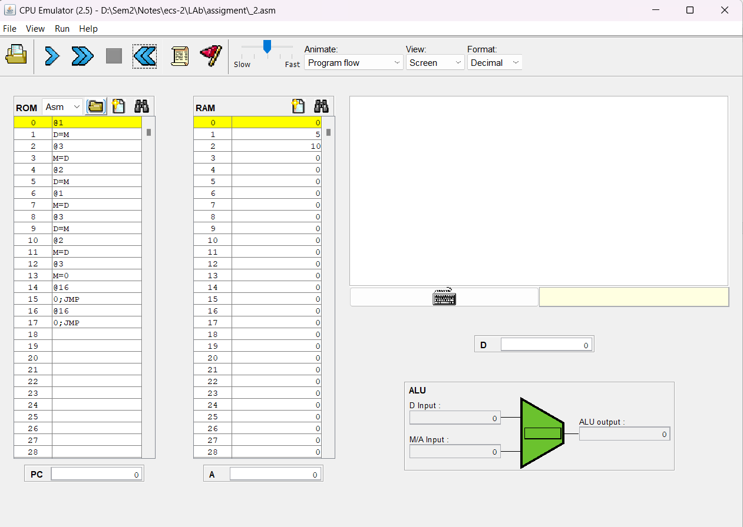

OUTPUT

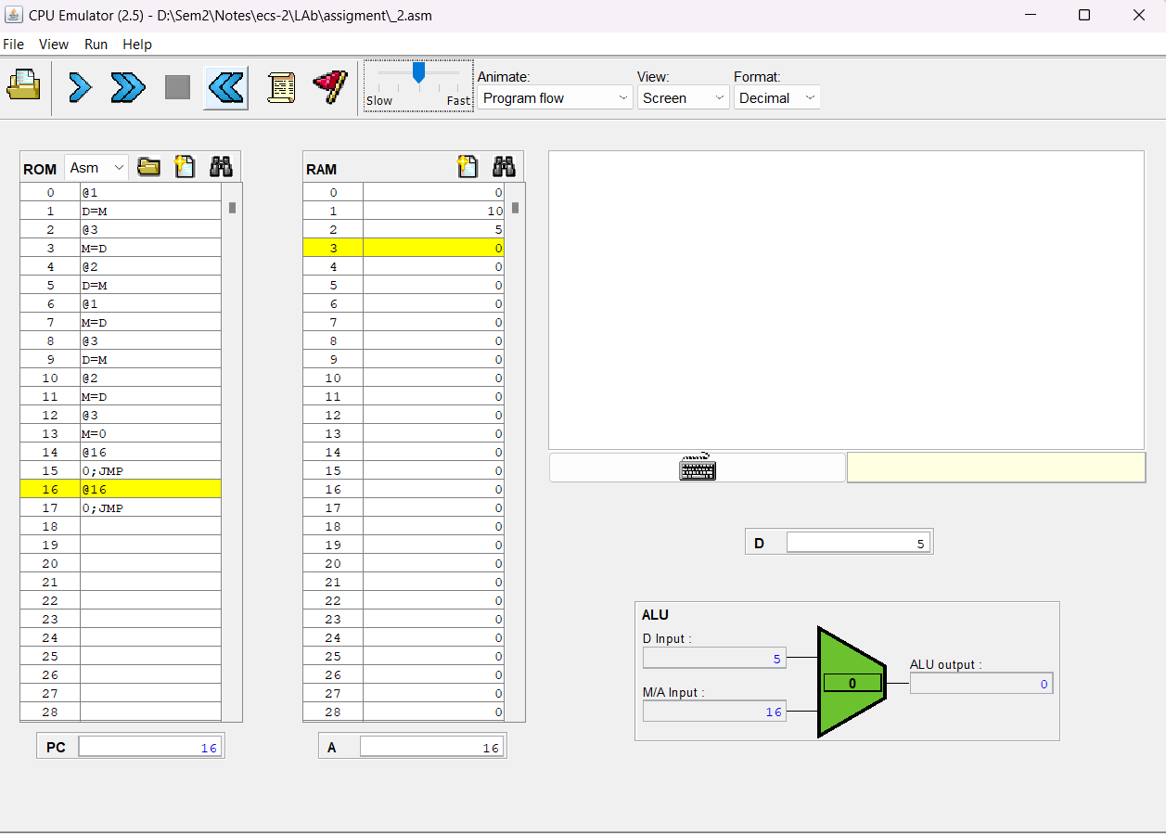

3. Write a hack assembly program to perform the sum of “n” numbers.

code

// this code will sum of n

//input

// @1 = n

//output

// @2 = sum

//steps

// do

// sum = sum + n

// n = n - 1

// while(n>0)

(LOOP)

    // sum = sum + n

    @1

    D = M

    @2

    M = M + D

    // n = n - 1

    @1

    M = M - 1

    @1

    D = M

    @LOOP

    D;JGT

    @END

    0;JMP

(END)

    @END

    0;JMP

Screen Shot

    INPUT

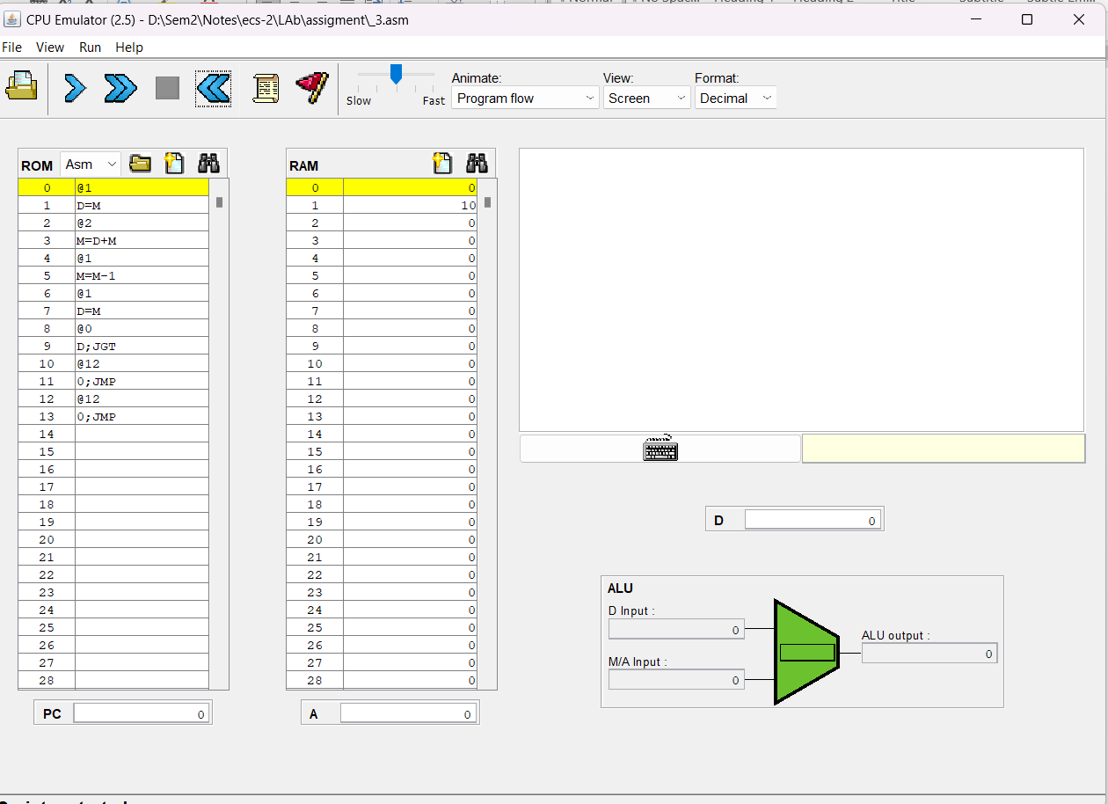

OUTPUT

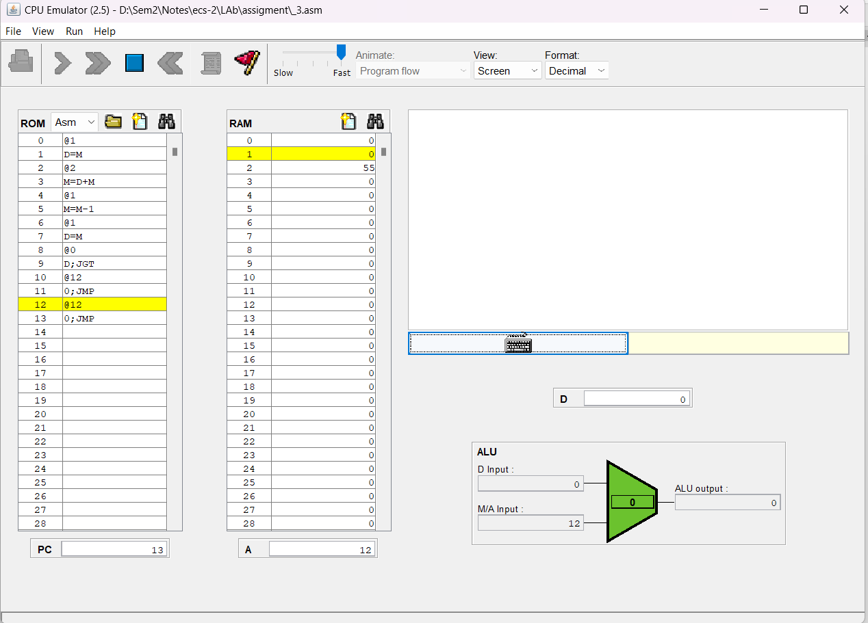

1. Write a hack assembly program for the following C statement.

if (a>=b)

return  a;

else

return b;

Code

// implement if-else

// check cmp a and b and return largest

//input

// @1 == a

// @2 == b

//output

// @5 == result

//code

// if(a>b):

//  return a

// else:

//  return b

// @5 = i

// i = a-b

// i;JGT

// inside if

// @5 == @1

// else:

// @5 == @2

@1

D = M

@2

D = D - M

@3

M = D

@3

D = M

@IF

D;JGT

@ELSE

0;JMP

// if i>=0

(IF)

    @1

    D = M

    @5

    M = D

    @END

    0;JMP

// else

(ELSE)

    @2

    D = M

    @5

    M = D

    @END

    0;JMP

(END)

    @3

    M = 0

    @END

    0;JMP

Screen Shot

    INPUT

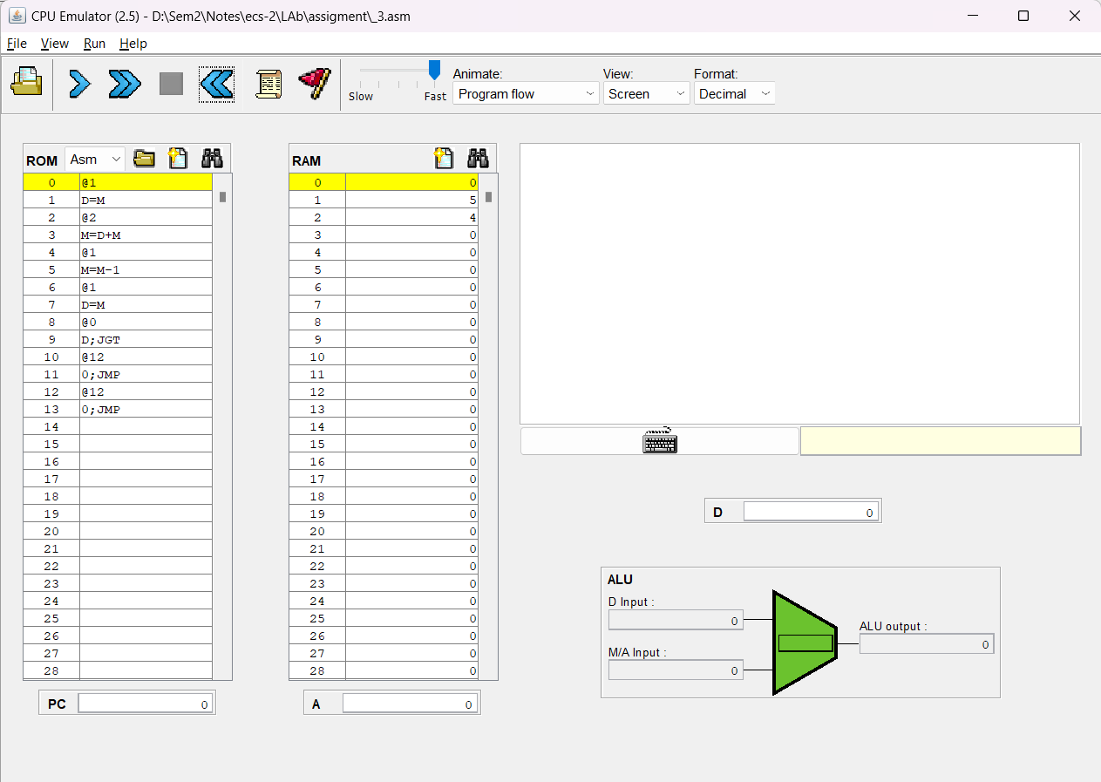

OUTPUT

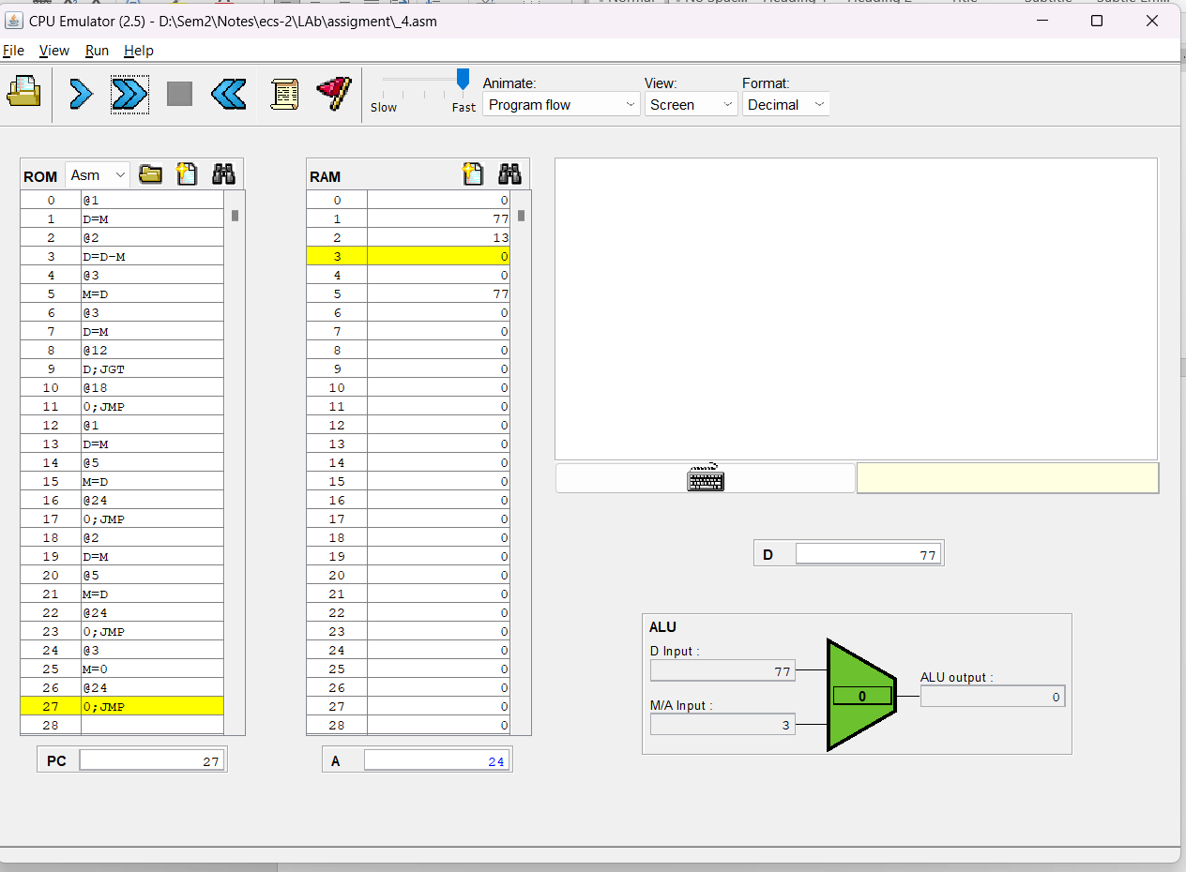

5. Write and execute a hack assembly program to perform multiplication of two operands.

CODE

// this one to multiplication of a\*b

// input

// @1 == a

// @2 == b

// output

// @3 == sum = a\*b

// do

// @3 = @3 + a

// @2 = @2 - 1

// @2

// D = M

// @LOOP

// D;JEQ

// @END

// 0;JMP

(LOOP)

    @1

    D = M

    @3

    M = M + D

    @2

    M = M - 1

    @2

    D = M

    @END

    D;JEQ

    @LOOP

    0;JMP

(END)

    @END

    0;JMP

Screen Shot

    INPUT

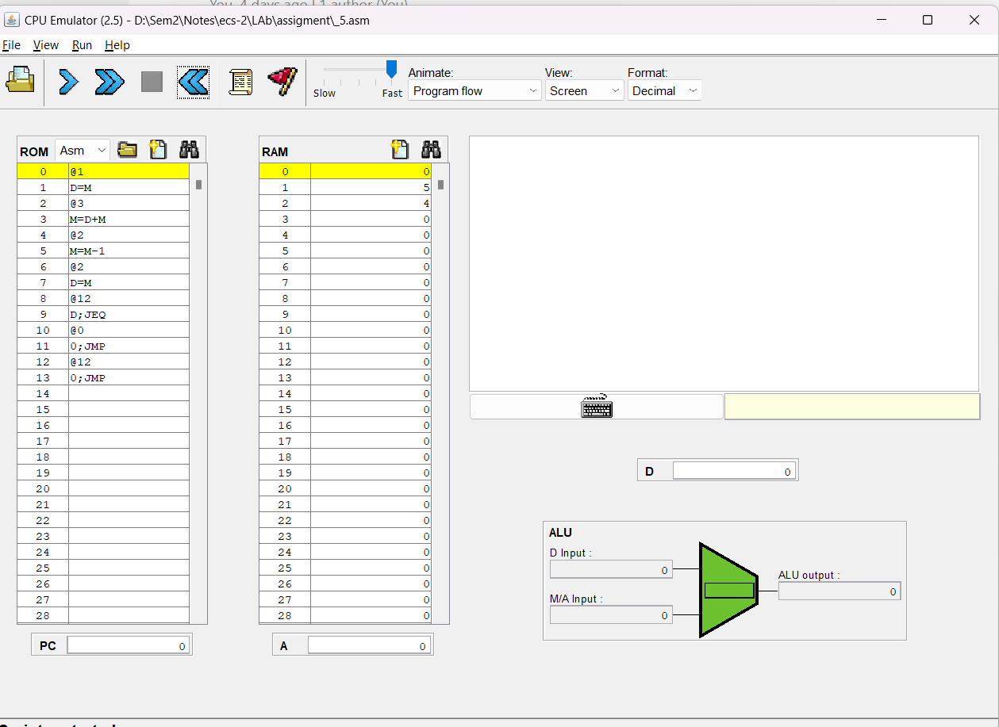

OUTPUT

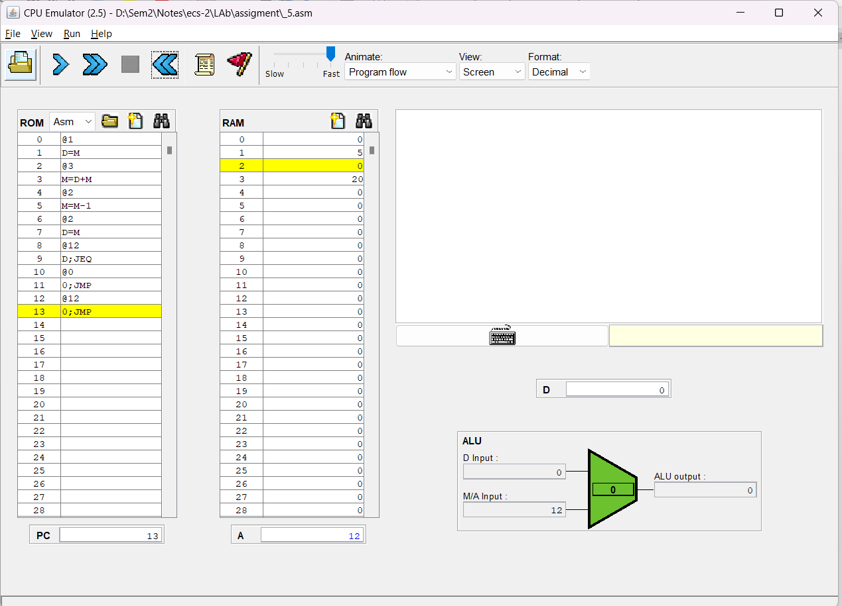

6.Write and execute a hack assembly program to perform division of two operands

CODE

// this one to divison of a/b

// input

// @1 ==> a

// @2 ==> b

// output

// @3 == c = a/b

//

//steps

//while(a-b>0)

//c++;

//a = a - b

(LOOP)

    @3

    M = M + 1

    @2

    D = M

    @1

    M = M - D

    @1

    D = M

    @LOOP

    D;JGT

    @END

    0;JMP

(END)

    @END

    0;JMP

Screen Shot

    INPUT

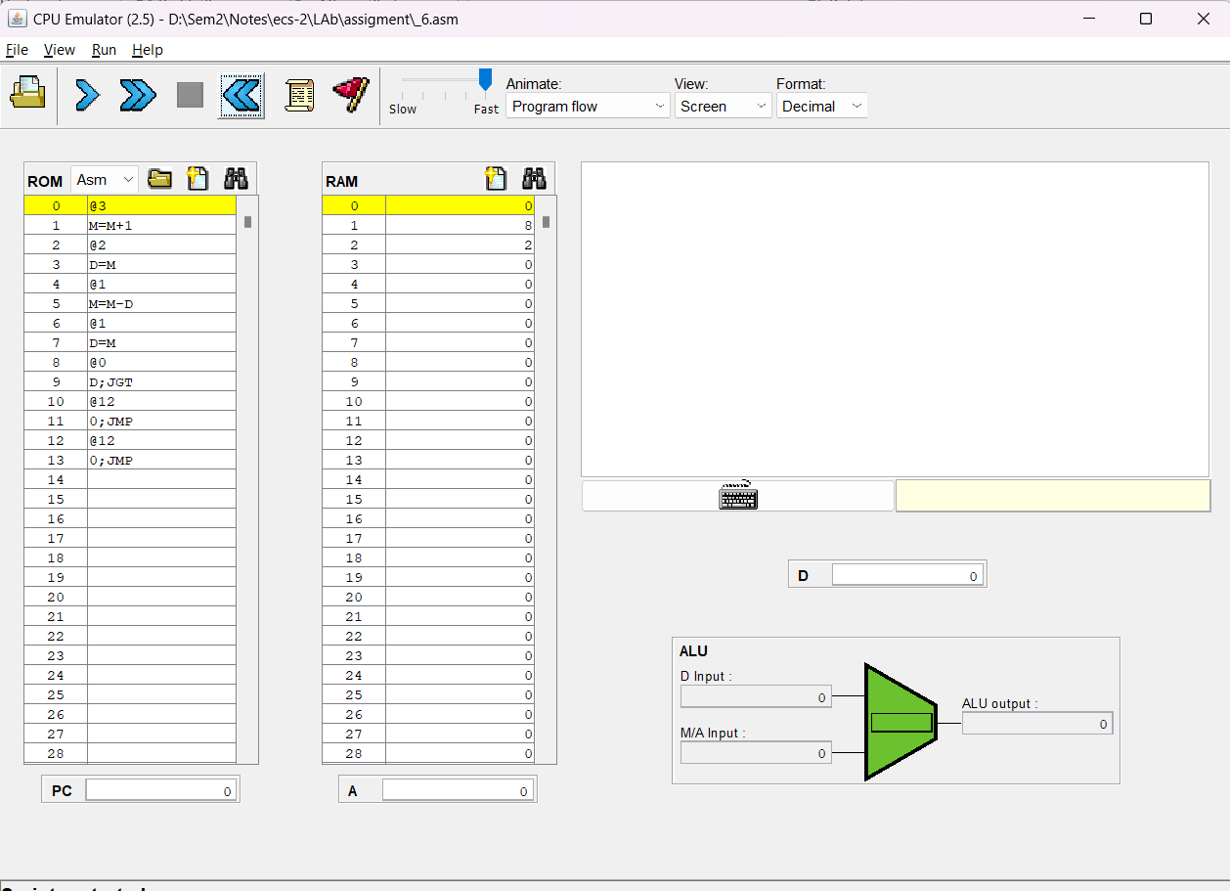

OUTPUT

