1. **Goal**

#### COMP 2401 A/C – Assignment #1

###### Due: Thursday, October 5 at 11:59 pm

For this assignment, you will write a program in C, in the Linux environment of the course virtual machine (VM), that simulates the escape of two heroes, Timmy Tortoise and Prince Harold the Hare, through a small valley known as Dragon’s Hollow.

Timmy and Harold were attempting to rescue a baby Dragon from the clutches of the evil wizard who kidnapped it. Unfortunately for our heroes, they were caught before they could complete their mission. Now, Timmy and Harold are fleeing to safety through Dragon’s Hollow, but the wizard has dispatched his minions after our heroes. Because the wizard’s flying monkeys are currently on vacation, the only minions available for this simulation are the attack birds.

Your program will simulate the attempted escape by our heroes through Dragon’s Hollow, as the wizard’s attack birds try to stop them. Your code will use well-designed modular functions and array techniques to implement this simulation, using console-based output.

###### Learning Outcomes

With this assignment, you will:

* + get familiar with the Linux programming environment and the course VM
  + write a small program in C that is correctly designed into modular functions, and correctly documented
  + practice with basic user output and the manipulation of primitive arrays in C
  + write functions that communicate with each other by passing parameters and using return values

###### Instructions

Your program will simulate Timmy and Harold’s escape through Dragon’s Hollow. Because the movements of each hero and bird is randomly generated, every execution of the simulation will have a different outcome. Your code must show the simulation as it progresses, including the changing positions of each hero and bird. It must print out the outcome of the simulation at the end, specifically whether the heroes escaped the Hollow or died in the attempt.

Your program must follow the programming conventions that we saw in the course lectures, including but not restricted to the correct separation of code into modular functions, basic error checking, and the documenta- tion of each function. A more comprehensive list of constraints can be found in the *Constraints* section of this document.

* 1. Understand the overall rules of the escape
     1. The escape simulates the behaviour of multiple participants: Timmy and Harold, who are trying to make it out of Dragon’s Hollow, and the wizard’s attack birds who are trying to stop our heroes.
     2. Dragon’s Hollow is organized as a two-dimensional (2D) grid of rows and columns, with the origin point (0,0) located in the top-left corner.
     3. Timmy and Harold move exclusively along the ground of the Hollow (the bottom row). Because of this, a hero’s *position* is the same as the *column* where they are located. Since a hero’s row is always fixed, the terms *position* and *column* are used interchangeably for hero participants.
     4. Each hero begins their escape at the left-most column on the ground, and each one successfully escapes the Hollow if they reach the right-most column without dying.
     5. The other rows represent the air above our heroes, where birds are flying.
     6. Every participant in the escape is represented by an avatar, which is defined as a single character. Timmy’s avatar is ‘T’, Harold’s is ‘H’, and every bird is represented as ‘v’ (lowercase v). When a hero dies, their avatar is changed to a cross ‘+’ that represents their grave.
     7. Your main() function must declare a single instance of Dragon’s Hollow as a 2D array of charac- ters, declared in local scope. This array is continuously updated with participants’ avatars and their changing positions in the Hollow, throughout the execution of the program. All helper functions must update that same instance of the Hollow.
     8. The chase is implemented as a continuous game loop that executes until each hero has either es- caped the Hollow by reaching its right-hand side, or died in the attempt.
     9. The simulation begins with no birds in the Hollow. At every iteration of the game loop, there is a 90% probability that a new bird is spawned and joins the others in attempting to stop our heroes. A newly spawned bird is initially positioned at row zero and a randomly generated valid column in the grid.
     10. At every iteration of the game loop, every participant (hero and spawned bird) is moved from their existing position to a new, randomly computed one, as described below. All row and column positions must be valid within the Hollow. If a new row or column is computed below zero, then it is repositioned at zero. If a new row or column is computed beyond the maximum, then it is reset to that maximum.
     11. At every iteration of the game loop, for each of our two heroes:
         1. if the hero has already escaped or is dead, then nothing happens; an escaped hero disappears from the grid, and a dead one is replaced with a cross avatar in the location of their death
         2. if the hero is still alive and in the Hollow, then a new position is computed for that hero, based on a randomly selected move, as described in instruction 3.2
         3. the hero is then moved in the Hollow from their old position to the newly computed one
     12. At every iteration of the game loop, for every bird that has been spawned:
         1. if the bird has already reached the ground in a previous iteration, then it has disappeared from the simulation; it is no longer participating, and nothing happens
         2. if the bird is still participating, then a new position is computed for that bird, as described in instruction 3.3, and the bird is moved to its newly computed position in the Hollow
         3. if the bird’s new position results in a *collision* with a live hero, because the bird has moved into the exact same position, then that hero dies instantly
         4. if a hero dies, their avatar is changed to a cross ‘+’ that represents their grave, and the Hollow is updated accordingly
     13. At the end of every iteration of the game loop, Dragon’s Hollow and the avatars that it contains is printed to the screen.
     14. Once the game loop has concluded, Dragon’s Hollow must be printed to the screen one final time, and the outcome of the escape must be printed out. The program must state either that both heroes have escaped, or that both heroes are dead, or it must indicate which hero escaped the Hollow and which one died.
  2. Understand the hero moves

Each hero has a set of possible moves that represents how they progress in Dragon’s Hollow. Each type of move is associated with the probability that the move is selected for that hero, and the number of columns (to the left or right) that the move represents. At every iteration of the game loop, a new move is randomly chosen for each hero, with a specific probability, as shown in Table 1.

Table 1: Hero moves

|  |  |  |  |
| --- | --- | --- | --- |
| Participant | Type of move | Probability | What happens |
| Timmy | Fast walk Slide  Slow walk | 50%  20%  30% | move 3 columns right move 2 columns left  move 1 column right |
| Harold | Sleep  Big hop | 20%  10% | no move  move 6 columns right |
|  | Big slide | 10% | move 4 columns left |
|  | Small hop | 40% | move 4 columns right |
|  | Small slide | 20% | move 2 columns left |

* 1. Understand the bird moves

At every iteration of the game loop, a position is randomly computed for each spawned bird, as follows:

* + 1. the bird moves in a downward direction from its current row in the Hollow by a randomly determined one or two rows
    2. the bird moves from its current column by a randomly determined one column to the left, or one column to the right, or stays in the same column
  1. Declare the required data
     1. The base code provided in the a1-posted.c file, which is available in *Brightspace*, contains the constant definitions and function prototypes that are recommended for your program to use. It also provides the [pseudo-random number generator (PRNG)](https://en.wikipedia.org/wiki/Pseudorandom_number_generator) function that your code must use to randomize hero and bird movements. The provided constants include the following:
        1. the MAX_ROW and MAX_COL preprocessor constants indicate the number of row and columns, re- spectively, that represent the dimensions of Dragon’s Hollow
        2. the MAX_BIRDS constant represents the maximum number of birds that can be spawned by the program at runtime
        3. the BIRD_FREQ constant specifies the odds of a new bird being spawned during each iteration of the main loop
     2. The main() function must declare the following data as *local variables* and initialize them:
        1. a 2D array of characters that represents Dragon’s Hollow; this array must be initialized at the beginning of the program, and updated with each participant avatar at their current position throughout the program execution; remember, variables in the C programming language always contain garbage before they are initialized by the programmer
        2. two [parallel arrays](https://en.wikipedia.org/wiki/Parallel_array) that work together to store the position of each bird that has been spawned
           1. one array represents the rows where the birds are located (rows), and the other array repre- sents the columns (cols)
           2. the location of each bird can be found at the same index in both arrays
           3. for example, the location of the third bird is stored at row rows[2] and column cols[2]
     3. To ensure that every execution of the program produces a different outcome, the PRNG must gener- ate a *unique* sequence of pseudo-random numbers every time the program runs. For this to happen, you must initialize the PRNG by seeding it with the current time. This is done by executing the following statement **once**, at the beginning of your program: srand( (unsigned)time( NULL ) );
  2. Design the functions

A valid design has been provided for you below, as a set of recommended functions that you can imple- ment for the required program functionality. You **must** ensure that your program is correctly designed, either by implementing these functions as provided, or by coming up with your own design, subject to the *Constraints* listed in section 4 of this document, and in instruction 3.5.2 below.

* + 1. The recommended functions include the following:
       1. a void initHollow(char hollow[MAX_ROW][MAX_COL]) function that initializes the hollow

parameter to all spaces

* + - 1. a void printHollow(char hollow[MAX_ROW][MAX_COL]) function that prints to the screen the current content of the grid contained in the hollow parameter; the layout and formatting of the output must be identical to what is shown in the assignment workshop video
      2. a void moveInHollow(char avatar, int oldRow, int oldCol, int newRow, int newCol, char hollow[MAX_ROW][MAX_COL]) function that moves a participant’s given avatar value, in- side the given hollow parameter, from the participant’s old position at (oldRow,oldCol) to its new position at (newRow,newCol)
      3. a char isDone(char avatar, char col) function that returns the provided, predefined con- stant equivalent to true if the hero with the given avatar and column position is dead or has escaped the hollow
      4. a char escapeOver(char tAvatar, char hAvatar, int tCol, int hCol) function that re- turns the provided constant equivalent to true if the escape has concluded, or the constant that represents false otherwise; the escape is over if each of the two heroes is either dead or has escaped
      5. a void printResult(char tAvatar, char hAvatar, int tCol, int hCol) function that prints to the screen the outcome of the escape, as one of the three possibilities: both heroes are dead, or both heroes have escaped, or one hero is dead and the other escaped; if the last case has occurred, the function must indicate by name which hero died and which one escaped
      6. a int moveHero(char avatar, int oldPos, char hollow[MAX_ROW][MAX_COL]) function that computes a new position (a new column) for a hero, in accordance with the probabilistic hero moves listed in Table 1, then moves the hero’s given avatar from their old position in the given Hollow to the new one, and returns that newly computed position as the return value
      7. a int moveBird(int index, int rows[MAX_BIRDS], int cols[MAX_BIRDS],

char hollow[MAX_ROW][MAX_COL]) function that computes a new position for the bird found at the given index in the given rows and columns arrays, in accordance with the probabilistic bird moves described in instruction 3.3, then moves the bird’s avatar from its old position in the given Hollow to the new one, and updates the rows and columns arrays with the bird’s new position

* + 1. **Design alternative:** You may choose to come up with your own design. However, your design must be equal or superior to the provided design, in accordance with every principle of correct soft- ware engineering that we uphold in this course, including encapsulation, abstraction, modifiability, extensibility, and code readability. If you are unable to defend your design choices to the course instructor, based on documented principles found in textbooks or peer-reviewed research, or if your design choices undermine the learning outcomes of the assignment, then your design may result in a grade of zero. If you choose this option, it is *strongly recommended* that you discuss your intended design with the course instructor at office hours, before you begin coding.
  1. Implement the program behaviour
     1. You must implement your program in accordance with all the escape rules described in instructions 3.1. 3.2, and 3.3.
     2. Your code must be separated into a minimum of eight (8) separate non-trivial modular functions, excluding the main() function, that communicate with each other exclusively through parameters, and it must reuse all the functions that you implemented.
     3. Your simulation must be randomized, the Dragon’s Hollow layout must be printed out after each execution of the game loop, and the printed layout must match the output shown in the workshop video. You may simulate the movement effect from the workshop video with the system("clear") statement before the Hollow is printed to the screen each time.
     4. As well, to slow down the execution so that the end user can better see the progress of the par- ticipants, you can add a short sleep cycle to every execution of the game loop. For example, the statement usleep(300000) will pause the execution for 300,000 micro-seconds.
  2. Document your program

You must document your program, as we covered in the course material, section 1.2.4. Every function except main() must have a block of comments before the function to indicate: (1) the function purpose,

1. the correct role for **each** of its parameters (covered in section 1.2.3 of the course material), and
2. the possible return value(s) if applicable. The program as a whole is documented in a README file.

**Do not** use inline comments as a substitute, as they cannot correctly document a procedural design.

* 1. Package your files
     1. Your program must be contained within one (1) source file that is correctly named, for example a1.c, that contains your main() function at the top of the file, followed by the remaining functions.
     2. You must provide a plain text README file that includes:
        1. a preamble (program author, purpose, list of source, header, and data files, if applicable)
        2. compilation and launching instructions, including any command line arguments
     3. Use either the tar or the zip utility in Linux to package the files above into one .tar or .zip file.
     4. Do not include any additional files or directories in your submission.

###### Constraints

Your design and implementation must comply with all the rules of correct software development and program- ming conventions that we learned during the course lectures, including but not restricted to:

* 1. Your program must be correctly separated into modular, reusable functions, and it must adhere to the correct programming conventions for C programming in Linux.
  2. The code must be written using the C11 standard that is supported by the course VM, and it must compile and execute in that environment. It must not require the installation of libraries or packages or any software not already provided in the course VM.
  3. Your program must not use any library functions or techniques not covered in this course, unless other- wise permitted in the instructions.
  4. Do not use any global variables.
  5. If base code is provided, do not make any unauthorized changes to it.
  6. Your program must reuse predefined constants and functions that you implemented, where possible.
  7. Your program must perform all basic error checking.
  8. Do not use recursion where iteration is the better choice.
  9. You may implement helper functions, but only if the design is consistent with the provided instructions. Design and implementation choices that undermine the learning outcomes will not earn any marks.
  10. All functions must be documented, as described in the course material, section 1.2.

###### Submission Requirements

* 1. You will submit in *Brightspace*, before the due date and time, one tar or zip file that includes all your program files, as described in the **Package your files** instruction.
  2. Late submissions will be subject to the late penalty described in the course outline. No exceptions will be made, including for technical and/or connectivity issues. Do not wait until the last day to submit.
  3. Only files uploaded into *Brightspace* will be graded. Submissions that contain incorrect, corrupt, or miss- ing files will be graded as is. Corrections to submissions will not be accepted after the due date and time, for any reason.

###### Grading Criteria

* 20 marks: code quality and design
* 50 marks: coding approach and implementation
* 25 marks: program execution
* 5 marks: program packaging

1. **Goal**

#### COMP 2401 A/C – Assignment #2

###### Due: Thursday, October 19 at 11:59 pm

For this assignment, you will write a program in C, in the Ubuntu Linux environment, to provide the end user with the ability to encrypt and decrypt messages, using a secret key. The algorithm that you implement will use a *chaining* approach. With chaining, each byte (i.e. each character) is encrypted in a slightly different way, because the encryption of each byte is dependent on the encryption result of the previous byte. This prevents the same character value from being encrypted identically every time. This approach is based on the [Cipher block chaining (CBC)](https://en.wikipedia.org/wiki/Block_cipher_mode_of_operation#Cipher_block_chaining_(CBC)) mode of the [Advanced Encryption Standard (AES)](https://en.wikipedia.org/wiki/Advanced_Encryption_Standard) encryption algorithm.

If the end user of your program chooses to encrypt a message (called the *plaintext*), your program will output the encrypted sequence (called the *ciphertext*) to the screen. If the user chooses to decrypt an encrypted sequence (ciphertext), your program will print out the decrypted message (plaintext).

1. **Learning Outcomes**

With this assignment, you will:

* + write a program in C that is correctly designed into modular functions, and correctly documented
  + organize a C program by reusing existing functions as much as possible
  + use bit masks and bitwise operators to manipulate values at the bit level

##### Instructions

Your program will prompt the user to indicate whether they wish to encrypt a readable message (the plaintext), or decrypt an already encrypted sequence of numbers (the ciphertext) back to its readable form. You will implement the encryption algorithm described below, and you will deduce and implement the corresponding decryption algorithm.

Your program must follow the programming conventions that we saw in the course lectures, including but not restricted to the correct separation of code into modular functions, basic error checking, and the documenta- tion of each function. A more comprehensive list of constraints can be found in the *Constraints* section of this document.

* 1. Understand the encryption algorithm
     1. Both the plaintext and the ciphertext must be stored as arrays of unsigned chars. We will manipu- late the individual characters using bit masks, exactly as we saw in the the course material, section

2.1.2. Remember: plaintext characters are stored in memory using their numeric ASCII value.

* + 1. The encryption algorithm processes each plaintext byte, one at a time, with a key that is initialized at the beginning of the program. The initial key value must be identical for both the encryption and the decryption processes, and it must be updated identically with every byte that’s encrypted or decrypted. If we encrypt a message with a specific initial key, we must use the **same** key for decryption. If we use a different initial key for decryption, we will get garbage instead of plaintext when we decrypt the ciphertext.
    2. Cipher-block chaining means that part of the encryption process for each plaintext byte requires the encrypted value of the *previous* plaintext byte. So our algorithm needs an initial value for encrypting the first plaintext byte, since there is no previous ciphertext byte to use. This *initial value* (IV) is set to 0b11001011.
    3. The encryption process has two separate parts:
       - the initialization of the key, and
       - the encryption of each plaintext byte into a ciphertext byte, using that key
    4. Initialization of the key:

*Definition #1:* Two *mirror bit positions* inside a byte are two bit positions that are the same as each other, relative to each end of the byte. For example, bit positions 0 and 7 are mirror bit positions, because they are both in the first position at either end of a byte. Bits 1 and 6 are also mirror bit positions (both are in second position from either end of the byte), as are bits 2 and 5, and so on.

*Definition #2:* The *mirror bit value* of a bit in a specific position is the value (zero or one) of the bit at the mirror bit position. For example, the mirror bit value of the bit in position 2 is the value (zero or one) of the bit in position 5.

The initialization of the key takes place as follows:

1. prompt the user to enter a partial key value; this must be a number between 1 and 15, inclusively, so that only the four least significant bits have values; this number is stored as an unsigned char
2. left-shift the partial key by 4 bits, so that the four least significant bits are moved into the four most significant bit positions
3. loop over the four most significant bits (from bit position 7 to 4, inclusively) of the partial key
4. for each of the four most significant bits, assuming i as the current bit position:
   1. compute a secondary bit position as (i-1) mod 4
   2. set the key bit at the secondary position to the *inverse* of the key bit at position i
      1. The encryption algorithm:

Once the key has been entered and initialized as described above, the program must prompt the user to enter the plaintext. This is entered from the command line as a single string, and it is stored as a null-terminated array of unsigned chars. You have been provided with a function in the base code to assist you with this.

The Encryption Algorithm:

For every byte of plaintext:

1. process the key and update its value, as follows:
   1. if the current key value is a multiple of 3, perform a circular left-shift of the key by 3 bits
   2. otherwise, perform a circular left-shift of the key by 2 bits
2. encrypt the plaintext byte using the key updated in step (1) above and the previous byte of ciphertext (or the IV if encrypting the first byte of plaintext), as follows:
   1. initialize a temp byte to zero
   2. loop over every bit position, starting at bit 0; for every bit position i:
      1. if the key bit at position i is one, perform circular right-shift of the previous ciphertext byte by 1 bit, otherwise keep the current value
      2. set the temp byte bit at position i to the result of an xor operation between the plaintext bit at position i and the previous ciphertext bit at the mirror bit position
   3. once the loop ends, return the temp byte value as the ciphertext byte
   4. **Implement the encryption functionality**
      1. You will begin with the base code in the a2-posted.c file that is posted in *Brightspace*. **Do not** make any changes to the provided code, including the function prototypes.
      2. Implement the getBit(), setBit(), and clearBit() functions, exactly as we saw in class.

Your program **must** reuse these functions to access and make all changes to the bits inside each byte. Do not access or modify any bits without using these functions.

* + 1. Implement a function that takes a byte and performs a circular left shift on it by one bit, and another function that does a circular right shift. As we discussed in class, in a *circular* shift, the bits shifted in are the same bits that were shifted out.
    2. Implement the unsigned char initKey() function that prompts the user to enter a correct partial key, then initializes the full key as described in instruction 3.1.5. The function returns the initialized key as the return value.
    3. Implement the unsigned char processKey(unsigned char currKey) function that updates the key from its current value in currKey, as described in step (1) of the encryption algorithm above. The function returns the updated key as the return value.
    4. Implement the unsigned char encryptByte(unsigned char pt, unsigned char key, unsigned char prev) function that encrypts the given plaintext byte pt, using the given key and the previous byte of ciphertext prev, as described in step (2) of the encryption algorithm. The function returns the corresponding encrypted ciphertext byte as the return value.
    5. Implement the void encode(unsigned char *pt, unsigned char *ct, unsigned char key, int numBytes) function that takes an array of plaintext characters stored in parameter pt, which contains numBytes bytes. The function encrypts each plaintext character in the array into its corres- ponding ciphertext byte using the given key, as described in the encryption algorithm in instruction

3.1.6. Each encrypted byte is stored into the ciphertext array ct.

* 1. Implement the decryption functionality

Write the functions required to implement the decryption algorithm. The decryption processes the key identically to the encryption, but the decryption of each byte using the updated key must perform the xor operation between different values than the encryption does.

**NOTE:** The xor operator ( ) has a very useful property. Assume that a and b are any numeric value, and that a b results in c. Then it is also true that b c results in a, and that a c results in b. So your decryption algorithm does not need to “reverse” the xor operation that was performed during encryption. Instead, it must perform the xor between different values than during encryption.

⊕ ⊕ ⊕

⊕

* + 1. Implement the unsigned char decryptByte(unsigned char ct, unsigned char key, unsigned char prev) function that decrypts the given ciphertext byte ct, using the given key and the previous byte of ciphertext prev. The function returns the corresponding decrypted plaintext byte as the return value.
    2. Implement the void decode(unsigned char *ct, unsigned char *pt, unsigned char key, int numBytes) function that takes an array of ciphertext bytes stored in parameter ct, which con- tains numBytes bytes. The function decrypts each ciphertext byte in the array into its corresponding plaintext byte using the given key. Each decrypted byte is stored into the plaintext array pt.
  1. Implement the main control flow
     1. Implement the main() function to first prompt the user for whether they want to encrypt a string, or decrypt a sequence of numbers.
     2. The user is then prompted for a partial key, and the full key is initialized as described in instruction

3.1.5. Your code must perform all error checking. Remember, a recoverable error like entering a value out of range is never a reason to terminate a program. Your code should keep prompting for a correct value until one is entered.

* + 1. If the user chooses to encrypt a string, your program does the following:

1. read a plaintext string from the command line, using a function provided in the base code; be- cause this string will contain multiple space-delimited words, you cannot use the scanf() library function for this; the provided function uses fgets() instead
2. encrypt the plaintext entered by the user, as described in the encryption algorithm
3. print out to the screen the space-separated ciphertext bytes, as decimal numeric values
   * 1. If the user chooses to decrypt an encrypted sequence, your program does the following:
4. read a space-separated sequence of decimal numeric values from the command line, up to a sentinel value of -1; the scanf() library function is the best choice for this, because one call to scanf() reads a single value up to a delimiter, which can be either a space or a newline character
5. decrypt the sequence entered by the user
6. print out to the screen the resulting plaintext as a string of ASCII characters

**NOTE:** The user should be able to decrypt any ciphertext that was produced by the algorithm with the same key value, and it should produce the original string as plaintext.

* 1. Test your program

You must test your program thoroughly. If your algorithm is correctly implemented, you will be able to decrypt the following sequence to its correct plaintext, using partial key 9 (bragging rights go to the first student who emails me the correct decrypted message!):

|  |  |  |  |  |  |  |  |  |  |  |  |  |  |  |  |  |  |  |  |
| --- | --- | --- | --- | --- | --- | --- | --- | --- | --- | --- | --- | --- | --- | --- | --- | --- | --- | --- | --- |
| 086 | 144 | 168 | 059 | 158 | 250 | 223 | 183 | 142 | 109 | 019 | 161 | 114 | 208 | 203 | 118 | 144 | 132 | 112 | 220 157 231 |
| 026 | 172 | 077 | 038 | 035 | 045 | 126 | 131 | 102 | 024 | 180 | 150 | 168 | 059 | 158 | 250 | 141 | 039 | 069 | 103 005 033 |
| 114 | 145 | 237 | 031 | 185 | 150 | 253 | 223 | 135 | 106 | 029 | 177 | 193 | 115 | 159 | 230 | 062 | 163 | 068 | -1 |

**NOTE:** You must try different values for the partial key. As long as you use the same value for both encryption and decryption, the algorithm should work.

* 1. Document your program

You must document your program, as we covered in the course material, section 1.2.4. Every function except main() must have a block of comments before the function to indicate: (1) the function purpose,

1. the correct role for **each** of its parameters (covered in section 1.2.3 of the course material), and
2. the possible return value(s) if applicable. The program as a whole is documented in a README file.

**Do not** use inline comments as a substitute, as they cannot correctly document a procedural design.

* 1. Package your files
     1. Your program must be contained within one (1) source file that is correctly named, for example a2.c, that contains your main() function at the top of the file, followed by the remaining functions.
     2. You must provide a plain text README file that includes:

1. a preamble (program author, purpose, list of source, header, and data files, if applicable)
2. compilation and launching instructions, including any command line arguments
   * 1. Use either the tar or the zip utility in Linux to package the files above into one .tar or .zip file.
     2. Do not include any additional files or directories in your submission.

##### Constraints

Your design and implementation must comply with all the rules of correct software development and program- ming conventions that we have learned during the course lectures, including but not restricted to:

* 1. Your program must be correctly separated into modular, reusable functions, and it must adhere to the correct programming conventions for C programming in Linux.
  2. The code must be written using the C11 standard that is supported by the course VM, and it must compile and execute in that environment. It must not require the installation of libraries or packages or any software not already provided in the course VM.
  3. Your program must not use any library functions or techniques not covered in this course, unless other- wise permitted in the instructions.
  4. Do not use any global variables.
  5. If base code is provided, do not make any unauthorized changes to it.
  6. Your program must reuse predefined constants and functions that you implemented, where possible.
  7. Your program must perform all basic error checking.
  8. Do not use recursion where iteration is the better choice.
  9. You may implement helper functions, but only if the design is consistent with the provided instructions. Design and implementation choices that undermine the learning outcomes will not earn any marks.
  10. All functions must be documented, as described in the course material, section 1.2.
  11. To earn full program execution marks, your code must compile and execute without warnings or errors, and it must be implemented in accordance with all instructions.

##### Submission Requirements

* 1. You will submit in *Brightspace*, before the due date and time, one tar or zip file that includes all your program files, as described in the **Package your files** instruction.
  2. Late submissions will be subject to the late penalty described in the course outline. No exceptions will be made, including for technical and/or connectivity issues. Do not wait until the last day to submit.
  3. Only files uploaded into *Brightspace* will be graded. Submissions that contain incorrect, corrupt, or miss- ing files will be graded as is. Corrections to submissions will not be accepted after the due date and time, for any reason.

##### Grading Criteria

* 20 marks: code quality and design
* 50 marks: coding approach and implementation
* 25 marks: program execution
* 5 marks: program packaging

1. **Goal**

#### COMP 2401 A/C – Assignment #3

###### Due: Thursday, November 9 at 11:59 pm

For this assignment, you will write a program in C, in the Ubuntu Linux environment, that allows the end user to manage a book club, with books that are stored in a collection structure. The program will encapsulate collection structure manipulations within single-purpose modular functions.

1. **Learning Outcomes**

With this assignment, you will:

* + write a program that uses structure data types to represent both a collection and its data
  + practice with pointers and memory management techniques, including dynamically allocated memory
  + write code that is separated into different header and source files

##### Instructions

The program will present the end user with a menu of options to manipulate a collection of books that have been rated (on a scale of 0 to 5) by members of a [book club](https://en.wikipedia.org/wiki/Book_discussion_club). The user will have the option to print all the books in the collection, or print the top rated books only, or add a new book to the collection.

Your program must follow the programming conventions that we saw in the course lectures, including but not restricted to the correct separation of code into modular functions, basic error checking, and the documenta- tion of each function. A more comprehensive list of constraints can be found in the *Constraints* section of this document.

* 1. Understand the data representation
     1. The base code provided in the a3-posted.tar file, which is available in *Brightspace*, contains the skeleton code that your program must use. **Do not** make any changes to the provided code, including the function prototypes.
     2. The defs.h header file contains the constants and data types that your program must use. Among those data types, it defines an [enumerated data type](https://en.wikipedia.org/wiki/Enumerated_type) that represents the order in which the books must be ordered in a collection (either by author, or by rating). You will note that enumerated data types are represented internally as numeric values, so it’s fine to pass them by value as function parameters. However, your program must always use the *constant names* of the enumerated values as provided, and not their numeric equivalents.
     3. The base code also contains the following structure data types that your program must use:
        1. the BookClubType contains the information for the book club, including its name and a collection of the books that the club members have read and rated
        2. the BookType contains the data for one book, including a unique id, the title, the author name formatted as "LastName, FirstName", the year of publication, and the rating (0 to 5)
        3. the BookArrayType represents a collection of books
     4. The BookArrayType structure type contains the following fields:
        1. the *size* of the collection is the number of elements that it currently stores
        2. the *elements* of the collection is an array of BookType structure pointers; each element of the array (each book) will be *dynamically allocated* before being added to the array, similar to what we did in the coding examples of section 3.2, program #5
        3. the *order* in which the elements must be stored in the array; books in the array can be stored in order by alphabetical order of its author name, or by its rating
  2. Organize the code
     1. For this assignment, and all future assignments in this course, your functions will be separated across multiple *source files* (i.e. the .c files). This is a standard Unix convention for packaging software to minimize program building time and to facilitate multi-developer software development.
     2. Your submission must separate the program’s functions into the following files:
* main.c : main(), printMenu()
* load.c : loadBookData()
* club.c : initBookClub(), addBookToClub(), printBooks(), printTopRatedBooks()
* books.c : initBook(), initBookArray(), addBookToArray(), findInsPt(), printBook(), printBookArray(), cleanupBookArray()
  + 1. You must include the definitions file at the top of every source file, with the line: #include "defs.h"
    2. Because we have not yet covered the details of compiling and linking, we have to use a somewhat “bad” way of compiling these multiple source files together. For example, if your program contains source files file1.c, file2.c, and file3.c, then you can use the following command to create the a3 executable: gcc -Wall -o a3 file1.c file2.c file3.c
  1. Implement the initialization functions
     1. Implement the void initBookArray(BookArrayType *arr, OrderType o) function that initializes every field of the given arr parameter to default values. The number of books stored in a new array is always zero, and the ordering of books in the array must be initialized to the given parameter.
     2. Implement the void initBook(BookType *b, int id, char *t, char *a, int y, float r) function that initializes every field of the given BookType structure, using the values found in the given parameters.
     3. Implement the void initBookClub(BookClubType *club, char *n) function that initializes the given BookClubType structure, including the club name using the n parameter. The club’s book array must be initialized by calling an existing function that you implemented in a previous step.
  2. Implement the book collection manipulation functions
     1. Implement the int findInsPt(BookArrayType *arr, BookType *b, int *insPt)

function that searches an array to find the index where a new book should be inserted, as follows:

* + - 1. loop over the elements of the given array arr, with the goal of finding the index where the given book b belongs, so that the elements of the array remain in the correct order
      2. if the array must be ordered by author, then find the array index where the new book belongs so that the array elements remain in *ascending* (increasing) alphabetical order by author; if the array contains multiple books by the same author, then these must be ordered by title
      3. if the array must be ordered by rating, then find the array index where the new book belongs so that the array elements remain in *descending* (decreasing) numerical order by rating
      4. when the insertion point is found, as an index in the given array where the new book belongs, it must be returned in the insPt parameter
      5. if any error occurs, the function returns an error flag, provided in the base code as a constant, or it returns a success flag otherwise
    1. Implement the int addBookToArray(BookArrayType *arr, BookType *b) function that stores the given book directly into its *correct position* in the given book collection.

At all times, the book collection must be ordered as indicated by the order field: either in ascending alphabetical order by author name, then by title for multiple books by the same author, or in de- scending order by book rating. To add a book to the collection, first its correct insertion point must be found, then the other books must be *moved* within the array to make room for it.

The addBookToArray() function must be implemented as follows:

* + - 1. check whether there is room in the array for the new book; if not, the book cannot be added, and an error flag must be returned
      2. find the insertion point for the new book by calling an existing function
      3. if the insertion point for the new book was found successfully, you must move each element one position towards the *back* (the end) of the array, from the last book down to the insertion point

**NOTE:** the insertion of the new book requires “moving” the other books to make room for the new one; **do not** add to the end of the array and sort; **do not** use any sort function or sorting algorithm anywhere in this program

* + - 1. store the new book into the array at the insertion point
      2. increase the size of the array
    1. Implement the void printBook(BookType *b) function that prints all the data for one book. Every field of the book must be printed out and perfectly aligned with the other books (this will require you to research the options for the format string parameter of the printf() function). You must refer to the assignment introduction video for the expected output format.
    2. Implement the void printBookArray(BookArrayType *arr) function that prints all the books in the given collection.
    3. Implement the void cleanupBookArray(BookArrayType *arr) function that deallocates the dy- namically allocated memory inside the given book collection.
  1. Implement the book club manipulation functions
     1. Implement the int addBookToClub(BookClubType *club, int id, char *t, char *af,

char *al, int y, float r) function that takes as parameters a new book id, title, author’s first name, author’s last name, year of publication, and rating. The function then creates a new book and adds it to the given book club’s collection. The function must do the following:

* + - 1. validate the id and the year as positive numbers
      2. validate the rating to be in the range between 0 and 5, inclusively
      3. if any parameter is invalid, then the function returns an error flag
      4. create a single string for the author’s name, using sprintf(), so that the author’s name is stored in the format "LastName, FirstName"
      5. dynamically allocate the memory for a new book, and initialize it by calling an existing function with the correct information
      6. add the new book to the book club’s collection, using an existing function
      7. return an error flag if the book could not be added to the collection, or success otherwise
    1. Implement the void printBooks(BookClubType *club) function that prints out the book club’s name, and all the books in the club’s book collection. You must reuse an existing function for this.
    2. Implement the void printTopRatedBooks(BookClubType *club) function that prints out the top 20% best-rated books in the given book club’s collection. The function **must** do the following:
       1. declare two temporary BookArrayType structures: one for all books ordered by rating, and one for the top-rated books only
       2. initialize both temporary book collections, using an existing function, so that both store the books in order by rating
       3. loop over the given club’s book collection and add each of its books to the temporary all books collection
       4. compute the number that represents 20% of the total number of books in the club
       5. loop over the temporary all books collection to add only that number of books to the temporary top-rated collection
       6. print out the club’s name and the top-rated books collection
  1. Implement the main control flow

Implement the main() function as follows:

* + 1. Declare a local BookClubType variable to store all the book club data in the program.
    2. Initialize the book club structure by calling a function previously implemented.
    3. Load the book data into the book club by calling a function provided in the base code.
    4. Repeatedly print out the main menu by calling the provided printMenu() function, and process each user selection as described below, until the user chooses to exit. Verify that the user enters a valid menu option. If they enter an invalid option, they must be prompted for a new selection.
    5. If any error occurs during the execution of a selected feature, a detailed error message must be printed out, and the main menu shown again for a new selection. The program should not terminate unless the user chooses to exit.
    6. The “print all books” functionality must be implemented by calling an existing function.
    7. The “print top rated books” functionality must be implemented by calling an existing function.
    8. The “add book” functionality must be implemented as follows:
       1. prompt the user to enter the new book’s data, including id, title, author first and last names, publication year, and rating
          1. the statement scanf("%[ˆ n]", title) will allow the user to enter a space separated se- quence that’s stored in title as a single string

\

* + - * 1. it may be necessary to read a single character from the command line using scanf() just

*before* the above statement

* + - * 1. the author’s first and last names must be entered as two separate strings
      1. use an existing function to create and add a new book with the user-provided information to the book club
      2. if any error occurs, the main() function must notify the user
      3. if the book is added successfully, the user must be notified as well
    1. At the end of the program, the book collection must be cleaned up by calling an existing function.

If any errors are encountered in the above, a detailed error message must be printed out to the end user. Existing functions must be reused everywhere possible.

* 1. Document your program

You must document your program, as we covered in the course material, section 1.2.4. Every function except main() must have a block of comments before the function to indicate: (1) the function purpose,

1. the correct role for **each** of its parameters (covered in section 1.2.3 of the course material), and
2. the possible return value(s) if applicable. The program as a whole is documented in a README file.

**Do not** use inline comments as a substitute, as they cannot correctly document a procedural design.

* 1. Package your files
     1. Your program must be separated into four (4) source files, as indicated in instruction 3.2.2.
     2. You must provide a plain text README file that includes:
        1. a preamble (program author, purpose, list of source, header, and data files, if applicable)
        2. compilation and launching instructions, including any command line arguments
     3. Use either the tar or the zip utility in Linux to package the files above into one .tar or .zip file.
     4. Do not include any additional files or directories in your submission.

##### Constraints

Your design and implementation must comply with all the rules of correct software development and program- ming conventions that we have learned during the course lectures, including but not restricted to:

* 1. Your program must be correctly separated into modular, reusable functions, and it must adhere to the correct programming conventions for C programming in Linux.
  2. The code must be written using the C11 standard that is supported by the course VM, and it must compile and execute in that environment. It must not require the installation of libraries or packages or any software not already provided in the course VM.
  3. Your program must not use any library functions or techniques not covered in this course, unless other- wise permitted in the instructions.
  4. Do not use any global variables.
  5. If base code is provided, do not make any unauthorized changes to it.
  6. Your program must reuse predefined constants and functions that you implemented, where possible.
  7. Your program must perform all basic error checking.
  8. Do not use recursion where iteration is the better choice.
  9. Compound data types must always be passed by reference, never by value.
  10. Return values must be used only to indicate function status (success or failure). Except where otherwise permitted in the instructions, data must be returned using parameters, and never using the return value.
  11. All dynamically allocated memory must be explicitly deallocated.
  12. You may implement helper functions, but only if the design is consistent with the provided instructions. Design and implementation choices that undermine the learning outcomes will not earn any marks.
  13. All functions must be documented, as described in the course material, section 1.2.
  14. To earn full program execution marks, your code must compile and execute without warnings or errors or memory leaks, and it must be implemented in accordance with all instructions.

##### Submission Requirements

* 1. You will submit in *Brightspace*, before the due date and time, one tar or zip file that includes all your program files, as described in the **Package your files** instruction.
  2. Late submissions will be subject to the late penalty described in the course outline. No exceptions will be made, including for technical and/or connectivity issues. Do not wait until the last day to submit.
  3. Only files uploaded into *Brightspace* will be graded. Submissions that contain incorrect, corrupt, or miss- ing files will be graded as is. Corrections to submissions will not be accepted after the due date and time, for any reason.

##### Grading Criteria

* 30 marks: code quality and design
* 35 marks: coding approach and implementation
* 30 marks: program execution
* 5 marks: program packaging

1. **Goal**

#### COMP 2401 A/C – Assignment #4

###### Due: Thursday, November 23 at 11:59 pm

For this assignment, you will write a program in C, in the Ubuntu Linux environment, that allows the end user to manage a restaurant, with patrons and reservations that are stored in different types of collection structures.

1. **Learning Outcomes**

With this assignment, you will:

* + write a program that manipulates collections using encapsulated functionality
  + implement different kinds of collections, including a dynamically allocated array and a doubly linked list
  + practice writing code that dynamically allocates its data and manages multiple pointers to the same data

##### Instructions

The program will present the end user with a menu of options to view restaurant data, including reservations and patrons. The user will have the option to print all the patron (customer) data, or print all the reservations at the restaurant, or print out the reservations for one patron only.

Your program must follow the programming conventions that we saw in the course lectures, including but not restricted to the correct separation of code into modular functions, basic error checking, and the documenta- tion of each function. A more comprehensive list of constraints can be found in the *Constraints* section of this document.

* 1. Understand the data representation

You will begin by understanding the base code provided in the a4-posted.tar file, which is available in

*Brightspace*.

The base code contains the following structure data types that your program must use:

* + 1. the PatronType contains the information for one patron (customer) of the restaurant
    2. the ResvTimeType contains the day and time information for a reservation at the restaurant
    3. the ResvType represents one reservation at the restaurant, including the date and time for that reservation, and a pointer to the patron that made the reservation

**NOTE:** It is mandatory that only **one instance** of each patron and each reservation exist in the program. Your program must not create any copies of this data. Instead, it must store multiple pointers to the same instance of data, where required.

* 1. Define your structure data types

You must update the defs.h header file with the new data types that you create, and you must add all function prototypes as forward references to this header file as well. **Do not** make any unauthorized changes to the provided code, including the function prototypes.

You will define the following new data types:

* + 1. The PatronArrayType structure type must contain the following:
       1. an elements field, which must be declared as a dynamically allocated array of PatronType *struc- tures* (not pointers), as we saw in the in-class coding example of section 3.3, program #1
       2. a size field that tracks the current number of patrons in the elements array
       3. a nextId integer field that stores the unique identifier that will be assigned to the next patron added to the array
    2. The ResvListType structure type defines a doubly linked list, with only a head (and no tail). The list structure must also have a nextId integer field that stores the unique identifier that will be assigned to the next reservation added to the list.
    3. The NodeType structure type works with the ResvListType structure to implement a *doubly* linked list of ResvType data (as a pointer, as we saw in the in-class coding examples).
    4. The RestaurantType structure type represents a restaurant in our program. It contains three fields: the restaurant’s name as a string, a linked list of all the reservations in the restaurant, stored as a ResvListType structure, and an array of all the restaurant patrons, as an instance of the PatronArrayType type. All three fields must be allocated statically.
  1. Organize the code
     1. Your submission must separate the program’s functions into the following source files:
* main.c : main(), printMenu()
* load.c : loadResData(), loadPatronData()
* restaurant.c : initRestaurant(), createResv(), printResByPatron(), cleanupRestaurant(), validateResvTime()
* resv.c : initResvList(), initResv(), initResvTime(), addResv(), lessThan(), printReservations(), printReservation(), cleanupResvList()
* patrons.c : initPatronArray(), addPatron(), findPatron(), printPatrons(), cleanupPatronArray()
  + 1. Each source file must #include the defs.h file, in order to have access to its contents.
    2. Because we have not yet covered the details of compiling and linking, we have to use a somewhat “bad” way of compiling these multiple source files together. For example, if your program contains source files file1.c, file2.c, and file3.c, then you can use the following command to create the a4 executable: gcc -o a4 file1.c file2.c file3.c
  1. Implement the patron management functions
     1. Implement the void initPatronArray(PatronArrayType *arr) function that initializes every field of the given patron collection to default values. The elements array must be dynamically al- located in this function, using a capacity provided as a constant in the base code; the number of patrons stored in a new array is always zero; and the starting point for unique patron identifiers can be found in a provided constant.
     2. Implement the void addPatron(PatronArrayType *arr, char *n) function that adds a new pa- tron to the back of the given patron collection. Because it consists of an array of structures (and not pointers), adding to the array means initializing the fields of the next element after the last initialized one. The new patron’s name is set to the given n parameter, and its id is initialized from the next available id in the collection, so that unique ids are generated in a sequential manner.
     3. Implement the int findPatron(PatronArrayType *arr, int id, PatronType **p) function that searches through the given patron collection to find the patron with the given id, and “returns” that patron using the p parameter. The function returns an error flag if the patron is not found, or a success flag otherwise.
     4. Implement the void printPatrons(PatronArrayType *arr) function that prints out to the screen all the details of every patron in the given patron collection.
     5. Implement the void cleanupPatronArray(PatronArrayType *arr) function that deallocates all the required dynamically allocated memory for the given patron collection.
  2. Implement the reservation management functions
     1. Implement the void initResvList(ResvListType *list) function that initializes both fields of the given list parameter to default values. Collections always start out empty, and the starting point for unique reservation identifiers can be found in a provided constant.
     2. Implement the void initResvTime(ResvTimeType **rt, int yr, int mth, int day, int hr, int min) function that dynamically allocates memory for a ResvTimeType structure, initializes its fields to the given parameters, and “returns” this new structure using the rt parameter.
     3. Implement the void initResv(ResvType **r, PatronType *p, ResvTimeType *rt) function that dynamically allocates memory for a ResvType structure, initializes its patron and reservation time fields to the given parameters, and “returns” this new structure using the r parameter. The reservation id must be set to a temporary value of zero until the new reservation is added to a reservation list in another function.
     4. Implement the int lessThan(ResvTimeType *r1, ResvTimeType *r2) function that compares two reservation times, and returns the constant associated with true if the first reservation begins earlier in date and time than the second one, and the constant for false otherwise.
     5. Implement the void addResv(ResvListType *list, ResvType *r) function that adds the reser- vation r *in its correct position* in the given list, so that the list remains ordered in ascending (in- creasing) order by reservation time. The linked list must be implemented *in accordance with the in-class coding examples*, with no dummy nodes.

This function must ensure that a unique identifier is generated automatically, in a sequentially in- creasing manner, and assigned to the new reservation.

* + 1. Implement the void printReservation(ResvType *r) function that prints out all the details of the given reservation. The output must match the workshop video, and every field must be aligned with the other reservations. The output for the month, day, hours, and minutes fields must be padded with zeros, as shown in the video.
    2. Implement the void printReservations(ResvListType *list) function that prints out the de- tails of every reservation in the given list. Because the list is doubly linked, it must be printed out **twice**: once in the forward direction, using the next links, and again in the backward direction, using the prev links. This step is mandatory to demonstrate that the links are correctly initialized when reservations are added to the list.
    3. Implement the void cleanupResvList(ResvListType *list) function that deallocates all the re- quired dynamically allocated memory for the given list.
  1. Implement the restaurant management functions
     1. Implement the void initRestaurant(RestaurantType *r, char *n) function that initializes the three fields of the given restaurant structure. The name must initialized from the given parameter, and the initialization of the other fields must be performed by calling existing functions.
     2. Implement the int validateResvTime(int yr, int mth, int day, int hr, int min) function that checks that the parameters represent a valid date and time. The year must be the current year or a future one, and the other parameters must be within valid ranges. The function returns an error flag if one or more of the fields is invalid, or a success flag otherwise.
     3. Implement the void createResv(RestaurantType *r, int pId, int yr, int mth, int day, int hr, int min) function that creates a new reservation and adds it to the given restaurant, as follows:
        1. validate the date and time parameters
        2. find the patron with the given id in the restaurant
        3. if an error is encountered in either step above, a detailed error message must be printed out, and the reservation cannot be created
        4. create and initialize a new reservation time, using the given parameters
        5. create and initialize a new reservation, using the new reservation time and the found patron
        6. add the new reservation to the restaurant
     4. Implement the void printResByPatron(RestaurantType *r, int id) function that prints out the restaurant name and the details of every reservation made by the patron with the given id.
     5. Implement the void cleanupRestaurant(RestaurantType *r) function that cleans up all the dy- namically allocated memory for the given restaurant r. This includes the patron collection, and the reservation list.
  2. Implement the main control flow

Implement the main() function as follows:

* + 1. Declare a local RestaurantType structure variable to store all the restaurant data in the program. You may allocate the restaurant either statically or dynamically.
    2. Initialize the local RestaurantType structure by calling an existing function.
    3. Load the provided data into the local restaurant structure, by calling two functions given in the base code.
    4. Repeatedly print out the main menu by calling the provided printMenu() function, and process each user selection as described below, until the user chooses to exit. Verify that the user enters a valid menu option. If they enter an invalid option, they must be prompted for a new selection.
    5. The “print patrons” and “print reservations” functionality must both print out the restaurant name before calling an existing function.
    6. The “print reservations by patron” functionality must prompt the user to enter a patron id before calling an existing function.
    7. At the end of the program, the restaurant data must be cleaned up.

If any errors are encountered in the above, a detailed error message must be printed out to the end user. Existing functions must be reused everywhere possible.

* 1. Document your program

You must document your program, as we covered in the course material, section 1.2.4. Every function except main() must have a block of comments before the function to indicate: (1) the function purpose,

1. the correct role for **each** of its parameters (covered in section 1.2.3 of the course material), and
2. the possible return value(s) if applicable. The program as a whole is documented in a README file.

**Do not** use inline comments as a substitute, as they cannot correctly document a procedural design.

* 1. Package your files
     1. Your program must be separated into five (5) source files, as indicated in instruction 3.3.1.
     2. You must provide a plain text README file that includes:
        1. a preamble (program author, purpose, list of source, header, and data files, if applicable)
        2. compilation and launching instructions, including any command line arguments
     3. Use either the tar or the zip utility in Linux to package the files above into one .tar or .zip file.
     4. Do not include any additional files or directories in your submission.

##### Constraints

Your design and implementation must comply with all the rules of correct software development and program- ming conventions that we have learned during the course lectures, including but not restricted to:

* 1. Your program must be correctly separated into modular, reusable functions, and it must adhere to the correct programming conventions for C programming in Linux.
  2. The code must be written using the C11 standard that is supported by the course VM, and it must compile and execute in that environment. It must not require the installation of libraries or packages or any software not already provided in the course VM.
  3. Your program must not use any library functions or techniques not covered in this course, unless other- wise permitted in the instructions.
  4. Do not use any global variables.
  5. If base code is provided, do not make any unauthorized changes to it.
  6. Your program must reuse the functions that you implemented, as well as predefined constants, every- where possible.
  7. Your program must perform all basic error checking.
  8. Do not use recursion where iteration is the better choice.
  9. Compound data types must always be passed by reference, never by value.
  10. Return values must be used only to indicate function status (success or failure). Except where otherwise permitted in the instructions, data must be returned using parameters, and never using the return value.
  11. All dynamically allocated memory must be explicitly deallocated.
  12. You may implement helper functions, but only if the design is consistent with the provided instructions. Design and implementation choices that undermine the learning outcomes will not earn any marks.
  13. All functions must be documented, as described in the course material, section 1.2.
  14. To earn full program execution marks, your code must compile and execute without warnings or errors or memory leaks, and it must be implemented in accordance with all instructions.

##### Submission Requirements

* 1. You will submit in *Brightspace*, before the due date and time, one tar or zip file that includes all your program files, as described in the **Package your files** instruction.
  2. Late submissions will be subject to the late penalty described in the course outline. No exceptions will be made, including for technical and/or connectivity issues. Do not wait until the last day to submit.
  3. Only files uploaded into *Brightspace* will be graded. Submissions that contain incorrect, corrupt, or miss- ing files will be graded as is. Corrections to submissions will not be accepted after the due date and time, for any reason.

##### Grading Criteria

* 35 marks: code quality and design
* 35 marks: coding approach and implementation
* 25 marks: program execution
* 5 marks: program packaging

1. **Goal**

#### COMP 2401 A/C – Assignment #5

###### Due: Thursday, December 7 at 11:59 pm

For this assignment, you will write a program in C, in the Ubuntu Linux environment, that simulates the escape of two heroes, Timmy Tortoise and Prince Harold the Hare, through a small valley known as Dragon’s Hollow, as they are pursued by an evil wizard’s attack birds and flying monkeys.

Unbeknownst to our heroes, the escape is being broadcast by the evil wizard over a stream socket, where any spectator can connect. So all of Timmy and Harold’s friends back in their home district are watching our heroes’ progress on their screens in real-time.

Your program will simulate the escape by our heroes through Dragon’s Hollow, as the wizard’s flying monkeys and attack birds try to stop them. The program will be implemented as multi-process, with *two separate instances of the same program*. One process computes all participant moves and displays them on the screen in one terminal window, and the other process allows a spectator to view the identical escape output, at the same time, in a different window. Your code will use well-designed modular functions, as well as inter-process communications (IPC) over stream sockets, to implement this simulation.

1. **Learning Outcomes**

With this assignment, you will:

* + write a multi-process program that uses stream socket IPC techniques
  + use command line arguments to determine program behaviour
  + optionally, practice writing code with threads and a mutex

##### Instructions

Your program will simulate Timmy and Harold’s escape through Dragon’s Hollow, as a variation of the client- server architecture. Each instance of the program will use command line arguments (covered in section 2.3 of the course material) to determine whether to behave as either a *server* process which simulates our heroes’ escape and displays its output, or as a *client* process which connects to a running server in order to receive and display the identical escape output.

Because the movements of each participant (hero, bird, and flying monkey) are randomly generated, every execution of the simulation will have a different outcome. Your code must show the simulation as it progresses, including the changing positions of each participant, in both terminal windows. It must print out the outcome of the simulation at the end, specifically whether the heroes escaped the Hollow or died in the attempt.

Your program must follow the programming conventions that we saw in the lectures, including but not re- stricted to the correct separation of code into modular functions, basic error checking, and documenting each function. A more comprehensive list of constraints can be found in the *Constraints* section of this document.

* 1. Understand the provided base code

The base code provided in the a5-posted.tar file contains the constant definitions and structure data types that your program must use, *without modifications*, as well as the required function prototypes.

* + 1. The PositionType stores the row and column for a participant’s current location in the Hollow.
    2. The ParticipantType contains the basic data for every participant (hero, bird, or monkey).
    3. The HeroType stores the data for one hero (Timmy or Harold).
    4. The FlyerType stores the data for one of the evil wizard’s minions, either a bird or a flying monkey.
    5. The HeroArrayType and FlyerArrayType types store collections of heroes or flyers, respectively. All hero and flyer instances *must be dynamically allocated*.
    6. The EscapeType contains the necessary data for the simulation. This includes a collection of all heroes and a collection of all flyers, and the two TCP/IP sockets required for the server process to communicate with the client process.
    7. The connect.c source file contains the functions necessary for the server and client to connect and communicate with each other. To understand these functions and how to use them, you must be familiar with the course material covered in section 5.3.
    8. A randomInt() function has also been provided for you. You must use this function throughout the program to randomize participant behaviour. The pseudorandom number generator must be seeded **once** at the beginning of the program, using the statement: srand( (unsigned)time( NULL ) );
  1. Understand the overall control flow
     1. Each instance of the program must begin by determining whether it must behave as a server that computes the participant moves and displays them, or as a client that connects to a server and displays the server’s escape output for its end users, who are the spectators.
     2. If the program is launched *with no command line arguments*, then it becomes a server process and waits for a client connection request. Once a client has connected, the server run the escape simulation and displays the output. Every time the Hollow is printed out by the server, and when the simulation result is printed, that same information must be sent to the client process over a TCP/IP socket, so that the client can display the progress of the simulation in real-time to the spectators.
     3. If the program is launched *with a command line argument*, then it becomes a client process. The command line argument must indicate the IP address where the server process is already executing. The client connects to that server, and every time the server sends data, the client prints it out. The client must be able to connect to a server at *any* IP address (use 127.0.0.1 for the same host).
  2. Understand the overall rules of the escape
     1. The escape simulates the behaviour of multiple participants: Timmy and Harold are trying to make it out of Dragon’s Hollow, and the wizard’s attack birds and flying monkeys are trying to stop them.
     2. Dragon’s Hollow is displayed as a 2D grid of rows and columns, with the origin point (0,0) located in the top-left corner. However, this grid is **not** stored in this program. Instead, it is reconstructed into a temporary variable, using participant positions, every time that the Hollow is printed.
     3. Timmy and Harold move exclusively along the ground of the Hollow (the bottom row). Each hero begins their escape on the left-hand side, at a randomly determined column between 0 and 4 inclu- sively, and the starting column for each hero must be different from each other. A hero successfully escapes the Hollow if they reach the right-most column without dying. Each hero begins the escape with a health indicator at 20 points, and they lose health points with every collision with a bird or flying monkey. If a hero’s health indicator reaches zero, the hero dies.
     4. The other rows represent the air above our heroes, where birds and monkeys are flying.
     5. Every participant is represented by an avatar, which is defined as a single character. Timmy’s avatar is ‘T’, and Harold’s is ‘H’. Every bird is represented as ‘v’ (lowercase v), and every monkey as a ‘@’. When a hero dies, their avatar is changed to a cross ‘+’ that represents their grave.
     6. Your program must declare a single instance of the escape, stored as an instance of EscapeType, in the runEscape() function. This structure is continuously updated with participant data, throughout the execution of the program. All helper functions must update that same instance of the escape.
     7. The escape is implemented as a continuous game loop that executes until each hero has either escaped the Hollow by reaching its right-hand side, or died in the attempt.
     8. The simulation begins with no birds and no monkeys in the Hollow. At every iteration of the game loop, there is a 80% probability that a new bird is spawned and joins the others in attempting to stop our heroes. A newly spawned bird is initially positioned in a randomly determined row between rows 0 and 4 inclusively, and a randomly generated valid column. Each bird is spawned with a randomized amount of strength, between 3 and 5 inclusively.
     9. At every iteration of the game loop, there is a 40% probability that a new flying monkey is spawned. A newly spawned monkey is initially positioned in a randomly determined row between rows 0 and 14 inclusively, and a randomly generated valid column. Each monkey is spawned with a randomized amount of strength, between 8 and 11 inclusively.
     10. At every iteration of the game loop, every participant (hero and spawned bird and monkey) is moved from their existing position to a new, randomly computed one, as described below. *All row and column positions must be valid within the Hollow.* If a new row or column is computed below zero, then it is repositioned at zero. If a new row or column is computed beyond the maximum, then it is reset to that maximum.
     11. At every iteration of the game loop, for each of our two heroes:
         1. if the hero has already escaped or is dead, then nothing happens; an escaped hero disappears from the grid, and a dead one is replaced with a cross avatar in the location of their death
         2. if the hero is still alive and in the Hollow, then a new position is computed for that hero, based on a randomly selected move, as described in instruction 3.4; the hero’s position is then updated to the newly computed one
     12. At every iteration of the game loop, for every bird and flying monkey (let’s give them the generic name *flyers*) that has been spawned:
         1. if the flyer has already reached the ground in a previous iteration, then it has disappeared from the simulation; it is no longer participating, and nothing happens
         2. if the flyer is still participating, then a new position is computed for that flyer, as described in instructions 3.4; the flyer’s position is then updated to the newly computed one
         3. if the flyer’s new position results in a *collision* with a live hero, because the flyer has moved into the exact same position, then that hero incurs damage, by having its health indicator decreased by the amount of strength of the flyer that collided with it; if a hero’s health indicator reaches zero (or less), then the hero dies
         4. if a hero dies, their avatar is changed to a cross ‘+’ that represents their grave
     13. At the end of every iteration of the game loop, the Hollow and both heroes’ health indicators must be printed to the screen and sent to the client process, as follows:
         1. a temporary grid is declared, as a 2D array of chars, and it is populated to represent Dragon’s Hollow, with the avatars of all participants placed in their current positions, except flyers that have reached the ground
         2. the 2D grid and the heroes’ health indicator information is [serialized](https://en.wikipedia.org/wiki/Serialization); for our purposes, this means that the information to be printed out is translated and formatted into a 1D array of chars that contains all the necessary borders, spacing, and newline characters, so that the output is contained in one very long string, which can be printed out with a single call to printf()
         3. the serialized Hollow is printed to the screen, then it is sent to the client process
     14. Once the game loop has concluded, Dragon’s Hollow must be printed to the screen one final time, and the outcome of the escape must be printed out, in both server and client terminal windows. Both processes must state either that both heroes have escaped, or that both heroes are dead, or they must indicate which hero escaped the Hollow and which one died. The server must also send a “quit” message to the client process, so that it can exit its loop and terminate.
  3. Understand the participant moves
     1. Each hero has a set of possible moves that represents how they progress in Dragon’s Hollow. Each type of move is associated with the probability that the move is selected for that hero, and the number of columns (to the left or right) that the move represents. At every iteration of the game loop, a new move is randomly chosen for each hero, with a specific probability, as shown in Table 1.

Table 1: Hero moves

|  |  |  |  |
| --- | --- | --- | --- |
| Participant | Type of move | Probability | What happens |
| Timmy | Fast walk Slide  Slow walk | 50%  30%  20% | move 2 columns right move 1 column left  move 1 column right |
| Harold | Sleep  Big hop | 20%  10% | no move  move 5 columns right |
|  | Big slide | 10% | move 4 columns left |
|  | Small hop | 40% | move 3 columns right |
|  | Small slide | 20% | move 2 columns left |

* + 1. Each move by a bird is computed as follows:
       1. the bird moves down from its current row in the Hollow by one row
       2. the bird moves from its current column by a randomly determined one column to the left, or one column to the right, or stays in the same column
    2. Each move by a flying monkey is computed as follows:
       1. the monkey moves vertically from its current row in the Hollow by a randomly determined number of rows, between -3 and +3 inclusively; a negative amount means that the monkey is flying upwards from its current row, and a positive amount means that it’s moving downwards
       2. the monkey moves horizontally from its current column by a randomly determined number of columns, between 1 and 3 inclusively; however, the *direction* of the monkey’s horizontal move (to the left, to the right, or the same column) depends on the location of the closest live, participating hero to the monkey’s current position:
          1. if the closest live hero is to the left of the monkey, then the monkey moves from its current column by a *negative* amount (towards the hero)
          2. if the closest live hero is to the right, the monkey moves by a *positive* amount
          3. if the hero is in the same column, the monkey stays in the same column
  1. Implement the program behaviour
     1. You must implement your program in accordance with all the escape rules described in instructions 3.2, 3.3, and 3.4. All participant data must be dynamically allocated.
     2. The program design has been provided for you as a set of function prototypes in the defs.h header file. A short description of each function has also been provided.
     3. The program output in both server and client terminal windows must match the output shown in the workshop video.
  2. BONUS: Implement multi-threaded behaviour

For five (5) bonus marks, you may implement a separate *communications manager* thread that takes care of outputting the Hollow to the screen and to the client process. Instead of the main control flow outputting the Hollow at every iteration (instruction 3.3.13), the communications manager does this independently, at predefined time intervals (500,000 micro-seconds is a good amount). This thread contains a loop that alternates between sleeping and outputting the Hollow. Your code must use a mutex to lock the escape data when the communications manager is constructing the Hollow from current participant positions, and when the main control flow is updating these positions.

* 1. Document your program

You must document your program, as we covered in the course material, section 1.2.4. Every function except main() must have a block of comments before the function to indicate: (1) the function purpose,

1. the correct role for **each** of its parameters (covered in section 1.2.3 of the course material), and
2. the possible return value(s) if applicable. The program as a whole is documented in a README file.

**Do not** use inline comments as a substitute, as they cannot correctly document a procedural design.

* 1. Package your files
     1. Your program must be separated into a minimum of seven (7) source files, including main.c and connect.c. Each file (except main.c and the client code) should contain at least four (4) functions that are functionally related to each other.
     2. You must provide a Makefile that separately compiles each source file into an object file, then links all the object files to produce the program executable. Your Makefile must also include the clean target that removes all the object files and the program executable.
     3. You must provide a plain text README file that includes:
        1. a preamble (program author, purpose, list of source, header, and data files, if applicable)
        2. compilation and launching instructions, including any command line arguments
     4. Use either the tar or the zip utility in Linux to package into one .tar or .zip file **all the files**

required to build and run your program.

* + 1. Do not include any additional files or directories in your submission.

##### Constraints

Your design and implementation must comply with all the rules of correct software development and program- ming conventions that we have learned during the course lectures, including but not restricted to:

* 1. Your program must be correctly separated into modular, reusable functions, and it must adhere to the correct programming conventions for C programming in Linux.
  2. The code must be written using the C11 standard that is supported by the course VM, and it must compile and execute in that environment. It must not require the installation of libraries or packages or any software not already provided in the course VM.
  3. Your program must not use any library functions or techniques not covered in this course, unless other- wise permitted in the instructions.
  4. Do not use any global variables.
  5. If base code is provided, do not make any unauthorized changes to it.
  6. Your program must reuse the functions that you implemented, as well as predefined constants, every- where possible.
  7. Your program must perform all basic error checking.
  8. Do not use recursion where iteration is the better choice.
  9. Compound data types must always be passed by reference, never by value.
  10. Return values must be used only to indicate function status (success or failure). Except where otherwise permitted in the instructions, data must be returned using parameters, and never using the return value.
  11. All dynamically allocated memory must be explicitly deallocated.
  12. You may implement helper functions, but only if the design is consistent with the provided instructions. Design and implementation choices that undermine the learning outcomes will not earn any marks.
  13. All functions must be documented, as described in the course material, section 1.2.
  14. To earn full program execution marks, your code must compile and execute without warnings or errors or memory leaks, and it must be implemented in accordance with all instructions.

##### Submission Requirements

* 1. You will submit in *Brightspace*, before the due date and time, one tar or zip file that includes all your program files, as described in the **Package your files** instruction.
  2. Late submissions will be subject to the late penalty described in the course outline. No exceptions will be made, including for technical and/or connectivity issues. Do not wait until the last day to submit.
  3. Only files uploaded into *Brightspace* will be graded. Submissions that contain incorrect, corrupt, or miss- ing files will be graded as is. Corrections to submissions will not be accepted after the due date and time, for any reason.

##### Grading Criteria

* 35 marks: code quality and design
* 35 marks: coding approach and implementation
* 25 marks: program execution
* 5 marks: program packaging
* *5 marks: bonus for implementing multi-threaded behaviour*

In this assignment, you will get used to working with the C language as well as working within the Linux/VirtualBox environment. The program will require you to use constants, variables, math expressions, random numbers, user I/O, IF statements, FOR loops and arrays.

### Chocolate Bar Orders

Assume that you have a corner store and need to order some chocolate bars. Write a program called

**chocolateBars.c** that displays the following menu:



|  |  |  |
| --- | --- | --- |
| 1. Oh Henry | $0.87 | each |
| 2. Coffee Crisp | $0.88 | each |
| 3. Aero | $0.50 | each |
| 4. Smarties | $1.29 | each |
| 5. Crunchie | $0.98 | each |

Your program should then ask the user for the # of boxes of each type of chocolate bar to be ordered (assume less than 1000 each time … you do not need to check for valid numbers ranges nor valid characters):

How many boxes of Oh Henry bars would you like (24 bars per box)? **5**

How many boxes of Coffee Crisp bars would you like (36 bars per box)? **10**

How many boxes of Aero bars would you like (48 bars per box)? **50**

How many boxes of Smarties would you like (24 bars per box)? **100**

How many boxes of Crunchie bars would you like (36 bars per box)? **500**

Your program should then display the total cost for each type of chocolate bar and the sub total indicating the final cost before taxes. It should also then display the HST (13%) amount followed by the total amount due as follows:

|  |  |  |  |  |  |  |  |  |  |  |
| --- | --- | --- | --- | --- | --- | --- | --- | --- | --- | --- |
| 5 | boxes | of | Oh Henry | (24 | x | $0.87 | per | box) | = | $ 104.40 |
| 10 | boxes | of | Coffee Crisp | (36 | x | $0.88 | per | box) | = | $ 316.80 |
| 50 | boxes | of | Aero | (48 | x | $0.50 | per | box) | = | $ 1200.00 |
| 100 | boxes | of | Smarties | (24 | x | $1.29 | per | box) | = | $ 3096.00 |
| 500 | boxes | of | Crunchie | (36 | x | $0.98 | per | box) | = | $ 17640.00 |
| Sub | Total |  |  |  |  |  |  |  | = | $ 22357.20 |
| HST |  |  |  |  |  |  |  |  | = | $ 2906.44 |

===========================================================

Amount Due = $ 25263.63

Notice how things are nicely aligned and formatted. Ensure that your code is also properly lined up. YOU MUST define the HST as well as all individual bar prices separately and bars per box separately as constants at the top of your code and use those throughout the program. You should not have any of these hard-coded in your calculations nor in your **printf()** statements. Test your program with each of the following test cases as well as the above test case:

|  |  |  |  |  |  |  |  |
| --- | --- | --- | --- | --- | --- | --- | --- |
| **Oh Henry** | **Coffee Crisp** | **Aero** | **Smarties** | **Crunchie** | **SubTotal** | **HST** | **Amount Due** |
| 1 | 1 | 1 | 1 | 1 | $142.80 | $ 18.56 | $161.36 |
| 1 | 2 | 3 | 4 | 5 | $456.48 | $ 59.34 | $515.82 |
| 0 | 0 | 0 | 0 | 0 | $ 0.00 | $ 0.00 | $ 0.00 |

### Amazon Delivery

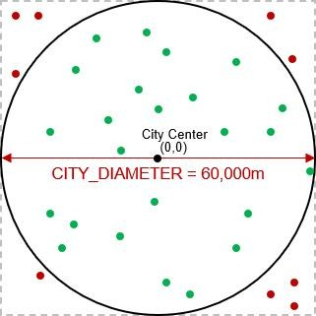Amazon hires many delivery drivers to deliver their thousands of packages each day within a city. You will write a program to assign various package-

delivery-locations to various drivers within the city’s boundaries. The delivery area for the city will be defined by a circle with diameter of 60,000 meters centered at the city’s center. Locations within the city’s delivery area (i.e., green circles shown) will be allowed, but any locations outside of the city’s delivery area (i.e., red circles shown) will not be considered.

The city center has location (**0**,**0**). Therefore, all valid delivery locations will have **x** and **y** coordinates each within the range of (**-30.0** km to **+30.0** km) … within the square bounding box. In addition, the delivery locations MUST also be within the city’s radius. In the image here, the red circles have coordinates within the (**-30.0** km to **+30.0** km) but they are not within the city’s radius, and are therefore invalid.

Write a program called **amazon1.c** that does the following:

1. The program should ask the user for the number of drivers, which must be a number from **2** to **200**, inclusively. If an invalid number is entered, it should display an error message and then ask the user again. This should continue until a valid number is entered. You may assume that only digit characters are entered by the user. Then, in the same manner, the program should ask the user for the number of packages to be delivered, which must be a number from **10** to **50000**, inclusively. Once both these numbers are valid, the program will continue.
2. The program should then compute a randomly-chosen (x, y) coordinate for each **driver** and store them in either one or two arrays (your choice). Each driver must have a coordinate that is within the city’s circular area (e.g., like the green circles shown). The coordinates MUST be stored in Kilometers, so you will need them to be **floats**.
3. The program should then compute a randomly chosen (x, y) coordinate for each **package** and store them in either one or two arrays (your choice). Each package must have a coordinate that is within the city’s circular area (e.g., like the green circles shown). The coordinates MUST be stored in Kilometers, so you will need them to be **floats**.
4. The program should then go through all the packages and determine the driver that is closest to it. You will need to use this formula to compute the distance between two points:

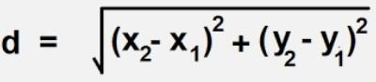

For each package, you will need to remember which driver was closest by storing the index of the driver (you can decide how to do that). If, for example, you have **5** drivers, then the indices are **0**, **1**, **2**, **3** and **4**.

1. The program should then display the number of drivers, the coordinates of each driver, the number of packages and the coordinates of each package along with the driver index for that package. The coordinates must all be displayed aligned nicely with the decimals aligned. Here is an example of the output for the program (the red indicates what the user entered):

Enter number of delivery drivers: **1**

*** Number of delivery drivers must be between 2 and 200 *** Enter number of delivery drivers: **6734**

*** Number of delivery drivers must be between 2 and 200 *** Enter number of delivery drivers: **3**

Enter number of packages to be delivered: **4**

*** Number of packages must be between 10 and 50000 *** Enter number of packages to be delivered: **789234**

*** Number of packages must be between 10 and 50000 *** Enter number of packages to be delivered: **10**

Drivers: 3

15.76 0.87

18.97 16.14

-13.68 19.94

Packages: 10

|  |  |  |
| --- | --- | --- |
| 21.37 | -18.43 | 0 |
| 9.94 | -14.75 | 0 |
| -5.67 | 4.20 | 2 |
| -10.13 | 12.12 | 2 |
| 6.60 | 13.68 | 1 |
| 12.90 | 4.32 | 0 |
| 9.83 | -15.38 | 0 |
| 24.23 | -1.21 | 0 |
| 15.70 | 4.24 | 0 |
| 28.06 | 3.36 | 0 |

Make sure to test your program a few times. The values should be as random as possible, so make sure that you do not use the same random number sequence each time.

### A Visual Display

Now copy your code into a file called **amazon2.c**. Adjust the code so that it just waits for the values from the user without display the prompts with **printf()**. Also, instead of printing error messages when invalid numbers are entered, the program should simply exit. Now adjust the program so that it prints out exactly: the number of drivers (without a newline character), followed by a space character, followed by the number of packages and then followed by a newline character. It should then print out all the packages one at a time as follows: print the **x** value, print a **space** character, print the **y** value, print a **space** character, print the **driver index** then print a **space** character. You MUST NOT print any newline characters at all when you print out the package information.

Run the program. Assuming that you enter **3** drivers and **10** packages, the output would look like this (the red was typed in by the user … and t he numbers will differ):

**3**

**10**

3 10

12.65 -19.03 2 -11.82 22.99 0 -11.72 -15.07 2 -15.28 14.30 0 -22.73 -5.30 2 -13.80 -

18.51 2 -12.80 11.97 0 16.44 -23.42 2 16.00 -2.92 2 14.71 14.86 1

Notice how it does not ask the user for the number of drivers and packages … it simply allows the user to enter them one at a time. It then outputs these two values and a newline character and then all the coordinates and driver indices for the packages.

The reason for these changes is that you will now run your data through a program that will display the data. The program is called **display.c**. Download it and compile it as follows:

**gcc -o display display.c -lX11**.

The last part of that line is a “minus elle ex eleven” which is the standard C library that is used for windows and graphics. Do NOT alter the code in **display.c**.

To test your program, you will “pipe” the output (i.e., send the output) from the **amazon2** program into the **display** program. Just do the following in the shell window:

**./amazon2 | ./display**

The character in-between is a vertical bar character. On my keyboard it is above the ENTER key … but the location on your keyboard will likely differ.

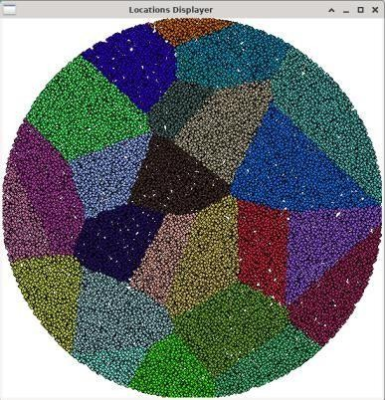

When you run it, a blank window will appear. Click back onto the shell window and type in **25** followed by **50000**. You will need to grab the window and drag it to update it.

After a bit of a delay … you should see something that looks like this … although the colors and shapes will be different each time →

Try your program with different a different number of drivers and packages.

IMPORTANT SUBMISSION INSTRUCTIONS:

Submit all of your **.c source** files and all other files needed for testing/running your programs. Make sure that your name and student number is in each source file at the top as a comment.

The code **MUST** compile and run on the course VM.

* If your internet connection at home is down or does not work, we will not accept this as a reason for handing in an assignment late ... so make sure to submit the assignment WELL BEFORE it is due !
* You WILL lose marks on this assignment if any of your files are missing. So, make sure that you hand in the correct files and version of your assignment. You will also lose marks if your code is not **written neatly with proper indentation and containing a reasonable number of comments.** See course notes for examples of what is proper indentation, writing style and reasonable commenting).

# COMP2401 - Assignment #2

## (Due: Wednesday, February 7th, 2024 @ 11pm)

In this assignment, you will work with arrays of strings and pack data into bytes based on bits. Then you will unpack them.

Data compression is an important topic in computer science because as time goes on, more and more data becomes available and there is always a need to reduce the amount of storage required to save the data. In this assignment, you will implement a VERY SIMPLE strategy for compressing some basic text from 8 bits to 6 bits.

As you know, each byte (i.e., **unsigned char**) in C is represented by an 8-bit binary value associated with it. So, when we read in characters from the user, they are represented using ASCII code values. You will create a quick encoder that will reduce text by trimming 8-bit bytes down to a 6-bit representation. Since **6** bits only allows **64** values … we will encode only the letters, digits and a few other characters and all other characters will be represented by a single common character. Here is how we will map the characters to a 6-bit value:

|  |  |  |
| --- | --- | --- |
| **CHARACTER** | **8-BIT ASCII VALUE** | **6-BIT VALUE** |
| NULL | 0 | 0 |
| A-I | 65-73 | 1-9 |
| a-i | 97-105 | 1-9 |
| ENTER (i.e., CR) | 10 | 10 |
| J-Z | 74-90 | 11-27 |
| j-z | 106-122 | 11-27 |
| [ | 91 | 28 |
| ] | 93 | 29 |
| @ | 64 | 30 |
| various symbols | 32-63 | 32-63 |
| all other characters | 64-255 | 31 |

1. Download the six files provided with this assignment (i.e., **convertTo6bit.c**, **usefulTools.c**, **usefulToos.h**, **compress.c**, **expand.c** and **convertToASCII.c**)

The program called **convertTo6bit.c** has been started for you. It reads the command-line arguments to the program (more on this later in the course) to decide if the debugging information should be shown. It then asks the user for a string of at most 255 characters. **You will insert code to convert the 8-bit ASCII characters from that string into a 6-bit character string by using the mapping shown in the above table**. The program then displays debugging information (if enabled) and finally sends the 6-bit encoded sentence to the console output. The code will make use of some functions provided in the **usefulTools.c** file … so you compile the program as follows:

**gcc -o convertTo6bit convertTo6bit.c usefulTools.c -lm**

Then run the program as follows:

**./convertTo6bit -d**

The program should display the 6-bit codes for each entered character and also display the string result (which will contain some characters that cannot be displayed). Here is some sample output. Make sure that these cases all work fine (also make sure that a **0** is always at the end of the output string):

|  |  |  |
| --- | --- | --- |
| **User Input** | **Displayed Codes** | **Visible Part of Converted String** |
| **Aa 19 @.** | **01 01 32 49 57 32 30 46 00** | 19 . |
| **A0A0A0A0** | **01 48 01 48 01 48 01 48 00** | 0000 |
| **I Love This Assignment!** | **09 32 13 16 23 05 32 21 08 09 20 32**  **01 20 20 09 07 15 14 05 15 21 33 00** | ! |
| **[abyz] ABYZ.@0189%~+=;** | **28 01 02 26 27 29 32 01 02 26 27 46**  **30 48 49 56 57 37 31 43 61 59 00** | ��189%+=; |
| **.** | **46 00** | . |

Run the program without the **-d** option (i.e., **./convertTo6bit**). You should not see the byte codes but just the final converted string.

1. 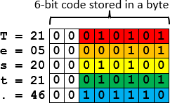The program called **compress.c** has also been started for you. After reading the command-line arguments it then reads in a string of converted characters from the **convertTo6bit** program. **You will insert code to pack the 6-bit character codes from the input string into 8-bit bytes (stored as an output string) so that the storage space required is reduced**. The program then displays debugging information (if enabled) and finally sends the compressed bytes to the console output as a string.

Consider the input string "Test.". The conversion of his string results in the 6-bit codes shown here on the right → along with their binary representation as stored in each of the 5 bytes.

To obtain the compressed output string bytes, you will need to take the 6 bits from each of the 5 input string bytes and pack them into the 8-bit bytes of the output string. To

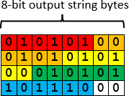do this, just copy the 6 bits from the first character into the first byte of the output string. There will be two bits remaining in the output string. Copy the first two bits from the next input string character into the output string to complete the first output string

byte. Then begin the second output string byte by copying in the remaining 4 bits from the second input string byte. Keep copying bits in this manner … filling up each output string byte and then moving on to the next one. As a result, the output string will have just 4 bytes with all the bits used except for the last two bits, which should be set to 0. Here is the result on the right →

This is an 80% compression ratio (i.e., the output string is 80% of the size of the original string).

You will need to keep track of how many bytes you are writing to the output string. You will not be able to use **strlen()** to determine the size of the output string because multiple bits could pack into a byte as all **0**’s, which will appear as a NULL-terminator to **strlen()** … causing it to return a smaller value that the string’s size. Here is an example that shows how this can happen when a simple string such as "A0A" is entered:

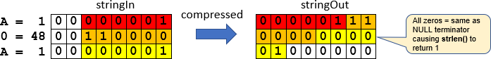

You will compile the program as follows:

**gcc -o compress compress.c usefulTools.c -lm**

Then run the two programs together as follows: **./convertTo6bit | ./compress -d**

This will run the **convertTo6bit** program first and the **|** character tells the shell window to use the output from that program as input to the **compress** program. That will allow us to type in a string of characters and see the resulting bits that get packed. Here is some sample output. Make sure that these cases all work fine:

|  |  |  |  |
| --- | --- | --- | --- |
| **User Input** | **Displayed Output** |  | **Visible Part of Converted String** |
| Aa 19 @. | **Compression ratio = 75.0%** |  | 1�� |
|  | **Before compression:** | **After compression:** |  |
|  | **000001** | **00000100** |  |
|  | **000001** | **00011000** |  |
|  | **100000** | **00110001** |  |
|  | **110001** | **11100110** |  |
|  | **111001** | **00000111** |  |
|  | **100000**  **011110** | **10101110** |  |
|  | **101110** |  |  |
| A0A0A0A0 | **Compression ratio = 75.0%** |  | pp |
|  | **Before compression:** | **After compression:** |  |
|  | **000001** | **00000111** |  |
|  | **110000** | **00000000** |  |
|  | **000001** | **01110000** |  |
|  | **110000** | **00000111** |  |
|  | **000001** | **00000000** |  |
|  | **110000** | **01110000** |  |
|  | **000001** |  |  |
|  | **110000** |  |  |
| I Love This Assignment! | **Compression ratio = 78.3%** |  | &P\X � E �=X@ |
|  | **Before compression:** | **After compression:** |  |
|  | **001001** | **00100110** |  |
|  | **100000** | **00000011** |  |
|  | **001101** | **01010000** |  |
|  | **010000** | **01011100** |  |
|  | **010111** | **01011000** |  |
|  | **000101** | **00010101** |  |
|  | **100000** | **00100000** |  |
|  | **010101** | **10010101** |  |
|  | **001000** | **00100000** |  |
|  | **001001** | **00000101** |  |
|  | **010100** | **01000101** |  |
|  | **100000** | **00001001** |  |
|  | **000001** | **00011100** |  |
|  | **010100** | **11110011** |  |
|  | **010100** | **10000101** |  |
|  | **001001** | **00111101** |  |
|  | **000111** | **01011000** |  |
|  | **001111**  **001110** | **01000000** |  |
|  | **000101** |  |  |
|  | **001111** |  |  |
|  | **010101** |  |  |
|  | **100001** |  |  |

|  |  |  |  |
| --- | --- | --- | --- |
| [abyz] ABYZ.@0189%~+=; | **Compression ratio = 77.3%**  **Before compression: 011100**  **000001**  **000010**  **011010**  **011011**  **011101**  **100000**  **000001**  **000010**  **011010**  **011011**  **101110**  **011110**  **110000**  **110001**  **111000**  **111001**  **100101**  **011111**  **101011**  **111101**  **111011** | **After compression: 01110000**  **00010000**  **10011010**  **01101101**  **11011000**  **00000001**  **00001001**  **10100110**  **11101110**  **01111011**  **00001100**  **01111000**  **11100110**  **01010111**  **11101011**  **11110111**  **10110000** | p�m� ��{  x�W��� |
| . | **Compression ratio = 100.0%**  **Before compression: 101110** | **After compression: 10111000** | � |

1. The program called **expand.c** has also been started for you. It reads in an 8-bit compressed string from the **compress** program. You will insert code to expand the compressed bytes back into the 6-bit character codes that were originally output from the **convertTo6bit** program (i.e., you will do the reverse of the **compress** program). The program then displays debugging information (if enabled) and finally sends the expanded bytes to the console output as a string. This time, you will be able to se the **strlen()** function to determine the number of bytes in the output string. You will compile the program as follows:

**gcc -o expand expand.c usefulTools.c -lm**

Then run the three programs together as follows:

**./convertTo6bit | ./compress | ./expand -d**

Here is some sample output. Make sure that these cases all work fine:

|  |  |  |  |
| --- | --- | --- | --- |
| **User Input** | **Displayed Output** |  | **Visible Part of Converted String** |
| Aa 19 @. | **Expansion ratio = 133.3%** |  | 19 . |
|  | **Before expansion:** | **After expansion:** |  |
|  | **00000100** | **000001** |  |
|  | **00011000** | **000001** |  |
|  | **00110001** | **100000** |  |
|  | **11100110** | **110001** |  |
|  | **00000111** | **111001** |  |
|  | **10101110** | **100000** |  |
|  |  | **011110** |  |
|  |  | **101110** |  |
| A0A0A0A0 | **Expansion ratio = 133.3%** |  | 0000 |
|  | **Before expansion:** | **After expansion:** |  |
|  | **00000111** | **000001** |  |
|  | **00000000** | **110000** |  |
|  | **01110000** | **000001** |  |
|  | **00000111** | **110000** |  |
|  | **00000000** | **000001** |  |

|  |  |  |  |
| --- | --- | --- | --- |
|  | **01110000** | **110000**  **000001**  **110000** |  |
| I Love This Assignment! | **Expansion ratio = 127.8%**  **Before expansion: 00100110**  **00000011**  **01010000**  **01011100**  **01011000**  **00010101**  **00100000**  **10010101**  **00100000**  **00000101**  **01000101**  **00001001**  **00011100**  **11110011**  **10000101**  **00111101**  **01011000**  **01000000** | **After expansion: 001001**  **100000**  **001101**  **010000**  **010111**  **000101**  **100000**  **010101**  **001000**  **001001**  **010100**  **100000**  **000001**  **010100**  **010100**  **001001**  **000111**  **001111**  **001110**  **000101**  **001111**  **010101**  **100001** | ! |
| [abyz] ABYZ.@0189%~+=; | **Expansion ratio = 129.4%**  **Before expansion: 01110000**  **00010000**  **10011010**  **01101101**  **11011000**  **00000001**  **00001001**  **10100110**  **11101110**  **01111011**  **00001100**  **01111000**  **11100110**  **01010111**  **11101011**  **11110111**  **10110000** | **After expansion: 011100**  **000001**  **000010**  **011010**  **011011**  **011101**  **100000**  **000001**  **000010**  **011010**  **011011**  **101110**  **011110**  **110000**  **110001**  **111000**  **111001**  **100101**  **011111**  **101011**  **111101**  **111011** | ��189%+=; |
| . | **Expansion ratio = 100.0%**  **Before expansion: 10111000** | **After expansion: 101110** | . |

1. Finally, the program called **convertToASCII.c** has also been started for you. It reads in the 6-bit code expanded string from the **expand** program. You will insert code to convert these 6-bit character codes back into ASCII codes (i.e., reverse of **convertTo6bit** program). The output string size will have the same as the input string. All 6-bit values of 31 represent all ASCII characters that were not able to be represented in 6-bits and when converted back to ASCII, they should be converted to the **'_'** (i.e., underscore) character. You will compile the program as follows:

**gcc -o convertToASCII convertToASCII.c usefulTools.c -lm**

Then run the four programs together as follows:

**./convertTo6bit | ./compress | ./expand | ./convertToASCII -d**

Here is some sample output. Make sure that these cases all work fine (also make sure that a **0**

is always at the end of the output string):

|  |  |  |  |  |  |  |  |  |  |  |  |  |
| --- | --- | --- | --- | --- | --- | --- | --- | --- | --- | --- | --- | --- |
| **User Input** | **Displayed Codes** | | | | | | | | | | | **Visible Part of Converted String** |
| **Aa 19 @.** | **65** | **65** | **32** | **49** | **57** | **32** | **64** | **46** | **00** |  |  | AA 19 @. |
| **A0A0A0A0** | **65** | **48** | **65** | **48** | **65** | **48** | **65** | **48** | **00** |  |  | A0A0A0A0 |
| **I Love This Assignment!** | **73** | **32** | **76** | **79** | **86** | **69** | **32** | **84** | **72** | **73** | **83** | I LOVE THIS ASSIGNMENT! |
|  | **32** | **65** | **83** | **83** | **73** | **71** | **78** | **77** | **69** | **78** | **84** |  |
|  | **33** | **00** |  |  |  |  |  |  |  |  |  |  |
| **[abyz] ABYZ.@0189%~+=;** | **91** | **65** | **66** | **89** | **90** | **93** | **32** | **65** | **66** | **89** | **90** | [ABYZ] ABYZ.@0189%_+=; |
|  | **46** | **64** | **48** | **49** | **56** | **57** | **37** | **95** | **43** | **61** | **59** |  |
|  | **00** |  |  |  |  |  |  |  |  |  |  |  |
| **.** | **46** | **00** |  |  |  |  |  |  |  |  |  | . |

Run the program without the **-d** option. You should not see the byte codes but just the final converted string.

Now that all the programs are working … here are 5 user strings that you can try to run through all 4 programs. You can cut/paste each one:

Q: Did you hear about the racing snail who got rid of his shell? A: He thought it would make him faster, but it just made him sluggish.

Q: How does a mathematician induce good behavior in her children? A: `I've told you n times, I've told you n+1 times...'

Have you heard of that new band "1023 Megabytes"? They're pretty good, but they don't have a gig just yet.

There are only 10 kinds of people in this world: those who know binary and those

who don’t.

“Knock, knock.” “Who’s there?” very long pause…. “Java.”

IMPORTANT SUBMISSION INSTRUCTIONS:

Submit all of your **.c source** files and all other files needed for testing/running your programs. DO NOT TAR your files. Make sure that your name and student number is in each source file at the top as a comment.

The code **MUST** compile and run on the course VM.

* If your internet connection at home is down or does not work, we will not accept this as a reason for handing in an assignment late ... so make sure to submit the assignment WELL BEFORE it is due !
* You WILL lose marks on this assignment if any of your files are missing. So, make sure that you hand in the correct files and version of your assignment. You will also lose marks if your code is not **written neatly with proper indentation and containing a reasonable number of comments.** See course notes for examples of what is proper indentation, writing style and reasonable commenting).

# COMP2401 - Assignment #3

## (Due: Wednesday, February 28th @ 11pm)

In this assignment, you will gain experience in using **structs** and **pointers**. Make sure to put comments in your code … especially ones to describe your functions, definitions and important parts of your code. You must also write your code as cleanly & efficiently as possible.

Assume that a private cell phone company wanted you to write a program to keep track of various calls made between its customers. You will use various structures to represent the type of phone plan, the customer, the calls made and the phone network itself. A header file called **phoneNetwork.h** has been provided with the necessary **struct** definitions that you will need as shown below … with type name definitions shown in red:

// Structure that stores a phone plan that a customer has

typedef struct {

unsigned short int minutesAllowed; // # mins/month allowed in phone plan unsigned short int minutesUsed; // # mins used this month so far

} PlanType;

// Structure that stores a customer

typedef struct {

char *name; // name of customer unsigned int id; // customer ID

char *number; // phone number of customer PlanType plan; // phone plan of customer unsigned short numOutCalls; // number of calls made this month

unsigned short numInCalls; // number of calls received this month

} CustomerType;

// Structure that stores a phone call that was made

typedef struct {

CustomerType madeFrom; // customer who made call CustomerType madeTo; // customer who was called time_t startTime; // time that call was started time_t endTime; // time that call ended

} CallType;

// Structure that stores the phone network’s customer and call data

typedef struct {

CustomerType customers[MAX_CUSTOMERS]; // data for customers registered with network unsigned int numCustomers; // number of customers registered

CallType calls[MAX_CALLS]; // data for all calls that took place this month unsigned int numCalls; // number of calls that took place this month

} PhoneNetworkType;

The next page shows an example of a phone network with **3** customers in which **2** phone calls were made. Make sure that you understand how the image matches up with the structures in the header file before you continue the assignment.

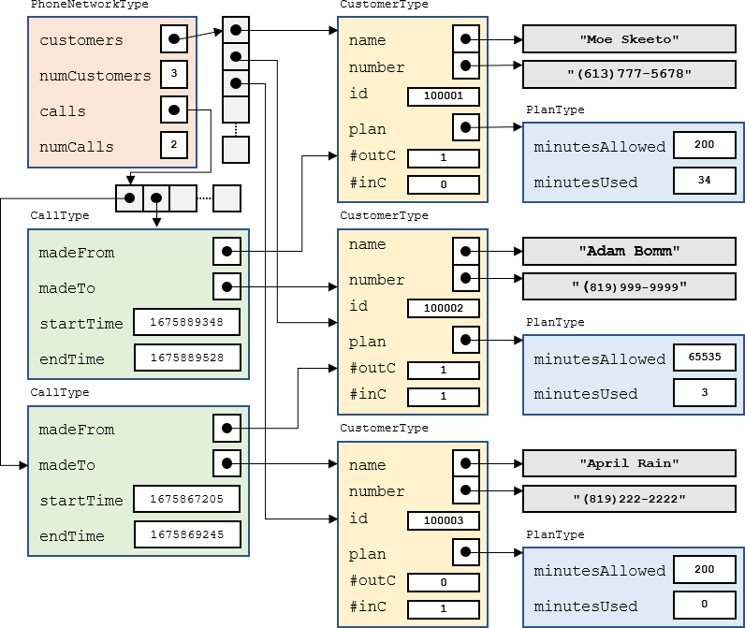

Download the **phoneSimulation.c** file. It contains a **main()** function with comments that indicate the steps you should follow. It also contains sample names, numbers and phone plan values that you will use. You will be writing a bunch of functions and procedures.

You must create a file called **phoneNetwork.c** that will contain ALL the functions and procedures that you will be asked to write.DO NOT write them in the **phoneSimulation.c** file.

You will need to include that additional file at the end of your **gcc** shell command so that it gets compiled along with the **phoneSimulation.c** file.

* 1. Write a **registerCustomer()** procedure that will register a customer in the phone network defined by the **phoneNetwork** variable that is provided. The procedure must have the following signature which takes a pointer to a phone network, a name, a phone number and a number of allowed phone plan minutes/month:

registerCustomer(PhoneNetworkType **\***, char **\***, char **\***, int)

For each customer you should have some kind of global counter so that each time you register a customer they get assigned a unique id (starting with 100001). It must return **1** if the customer was able to be added (i.e., not past capacity) and **0** otherwise.

Call this procedure from the **main()** function so that it creates exactly **20** customers … with the names, phone numbers and the allowed number of phone plan minutes provided in the Sample arrays.

* 1. Write a **displayCharges()** procedure that takes a pointer to a **PhoneNetworkType** and then displays all customers in the phone network provided … showing their id, phone number, name and phone plan minutes allowed. It should show “UN” for unlimited-minute phone plans and “PPM” for phone plans that require paying per minute of usage. Call this procedure at the end of the **main()** function as shown by the comment in the code. You will add more functionality to this procedure later. Make sure to test your code … the output should be aligned nicely and approximately as follows:

|  |  |  |  |
| --- | --- | --- | --- |
| ID | Phone Number | Name | Plan |
| 100001 | (613)111-1111 | Rob Banks | UN |
| 100002 | (819)222-2222 | April Rain | 200 |
| 100003 | (613)333-3333 | Rita Book | PPM |
| 100004 | (343)444-4444 | Sue Permann | UN |
| 100005 | (819)555-5555 | Tim Bur | PPM |
| 100006 | (613)666-6666 | Paddy O'Lantern | UN |
| 100007 | (343)777-7777 | Sam Pull | 200 |
| 100008 | (613)888-8888 | Sandy Beach | UN |
| 100009 | (819)999-9999 | Adam Bomm | UN |
| 100010 | (613)555-1234 | Hugo First | UN |
| 100011 | (613)555-5678 | Dan Druff | 200 |
| 100012 | (613)666-1234 | Mabel Syrup | UN |
| 100013 | (613)666-5678 | Mike Rohsopht | UN |
| 100014 | (343)777-1234 | Adam Sapple | 100 |
| 100015 | (613)777-5678 | Moe Skeeto | 200 |
| 100016 | (819)888-1234 | Anita Bath | UN |
| 100017 | (343)888-5678 | Rusty Chain | PPM |
| 100018 | (613)999-1234 | Stu Pitt | 200 |
| 100019 | (613)999-5678 | Val Crow | UN |
| 100020 | (613)444-1234 | Neil Down | UN |

* 1. Write a **resetMonth()** procedure that simulates the resetting of phone call data for a new month of calls. It must take a pointer to a **PhoneNetworkType**. The procedure should reset everything as if there have been no calls made in the network so that things begin from scratch. Call this procedure in your **main()** function right after creating the customers.
  2. Write a **recordCall()** function that simulates a call that has been made in the network. It must have the following signature, taking a pointer to the network as its 1st parameter:

char recordCall(PhoneNetworkType **\***, char **\***, char **\***, time_t, time_t);

The 2nd parameter is the phone number that the call was made from, the 3rd parameter is the phone number that the call was made to, the 4th parameter is the time that the call was started and the last parameter is the time that the call ended. The time is designed as a **time_t** type. This is a large integer number that represents the number of seconds that has elapsed since 00:00:00 UTC, January 1, 1970. It is the typical standard that is used to record time-of-day in computer science.

The function should return **0** if the call could not be recorded (this could happen if the number of calls that were made in the phone network has reached its capacity or if either of the phone numbers are invalid). Otherwise, the function should return 1. To record the call, you will need to do a few things. You will need to:

* + 1. Determine how many minutes the call lasted (rounded up to the nearest minute)
    2. Find the customer that made the call and record that number of minutes used as well as the fact that this customer made this outgoing phone call.
    3. Find the customer that received the call and record the fact that this customer received this incoming phone call. If it was a PAY_PER_MINUTE customer that received the call, the number of minutes used should be reduced as a result of this phone call, but other types of phone plans do not need to have the minutes reduced for incoming calls.
    4. Update the appropriate from/to/start/end information in the network’s **calls** array accordingly.
  1. To test the **recordCall()** function, after resetting the month in the **main()** function, you should write code to make **10** calls (we will increase this to **100** later). To do this, choose a random customer to make the call and a random one to receive the call (make sure that it is not the same customer that makes and receives the call at the same time as this is invalid). You will need to choose a random start time for the call and a random end time. To do this, we will need to generate realistic **time_t** values. There is a **struct** tm structure defined in <time.h> that allows us to specify an exact year, month, day, hour, minute and second time. Here is what the structure looks like:

**struct** tm {

int tm_sec; // seconds 0-59

int tm_min; // minutes 0-59

int tm_hour; // hours 0-23

int tm_mday; // day of the month 1-31 int tm_mon; // month 0-11

int tm_year; // year since 1900

int tm_wday; // day of the week 0-6 int tm_yday; // day in the year 0-365

int tm_isdst; // daylight saving time (we will use -1 to disable)

};

You should generate a start time for the phone call by making a variable of type **struct tm** and then setting its values so that the call was made in **Feb 2024**. The day of the month should be chosen randomly as a number from **1-29** (since 2024 is a leap year). The hour, minute and second of the day should all be chosen randomly.

To get your **struct tm** variable into a **time_t** format that you need for the **recordCall()** function, you simply call the **mktime()** function from <time.h> with the address of your struct tm variable. That function will return the value you need for your call’s start time. As for the call’s end time, you can take that start time value and simply add a random number of seconds so that the call lasts at most two hours (i.e., at most **120** mins **\* 60** seconds). At this point, you will not know if your code works properly until you write the next procedure.

* 1. Write a **displayCallLog()** procedure that displays the phone call data. It must take a pointer to a **PhoneNetworkType**. For each call made, the procedure should display the phone number that the call was made from, the number it was made to, the start date/time of the call, the end date/time of the call and the length of time (in minutes with one decimal place) that the call lasted. The output should be formatted neatly and look roughly as follows:

Call From # Call To # Start Time: End Time Call Length

|  |  |  |  |  |  |  |  |
| --- | --- | --- | --- | --- | --- | --- | --- |
| (613)555-1234 | (613)333-3333 | 2024-02-07 | 12:57:50 | 2024-02-07 | 13:19:32 | 21.7 | minutes |
| (613)999-1234 | (613)333-3333 | 2024-02-25 | 05:34:07 | 2024-02-25 | 07:26:46 | 112.7 | minutes |
| (613)444-1234 | (819)999-9999 | 2024-02-15 | 08:20:22 | 2024-02-15 | 09:59:54 | 99.5 | minutes |
| (613)555-1234 | (343)444-4444 | 2024-02-16 | 09:12:20 | 2024-02-16 | 09:52:32 | 40.2 | minutes |
| (613)555-1234 | (819)222-2222 | 2024-02-16 | 03:13:00 | 2024-02-16 | 03:24:41 | 11.7 | minutes |
| (343)888-5678 | (613)999-5678 | 2024-02-12 | 18:55:09 | 2024-02-12 | 20:35:15 | 100.1 | minutes |
| (343)777-7777 | (613)111-1111 | 2024-02-21 | 02:23:53 | 2024-02-21 | 03:40:39 | 76.8 | minutes |
| (343)777-7777 | (613)999-5678 | 2024-02-28 | 13:33:57 | 2024-02-28 | 14:51:59 | 78.0 | minutes |
| (343)777-1234 | (613)555-1234 | 2024-02-12 | 18:23:27 | 2024-02-12 | 18:54:04 | 30.6 | minutes |
| (343)888-5678 | (613)444-1234 | 2024-02-06 | 12:49:37 | 2024-02-06 | 12:50:00 | 0.4 | minutes |

Note: To extract the date/time information from the **time_t** values, you will need to get the **time_t** value into a struct tm variable so that you can extract what you need. To convert a **time_t** value called **timeValue** into a struct tm variable called **daytime**, you can call the **localtime()** function as follows: **struct** tm daytime = **\***localtime(**&**timeValue);

Don’t forget to adjust the year and month values accordingly after the conversion.

* 1. Finally, we will adjust the **displayCharges()** procedure so that it computes and displays the appropriate monthly charges for each customer. Here is how the charges work:
     1. For customers with UNLIMTED minute phone plans, the base cost is **$34.99** per month (before taxes).
     2. For customers with phone plans that have a specified number of minutes, the base cost is

**$9.99** per month. But there is an extra **15** cents charge for every minute that the customer went over the plan's allowed minutes. So, a customer that used up **126** minutes on a 100- minute phone plan would pay **$9.99** + (**$0.15** * **26**) = **$13.89** before taxes.

* + 1. For customers with a PAY_PER_MINUTE phone plan, the customer simply pays **$0.15** per minute for the first **100** minutes and then they pay **$0.35** for every minute over the **100**.

Adjust your **displayCharges()** procedure so that it also displays (alongside the current customer information) the number of outgoing calls made, the number of incoming calls received, the number of minutes used, the number of minutes gone over, the base cost, the extra cos (for going over), the HST amount and the final total. The information must be aligned and displayed neatly. Here is an example of the output:

|  |  |  |  |  |  |  |  |  |  |  |
| --- | --- | --- | --- | --- | --- | --- | --- | --- | --- | --- |
| Phone Number | Name | Plan | Out | In | Used | Over | Base | Extra | HST | Total |
| (613)111-1111 | Rob Banks | UN | 3 | 5 | 234 | 0 | 34.99 | 0.00 | 4.55 | $ 39.54 |
| (819)222-2222 | April Rain | 200 | 6 | 3 | 303 | 103 | 9.99 | 15.45 | 3.31 | $ 28.75 |
| (613)333-3333 | Rita Book | PPM | 2 | 7 | 563 | 463 | 15.00 | 162.05 | 23.02 | $ 200.07 |
| (343)444-4444 | Sue Permann | UN | 6 | 9 | 382 | 0 | 34.99 | 0.00 | 4.55 | $ 39.54 |
| (819)555-5555 | Tim Bur | PPM | 4 | 4 | 367 | 267 | 15.00 | 93.45 | 14.10 | $ 122.55 |
| (613)666-6666 | Paddy O'Lantern | UN | 8 | 5 | 729 | 0 | 34.99 | 0.00 | 4.55 | $ 39.54 |
| (343)777-7777 | Sam Pull | 200 | 4 | 6 | 246 | 46 | 9.99 | 6.90 | 2.20 | $ 19.09 |
| (613)888-8888 | Sandy Beach | UN | 6 | 7 | 329 | 0 | 34.99 | 0.00 | 4.55 | $ 39.54 |
| (819)999-9999 | Adam Bomm | UN | 4 | 3 | 280 | 0 | 34.99 | 0.00 | 4.55 | $ 39.54 |
| (613)555-1234 | Hugo First | UN | 4 | 3 | 295 | 0 | 34.99 | 0.00 | 4.55 | $ 39.54 |
| (613)555-5678 | Dan Druff | 200 | 4 | 6 | 170 | 0 | 9.99 | 0.00 | 1.30 | $ 11.29 |
| (613)666-1234 | Mabel Syrup | UN | 3 | 10 | 165 | 0 | 34.99 | 0.00 | 4.55 | $ 39.54 |
| (613)666-5678 | Mike Rohsopht | UN | 5 | 2 | 343 | 0 | 34.99 | 0.00 | 4.55 | $ 39.54 |
| (343)777-1234 | Adam Sapple | 100 | 5 | 2 | 327 | 227 | 9.99 | 34.05 | 5.73 | $ 49.77 |
| (613)777-5678 | Moe Skeeto | 200 | 5 | 6 | 341 | 141 | 9.99 | 21.15 | 4.05 | $ 35.19 |
| (819)888-1234 | Anita Bath | UN | 10 | 4 | 752 | 0 | 34.99 | 0.00 | 4.55 | $ 39.54 |
| (343)888-5678 | Rusty Chain | PPM | 5 | 7 | 757 | 657 | 15.00 | 229.95 | 31.84 | $ 276.79 |
| (613)999-1234 | Stu Pitt | 200 | 4 | 5 | 285 | 85 | 9.99 | 12.75 | 2.96 | $ 25.70 |
| (613)999-5678 | Val Crow | UN | 5 | 2 | 209 | 0 | 34.99 | 0.00 | 4.55 | $ 39.54 |
| (613)444-1234 | Neil Down | UN | 7 | 4 | 488 | 0 | 34.99 | 0.00 | 4.55 | $ 39.54 |

You MUST ensure that you are not using “magic numbers” in your code. You should add appropriate definitions to **phoneNetwork.h** for all cost amounts minute-limit values and tax amounts.

Make sure that your code compiles, runs and produces the correct output. Hand this test code in with your assignment.

IMPORTANT SUBMISSION INSTRUCTIONS:

Submit all your **.c** and **.h** source code files as individual files (i.e., DO NOT **TAR/RAR**/**ZIP/COMPRESS** anything):

1. A **Readme** text file containing
   * your name and studentNumber
   * a list of source files submitted
   * any specific instructions for compiling and/or running your code
2. All of your **.c source** files and all other files needed for testing/running your programs.

The code **MUST** compile and run on the course VM. You WILL lose marks on this assignment if any of your files are missing. So, make sure that you hand in the correct files and version of your assignment. You will also lose marks if your code is not **written neatly with proper indentation and containing a reasonable number of comments.**

# COMP2401 - Assignment #4

## (Due: Wednesday, March 13th, 2024 @ 11pm)

In this assignment, you will gain additional practice using structs, pointers and dynamic memory allocation while creating a graph that makes use of Linked-Lists.

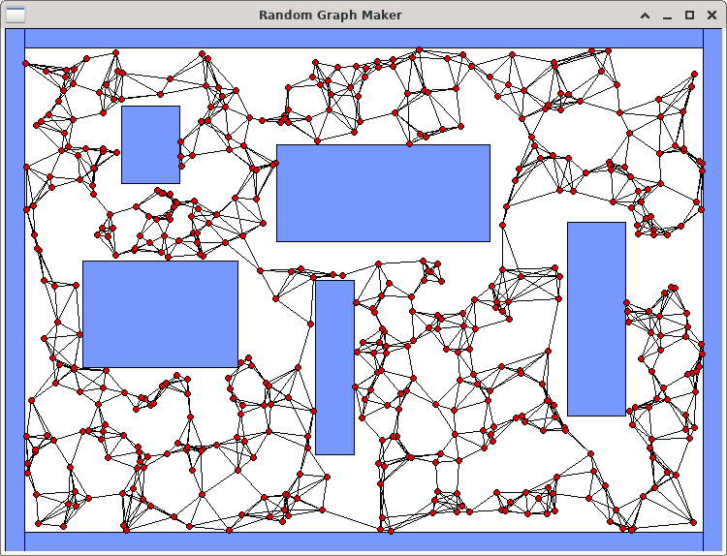In the world of robotics, it is ALWAYS a good idea to program a robot to move around in its environment without hitting things. If a map of the environment is given, a robot can plan paths around the obstacles. There are many ways to perform path planning and some of the solutions involve creating a graph that can be traversed. In this assignment, we will create a random graph with vertices connected to their **k**-nearest neighbours, for some value of **k**. We will run our code on five fixed environments that are composed of rectangular obstacles. These environments will be given to you. The bottom left of the environments is always coordinate (0, 0).

To begin the assignment, you should download the following files:

* **display.c** and **display.h** – code for displaying the environment and graph.
* **obstacle.h** – structures required for this assignment.
* **graphMaker.c** – your code will be mostly written here (but there is no **main** function).
* **graphTester.c** – this is the test program that you will run.

You MUST not alter the **display.c**, **display.h** nor **obstacle.h** files. You are also NOT allowed to alter the **structs** defined in the **obstacle.h** file, NOR are you allowed to create any additional structs on this assignment. You MUST NOT CREATE ANY STATIC ARRAYS on this assignment.

**\*\*\* ALERT \*\*\*** You must write your code in a modular/logical way by making helper functions/procedures for various parts of the code so that your **createGraph()** procedure (see parts 2 to 4) is **not more than 50 lines long** including comments and blank lines.

1. You MUST first create a proper **makefile** that defines the proper dependencies, compiles the files and creates an executable called **graphTester**. You will need to include the **-lX11** library (that’s “minus L X eleven”) when creating the executable file. The **make clean** command should also work properly. The program must be run by supplying 3 command-line parameters as follows:

**./graphTester <V> <K> <E>**

Here, **<V>** is a number from 20 to 2000 (inclusively) which represents the number of vertices to add to the graph. **<K>** is a number between 1 and 25 (inclusively) that indicates the number of nearest-neighbours that each vertex will attempt to be connected to in the graph. **<E>** is a number from 1 to 5 (inclusively) representing the environment number to use. If your make file works properly, you should be able to run the program by supplying any numbers at this time, as long as they are within the proper range. The program should display the environment that you chose in a graphical window … and then wait for you to close the window.

1. Your task will be to write all your code in the **graphMaker.c** file. Currently, there are just two blank procedures there and there is also a helper function called **linesIntersect()** that you will use. Your first task will be to write code in the **createGraph()** procedure so that it creates the vertices of the graph.

Look at the **Environment** typedef in the **obstacles.h** file. It contains a **numVertices** attribute which has been set from the command line and indicates how many vertices you need to create. The **vertices** attribute will point to a dynamically-allocated array of vertex pointers. You will need to allocate the array and set that **vertices** attribute to point to it. Then you need to create the **numVertices** vertices by allocating each vertex dynamically as well.

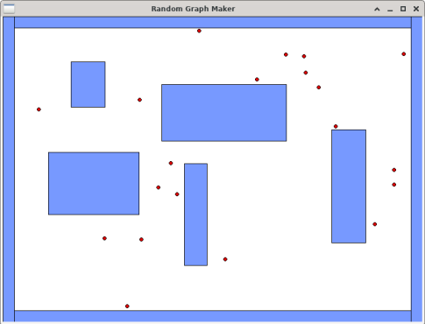

**typedef struct** {

**unsigned short** k; **unsigned short** maximumX; **unsigned short** maximumY; Obstacle **\***obstacles;

**unsigned short** numObstacles; Vertex **\*\***vertices; **unsigned short** numVertices;

} Environment;

**typedef struct** vert {

**short** x;

**short** y;

**struct** neigh **\***neighbours;

} Vertex;

**typedef struct** obst {

**short** x;

**short** y;

**short** w;

**short** h;

} Obstacle;

Look at the **Vertex** typedef in the **obstacles.h** file. Each vertex has an **x** and **y** coordinate as well as a pointer to a list of **neighbours**.

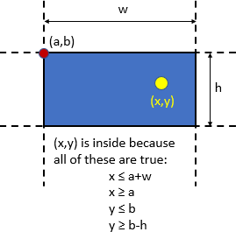For each vertex, you must choose a random **x** value within the range of **0** to **maximumX** and a **y** value between **0** and **maximumY**. These maximums are attributes of the Environment structure. You must also ensure that the chosen (**x**, **y**) values are not inside (nor on the boundary of) any of the environment’s obstacles. Notice that the environment has an **obstacles** array attribute. If you look at the **graphTester.c** file, you will notice that this array has already been created for you according to the environment selected via command-line arguments.

Each **Obstacle** is assumed to be a rectangle with its top-left corner being an (**x**, **y**) point and having width **w** and height **h**.

The diagram here shows how to tell whether or not a point **(x, y)** is inside the rectangle defined with **(a, b)** being the top-left corner.

Once you have this completed, run your program as follows: **./graphTester 20 1 1** You should see something similar to what is shown here, except that your vertices will be in different locations. You should be able to count **20** red circles every time and no circle centers should be inside of a blue obstacle. It is possible, however, that a portion of the circle will be inside of an obstacle, but the very center pixel of the circle should NEVER be inside of an obstacle. Run again using **./graphTester 2000 1 1** and ensure that no circle centers are inside any obstacles. You may have to click on the window and move it a bit to ensure that the window displays all the vertices.

1. Now it is time to create the graph edges. There will be no array to store the edges. Instead, each vertex will store a linked-list of the vertices that it is connected to (i.e., that vertices *neighbours*). Each vertex has an attribute called **neighbours** that should point to the head of a singly-linked-list of **Neighbour** types. The **Neighbour** type keeps a pointer to the **vertex** it represents as well as a pointer to the **next** neighbour in the list.

**typedef struct** neigh { Vertex **\***vertex; **struct** neigh **\***next;

} Neighbour;

For each vertex **v**, you will go through all other vertices and find the **k**-closest vertices to **v**. The **k** value is chosen from the command-line-arguments and has been stored in the Environment struct. Consider vertex **v** in the graph below on the right. On the left, it shows the **Vertex** struct that represents it. The neighbours attribute points to the head of the linked-list that stores the **k**- nearest neighbours of **v**, where **k** = **4**. Although the order of the neighbours does not matter, it is shown such that the closest one to **v** (i.e., the blue one) is the head of the list.

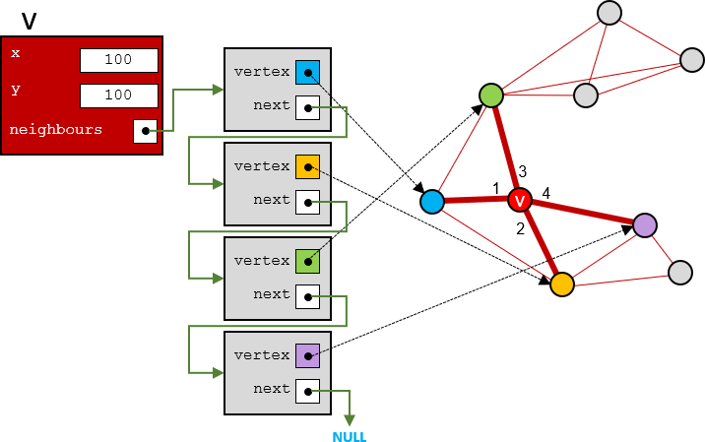

When checking for the nearest neighbours you will need to compute the distance between two vertices. You need not compute the exact distance because we don’t need that value. We just need to find the closest neighbours. So, it is enough to compute the square of the distance between the points. This is faster since we do not have to compute the square root operation. The square of the distance between two points (x1,y1) and (x2,y2) is (x2-x1)(x2-x1) + (y2-y1)( y2-y1). You can use whatever algorithm you want to determine the k-nearest neighbours, but simplest is best.

Once you have this completed, run your program as follows: **./graphTester 30 3 1** You should see something similar to what is shown here, except that your vertices will be in different locations. You may have to move the window once to make sure that all the vertices are

displayed. Each vertex should have **at least 3** edges connected to it. Some vertices have more than three edges connected to them. That is because in addition to that vertex’s **3**-nearest neighbours, other vertices have that vertex as their neighbour, so they connect to it as well.

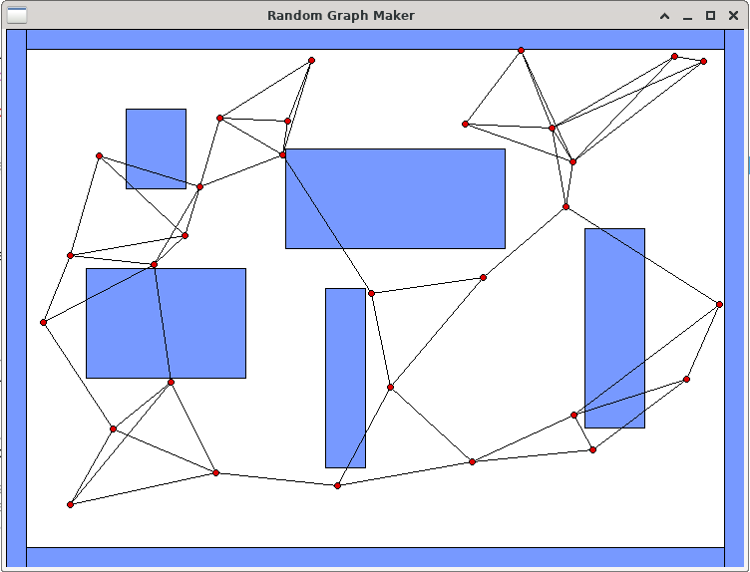

Run your program again as follows: **./graphTester 100 25 1** You should see something “similar to” what is shown below. Each vertex will have exactly **25** nodes in its **neighbours** list.

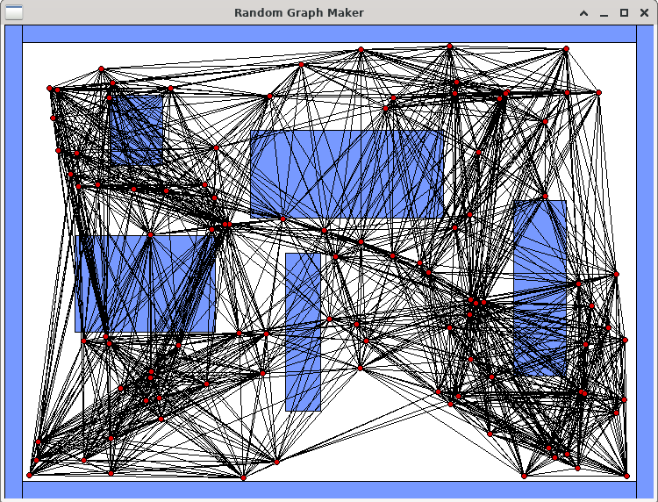

1. Now we need to make sure that we DO NOT add any edges to the graph that cross obstacles. In your code, before you decide to add a neighbour to a vertex, you will need to first make sure that the edge that would join them does not cross any obstacles. If it does, then you will not add the neighbour. That means, it is possible that a vertex will end up with zero neighbours. If, for example, we find the **25**-nearest neighbours for a vertex **v** and **18** of those neighbours would

result in an edge that would cross an obstacle, then we only add the **7** neighbours to **v** that do not intersect anything, resulting in **v** having a **neighbours** list with only **7** nodes in it.

To do this, you should make use of the **linesIntersect()** function provided. Before adding neighbouring-vertex **w** to vertex **v**’s **neighbours** list, you will need to ensure that the line segment from **v** to **w** does not intersect any of sides of any rectangular obstacle in the environment’s **obstacles** list.

Once you get your code written, run your program again as before: **./graphTester 100 25 1** You should see something “similar to” what is shown below. None of the edges should intersect any blue obstacle. Run it many times.

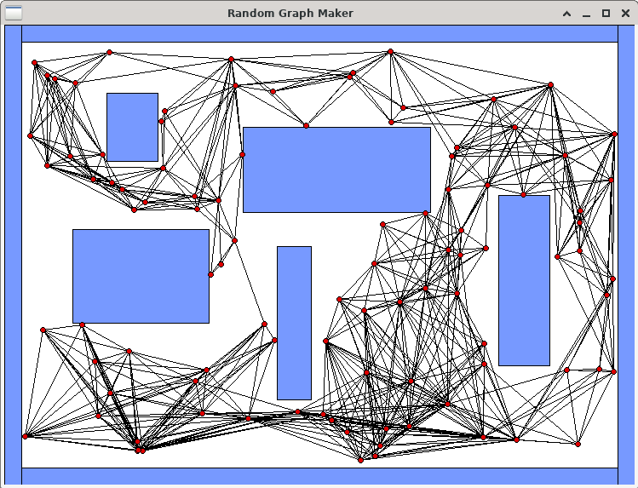

Try out a some of the other environments. Here are environments **2** & **3** with **2000** vertices and **k**=**25**:

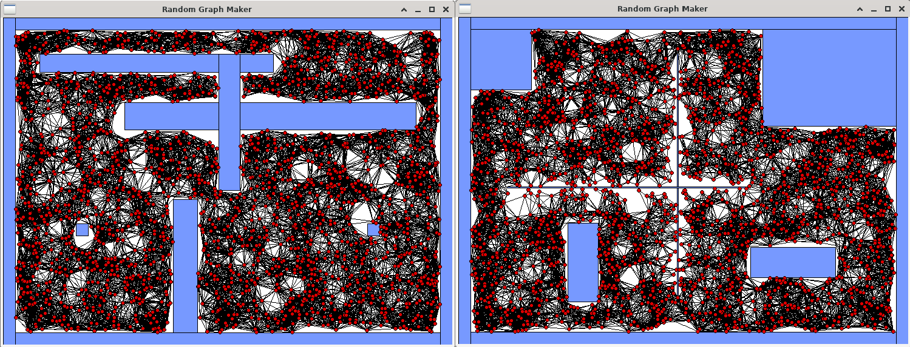

Here are environments **4** & **5** with **2000** vertices and **k**=**25**:

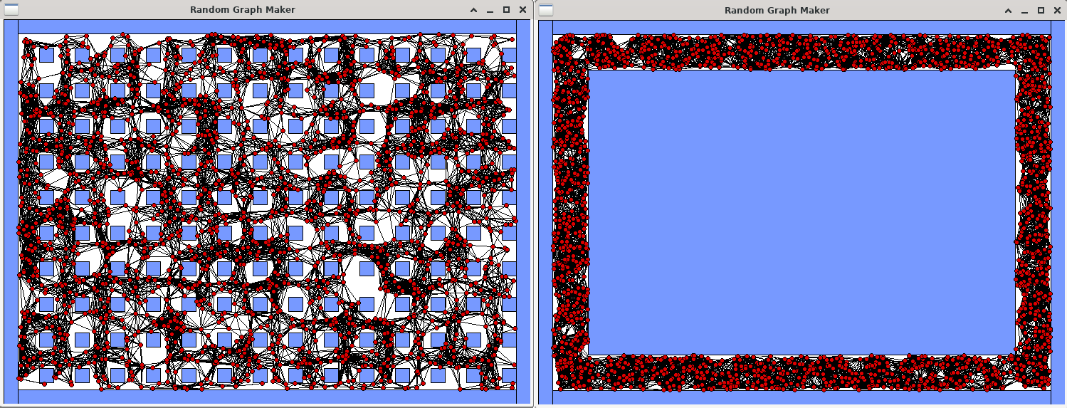

1. Finally, write code in the **cleanupEverything()** procedure so that your program has no memory leaks **nor errors**. Use **valgrind –leak-check=yes ./graphTester 2000 25 1** to do this … although you should try various combinations of grid sizes and environments as well.

IMPORTANT SUBMISSION INSTRUCTIONS:

Submit:

* 1. A **Readme** text file containing
     + your name and studentNumber
     + a list of source files submitted
     + any specific instructions for compiling and/or running your code
  2. Your **makefile** and ALL the **.c** and **.h** files needed to compile and run.

The code **MUST** compile and run on the course VM.

* If your internet connection at home is down or does not work, we will not accept this as a reason for handing in an assignment late ... so make sure to submit the assignment WELL BEFORE it is due !
* You WILL lose marks on this assignment if any of your files are missing. So, make sure that you hand in the correct files and version of your assignment. You will also lose marks if your code is not **written neatly with proper indentation and containing a reasonable number of comments.** See course notes for examples of what is proper indentation, writing style and reasonable commenting).