Cross-Media Information Retrieval System

Objectives
The investigators plan to construct a cross-media information retrieval system that combines feature extraction techniques, metadata, and optimised multidimensional search methods. Although there has been a tremendous amount of research into many aspects of such a system, very little work has been done on cross-media information retrieval. Such a system would allow the user to enter a piece of media as a query and might retrieve an entirely different type of media as a related document. For instance, one could envisage an entertainment application where an image of an actor may be entered, and film clips of that actor are retrieved. A more practical application could be one where a fingerprint is entered, and likely sound clips and photos of the person are retrieved. The goal of this work is to show that such a system is effective and plausible.

Summary
We believe that this presents an interesting, yet solvable challenge. There has been considerable research on the various components of such a system, but there remain many technical and theoretical difficulties with linking all the components together. Thus, this proposal represents a worthwhile endeavour both as a useful application and as an advance in frontier research. The key technological challenges and possible solutions are listed below. Each of the primary technological components is described below, along with how we plan to solve the related issues.

Feature Extraction
Feature extraction on media, whether images, audio, video or otherwise, involves the analysis of a file, or portion of a file, to extract a small set of quantifiable features which represent the most relevant properties of the media. The benefit of extracting these features is that a set of features is much easier to compare, analyse and manipulate than the huge amount of information in the media file.
Since we wish for the retrieval system to be able to associate media files in various different ways, a variety of different feature sets will be created. This allows, for instance, images to be described by their colour distribution or via edge detection algorithms. Similarly, music audio may be described by timbral features or melodic features. By providing several feature sets that can be combined in different ways, we can search the database using different similarity measures.

Metadata Creation
In order to support true cross-media queries, it is necessary to provide a means whereby one can say that two documents of different media types can be considered similar. As an example, it is clear that an audio recording of a person speaking and a photo of that person are related, yet this information is in no way revealed through the use of feature extraction.
To relate such documents, metadata must be explicitly entered into the database. Such metadata can pool together images, audio, video and text related to the same subject. The metadata is linked and ranked, so that an obscure relation, such as the photo of a group of people and a video of one person in the group, might be ranked lower than audio and video of the same person in the same context. We thus define a similarity measure that utilises the metadata. This similarity measure can be used in series or in parallel with the feature based measure, hence allowing full cross-media queries. An example is given in Figure 1.

Similarity Searching and Indexing
Due to the combined use of metadata and features, the database must support several radically different types of internal search methods. First, relationships based on features require a multidimensional similarity index. There is a large literature on this but it remains to be seen which index is most suited for such a problem, and what modifications it would require. Furthermore, the metadata gives rise to complex relationships between documents. Ranked linkages of metadata connections may give rise to nonmetric relationships (an image may come from a film, which features a song, but the image is only tangentially related to the song). Thus the appropriate way to search the metadata remains a challenging task. Graph theory and small world networks may be highly applicable to this problem.

Computational Cost
Computational costs are incurred in several different places. Since this is planned as a system with feature extraction on the query, and a multidimensional search on the data, then large query documents and large databases can both result in an excessive retrieval times. Thus, some optimisation is necessary. The researchers will investigate several schemes with the goal of minimising the time it takes to construct the database (feature extraction on all documents, creation of metadata, construction of a search index) and the time it takes to retrieve documents (feature extraction on the query document, searching the index using both metadata and feature similarity, ordering and presentation of results).

Presentation
Design, interface and presentation become important concerns when one considers that a goal of providing a cross-media retrieval system is to uncover previously unknown relationships between query documents and documents in the database. Thus it is not merely sufficient to say that an audio clip is related to, in order, two audio files, an image, another audio file, a video clip, etc… Since metadata information is already incorporated into the database, the results should be presented in a more structured manner. A more relevant presentation should reveal, for instance, that an audio clip is related to the audio stream from a certain video, with these related images, and to another audio clip that relates to a certain subject. The choices for how to present the retrieved results are numerous, and user testing is necessary to determine the most effective approach.

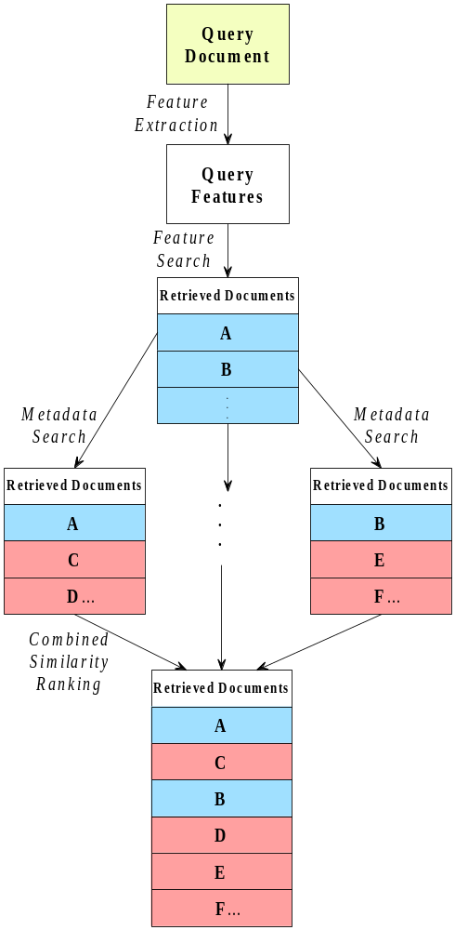
Figure 1. A flowchart depicting how a cross-media query can be performed using a combination of a feature similarity measure and a metadata similarity measure.

