Install R and RStudio for Mac and Windows users

**Mac Users**

**To Install R**

1. Open an internet browser and go to <https://cloud.r-project.org>.
2. At the top of the page, under "Download and Install R", click the link "Download R for (Mac) OS X".

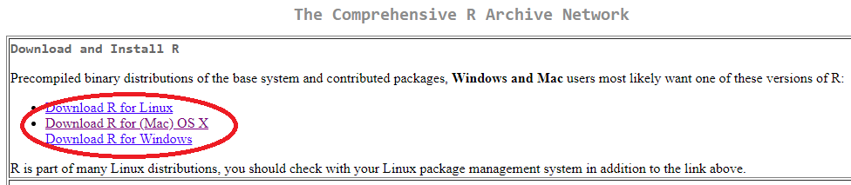

1. About halfway down the page, under “Latest release”, click the link for the latest version of R, which is 3.6.2 as of January 2020.

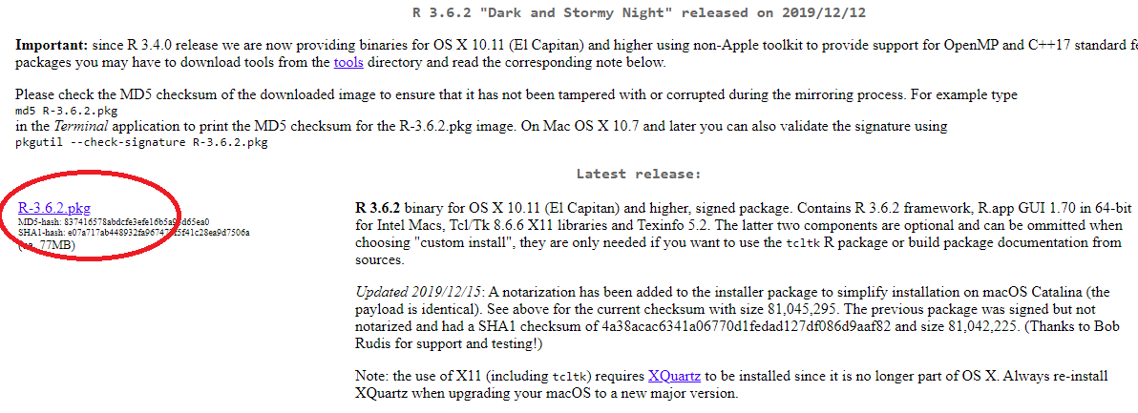

1. Save the .pkg file, double-click it to open, and follow the installation instructions.
2. Now that R is installed, you need to download and install RStudio.

**To Install RStudio**

1. Go to <http://www.rstudio.com/download>
2. Scroll down. Under “RStudio Desktop”, click "Download".
3. Click on the version recommended for your system, or the latest Mac version, save the .dmg file on your computer, double-click it to open, and then drag and drop it to your applications folder.

**Windows Users**

**To Install R**

1. Open an internet browser and go to <https://cloud.r-project.org>.
2. At the top of the page, under "Download and Install R", click the link "Download R for Windows".

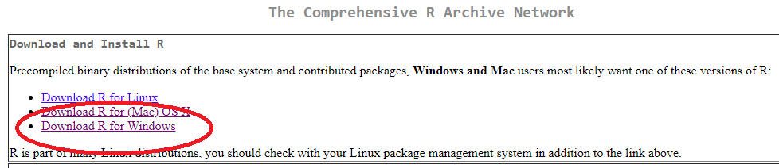

1. Click on the "install R for the first time" link at the top of the page.

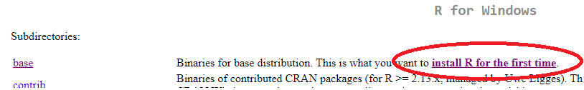

1. Click "Download R <*version-number*> for Windows" and save the executable file somewhere on your computer. Run the .exe file and follow the installation instructions.

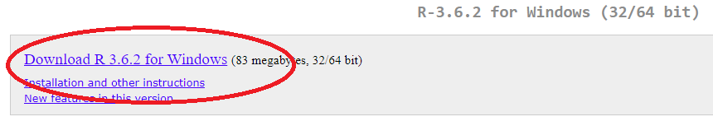

1. Now that R is installed, you need to download and install RStudio.

**To Install RStudio**

1. Go to <http://www.rstudio.com/download>
2. Scroll down. Under “RStudio Desktop”, click "Download".
3. Click on the version recommended for your system, or the latest Windows version, and save the executable file. Run the .exe file and follow the installation instructions.