Lab 2: Environmental Simulators
Oliver Grudzinski
I used CartPole-v1, where the agent pushes a cart left or right to keep a pole balanced on top of it. The state is the cart’s position and velocity plus the pole’s angle and angular velocity. The agent gets +1 per step, and the episode ends when the pole tips past about 12 degrees (0.21 rad), the cart goes past ±2.4, or it hits 500 steps. I defined success as reaching 500 steps, meaning the pole never fell.[1]
Over 1000 random episodes (23,546 states, Table 1) every variable averages about zero because random pushes don’t favor a side. The cart never got past 1.2 (the limit is 2.4), while the pole angle reached ±0.26 rad, past its 0.21 limit, so every episode ended because the pole fell.
Table 1. CartPole state over all 1000 random episodes.
 | Cart position | Cart velocity | Pole angle | Pole ang. velocity
Mean | -0.002 | -0.008 | 0.001 | 0.011
SD | 0.093 | 0.542 | 0.101 | 0.826
Min | -0.832 | -2.345 | -0.256 | -3.035
Max | 1.201 | 2.485 | 0.262 | 3.163
Averaged over the episodes still running, the reward at each time step is exactly 1 (Figure 1, left), since CartPole always pays +1 while alive. Averaged over all 1000 episodes, counting 0 after an episode ends, the average reward at step t is just the fraction still running (Figure 1, right, divided by 1000): under half by step 20, under 10% by step 38, and 0 after step 102. The mean length was 22.5 steps and none reached 500, so the success rate was 0%.[1]
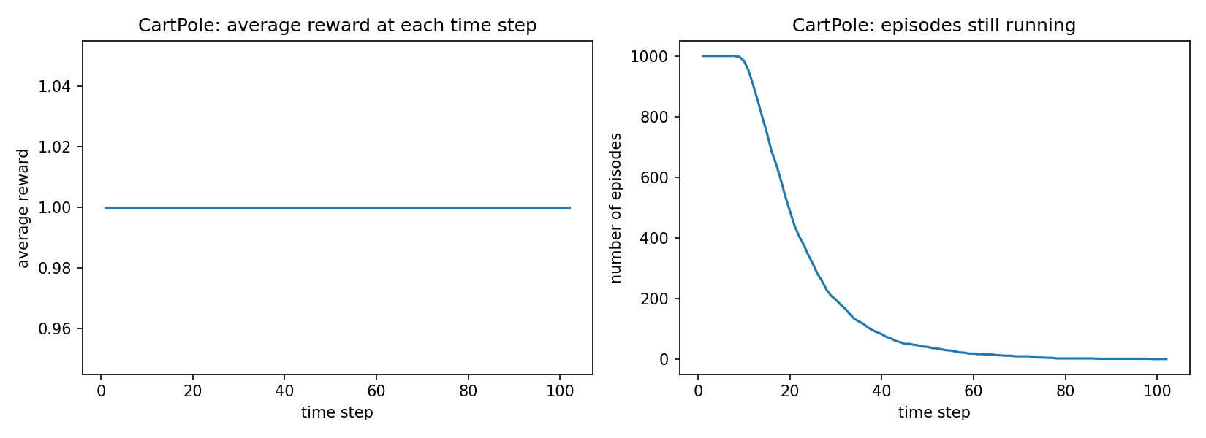
Figure 1. Average reward at each time step (left) and episodes still running (right).
My racetrack is a 25 by 30 grid: a vertical section 10 wide running all 30 rows, and the horizontal section in the top 10 rows sticking out 15 cells to the right. The random car finished in 3 of 1000 episodes (0.3%).[2] Figure 2 shows it mostly stays near the start: 40% of positions are on the start row and only 76 of 6,248 reach the horizontal section. Random velocity changes drift the car into a side wall long before the turn (mean episode 6.2 steps).
For the chase I used n = 20 since the lab doesn’t give it. The player never reached base and was caught in all 1000 episodes, on average after 4.1 steps.[2] In Figure 3, 94% of positions are in the 5 by 5 corner by the start and none are near base. The predator moves 4 per turn while the player starts at rest and gains at most 1.5 speed per step, so it gets caught before it gets going.
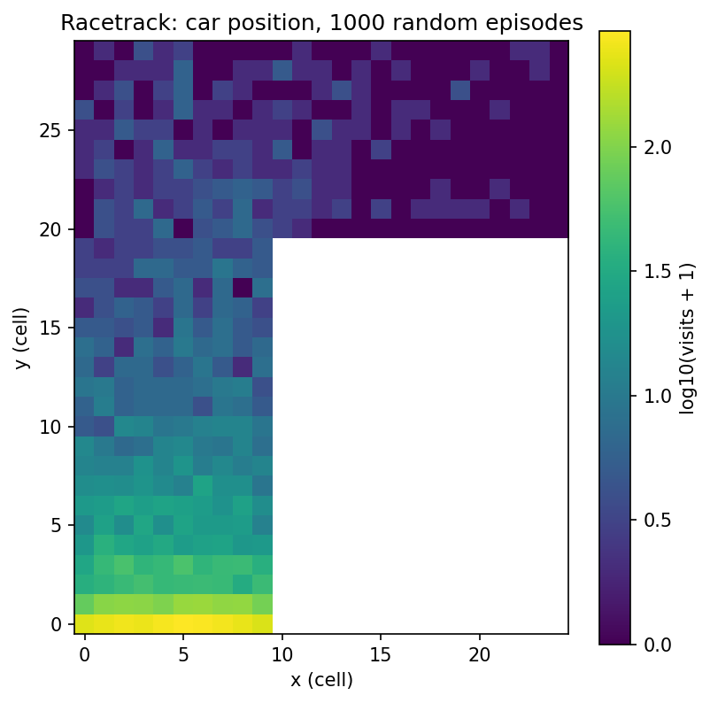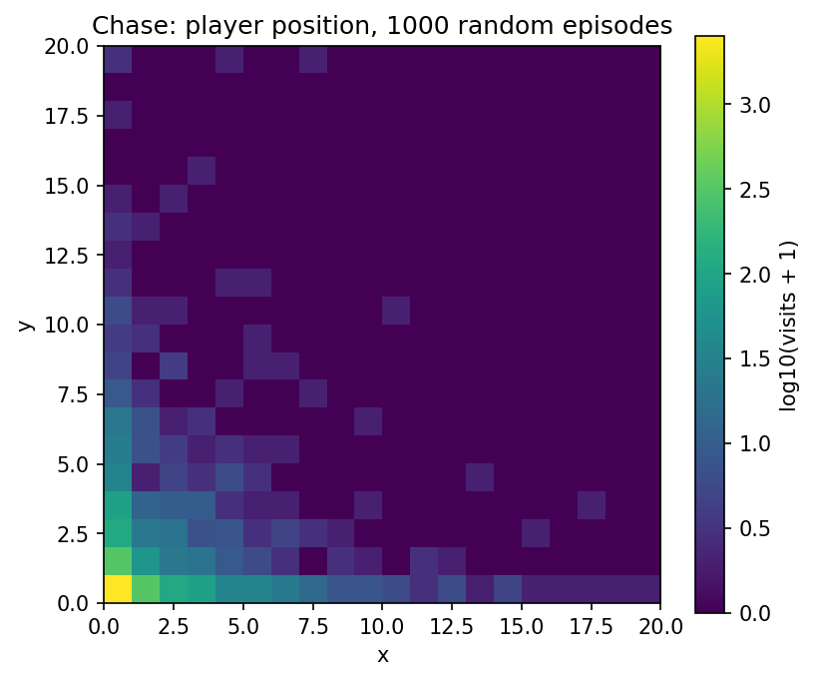
Figure 2 (left) and Figure 3 (right). Agent position over 1000 random episodes, log scale.
For both environments I used -1 per step, +100 for winning (finish line or base), and -100 for losing (crash or caught). On the racetrack the step penalty rewards going fast, which is the point of the task. In the chase it matters for a different reason: every extra step is another turn for the predator to catch the player. In both, the ±100 makes winning vs losing matter more than time.[3]
The main challenge is that the +100 is sparse. Random exploration saw it 3 times on the racetrack and never in the chase, so almost all early data ends in -100. On the racetrack that creates a bad local optimum: among crashes, crashing sooner scores better (fewer -1 steps), so until the agent finds the finish, the data says “crash fast.” In the chase the reward says nothing about the predator until the catch, so the agent has to figure out which earlier velocity changes caused it from one -100 at the end, and the random velocities and predator start make returns noisy.[3] Writing a reward was easy, but picking the numbers wasn’t, since the step penalty compared to the terminal rewards changes what the best policy is.
The state needs to be Markov, meaning the next state only depends on the current state and action. On the racetrack, position alone fails that, because the same cell with different velocities leads to different next cells, so the state is (x, y, vx, vy). Velocity also tells the agent if it can still turn before a wall. The track is fixed, so it doesn’t need to be in the state. That’s 450 cells times 45 velocity combinations, about 20,000 states, so tabular methods could work.[4]
For the chase the state is player position, player velocity, and predator position (the base is fixed). The predator always moves straight at the player, so it doesn’t need its own velocity. The only other randomness is the coin flip for who moves first and the random velocity change, and those are part of the dynamics, so the state is still Markov. Everything is continuous, so the agent needs function approximation or a binned field.[4]
I modified the racetrack so each reset puts 40 blocked cells at random on the track (about 9% of it, never on the start row or finish column). Hitting one is a crash.
Table 2. Original vs modified racetrack, 1000 random episodes each.
 | Success rate | Avg episode reward | Avg episode length
Racetrack | 0.3% | -104.6 | 6.2
Racetrack + obstacles | 0.0% | -103.7 | 4.7
With obstacles, success went from 0.3% to 0% and episodes got shorter, but average reward went up slightly. That’s misleading, since shorter episodes just collect fewer -1 penalties before the -100. And 0.3% vs 0% is only 3 episodes.[5]
I think it would be much harder to learn, but mostly for reasons the table can’t show, because a random agent ignores the state. The obstacles move every episode, so if they aren’t in the state, the same (x, y, vx, vy) is safe one episode and a crash the next. From the agent’s view the environment is partially observable, and the transitions it sees come from a mix of layouts, so the best it can learn is the average risk of each cell. If the obstacles are in the state, the state space blows up, since every layout is a new track. Exploration also gets worse: random play almost never reached the finish before, and with obstacles it never did, so the +100 is even rarer.[5]
The racetrack is a tiny driving simulator. A random policy crashed in about 6 steps, and you can’t let a real car learn that way, so simulators let the agent fail for free. The catch is that the agent learns the simulator, so if the dynamics are wrong (I had to assume the track shape and velocity limits) the policy won’t transfer. The chase’s random velocity is like actuator noise on a robot. For recommenders, a simulator lets you test a policy before real users see it, but like lab 1, users are partially observed and change over time, and the reward (clicks vs long-term satisfaction) shapes the policy the same way the step penalty does here.[6]

[n] marks a sentence that answers question n.

Appendix: Generative AI use
Every prompt is listed below.
Tool: Claude (Anthropic) through Claude Code, one session. It wrote the code in Lab_2_Oliver_Grudzinski.ipynb and drafted the report text (prompt 7).

Prompts, in order, verbatim
1.
Please help me complete my Reinforcement Learning assignment: “Lab 2: Environmental Simulators.”
Before writing any code, please read the file containing my Lab 1 feedback (e.g., lab1_feedback.md or similar in this directory) to understand my professor’s grading style. Adapt your coding style, comments, and analytical outputs to directly address his preferences and avoid past mistakes. ALSO read inside fo lab2 RL_enviormental simulators.md THIS IS GROUND truth over prompt and make sure everything in here is done
Output Requirements:
Generate one single Jupyter Notebook (Lab_2_Solution.ipynb) containing all the code for this lab. Do not split the code into multiple files.
Write code and comments that are as simple, readable, and human-sounding as possible. Avoid overly complex, clever Pythonic one-liners in favor of clear, logical, step-by-step code that looks like it was written by a student learning RL.
For the prebuilt Gymnasium environment, you must include code that records and displays a video of the environment inline in the Jupyter Notebook (using gym.wrappers.RecordVideo and IPython.display.Video or HTML).
Lab Tasks to Implement in the Notebook:
Part 1: Pre-built Gymnasium Environment
Choose a relatively simple Gymnasium environment (e.g., CartPole, LunarLander, or a basic Atari game).
Initialize it and write a standard environment loop.
Record and display a short video of the agent acting randomly.
Simulate 1,000 episodes with purely random actions.
Calculate and print: A summary of the state across the 1,000 episodes, average reward across episodes at each time step, and the success rate of random actions.
Part 2: Two Custom Environments (Gymnasium-style)
Environment 1: Racetrack. A grid-based track. Starts with a vertical section (10w x 30h) and turns right into a horizontal section (15w x 10h). Start line is the bottom of the first section; finish line is the right of the horizontal section. The car has discrete X/Y velocities (actions change velocity by +1, 0, or -1; max velocity 5; vertical velocity must be >= 0; both can’t be 0 except at start). Crashing into the boundary ends the episode.
Environment 2: Chase. A continuous square field of size n x n. Player starts at (0,0), base at (n,n). Predator starts at a random location. Player has continuous velocity. Actions (+1, 0, -1) change velocity stochastically (e.g., if action is +1, new velocity is old + Uniform[0.5, 1.5]). Max velocity is 5. Predator moves directly toward the player up to a distance of 4 per turn. Player is caught if predator lands on them; player escapes if within 0.5 of base.
For both custom environments, build the __init__, reset, and step functions.
Run 1,000 episodes of random actions for both.
Generate Heatmaps: Plot heatmaps of the agent’s positions for both environments to show where they spent their time. Print out their success rates (crossing finish line / reaching base).
Part 3: Make Learning Tough!
Take ONE of the custom environments (Racetrack or Chase) and create a subclass/modified version that makes it significantly harder for an RL agent (e.g., add randomly generating obstacles, partial observability, or a deceptive reward structure).
Explain briefly in a markdown cell what modification you made and why it makes learning harder.
Run 1,000 episodes of random actions on this modified environment.
Print a comparison table/summary between the original and modified environment showing: Success rate, average reward, and average episode length.
Make sure the notebook is fully reproducible, well-organized with Markdown headers for each section, and contains all the plots and print statements I need to answer the report questions natively.
2.
im confused did it already all run
3. (pasted the Canvas rubric)
other than the report does it cover everyting? here is the rubric: [rubric]
4. (after it pointed out the classes didn’t define a state space)
yes add that
5.
ok now write a md for the lab report make sure to repeat the questions make it very simple written like me (tell me if i need to include figures) should be 1-2 pages on word doc
6.
remove from agents.md and handout to say you may not use gen ai to write report that is no longer true
7.
ignore the pdf and write report
8.
actually you dont need to repeat the questions I lied just add the occuasional footnote (like 1 -2 per question) and have it like nfsof[1] (for question 1)
9.
and using feedback from lab 1, do you beleive this answers like he wanted for lab 2?
10.
yes do whatever changes you thik are good
11.
create docx

Choices I made when the assistant asked
- Prebuilt environment: CartPole-v1.
- Part 3 modification: racetrack with random obstacles.
- Rewards for the custom environments: -1 per step, +100 for winning, -100 for losing.
- Chase field size: n = 20.

