Lab 3: Classical Reinforcement Learning
Oliver Grudzinski
I used the example race_environment class as-is, with a small subclass so a crash sends the car back to the start line and the episode keeps going. The state is (x, y, vertical speed, horizontal speed). Position alone isn’t Markov because the same cell at different speeds leads to different places, and the track never changes so it doesn’t need to be in the state.[1] Reward 1 is the example reward: 1 / max(1, squared distance to the middle of the finish line) each turn, and 10 for crossing. Reward 2 is mine: -1 every turn, so the return is minus the number of turns and the fastest race is the best one.[1]
With random actions the car took 3,463 turns on average to finish the modified track, but it always finished. On the original track, where a crash ends the race, it finished 1 of 100 races.[2] The modification helps since every episode eventually reaches the +10, so the finish actually shows up in the data. But reward 1 is always positive, so nothing punishes a long race, and a crash only costs the reward the car would have gotten later. With γ = 0.9, sitting next to the finish forever is worth 1 / (1 - 0.9) = 10, the same as crossing it.[2]
I trained each algorithm on both rewards for 3,000 episodes with ε = 0.1, γ = 0.9, α = 0.5, Q starting at 0, and a 1,000-turn cap that counts as a fail.[3] Episodes start near the cap and drop to 25 to 70 turns (Table 1, Figures 1 and 2). Training time follows episode length since every turn is one step and one update, so most of the compute goes into the first few hundred episodes.[3]
Table 1. Training results. Greedy = 100 test races with ε = 0 after training.
Algorithm | Reward | Total turns | Length, first 100 | Length, last 100 | Greedy length | Greedy success
MC | 1 | 133,503 | 156 | 30 | 17.1 | 100%
SARSA | 1 | 843,927 | 986 | 40 | 19.3 | 100%
Expected SARSA | 1 | 209,005 | 945 | 28 | 16.3 | 100%
MC | 2 | 137,588 | 624 | 25 | 12.9 | 100%
SARSA | 2 | 687,958 | 780 | 71 | 201 | 85%
Expected SARSA | 2 | 686,284 | 728 | 67 | 29.4 | 100%
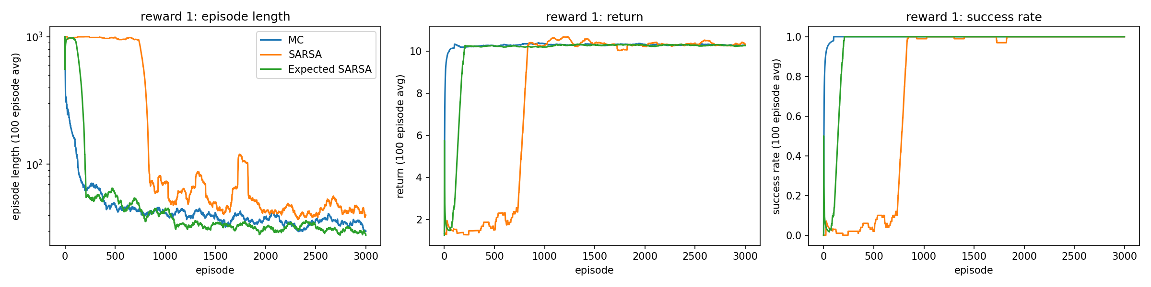
Figure 1. Reward 1, 100-episode moving averages.
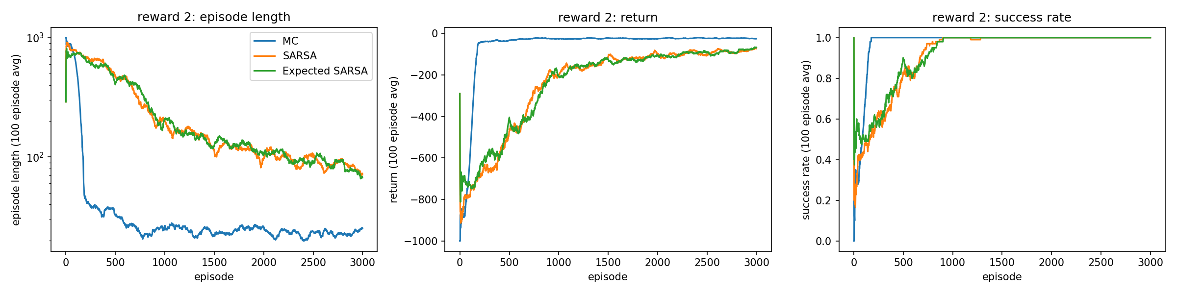
Figure 2. Reward 2, 100-episode moving averages.
MC was the most sample efficient on both rewards, using the fewest total turns by far (Table 1).[3] One MC update pushes the final reward back to every state in the episode, while TD(0) only moves it back one step per visit. On reward 1, SARSA was stuck near the cap for about 800 episodes because any action it tried got a positive value and beat the untried 0s. On reward 2, Q = 0 is optimistic, so the TD agents kept trying new actions and were still improving at 3,000 episodes.[3]
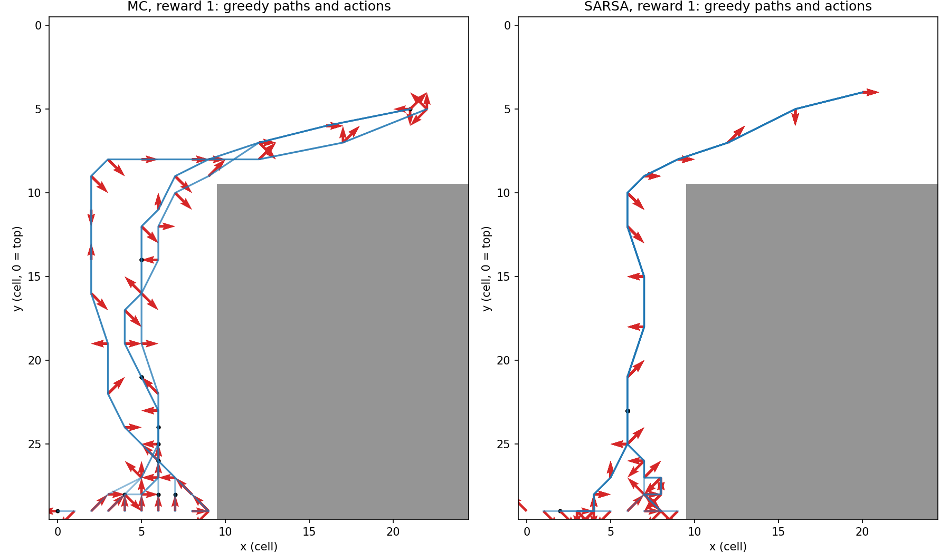
Figure 3. Greedy races from each start cell. Arrows show the velocity push, dots mean no change.
On reward 1, MC and SARSA both drive up the middle of the vertical section, push right around y = 10, and cross at about y = 5, which is where reward 1 peaks. SARSA funnels every start cell into one line, while MC uses two or three routes.[4]
All Q-values start at 0. With reward 1, the best start-line values ended at 0.75 (MC) and 0.50 (SARSA), which fits a +10 discounted over a 20-ish turn race (10 × 0.9^20 ≈ 1.2). With reward 2, MC’s start value is -8.6, right in the range its 13 to 25 turn races give (-7.5 to -9.3). SARSA’s is -5.8, which would mean an 8-turn race, so it hasn’t converged. Bootstrapping off neighbors that are still near 0 keeps it too optimistic.[5]
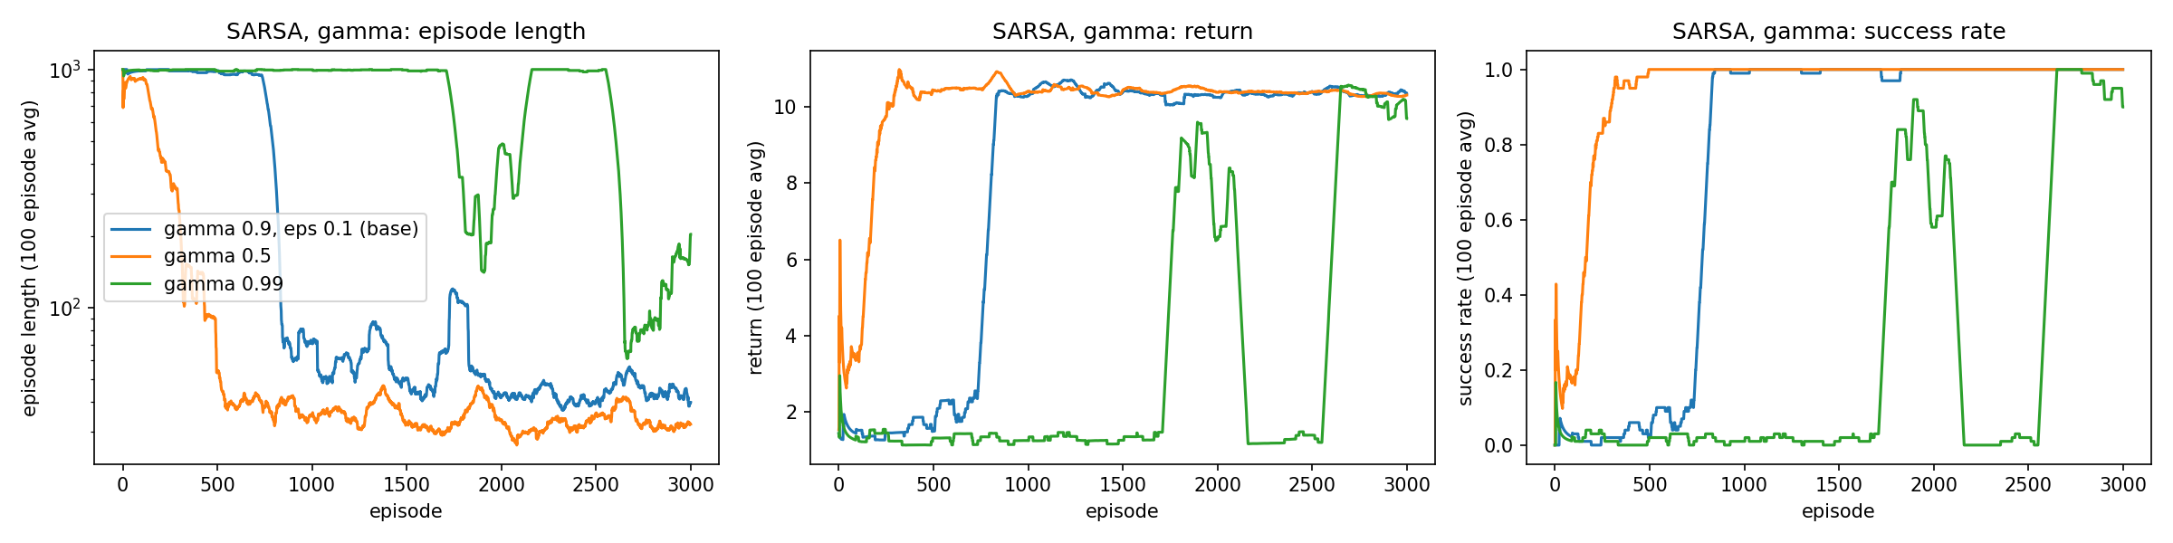
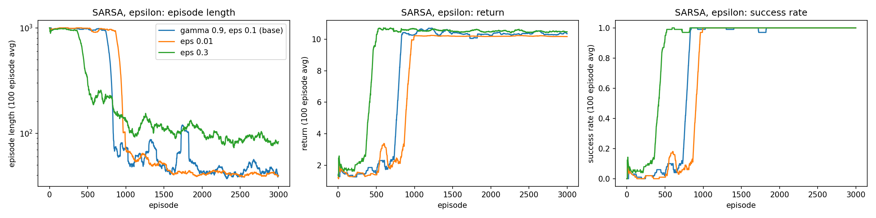
Figures 4 and 5. SARSA on reward 1 with different γ (top) and ε (bottom).
γ mattered more than ε. γ = 0.5 learned about twice as fast, since a short horizon mostly follows reward 1’s distance term, which already points at the finish. γ = 0.99 failed, and its greedy policy just parks on the start line. Parking is worth about 0.09 vs about 8 for finishing, so that’s a learning problem, not what the reward wants. I think with a 100-turn horizon every target includes lots of crashes back to the start, so the estimates stay noisy.[6] Higher ε found the finish sooner (episode 500 for ε = 0.3 vs 850 for 0.1) and gave the best greedy policy (15.4 turns), but its training episodes stayed twice as long because 30% of its moves are random.[6]
To wreck learning I reran all three algorithms on two broken setups. Failure 1 was ε = 0 with reward 1. Since the rewards are positive and Q starts at 0, the first action tried in a state stays greedy forever, and since the agent’s policy decides what data it collects, it never sees anything else. All three got 0% success, and the MC agent just drove into the same wall over and over (107 crashes in 1,000 turns).[7] Failure 2 was +1 every turn. Longer races are worth more now, so the best policy never finishes, and success dropped to 0 to 3%.[7]
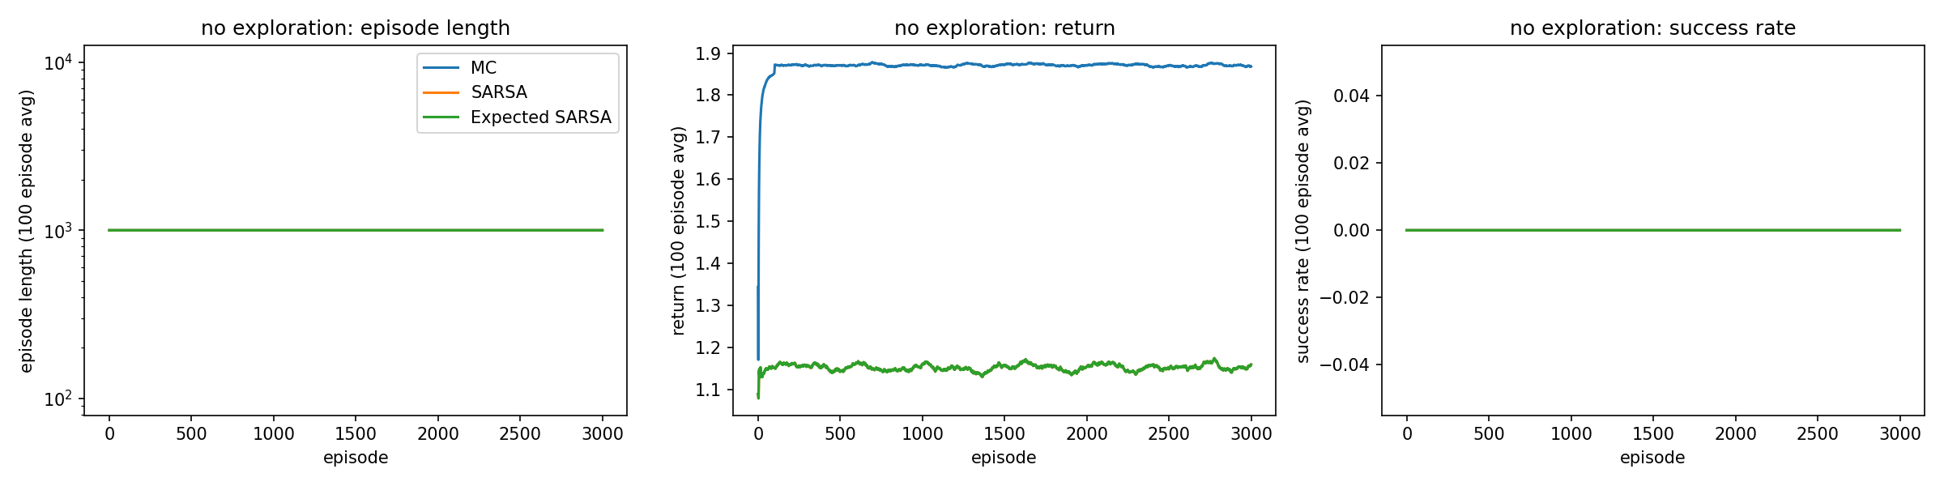
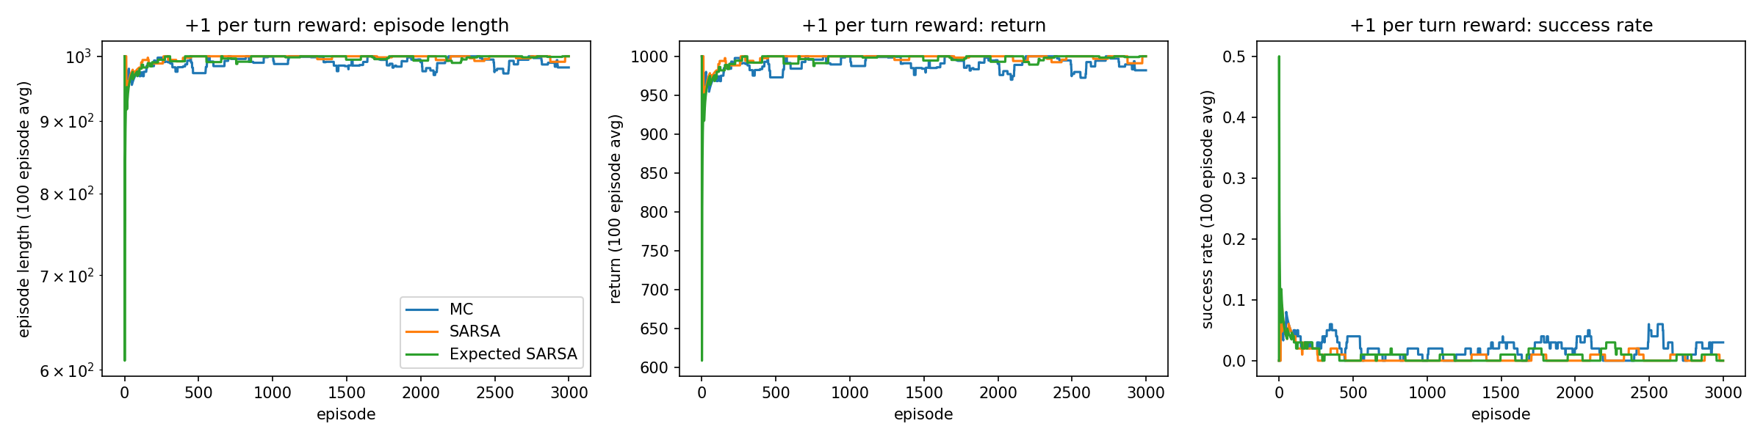
Figures 6 and 7. Failure 1 (ε = 0) and failure 2 (+1 per turn).
I fixed failure 1 without turning ε back on by starting every Q at 20, which is above anything reward 1 pays. Untried actions now look better than tried ones, so a greedy agent still tries everything before settling. All three got back to 100% success (Figure 8), MC in about 150 episodes and the SARSAs in about 900 (with ε = 0 they’re the same update). MC was the most robust overall. It recovered fastest, was the most sample efficient in normal training, and never got stuck like SARSA did.[7]
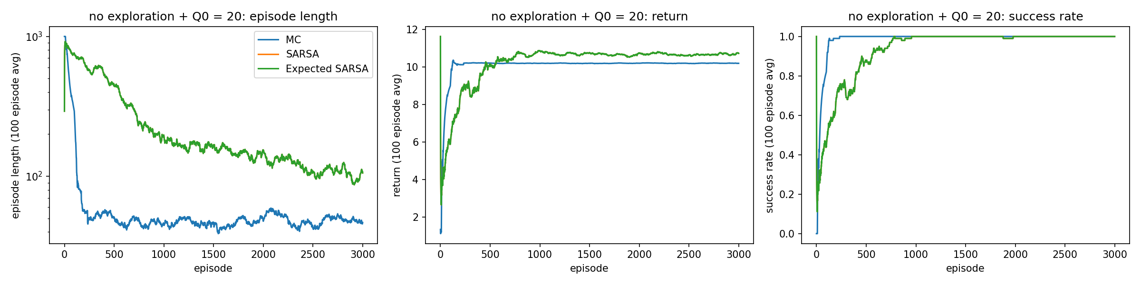
Figure 8. Repair of failure 1: ε = 0 with Q starting at 20.

[n] marks a sentence that answers question n.

Appendix: Generative AI use
Every prompt is listed below.
Tool: Claude (Anthropic) through Claude Code.

Prompts, in order, verbatim
1.
use markitdon to convert rl_classical alorgithms pdf to md
2.
remove that from agents.md ai can write
3.
include this rubric too
(followed by the Canvas “Monte Carlo Rubric” pasted as text, now copied into RL_Classical_Algorithms.md under “Grading Rubric”)
4.
help me look at lab_3 and help me do the lab look at the markdown for the lab guidance, also look at lab 1 with the feedback and how he graded and use that to guide you. write everything as simple as possible, and inside of one jupter notebook. (make sure agent.md) and make everything sound like my college level writig and my wiritng style, really simple code commetns etc put it in the point of view as being me.
Act as an expert in Reinforcement Learning and Python. I need to complete a lab assignment focusing on Classical Reinforcement Learning in a custom Racetrack gridworld.Please write the complete code for this assignment in a single, well-commented Jupyter Notebook structure (using code blocks for cells). To avoid indexing errors and state-space complexity, you must use Python dictionaries to store Q-values and state visit counts (e.g., Q[state][action]) rather than pre-allocated NumPy arrays. Keep the code as simple, readable, and standard as possible. Do not add unnecessary features.Here are the exact requirements to implement in order:1. Environment Setup (The Modified Racetrack)Grid: Vertical section 10 wide x 30 high. Right turn into horizontal section 15 wide x 10 high (Total bounding box is 25 wide x 30 high).Start line: Bottom row of the first section.Finish line: Rightmost column of the horizontal section.State: (x, y, v_x, v_y).Actions: 9 possible combinations of changing velocities by +1, -1, or 0.Constraints: $0≤v_{y}<5$ and $−5<v_{x}<5$. Both velocities cannot be 0 except at the starting line.Dynamics: If the car attempts to go through the track boundary (crashes), it is automatically returned to a randomly selected position on the starting line, its velocity is set to 0, and the episode continues (do not terminate the episode on a crash). Crossing the finish line ends the episode.2. Random SimulationCreate a simulation function and run 100 races with random valid actions. Print the average number of turns it takes to finish.3. Reward FunctionsImplement reward_1 (Professor’s reward): $r(s^{′},a,s)=10$ if crossing the finish line, else $r=1/max(1,((x−\text{track_width})^{2}+(\text{horizontal_track_width}−y)^{2})^{1/2})$.Implement reward_2 (Custom): Design a very simple, standard alternative reward function (e.g., -1 for every step, -10 for a crash, +100 for finishing).4. RL AlgorithmsImplement the following algorithms to train agents. Train each for a reasonable amount of episodes (e.g., 2,000 - 5,000). For each, record episode length, average return, and success rate over training.On-policy, first-visit Monte Carlo Control with $ε$-soft policies.SARSA with $ε$-greedy policies.Expected SARSA with $ε$-greedy policies.5. “Wreck the Learning” ExperimentsCreate a function or configuration to purposefully ruin the learning (e.g., setting $ε=1.0$ for pure random exploration, or $γ=0$ for zero foresight).Run this broken configuration on SARSA to prove it fails (record metrics).Run a “repaired” version showing recovery.6. Visualizations (Matplotlib)Plot learning curves comparing the algorithms (Episode vs. Episode Length, Average Return, and Success Rate).Plot a visualization of the learned policy for two different agents on the track (e.g., drawing arrows for the greedy action’s velocity change at each track cell, assuming $v_{x}=0,v_{y}=0$).Please generate the complete, self-contained Python code. Prioritize robust boundary-checking in the environment step() function and use dictionary-based Q-tables to guarantee no array dimension mismatch errors.
(Claude used the provided example race_environment class and reward as-is instead of rebuilding the environment from the spec above, per the lab 1 feedback.)
5.
is it done
6.
is it done now
7.
ok a few things on the report, it should only be max 2 pages worht of text, and dont say my professor it is being submited to the preffesor just say example and write more like my wirint style
8.
well it is okay to have more pages with the figures but the text should only be so much

