1.

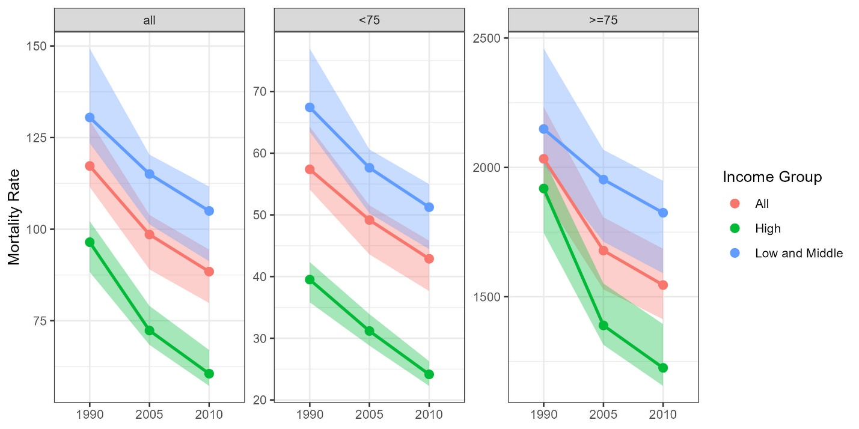

2.

I chose a line graph because this is typically used when time is involved

Area (ribbons) seemed to look better than area bars

It seems like they wanted to compare the income groups so that’s what I put inside of each group.

* Since the >=75 group has much larger values, I thought it was best to let those axes be free.
* If we were to put different colors by age group in the same plot, then the >=75 group would dominate, and we wouldn’t be able to compare

3.

A few things to note

* They seem to want to compare if the metrics change over time (I think this because this is the pvalue they report for – not across ages or income groups)
* It wouldn’t really be possible to plot all metrics on the same figure due to their large different scales
* I personally think boxplots would be best, and they are what I would have used if we had the data for it

So I think what I would try is to do something similar to the figure above, except with boxplots. Then instead of just a single line of plots, I would have a grid of plots, where each row corresponds to a metric and the column corresponds to the age group (or vice versa).

Then you could add stars to indicate which metrics significantly vary over time.

It is worth noting that the plot would change a lot if they were interested in something other than the change over time.

I don’t think the total sample sizes add much, so I’ve omitted them from the figure