# Mean absolute error

In [statistics](http://en.wikipedia.org/wiki/Statistics), the **mean absolute error (MAE)** is a quantity used to measure how close forecasts or predictions are to the eventual outcomes. The mean absolute error is given by



As the name suggests, the mean absolute error is an average of the absolute errors , where is the prediction and the true value. Note that alternative formulations may include relative frequencies as weight factors.



**Mean Bias Error (MBE)**

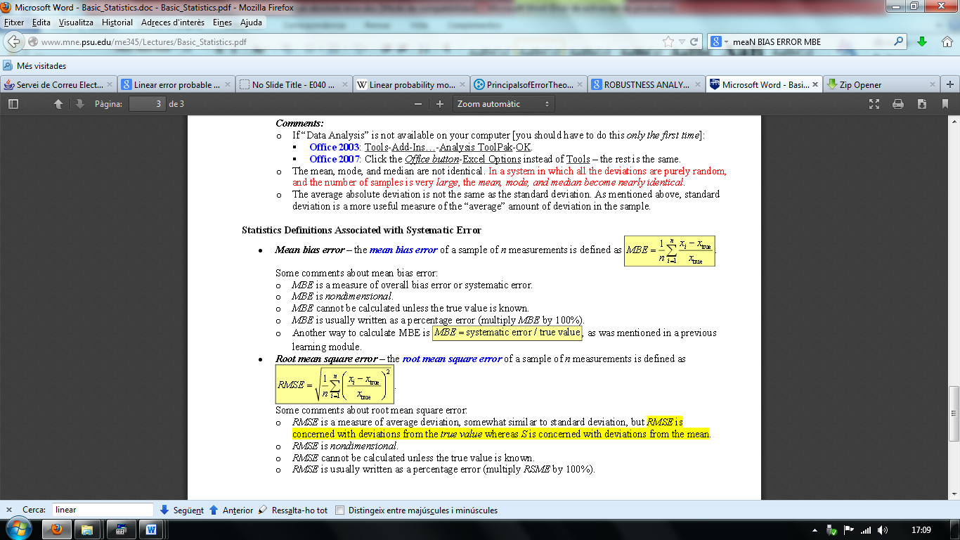

Normalized RMSE

NRMSE = [RMSE / (xmax - xmin)], on xmax = valor observat màxim; xmin = valor observat mínim

PAE

?

Mean Squared error



Mean Error

Igual que Mean absolute error però sense el valor absolut

SNR

Només he trobat això:

SNR=MEAN/STD.DEV

que és el coeficient de variació.

PSNR **Peak signal-to-noise ratio**

