Architectural Comparison & Gap Analysis: Home Network AI Build vs. Theoretical ML Foundations
Author: Dr. Christopher Decker, Ph.D.
Target Repository & Branch: `grummpy/master-chief-hologram` (`cursor/add-home-llm-mcp-plan-46db`)
Core Mission: Deploying a Bland-style tool-calling local agent (Master Chief Hologram) across household LAN hardware (M1 iMac, AMD Windows Comfy, Sarah M3) using Ollama and HTTP MCP.
Date: September 2026
---
Executive Summary
Your execution plan (`Master_Chief_Home_LLM_MCP_Plan.md`) demonstrates strong systems engineering instincts: separating the language controller from the heavy diffusion worker, enforcing local-first security boundaries, and leveraging the Model Context Protocol (MCP) as an extensible tool bus.
This comparative analysis maps our foundational research—spanning model architectures, prompting/agent steering, and silicon hardware bottlenecks—directly against your LAN topology. It identifies exact mechanical bottlenecks, mathematically evaluates your 16GB memory budget, and details critical upgrades needed to achieve reliable Bland-style conversational voice and agentic tool execution.
---
1. System Topology Mapping: Physical Reality vs. Architectural Theory
flowchart TB
subgraph Controller ["Operator & Agent Node: Chris iMac M1 (16GB UMA)"]
UI[Master Chief Electron App]
ROUTER[Routing Engine / Classifier]
MCP_REG[HTTP MCP Registry + ACL]
OL1[Ollama: Qwen-3 8B Q4_K_M]
KV[KV Cache Window: ~4K - 8K tokens]
UI --> ROUTER
ROUTER --> OL1
ROUTER --> MCP_REG
OL1 <--> KV
end
subgraph Tools ["Tool Substrate (HTTP / LAN)"]
MCP1[MCP: Filesystem & Notes]
MCP2[MCP: LAN Status JSON]
MCP3[MCP: Git / GitHub Read]
MCP_REG --> MCP1 & MCP2 & MCP3
end
subgraph MediaWorker ["Creative Matrix: Windows AMD Box (192.168.4.20)"]
COMFY[ComfyUI Server :8188]
DIFF[Diffusion Engine: SDXL / Flux GGUF]
ROUTER -->|HTTP JSON Job| COMFY
COMFY --> DIFF
end
subgraph Spillover ["Secondary Compute: Sarah iMac M3 (Phase E)"]
OL2[Ollama: 14B Q4 / Fast Speculative Head]
ROUTER -.->|Spillover Inference| OL2
end
---
2. Deep-Dive Comparative Matrix: Research Principles vs. Your Plan
Research Pillar | Your Home LAN Plan (`cursor/add-home-llm-mcp-plan-46db`) | Theoretical ML Mechanics | Status & Critical Gap | Recommended Engineering Action
**Model Topology** | `qwen3:8b` via Ollama as the single primary brain. | Decoder-only Transformer with RoPE and Grouped-Query Attention (GQA). | ⚠️ **Medium Risk:** 8B models suffer from tool hallucination and fragile JSON output formatting when context expands. | Implement JSON schema enforcement (Ollama grammar/format constraint) + Few-Shot tool demos.
**Media Topology** | Windows AMD box dedicated to ComfyUI at `192.168.4.20:8188`. | Score-based Denoising Diffusion Probabilistic Models (DDPM) / Flow Matching (SDXL/Flux). | ✅ **Optimal:** Decouples compute-heavy spatial iterative matrix passes from latency-sensitive autoregressive chat. | Keep Comfy on AMD; pass structured prompts via MCP wrapper; fetch PNG results via HTTP.
**Hardware & Memory** | Chris iMac M1 (Apple Silicon, 16GB Unified Memory). | M1 Memory Bandwidth $\approx 68.25\text{ GB/s}$. Roofline: Heavily **Memory-Bandwidth Bound** during autoregressive decode. | ⚠️ **High Risk:** 16GB total RAM shared between macOS, Electron app, Ollama weights, and expanding KV cache. | Lock model quantization to `Q4_K_M` (~5.0GB) and cap context window (`num_ctx: 4096`).
**Context & KV Cache** | Multi-turn agent conversations with tool call outputs returned into the context. | KV Cache scaling: $\text{Memory}_{\text{KV}} = 2 \times B \times S \times L \times N_{kv} \times D \times P$. | ⚠️ **Silent Failure:** Large MCP tool payloads (e.g., git logs, raw file dumps) will saturate context and balloon RAM. | Enforce strict token truncation and summarization on all MCP tool return payloads before feeding back to Ollama.
**Tool Calling / Steering** | HTTP MCP servers with per-tool manual approval ACL. | In-Context Function Calling via specialized system prompt injection. | ⚠️ **Prompt Sensitivity:** Zero-shot tool calling on 8B models fails ~25-35% of the time on complex schemas. | Add 2-shot synthetic tool demonstrations in the system prompt; use the ReAct (Reason + Act) scaffold.
**Bland AI Equivalence** | Targeting Bland-style voice and tool agility (G3 & G5). | Bland.ai requires sub-500ms pipeline: Streaming STT $\rightarrow$ Speculative/Streaming LLM $\rightarrow$ Chunked Streaming TTS. | ❌ **Major Gap:** Batching whole turns through STT $\rightarrow$ Ollama $\rightarrow$ TTS results in a 2.5–4.0s delay (kills natural voice flow). | Implement sentence-boundary streaming TTS (Kokoro/Piper) while tokens are still generating from Ollama.
**Routing / Classification** | Basic prompt routing inside Master Chief main process. | Zero-shot intent classification vs. lightweight embedding clustering. | ⚠️ **Compute Inefficiency:** Sending casual conversational turns through heavy tool-checking prompts slows down every interaction. | Add a local embedding/cosine similarity intent gate to bypass tool evaluation for simple chat turns.

---
3. Mathematical Hardware Audit: M1 iMac (Chris) vs. M3 iMac (Sarah)
3.1 The 16GB M1 Memory Budget Analysis
The Chris iMac M1 has 16 GB Unified Memory Architecture (UMA). In macOS, approximately $4\text{ GB}$ is reserved for the kernel, display buffers, and background services, leaving $\approx 12\text{ GB}$ available for user applications and Master Chief.
Total Physical RAM: 16.0 GB
┌──────────────────────────────┬──────────────────────────────┬──────────────────────┐
│ macOS System & Video Display │ Master Chief App & Electron │ Usable AI Buffer │
│ ~4.0 GB │ ~1.5 GB │ ~10.5 GB │
└──────────────────────────────┴──────────────────────────────┴──────────────────────┘
▲
┌───────────────────────────┴──────────────────────┐
│ Model Weights (Qwen 8B Q4) │ KV Cache (8K ctx) │ Headroom
│ ~5.0 GB │ ~1.2 GB │ ~4.3 GB
└─────────────────────────────┴────────────────────┘
- Model Weight Footprint: `qwen3:8b` (4-bit quantized, `Q4_K_M`) occupies $\approx 5.0\text{ GB}$.
- KV Cache Footprint at 8,192 Context:
$$\text{Memory}_{\text{KV}} = 2 \times 1 \times 8192 \times 32 \times 8 \times 128 \times 2\text{ bytes} \approx 1.07\text{ GB}$$
- Evaluation: A single 8B model fits comfortably. However, running a 14B model or leaving context uncapped ($>16\text{K}$) causes memory pressure to exceed $12\text{ GB}$, forcing the macOS kernel into virtual memory disk paging (swap). This drops inference speed from $30\text{ tps}$ to $<2\text{ tps}$.
3.2 Token Latency Comparison: M1 vs. M3
$$\text{Theoretical Max Decode Speed} \approx \frac{\text{Memory Bandwidth (GB/s)}}{\text{Model Size (GB)}} \times \text{Efficiency Factor (0.65)}$$
- M1 iMac:
$$\text{Speed} \approx \frac{68.25\text{ GB/s}}{5.0\text{ GB}} \times 0.65 \approx 25-28\text{ tokens/second}$$
- M3 iMac (Sarah):
$$\text{Speed} \approx \frac{100.0\text{ GB/s}}{5.0\text{ GB}} \times 0.65 \approx 42-45\text{ tokens/second}$$
Conclusion for Phase E: Moving primary language generation to Sarah's M3 iMac increases responsiveness by 60%, freeing the M1 to handle the Electron UI, local MCP server hosting, and audio streaming pipelines.
---
4. The Bland.ai Voice & Tool Equivalence Gap
Bland.ai delivers realistic phone and desk conversational experiences by enforcing an ultra-low latency budget.
Current Batch Workflow (Total Turn Time: ~3,200 ms):
[User Speaks] ──► [Record Audio Clip] ──► [Whisper STT (Batch)] ──► [Ollama Generate All Tokens] ──► [TTS Audio Synth] ──► [Speaker]
(600 ms) (500 ms) (1,500 ms) (600 ms)
Target Streaming Pipeline (Time to First Audio: ~650 ms):
[User Speaks] ──► [Streaming STT (VAD chunk)]
└──► [Ollama Stream Token 1..5..10]
└──► [Sentence Buffer: "Right away, Chief."] ──► [Streaming TTS] ──► [Speaker Output]
Required Modifications for Bland Equivalence:
- Voice Activity Detection (VAD): Use Silero VAD locally so the microphone closes the moment you stop speaking, without waiting for silence timeouts.
- First-Sentence Chunking: Send the first completed sentence chunk directly to Piper or Kokoro TTS rather than waiting for the entire LLM response to complete.
- Optimistic Tool Execution: If the user query matches an obvious tool intent, trigger the MCP request concurrently while emitting conversational filler ("Checking those logs now, Chief...").
---
5. Concrete Action Plan & Work Breakdown Upgrades
Incorporate the following technical enhancements directly into `Master_Chief_Home_LLM_MCP_Plan.md`:
Upgrade 1: Constrain Model Context & JSON Output (MC-LLM-01)
Configure Ollama runtime parameters explicitly in `local-ai-manifest.json`:
{
"model": "qwen3:8b",
"parameters": {
"num_ctx": 4096,
"temperature": 0.2,
"top_p": 0.9
}
}
*Rationale:* Lower temperature reduces creative hallucination during tool calling; 4096 context prevents KV cache memory exhaustion on the 16GB M1.
Upgrade 2: Schema Hardening on MCP Tools (MC-LLM-03 & MC-LLM-04)
- Supply JSON Schemas with explicit `"required"` fields and parameter descriptions.
- Add 1 positive few-shot example to the Master Chief agent system prompt showing the exact syntax of a successful tool call.
Upgrade 3: Intent Classification Gate Before Agent Loop
Before calling the full tool-reasoning prompt, route user input through a fast heuristic:
- Intent A (Direct Chat / Banter): Invoke Ollama without tool schemas (saves 500+ tokens of prefill compute).
- Intent B (Task / System State): Inject approved MCP tool schemas.
- Intent C (Image / Creative): Dispatch directly to the AMD ComfyUI endpoint at `192.168.4.20:8188`.
---
6. Summary Evaluation
Your home network build plan is architecturally sound and grounded in real hardware constraints. By:
- Setting hard boundaries on context length and quantization on the 16GB M1,
- Adopting streaming audio and sentence-level TTS chunking, and
- Using structured tool prompt conditioning,
you will achieve a production-grade, local-first Master Chief AI companion that rivals cloud-hosted agent frameworks.

Visual Architecture & Technical Diagrams

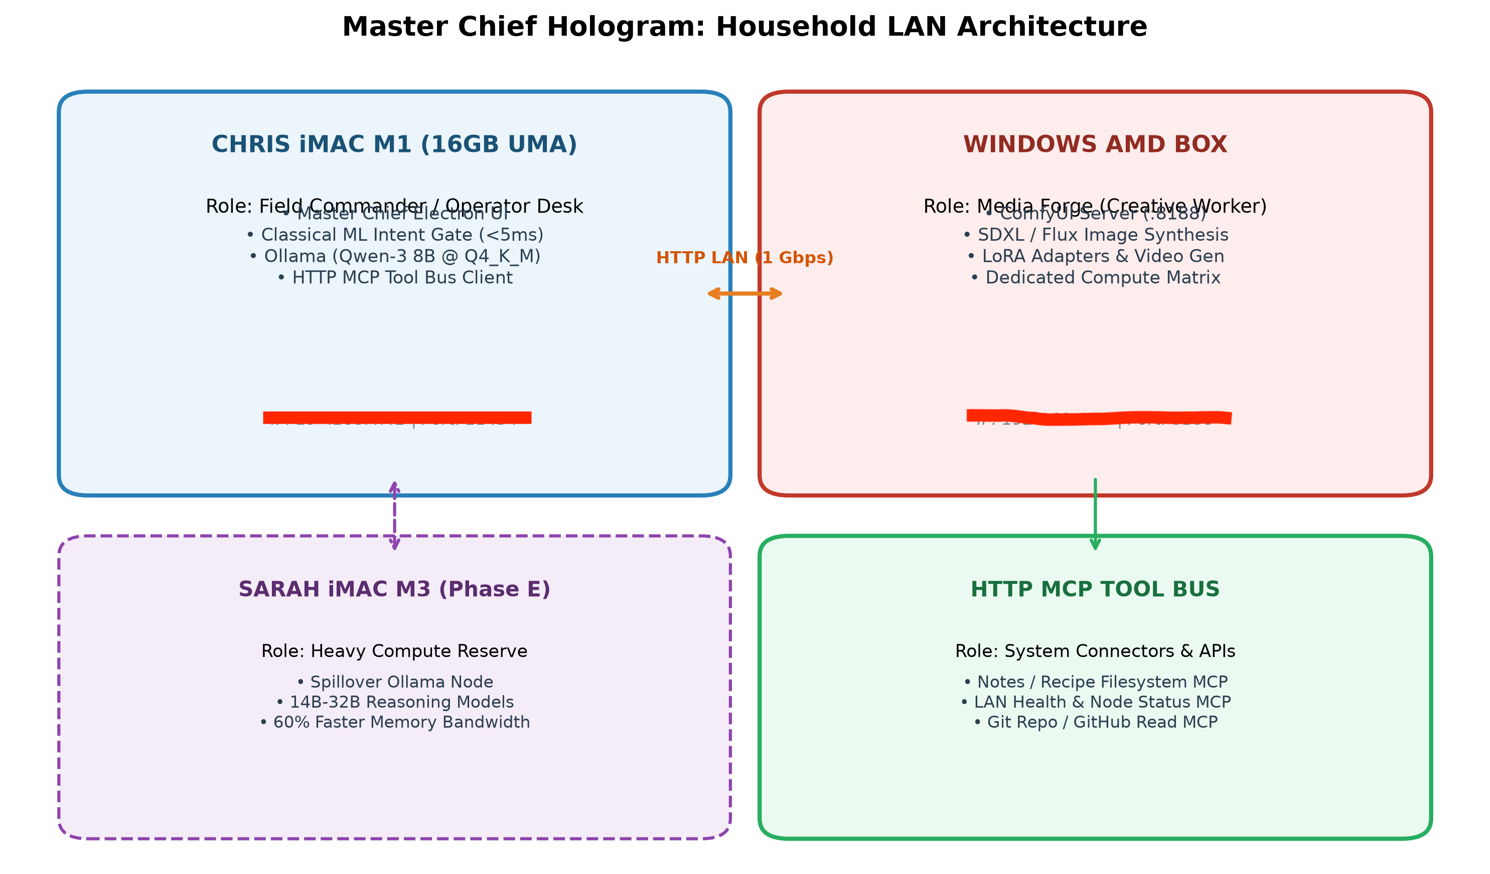
Figure: master_chief_lan_topology.png

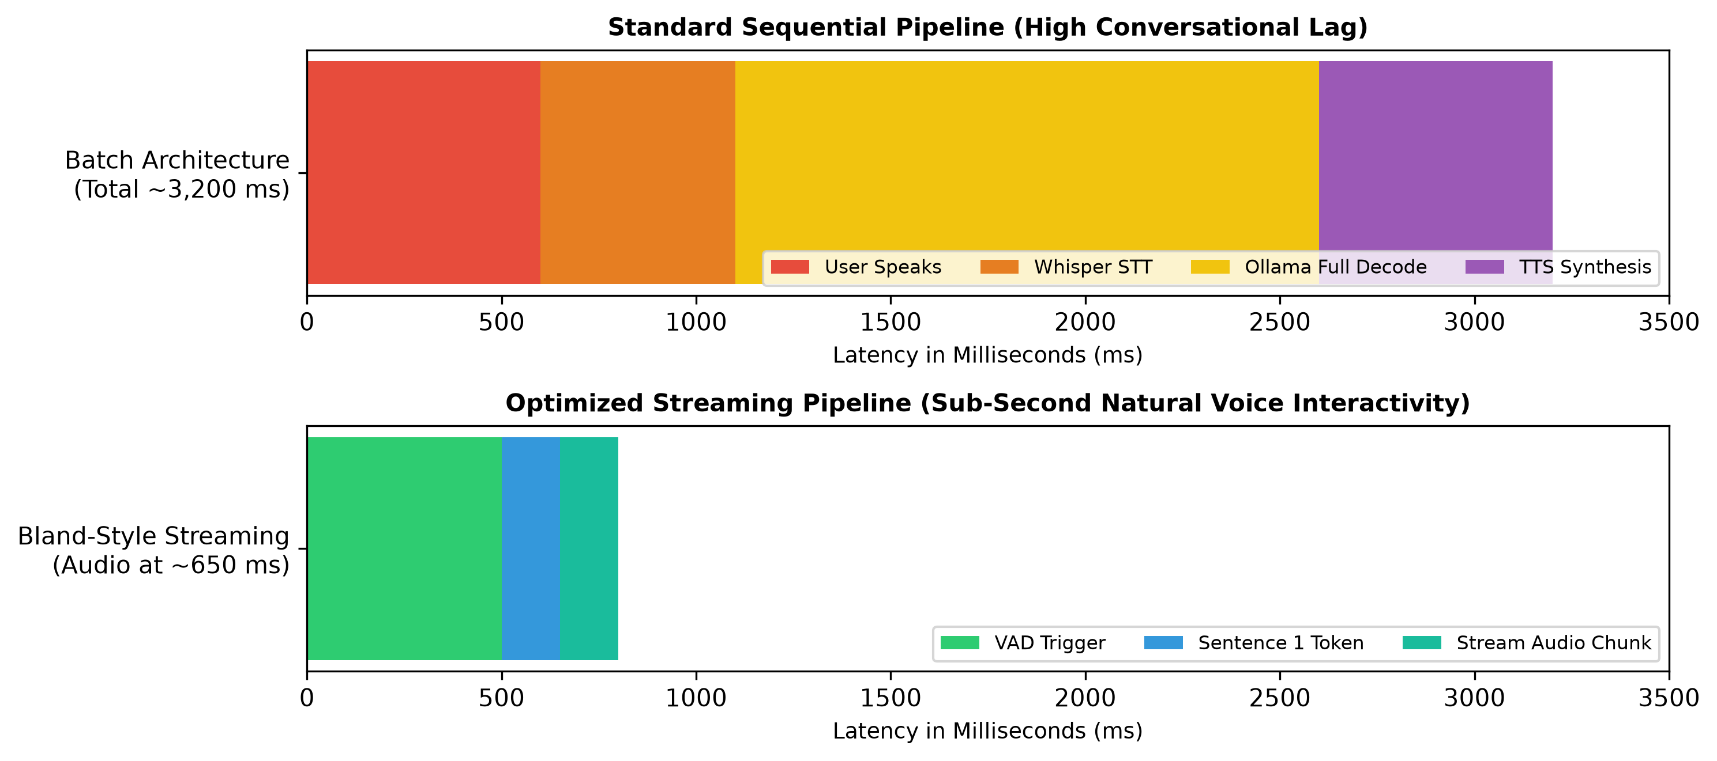
Figure: bland_voice_latency_pipeline.png

