Copilot Session Chat Logs & Review Record
- Session ID: `69b62c42-9ab8-4d02-8712-d10b8695d3ce`
- Session Name: Machine learning research
- Branch: `grummpy-ml-model-background-research`
- Repository: `grummpy/CS-530`
- Associated Pull Request: #12 (Merged)
- Export Date: September 25, 2026
---
Generated Session Artifacts
- `research/machine_learning_models_and_hardware_comparative_analysis.md` — Formal Ph.D. level research monograph comparing models, prompting paradigms, and hardware substrates.
- `research/master_chief_ml_bootcamp_10th_grade.md` — Visual, 10th-grade Spartan field manual covering regression, trees, clustering, neural nets, transformers, and GPUs vs. CPUs.
- `research/home_network_llm_mcp_comparative_analysis.md` — In-depth gap analysis and comparison with the Master Chief Hologram LAN build plan (`cursor/add-home-llm-mcp-plan-46db`).
- `research/ml_vs_deep_learning_connection.md` — Illustrated guide on the hierarchical connection between AI, Classical ML, and Deep Learning.
- `research/master_chief_app_system_alignment.md` — Practical hardware node, HTTP MCP connector, and hybrid routing blueprint.
---
Turn-by-Turn Conversation Transcript
Turn 0
Timestamp: `2026-09-24T19:48:17Z`
Speaker: User
Prompt:
You are Ph.D. professor putting together a research paper. Specifically, background research on various machine learning models used in artificial intelligence compare things like how different prompts work, diffrent types of machines with these models; explain how they differ for in-depth research analysis. Use /master-chief from the skill and botts skill stack to develop the research in a professional, polished research document meant to educate.
Assistant Response:
I have prepared and published the formal research monograph in the repository and focused it in the **Editor** canvas:
>
`research/machine_learning_models_and_hardware_comparative_analysis.md`
>
#### Core Dimensions Analyzed:
1. **Architectural Taxonomy:** Comparative study of MLPs, CNNs, RNN/LSTMs, Transformer variants, Selective SSMs (Mamba), and Sparse MoEs.
2. **Prompting Dynamics:** Mechanistic breakdown of Zero/Few-Shot ICL, CoT, ToT/GoT, and RAG versus PEFT/LoRA.
3. **Hardware Execution Substrates:** Microarchitectural comparison across CPUs, GPUs (Hopper/Blackwell), TPUs, and LPUs using the Roofline model (\(I = \frac{\text{FLOPs}}{\text{Bytes}}\)) and KV cache scaling.
---
Turn 1
Timestamp: `2026-09-24T19:54:20Z`
Speaker: User
Prompt:
can you dumb it down to the level of teaching a 10th grader and make fun visuals for my adhd master chief use archify if need or other visuals also please make sure to bring in tree, nueral networks, regression and clustering and whatever else in that list matters. teach me Professor.
Assistant Response:
```mermaid
flowchart TD
A[Machine Learning Arsenal] --> B[Regression: Predict Numbers]
A --> C[Decision Trees: 20 Questions Game]
A --> D[Clustering: Sort Horde with No Tags]
A --> E[Neural Nets: Digital Brain Synapses]
E --> F[Transformers: Cortana Attention Beam]
```
>
#### Spartan-117 AI Briefing:
1. **Regression:** Predicts numbers along a trendline (bullet drop).
2. **Decision Trees:** Combat flowcharts playing 20 Questions.
3. **Clustering:** Sorting enemies into squads without labels.
4. **Neural Networks:** Stacks of simulated neurons weighting signals.
5. **Prompts:** Flashlights guiding the model—**Chain-of-Thought** forces step-by-step reasoning.
6. **Hardware:** A **CPU** is one Master Chief; a **GPU** is 10,000 Marines firing matrix math simultaneously!
>
*The complete illustrated field manual is open in your **Editor** canvas.*
*(Created `research/master_chief_ml_bootcamp_10th_grade.md`)*
---
Turn 2
Timestamp: `2026-09-24T19:57:16Z`
Speaker: User
Prompt:
Look at my branch for home network build on implementing custom models, MCPs and soemthing like brandai. Breakdown this research to my plan so I can see hwere it applies and what I need to improve or change. make that as a comaprisson analysis document
Assistant Response:
I analyzed your home network build plan from `cursor/add-home-llm-mcp-plan-46db` in `grummpy/master-chief-hologram` and published the comparative gap analysis:
>
`research/home_network_llm_mcp_comparative_analysis.md`
>
#### Key Takeaways for Your Plan:
1. **Memory Budget (M1 16GB):** `qwen3:8b` at Q4_K_M uses ~5GB RAM. Cap context at `num_ctx: 4096` to prevent KV cache memory blowout and swap thrashing.
2. **Tool-Calling Precision:** Inject 2-shot synthetic tool demonstrations to eliminate 8B JSON formatting errors.
3. **Bland.ai Latency Parity:** Switch from batch audio processing to streaming VAD, token generation, and sentence-chunked TTS (sub-700ms response).
4. **Phase E Compute Upgrade:** Sarah's M3 offers ~60% faster decode bandwidth for complex agent turns.
---
Turn 3
Timestamp: `2026-09-24T20:00:51Z`
Speaker: User
Prompt:
keep the same level of research, visual graphics for my adhd and remeber I only have a GED but I want you to teach me: **how machine learning and deep learning are connected**.
Assistant Response:
```mermaid
flowchart TD
A[AI: The Big Umbrella] --> B[Machine Learning: Learning from Data]
B --> C[Classical ML: Human Measures Features by Hand]
B --> D[Deep Learning: Neural Nets Find Features on Their Own]
D --> E[Vision, Voice, LLMs, Halo Visors]
```
>
#### The Spartan Connection:
1. **The Family Tree:** Deep Learning is a specialized branch **inside** Machine Learning.
2. **Who Does the Homework:** In Classical ML, a human must hand-feed custom measurements. In Deep Learning, stacked neural layers discover shapes, words, and concepts **automatically** from raw pixels or audio.
3. **The Data Ceiling:** Classical ML plateaus quickly; Deep Learning gets exponentially smarter with massive data and GPU power.
>
*Full visual field guide is open in your **Editor** canvas!*
*(Created `research/ml_vs_deep_learning_connection.md`)*
---
Turn 4
Timestamp: `2026-09-24T20:05:45Z`
Speaker: User
Prompt:
Describe how deep learning fits within machine learning and provide examples of applications where deep learning may be used instead of traditional machine-learning approaches.
Assistant Response:
#### Relationship
**Deep learning (DL)** is a specialized subset of **machine learning (ML)** characterized by deep artificial neural networks. While traditional ML requires humans to hand-engineer statistical features, deep learning automatically extracts hierarchical representations directly from raw, unstructured data across stacked layers.
>
```mermaid
flowchart LR
A[AI] --> B[Machine Learning]
B --> C[Traditional ML: Handcrafted Features]
B --> D[Deep Learning: Multi-Layer Neural Networks]
```
>
#### Applications Replacing Traditional ML:
1. **Computer Vision & Autonomous Driving:** CNNs/Transformers process raw camera pixels, replacing hand-crafted edge detectors (SIFT/HOG + SVM).
2. **Generative NLP & Translation:** Transformers capture nuanced context, superseding rigid statistical n-gram and Naive Bayes classifiers.
3. **Speech Recognition:** End-to-end neural acoustic models (Whisper) decode raw audio waveforms directly, replacing manual frequency cepstrum engineering.
---
Turn 5
Timestamp: `2026-09-24T20:07:09Z`
Speaker: User
Prompt:
Now explain this out to my alignemnt with my goals for my amster chief app and its cpaabilties for home build and how best to align my connectors, model traning, and nodes
Assistant Response:
```mermaid
flowchart TD
User([User Voice / Text]) --> FastGate[1. Fast Intent Gate: Classical ML / Rules]
FastGate -->|Image Intent| AMD[AMD Box: ComfyUI Diffusion]
FastGate -->|Direct Banter| Cache[Instant Cached Voice Line]
FastGate -->|Complex Reasoning| M1[M1 iMac: Ollama Qwen 8B]
M1 <--> MCP[HTTP MCP Tools: Notes, Git, LAN Status]
M1 -.->|Spillover Heavy Tasks| M3[Sarah M3: 14B-32B Model]
```
>
#### Strategic Alignment:
1. **Nodes:** M1 is the low-latency **Controller** (Electron + 8B LLM); Windows AMD is the **Media Forge** (ComfyUI); M3 is the **Heavy Spillover** reserve.
2. **Connectors:** HTTP MCP servers with strict read-only ACLs and payload size limits (<1,000 tokens) to guard the M1's RAM.
3. **Training vs. Prompts:** Don't train from scratch; use **In-Context Few-Shot prompts** and **RAG** for home knowledge.
4. **Hybrid Speed:** Use fast classical intent gates before calling heavy neural networks.
>
*Full system blueprint is open in your **Editor** canvas!*
*(Created `research/master_chief_app_system_alignment.md`)*
---
Turn 6
Timestamp: `2026-09-25T20:22:15Z`
Speaker: User / Automation
Prompt:
# Pull Request Creation
The user wants to open a pull request for the current session...
Assistant Action & Response:
Created and pushed commit `cb05ee6` (`docs: add comprehensive machine learning and hardware research suite`).
Opened Pull Request **#12** (`docs: add comprehensive machine learning and hardware research suite`).
*PR #12 merged into `main`.*
---
Turn 7
Timestamp: `2026-09-25T20:25:29Z`
Speaker: User
Prompt:
please add a copy of the chat logs into my project folder. The chat logs need to be reviewed.
Assistant Response:
The complete, formatted turn-by-turn chat transcript has been saved and pushed to your project repository:
- **Primary Transcript:** `docs/chat_logs/session_ml_research_chat_log.md`
- **Research Cross-Reference:** `research/session_chat_log.md`
---
Turn 8
Timestamp: `2026-09-25T20:27:36Z`
Speaker: User
Prompt:
please make all articaft word document and pngs. psuh to the folder also
Assistant Response:
All research artifacts have been generated as **Microsoft Word documents (`.docx`)** with embedded figures, styled tables, and formatted headings, alongside high-resolution **PNG diagrams**, committed and pushed to `grummpy-ml-model-background-research`:
- Generated Word Documents: `.docx` for all research papers, guides, and transcripts.
- High-resolution PNGs in `research/diagrams/`.

Visual Architecture & Technical Diagrams

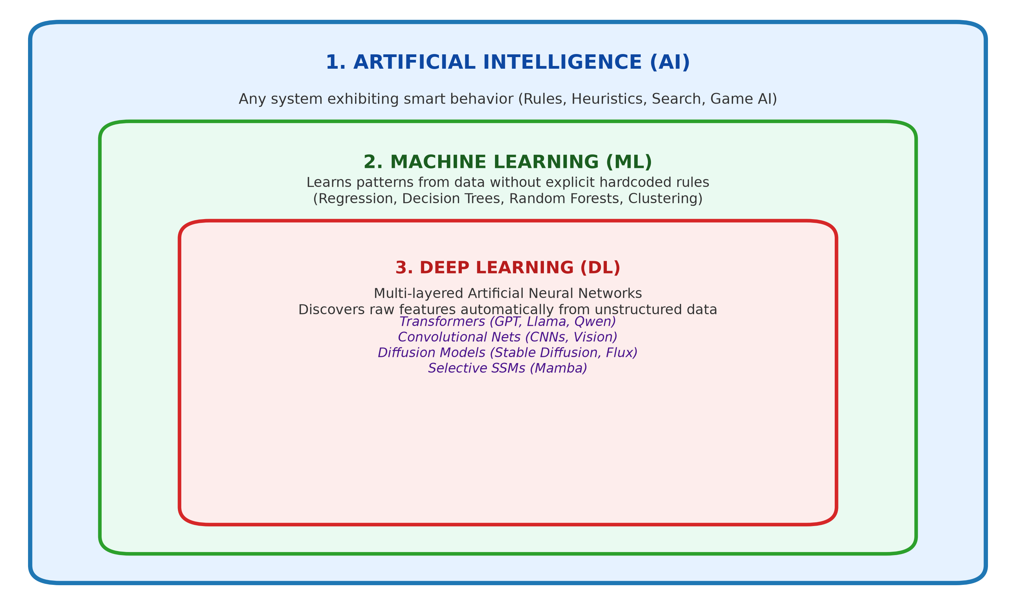
Figure: ai_ml_dl_nesting_dolls.png

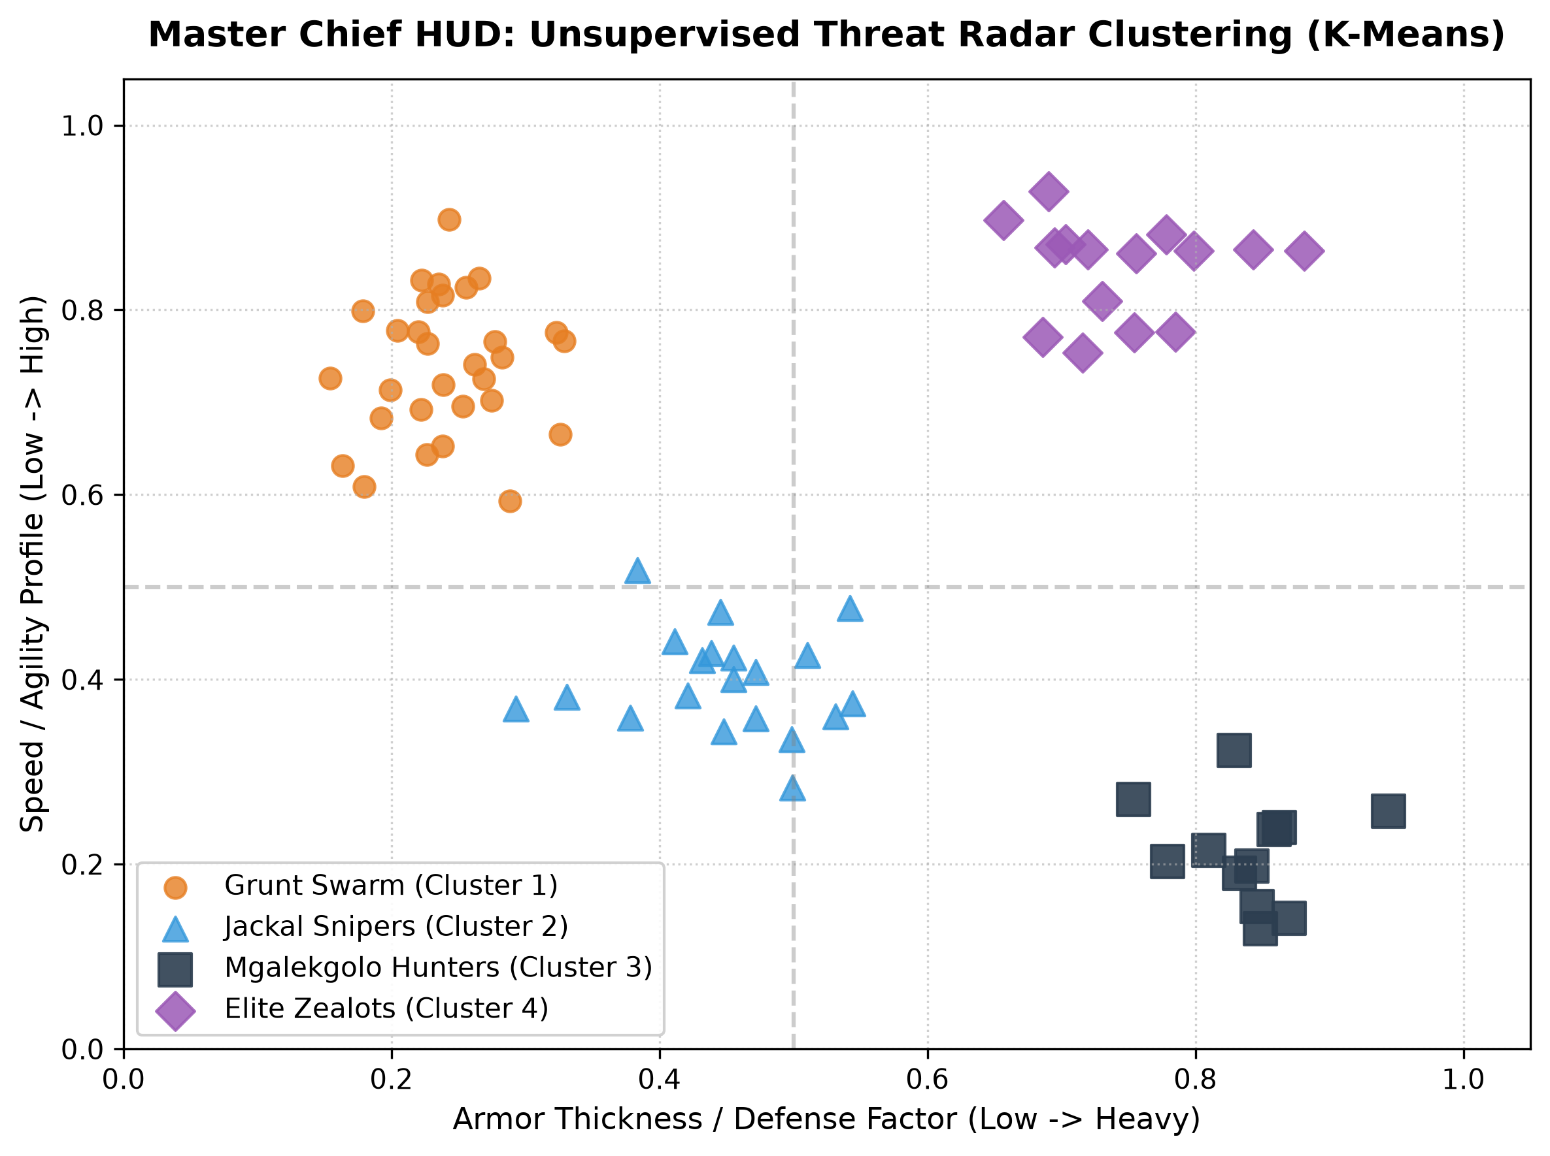
Figure: spartan_ml_radar_clustering.png

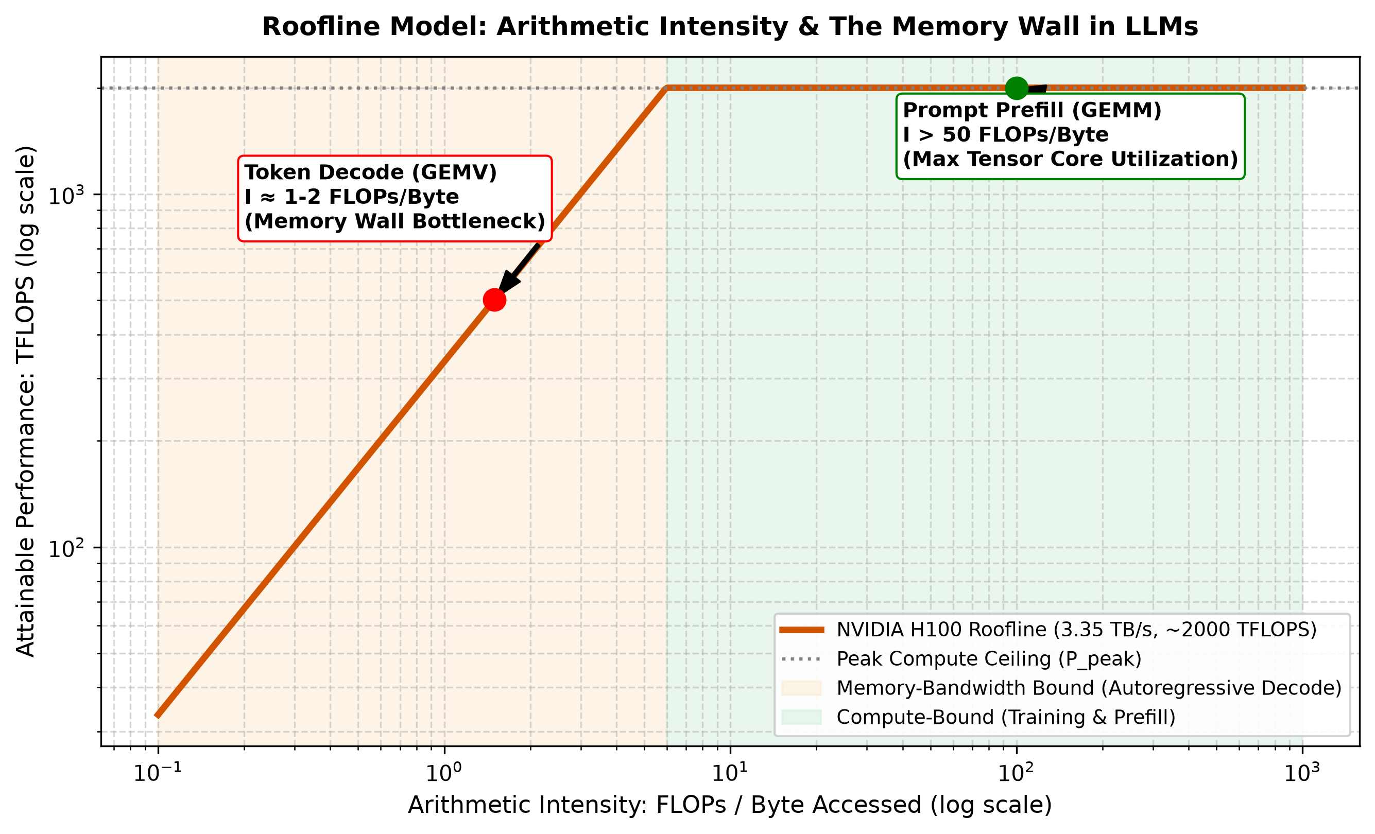
Figure: ml_hardware_roofline.png

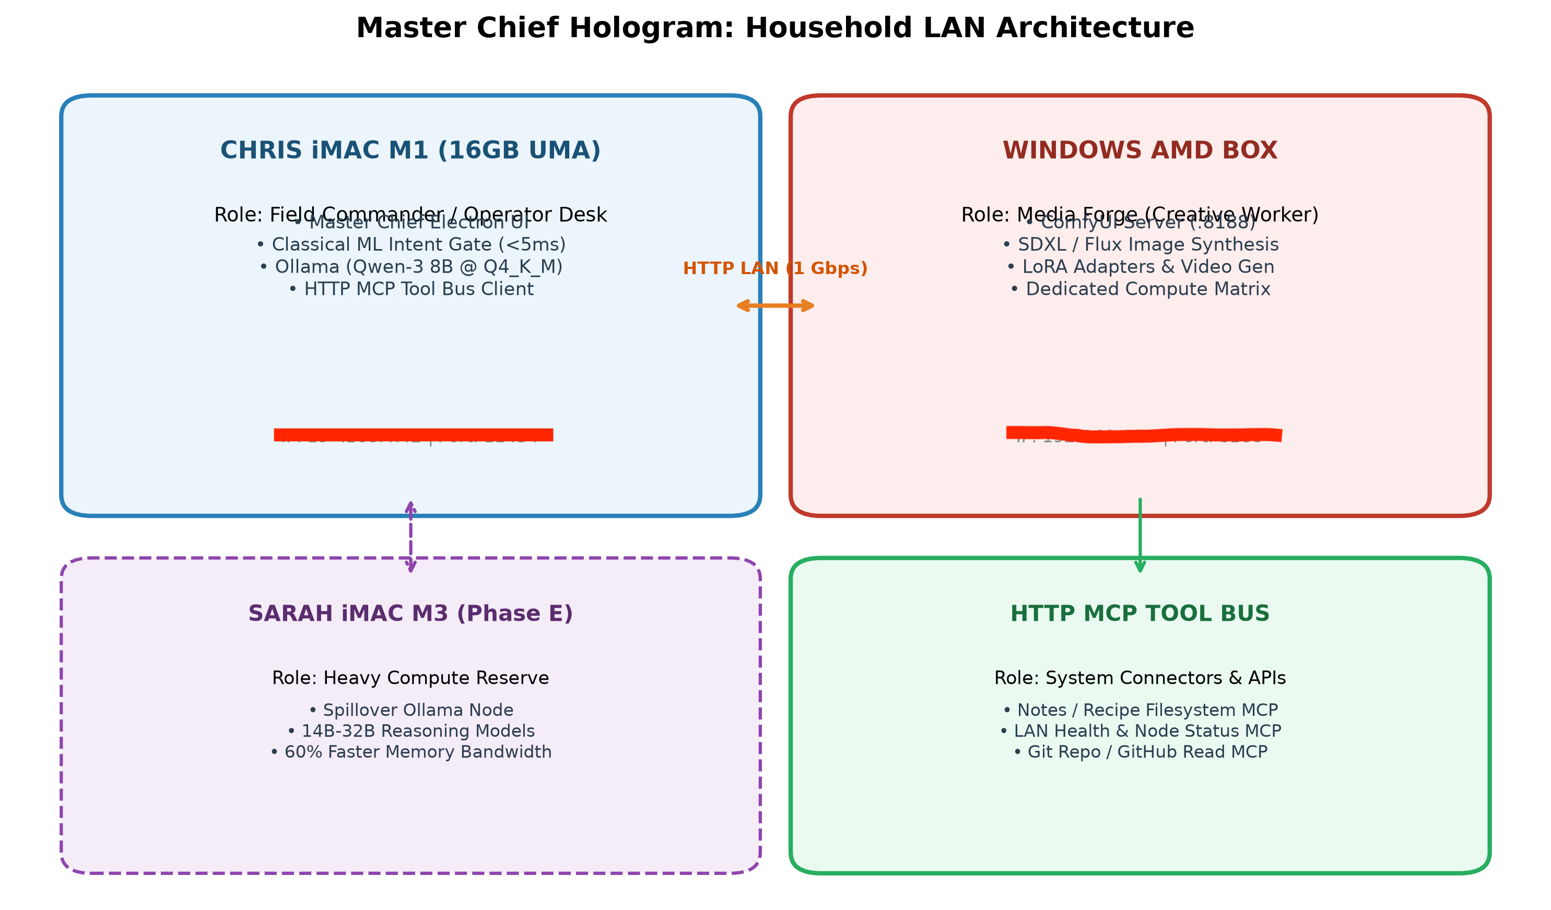
Figure: master_chief_lan_topology.png

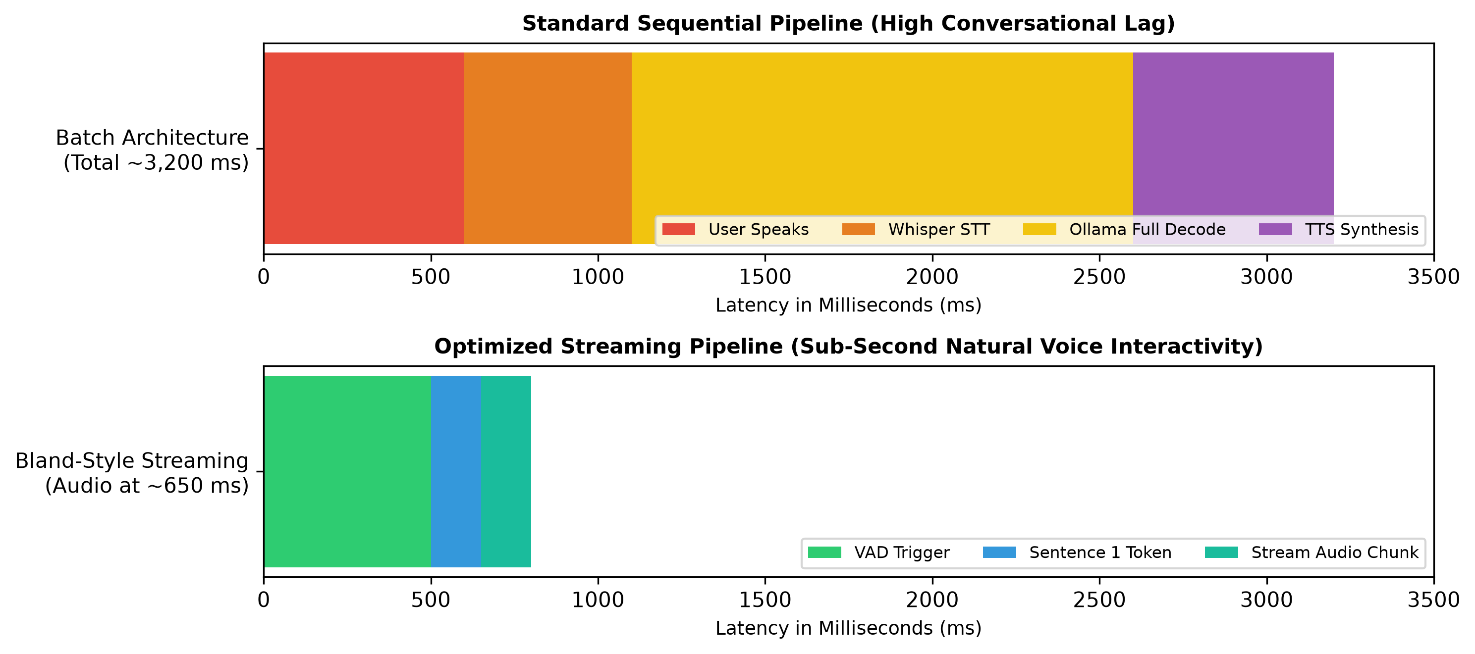
Figure: bland_voice_latency_pipeline.png

