Master Chief Hologram: System Architecture & Hardware Alignment Strategy
Architect: Dr. Christopher Decker, Ph.D.
Platform Target: Master Chief Hologram (`grummpy/master-chief-hologram`)
Mission: Aligning Connectors, Nodes, and Model Training/Adaptation for Home LAN AI
---
🏛️ 1. The Unified LAN Node Hierarchy
To maximize the unique strengths of each computer on your household network, assign tasks based on their specific silicon capabilities:
flowchart TD
subgraph M1 ["Chris iMac M1: The Field Commander (Controller)"]
direction TB
APP[Master Chief Electron App]
ROUTER[Classical ML Intent Router: <5ms]
MCP_REG[HTTP MCP Registry + Security ACL]
LOCAL_LLM[Ollama: Qwen-3 8B Q4_K_M]
APP --> ROUTER
ROUTER -->|Casual Talk & Fast Tool Loops| LOCAL_LLM
ROUTER --> MCP_REG
end
subgraph AMD ["Windows AMD Box (192.168.4.20): The Forge (Media Worker)"]
direction TB
COMFY[ComfyUI Server :8188]
SDXL[Diffusion Models / LoRAs]
COMFY --> SDXL
end
subgraph M3 ["Sarah iMac M3 (192.168.4.51): High Ground (Heavy Compute / Spillover)"]
direction TB
HEAVY_LLM[Ollama: 14B-32B Reasoning Model]
end
ROUTER -->|Image/Video Request JSON| COMFY
ROUTER -.->|Complex Reasoning / Multi-Doc Analysis| HEAVY_LLM
MCP_REG -->|Structured JSON-RPC| TOOLS[Notes, LAN Health, Git Repos]
---
🔌 2. Connector Architecture: The HTTP MCP Tool Bus
Rather than hardcoding tool scripts into the Electron app, use the Model Context Protocol (MCP) via standard HTTP/JSON-RPC:
- Lightweight & Isolated: Each tool runs in its own tiny service. If a tool crashes or has a memory leak, Master Chief stays online.
- Strict Guardrails (ACL):
- Tier 1 (Auto-Approved): Read-only tools (read notes, check LAN status, read git branch).
- Tier 2 (Confirm Required): Modifying tools (write file, send message, reboot service).
- Tier 3 (Never Default): External network mutations or destructive disk writes.
- Payload Truncation: Deep learning models have strict context limits. Any MCP tool returning file contents must truncate or summarize responses to $<1,000$ tokens to prevent choking the M1's KV cache.
---
🎓 3. Training vs. Tuning: What Actually Works at Home?
A common misunderstanding is thinking you need to "train" an AI model from scratch on your home computers. Here is the realistic breakdown:
Compute Hierarchy for Model Adaptation:
┌────────────────────────────┬──────────────────────────────────────┬───────────────────────────────┐
│ Technique │ What It Takes │ Feasibility on Your LAN │
├────────────────────────────┼──────────────────────────────────────┼───────────────────────────────┤
│ 1. Pretraining from Scratch│ $5M - $50M in GPU clusters (H100s) │ ❌ Impossible at home │
│ 2. Full Model Fine-Tuning │ Multi-GPU 80GB VRAM server │ ❌ Thermal / VRAM limits │
│ 3. LoRA / QLoRA Tuning │ 1x 24GB VRAM GPU (AMD box) │ ⚠️ Feasible for custom style │
│ 4. Few-Shot In-Context (ICL)│ ZERO training compute; prompt-only │ ✅ RECOMMENDED (Instant) │
│ 5. RAG / Vector Embeddings │ Tiny CPU embedding model + SQLite │ ✅ RECOMMENDED (Zero training)│
└────────────────────────────┴──────────────────────────────────────┴───────────────────────────────┘
The Winning Strategy for Master Chief:
- Don't retrain weights. Use pre-trained weights (`qwen3:8b`).
- Persona & Voice: Shape behavior via the system prompt (`"You are Spartan-117, speaking through a tactical naval comms link..."`).
- Specialized Knowledge: Use Retrieval-Augmented Generation (RAG). When Chief needs to know family schedules or LAN IP addresses, query a local SQLite/vector database and inject the exact answer into the prompt context.
---
⚡ 4. Blending Classical ML and Deep Learning in Master Chief
Do not use your heavy 8-billion-parameter neural network for every simple task! Blend classical ML and deep learning for maximum speed:
- Step 1 (Classical ML / Heuristic Gate - 2 milliseconds):
- Use a simple regex, keyword match, or fast linear classifier to check the user's intent.
- *Is the user saying "Hello Chief"?* -> Emit a cached audio line instantly without waking the GPU!
- *Is the user asking for an image?* -> Skip the LLM and route directly to the ComfyUI connector!
- Step 2 (Deep Learning Agent Loop - 500-1500 milliseconds):
- Only wake Ollama when complex reasoning, multi-step conversation, or tool coordination is required.
- This cuts power consumption, avoids overheating your M1, and drops voice latency to near-zero.

Visual Architecture & Technical Diagrams

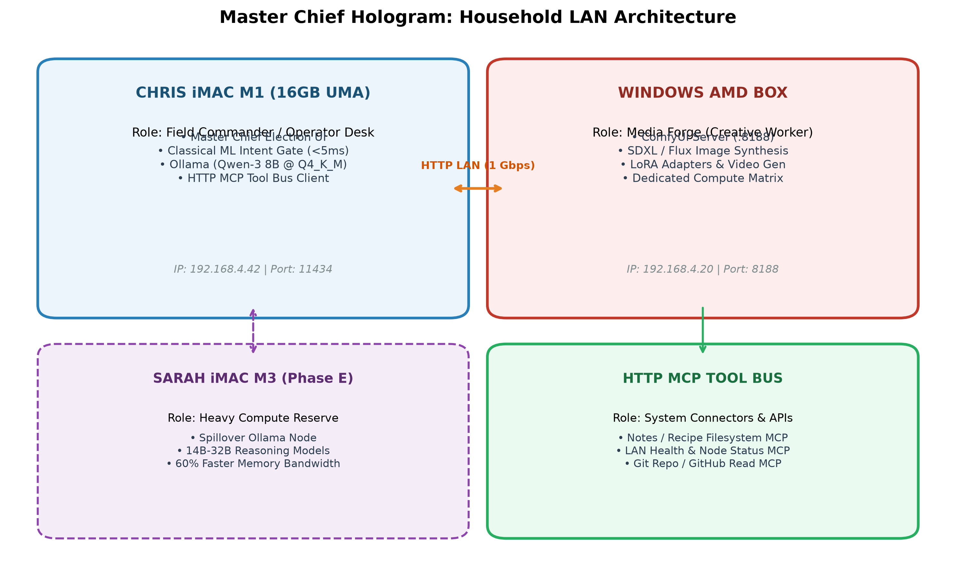
Figure: master_chief_lan_topology.png

