The Neural Connection: How Machine Learning and Deep Learning Fit Together
Instructor: Dr. Christopher Decker, Ph.D.
Series: CS-530 Visual Learning Monograph
Student: Spartan Master Chief (Clear, Visual, Zero-Nonsense Guide)
Topic: How Machine Learning and Deep Learning Are Connected
---
🎯 The Big Picture: Russian Nesting Dolls
To understand how Machine Learning (ML) and Deep Learning (DL) connect, imagine a set of UNSC military boxes stacked inside each other:
flowchart TD
subgraph AI ["1. ARTIFICIAL INTELLIGENCE (The Big Dream)"]
direction TB
A1["Any computer program that mimics smart behavior.<br/>(Chess rules, video game enemy pathfinding, Siri)"]
subgraph ML ["2. MACHINE LEARNING (The Training Academy)"]
direction TB
M1["Programs that learn from data and adjust their dials<br/>instead of following rigid hardcoded rules.<br/>(Linear regression, Decision Trees, K-Means)"]
subgraph DL ["3. DEEP LEARNING (The Neural Super-Soldier)"]
direction TB
D1["A specialized branch of ML powered by deep neural networks.<br/>Learns raw patterns on its own across dozens of layers.<br/>(Transformers, GPT-4, Vision Visors, Diffusion)"]
end
end
end
**The Golden Rule:**
**All Deep Learning IS Machine Learning.**
But **not all Machine Learning is Deep Learning.**
*(Just like all Spartans are UNSC soldiers, but not every UNSC soldier is a 7-foot armored Spartan super-soldier!)*
---
🔍 The Game-Changing Difference: Who Does the Homework?
How do traditional Machine Learning and Deep Learning actually operate differently when solving a mission?
Scenario: Identifying an Incoming Covenant Ghost on Radar
METHOD A: Classical Machine Learning (Human Does the Heavy Lifting)
┌─────────────────┐ ┌────────────────────────┐ ┌─────────────────┐ ┌────────────┐
│ Raw HUD Pixels │ ───► │ Human Engineer │ ───► │ ML Model │ ───► │ "It is a │
│ of incoming vehicle │ Hand-measures: │ │ (Decision Tree) │ │ Ghost!" │
│ │ │ - Weight: 1.2 Tons │ │ Compares numbers│ │ │
│ │ │ - Color: Purple │ │ │ │ │
│ │ │ - Speed: 80 km/h │ │ │ │ │
└─────────────────┘ └────────────────────────┘ └─────────────────┘ └────────────┘
▲
(Feature Engineering: Painful bottleneck!)
─────────────────────────────────────────────────────────────────────────────────────────────
METHOD B: Deep Learning (Model Does EVERYTHING End-to-End)
┌─────────────────┐ ┌──────────────────────────────────────────────────┐ ┌────────────┐
│ Raw HUD Pixels │ ───► │ Deep Neural Network (Hidden Layers) │ ───► │ "It is a │
│ (Zero human │ │ [Layer 1: Edges & Contours] │ │ Ghost!" │
│ prep required) │ │ [Layer 2: Curved Purple Armor Panels] │ │ │
│ │ │ [Layer 3: Boosters & Plasma Guns] │ │ │
│ │ │ [Layer 4: Full Vehicle Recognition] │ │ │
└─────────────────┘ └──────────────────────────────────────────────────┘ └────────────┘
- In Classical Machine Learning:
The human has to extract the features by hand (called *Feature Engineering*). You have to tell the computer: *"Look at column 3 for speed, column 4 for armor thickness."* If the human forgets to measure something important, the model fails.
- In Deep Learning:
You dump raw pixels, audio waves, or text files straight into the network. The deep layers of neurons automatically discover what matters without any human hand-holding!
---
🧠 What Makes Deep Learning "Deep"?
The word "Deep" simply means: Layers stacked on top of layers!
- A Shallow model has 0 or 1 hidden layer.
- A Deep model has dozens or hundreds of stacked hidden layers.
flowchart LR
subgraph InputLayer ["Raw Sensory Input"]
P1[Raw Pixels]
end
subgraph Layer1 ["Layer 1: Micro Details"]
L1[Detects Straight Lines, Diagonal Edges]
end
subgraph Layer2 ["Layer 2: Parts"]
L2[Combines Lines into Circles, Visors, Handles]
end
subgraph Layer3 ["Layer 3: Objects"]
L3[Recognizes Helmet, MA40 Assault Rifle, Shoulder Pads]
end
subgraph OutputLayer ["Final Decision"]
OUT[Spartan-117 Identified: 99.8%]
end
P1 --> L1 --> L2 --> L3 --> OUT
Each layer takes the output of the layer before it and abstracts it:
- Layer 1 sees: `| / \ —` (slashes and edges).
- Layer 2 sees: curves and circles.
- Layer 3 sees: a visor and armor plate.
- Final Layer shouts: *"That's the Master Chief!"*
---
📈 The Data Scaling Curve: Why Deep Learning Conquered AI
Why did the world suddenly switch from classical ML to Deep Learning over the last 10 years?
Accuracy / Capability
▲
│ / (Deep Learning / Neural Nets)
│ / Keeps getting smarter the more
│ / data and compute you feed it!
│ /
│ -------------------------/ (Classical ML: Trees, Regression, SVM)
│ / Hits a plateau! More data doesn't help.
│ /
│ /
└────────────────────────────────────────────────► Amount of Training Data
- Classical ML hits a brick wall: Giving a decision tree 10,000,000 pictures doesn't make it 10,000 times smarter. It runs out of steam because human-made features can't capture infinite nuance.
- Deep Learning scales infinitely: The bigger the neural network and the more data you feed it, the more intelligent and capable it becomes. That is why ChatGPT, Midjourney, and self-driving cars exist today.
---
⚔️ Head-to-Head Comparison: When to Use Which
Tactical Scenario | Classical Machine Learning | Deep Learning
**Best Data Type** | Numbers, spreadsheets, CSV files, SQL tables | Images, audio, human speech, messy text, video
**Data Needed** | Hundreds to thousands of rows | Hundreds of thousands to billions of examples
**Compute Power Needed** | Simple CPU (runs in seconds on your laptop) | Massive GPUs (NVIDIA H100, RTX 4090, Apple Silicon)
**Training Time** | Seconds to minutes | Days to weeks across GPU server clusters
**Can you explain why?** | **Yes (White Box):** You can inspect the tree branches | **Hard (Black Box):** Millions of math weights working together
**Real-World Example** | Predicting house prices, loan approval, fraud score | Cortana speech recognition, AI art, LLM chatbots

---
💡 The Takeaway Formula
$$\text{Artificial Intelligence} \supset \text{Machine Learning} \supset \text{Deep Learning}$$
- Machine Learning taught computers how to find patterns in numbers using statistics.
- Deep Learning stacked thousands of artificial neurons together so computers could learn complex sights, sounds, and human language all by themselves!

Visual Architecture & Technical Diagrams

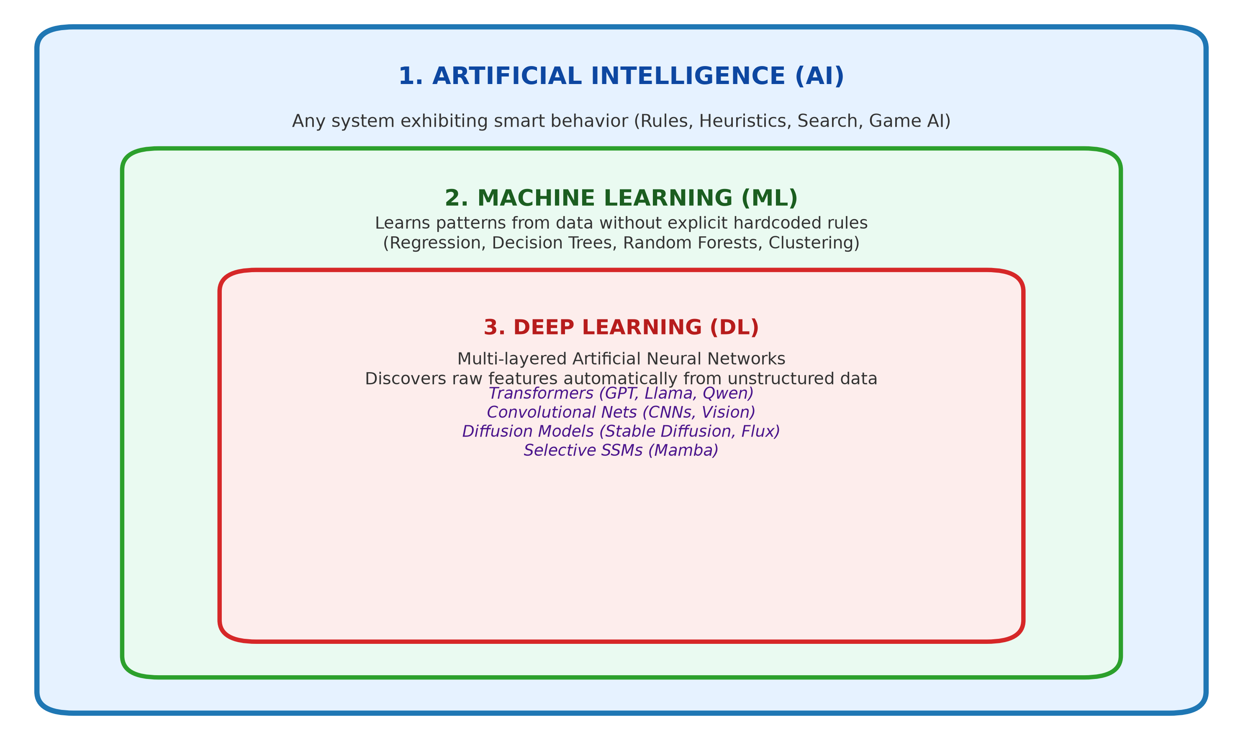
Figure: ai_ml_dl_nesting_dolls.png

