# NM2207

Week 2

Assignment

Overview of what we’ll do today:

* Sweeten up your homepage and link to Session02.assignment with relative links
* Code up a webpage with some old and new HTML elements
* Learn to format all your code with proper indentation
* Upload your homepage and Session02.assignment to the server and update all the links
* Deadline: Monday Aug 24, 11.59 pm

Part 1. Edit your nm2207 homepage: Sweeten up your homepage visually a bit: include at least a picture of yourself /, a short bio, add a little styling /, put your homework links in a separate section /.

How to do this? Edit the index.html in your local NM2207/web folder first.

(e.g.: C:/Users/kokil/Documents/NM2207/web/index.html)

When you’re done, replace the one in YOUR web folder on nm2207, with the new one.

(e.g: [your user id]/web/index.html)

Make sure to keep a backup copy in case you mess up the first three times!

a. Name your home page index.html (if it isn't already).

b. Make sure your directories are organized nicely, and the same on the server as on your local machine so that all the relative links work. Update on nm2207.org.

Part 2. Watch and code along with the HTML Forms and Formatting Forms with Tables in HTML videos from my colleague Prof. Jen Golbeck at Maryland, shared with permission:

1. <https://www.youtube.com/watch?v=c5ugqp9rl-c&list=PLk_jmmkw5S2Dst2tllJx4RpMj0n7GWLLi&index=9&t=0s>
2. <https://www.youtube.com/watch?v=fWE2tvT929g&list=PLk_jmmkw5S2Dst2tllJx4RpMj0n7GWLLi&index=9>

These videos are intended to help you for the following coding tasks.

1. Practice more coding: Use your creativity to **create a contact form** as below in the index.html which is within the Session02.assignment folder. Ignore the styling in this image.

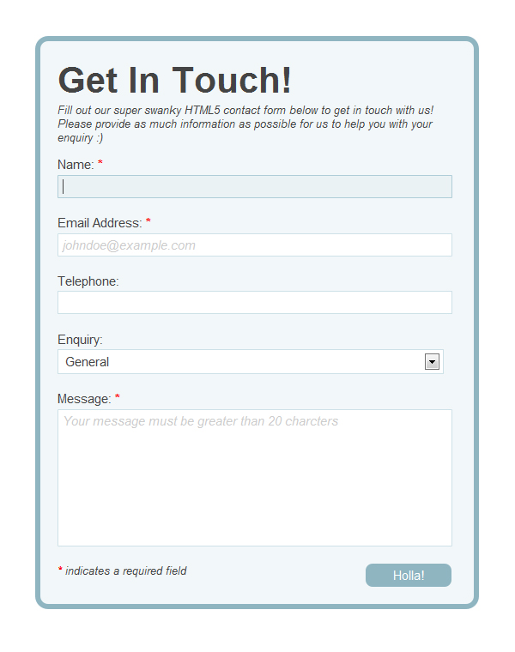

The two elements used in this form are **input type=”text”** and **input type “selector**”.

You can also add a **radio button** to ask them if they are married or not.

All of these elements are described here: <https://www.w3schools.com/html/html_forms.asp>

Fig.2 The different kinds of input elements

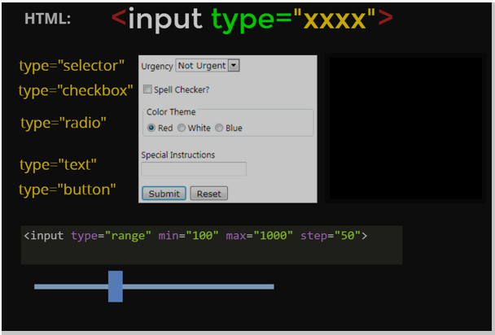

“Selector”, “Checkbox”,”Radio”,”Text”,”Button”  
<input type=”range” min=”100” max=”1000” step=”50”>

Part 3. Code formatting

a. Learn how to **indent your code** properly: <https://www.youtube.com/watch?v=_JFIeY46sIU>

b. Practice this:

Select All -> Edit menu -> Line -> Reindent

c. Explore other tips and tricks for formatting HTML code in Sublime Text on the web. You will probably find better ideas than we did!

Part 4. Upload

When you are done, upload your Session02.assignment folder into FileZilla, and update the links on your homepage so that your tutor can find the homework. Make sure all the links work, and the photos are visible too!

If any of the links break, identify which one, and check the paths.

* If you have used absolute paths (e.g. paths starting with “C:”) then you need to use relative paths instead
* If you have used relative paths but something is still breaking, then your files are not where you expect them to be. Before reaching out with screenshots, please check each path manually. Your tutor will have to do the same.