Proposed Rule Changes

CHANGE IN POSITION ELIGIBILITY
There is some thought that our position eligibility is too liberal and requirements should be more stringent, hence the proposal below. This change, if implemented would take effect for the 1996 season, unless there are strenuous objections, in which case it would take effect for the 1997 season.

EXISTING RULE:
Hitters may only play positions for which they have defensive ratings, with the following exceptions:
- CF can play any OF;
- LF/RF can play the other LF/RF for which they are not rated;
- LF/RF rated Vg or Ex may play CF;
- SS can play 2nd base;
- 2nd base can play SS if rated Vg or Ex at 2nd base;
- Anyone can play 1B.

PROPOSED RULE:
Hitters may only play positions for which they have defensive ratings, with the following three (3) exceptions:
- CF can play any OF;
- LF/RF can play the other LF/RF for which they are not rated;
- LF/RF rated Vg or Ex may play CF;
- SS can play 2nd base;
- 2nd base can play SS if rated Vg or Ex at 2nd base;
- Anyone can play 1B.

CHANGE IN DRAFT LOTTERY
The rule change proposed below is intended to reduce somewhat the seemingly strong incentive to purposefully tank seasons in order to improve the chances to get the #1 pick in the draft for any given year. This proposal would substantially reduce the likelihood among the three worst teams, and significantly improve the chances for the 6th through 13th seeded teams. If owners behave rationally, this would seemingly reduce, but not eliminate the incentive to come in last, as the marginal differences between any one position are nominal. This might result in slightly better competitive balance with fewer teams at the extremes. This change, if implemented would take effect for the 1997 draft.

EXISTING RULE:
The number of chances out of 1,000 for each seed are: 1st-250 (25%), 2nd-199 (20%), 3rd-156 (15.6%), 4th-119, 5th-88, 6th-63, 7th-43, 8th-28, 9th-17, 10th-11, 11th-8, 12th-7, 13th-6, 14th-5 (0.5%)

Comparison of Existing vs. Proposed Rule
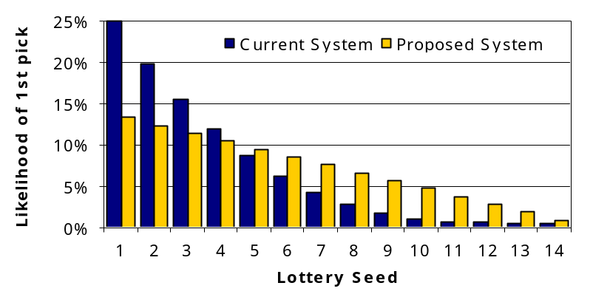

PROPOSED RULE:
Instead of the above, the 1st seed would have 14 chances 13.3%, the 2nd seed 13 (12.4%) chances ... and the 14th seed 1 chance (1%).

MINOR CHANGE IN HOW FORFEITED DRAFT PICKS ARE HANDLED.

Teams Unable to Field All Positions Due to Usage Violations
Any team which fails to field all positions, to maintain a staff of eight (8) available pitchers and two (2) available catchers, or is unable to maintain a 25-man roster will have players assigned to their team from the free agent pool to fill the void. The commissioner will assign these players on the basis of most playing time (PA or BFP) and not having a “Prone” injury rating, at the position that needs to be filled. In addition, each player signed to field a complete team will result in the forfeiture of a draft pick for the following season, starting with the 8th round pick, and then 7th round pick, etc., for subsequent playing time shortages. In order to reduce the possibility of a team playing short in the subsequent season due to poor planning in the current season, any forfeited picks will be replaced by picks at the end of the draft

