Player Tendencies

Overview
The DMB computer manager automatically adapts to game situations and the ratings and stats of the players involved in those situations. For example:
- when faced with a baserunning situation, it attempts to take the extra base more often with a better baserunner and less often against an outfielder with a good arm
- it is more likely to let a starting pitcher work out of a jam if he's a very good pitcher and/or the potential relief pitchers aren't very good
- it will use one-run strategies such as the bunt and the hit and run much more often in close games than in blowouts
As a result, it is not necessary to use manager tendencies or player-specific tendencies to get the computer manager to handle players in a way that makes good baseball sense.
To put this another way, if you create a full set of tendencies for every player on a roster, simply to get them to act in a way that is already indicated by their stats and ratings, you're doing a lot of unnecessary work.
Sometimes, however, you may wish to override the computer manager's desire to play the percentages. By setting manager tendencies, you can influence how often the computer manager uses certain tactics for all players on a team. And by setting player-specific tendencies, you can influence how often the computer manager uses certain tactics when that player is involved.

Player tendencies are optional
Because the DMB computer manager can produce very accurate results simply by consulting player ratings, manager and player tendencies are optional. If there's an opportunity to take an extra base involving a player with no Running tendency, the computer manager uses the manager tendency for Running instead. If that manager tendency is Neutral, the decision is made solely on the basis of the player's Running rating.

Changing player tendencies
The player tendencies window enables you to change the tendencies for any player on a roster:
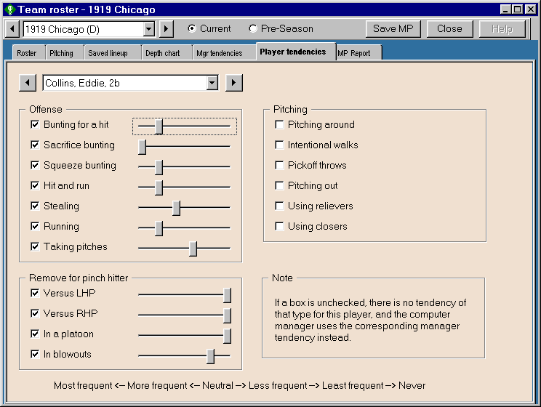
To add, remove or change tendencies for a player, start by selecting that player using the drop-down list at the top of this window. DMB displays the current set of tendencies for that player. If no tendency is assigned for a particular aspect of the game, the box is unchecked and the slider does not appear. As noted in the above window, if a box is unchecked, there is no tendency of that type for the player, and the computer manager uses the corresponding manager tendency instead.
The sliders on this screen have 6 settings that allow you to set player tendencies in the situations described. The settings range from Most frequent to Neutral to Least Frequent to Never.
To assign a tendency, check the box to make the slider appear, then click on the slider bar or drag the slider until you're happy with the setting. To change a tendency, click on the slider bar or drag the slider. To delete a tendency, uncheck the box.

Reasonable limits
DMB is a strategy game that is designed to provide you with a real baseball experience. It's not like many video games that give you so much control that you can easily play games and produce statistics that bear little or no resemblance to real big-league games. As a result, there are reasonable limits on the impact of player tendencies.
It's not possible, for example, to set a tendency that tells a certain player to attempt a steal every time he reaches first base with second base open. There isn't a player in history who has done that, and it's just not realistic to allow that to happen in your DMB games. Similarly, it doesn't make sense to allow a runner with a Poor jump rating and a Poor steal rating to attempt 50 steals a season.
It is possible, however, to set a player's Stealing tendency to Most Frequent. By doing so, you're telling the computer manager to give that player the green light more often than it normally would for a player with his ratings.
How much more often? It varies from tactic to tactic, but it's generally in the range of 20-40%. In other words, you can't use player tendencies to double or triple the rate at which a player attempts to steal, take extra bases, bunt for hits, and so on. Game situations and player ratings are still the most important factor in how the computer manager makes decisions.
On the other hand, it's not all that unusual for a real-life player to go several seasons without trying to steal a base or drop down a bunt. So it is possible to assign a Never tendency, and the computer manager will honor that request.

Offensive tendencies
Most of these tendencies have the same meaning as in the context of manager tendencies, so we won't describe them again here.
Bunting. As is the case with all tendencies, a player's bunt rating is still the most important factor in determining how often the computer manager asks a player to bunt, but you can use the three bunting tendencies to increase, decrease, or eliminate bunt attempts by this player.
Setting the Bunting for a hit tendency to Never only stops a batter from attempting a bunt in non-sacrifice and non-squeeze situations. If Sacrifice and Squeeze bunting tendencies are not set to never as well, it is still possible for a batter to get a bunt single if he beats one out in a sacrifice or squeeze bunt situation.
Similarly, if you set Sacrifice bunting to Never but do not do the same for Squeeze bunting, it is possible for a hitter to sacrifice in squeeze situations. This is why the batter would compile sac hit statistics.
Hit and run. DMB players don't have a hit and run rating, but the computer manager does look at a player's skills to determine how often he should be asked to execute a hit and run play. Strikeout-prone hitters are less likely to be called upon, while contact hitters and slower runners (who are prone to grounding into double plays) are more likely to participate in a hit and run play. You can use the hit and run tendency to increase, decrease, or eliminate the hit and run play when this player is batting.
Stealing. As is the case with bunting, this tendency is quite straightforward. The computer manager will continue to rely on the ratings of the players involved (jump and steal for the runner, hold for the pitcher, throwing for the catcher) and the game situation to decide when a steal attempt makes sense. You can, however, use this tendency to increase or decrease the attempt rate for a player, or eliminate steal attempts altogether.
Running. This tendency governs how many chances the computer manager will take on the base paths. When the computer manager makes a running decision, it compares the chances of gaining the extra base safely to a minimum threshold based on the game situation.
The chances of gaining the extra base are determined by the nature of the batted ball, whether the runner was going on the pitch or on contact, the running rating of the runner, and the throwing rating of the outfielder.
The minimum threshold is based on the game situation and whether it makes more sense to play for one run (as in the late innings of a close game) or a big inning. Depending on the number of outs and where the runners are situated, the value of taking the extra base can be high or low, as can be the cost of getting thrown out. The computer manager takes these factors into consideration when deciding how high the chances of success need to be to justify taking the risk of getting thrown out.
The Running tendency controls the minimum threshold. If you choose "less frequent" or "least frequent", the minimum threshold rises. That causes the computer manager to send the runner only when the chances of success are higher. If you choose "more frequent" or "more frequent", the minimum threshold is lowered, and the computer manager will take more chances with this runner.
Setting the Running tendency to Never means that the runner will always be held if there is any chance he could be thrown out. Because taking an extra base is automatic for even the worst runners on some batted balls (e.g. very deep flies), especially if the hit and run is on or the runner goes on contact with two out, players with a Running tendency of Never will run from time to time. But you won't see them trying to advance when the outcome is uncertain.
NOTE: The Running tendency does not apply to situations where a batter tries to stretch a single into a double or a double into a triple. In those cases, the batter/runner makes his own decision and is not influenced by any manager or player tendency.
While it's true that you can dramatically reduce the number of outs your players make on the bases by assigning the Never tendency, that doesn't necessarily mean it's good strategy. You may miss out on high percentage opportunities to score a runner from third on a fly ball or from second on a single, and if the other hitters don't cash those runs in, your team will leave more runners on base. You may also hit into more double plays if your runners aren't taking advantage of running opportunities.
Taking pitches. This tendency enables you to increase or decrease the likelihood that your best hitters will have the green light to swing with three balls and no strikes. It doesn't affect any other counts. And you don't need to use this tendency to prevent your weaker hitters from swinging at 3-0 pitches because the computer manager never gives the green light to weaker hitters.

Pinch hitting tendencies
There are four tendencies in the category of "Remove for pinch hitter" that govern how often this player should be lifted in different situations:
- the "Versus LHP" and "Versus RHP" tendencies enable you to indicate how seriously the computer manager should consider using a pinch hitter in place of this player. Choose Never to tell the computer manager not to pinch hit for this player (except perhaps in blowout situations).
NOTE: Player tendencies were introduced in version 9. In previous versions, different manager profile settings called "can be PH for" enabled you to indicate that a player should never be replaced by a pinch hitter against left- or right-handed pitchers. Those settings no longer exist, and when you convert a DMB database to version 9 format, they are assigned to the "versus LHP" and "versus RHP" player tendencies instead.
- the "In a platoon" tendency applies only if this player is in the starting lineup and a platoon partner is listed in the depth chart at his position. To prevent a player from being removed for a platoon partner, choose Never. (You can achieve this same effect more easily by removing the platoon player from the depth chart.)
- the "In blowouts" tendency applies only in the late innings of a game in which one team has a very big lead.
In all game situations other than blowouts, the computer manager uses a pinch hitter only if he is rated to be better than the scheduled hitter against the current pitcher. This assessment takes into account the handedness and the left/right splits of both the batter and the pitcher.
The player tendencies for pinch hitting indicate how much better the pinch hitter needs to be. A "least frequent" setting tells the computer manager to pinch hit less often; that is, only when the pinch hitter is much better than the scheduled hitter. A "most frequent" setting tells the computer manager to pinch hit more aggressively; that is, even when the pinch hitter is only a little better than the scheduled hitter.
Pinch hitting in blowouts is a different matter altogether. In these situations, the goal is not to gain an advantage, it's to replace the team's better players to reduce their risk of injury. In blowouts, the computer manager generally replaces a better player with a weaker one, so the relative strength of the players is not a concern. Instead, the blowout pinch hitting tendency influences the computer manager decisions about (a) how big a lead is needed for the game to be treated as a blowout and (b) how early in the game it will begin to remove players.
In blowout situations, the "In blowouts" tendency takes precedence over the other pinch hitting tendencies. If a player's tendencies are set to Never for the three non-blowout situations, he can still be replaced by a pinch hitter in a blowout.

Pitching tendencies
Most of these tendencies have the same meaning as in the context of manager tendencies, so we won't describe them again here.
Using relievers, Using closers. These settings indicate how aggressively the computer manager should go to the bullpen with this pitcher already in the game. They have no any impact on how often this pitcher is brought into the game in the first place.
The Never setting for "Using relievers" and "Using closers" doesn't really mean never. It would be highly unrealistic to ask a pitcher to stay in the game no matter how tired he gets or how hard he's being hit. The computer manager always reserves the right to lift a tired or ineffective pitcher regardless of your tendencies, though it will stick with an ineffective pitcher longer if you choose "less frequent", "least frequent", or "never".
Instead, a setting of Never tells the computer manager to keep this pitcher in the game until he gets tired, until he loses effectiveness, or until the opposing team creates a meaningful threat, whichever comes first. With this setting, the computer manager won't go to a setup man or closer just because that potential reliever is a better pitcher.
TIP: If you want a closer to be used as often as possible, set the team's manager tendency for "Using closers" to "most frequent". Or, if you want a little more control, set the "Using closers" tendency for some of the team's starting pitchers and middle relievers to "most frequent".

