

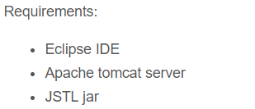

<http://www.thejavageek.com/2013/08/11/mvc-architecture-with-servlets-and-jsp/>

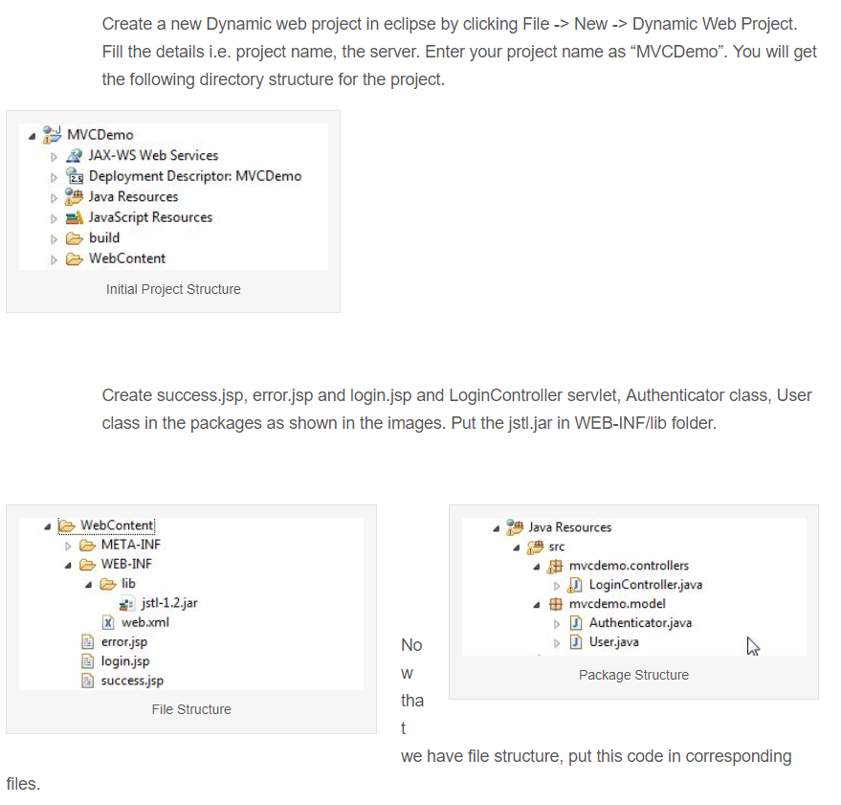

LoginController Servlet

package mvcdemo.controllers;

import java.io.IOException;

import javax.servlet.RequestDispatcher;

import javax.servlet.ServletException;

import javax.servlet.http.HttpServlet;

import javax.servlet.http.HttpServletRequest;

import javax.servlet.http.HttpServletResponse;

import mvcdemo.model.Authenticator;

import mvcdemo.model.User;

import sun.text.normalizer.ICUBinary.Authenticate;

public class LoginController extends HttpServlet {

private static final long serialVersionUID = 1L;

public LoginController() {

super();

}

protected void doPost(HttpServletRequest request,

HttpServletResponse response) throws ServletException, IOException {

String username = request.getParameter("username");

String password = request.getParameter("password");

RequestDispatcher rd = null;

Authenticator authenticator = new Authenticator();

String result = authenticator.authenticate(username, password);

if (result.equals("success")) {

rd = request.getRequestDispatcher("/success.jsp");

User user = new User(username, password);

request.setAttribute("user", user);

} else {

rd = request.getRequestDispatcher("/error.jsp");

}

rd.forward(request, response);

}

}

Autenticator.java

|  |  |
| --- | --- |
| 3  4  5  6  7  8  9  10  11  12  13 | package mvcdemo.model;    public class Authenticator {    public String authenticate(String username, String password) {  if (("prasad".equalsIgnoreCase(username))  && ("password".equals(password))) {  return "success";  } else {  return "failure";  }  }  } |

User.java

package mvcdemo.model;

public class User {

private String username;

private String password;

public User(String username, String password){

this.username = username;

this.password = password;

}

public String getUsername() {

return username;

}

public void setUsername(String username) {

this.username = username;

}

public String getPassword() {

return password;

}

public void setPassword(String password) {

this.password = password;

}

}

Error.jsp