Práctica 1.
Ruben Santacatalina Pellicer

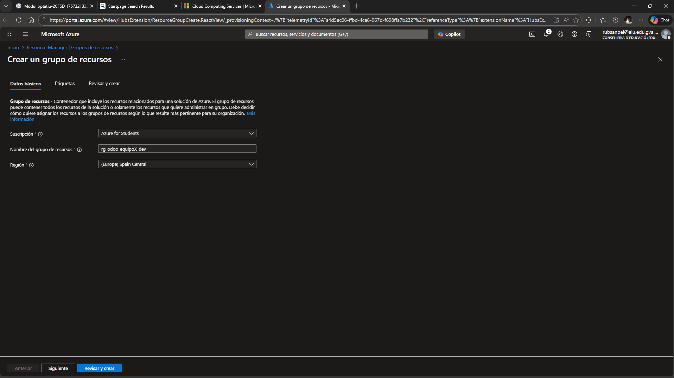
- Ir a Resource groups → Create.
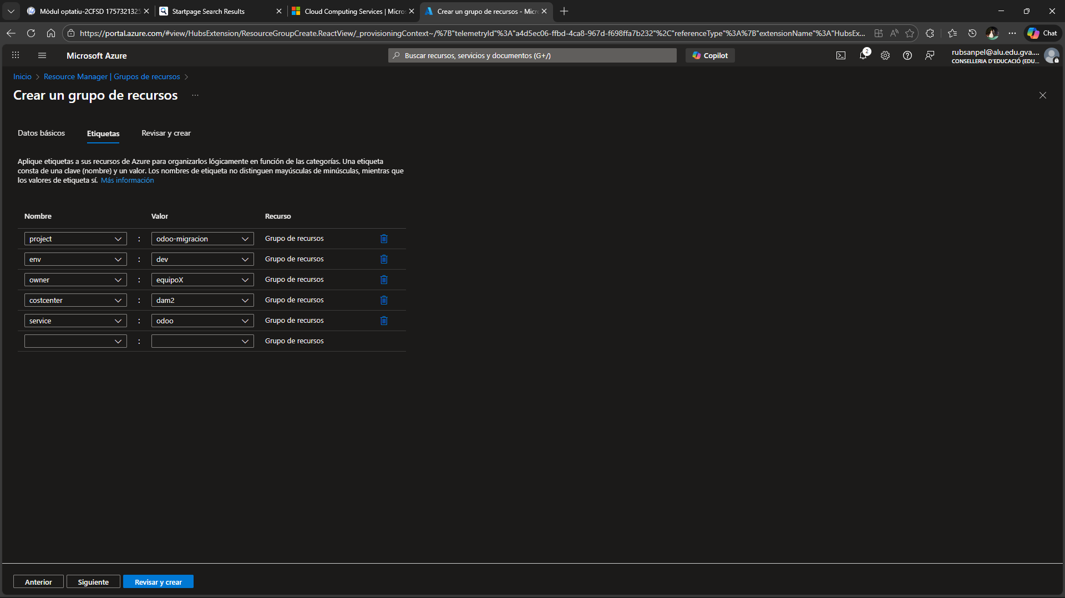
- Añadir estas tags (etiquetas):
  - project=odoo-migracion
  - env=dev
  - owner=equipoX
  - costcenter=dam2
  - service=odoo

- Ir a Cost Management + Billing → Budgets → Add.
- Alcance: ese Resource Group (no la suscripción entera).

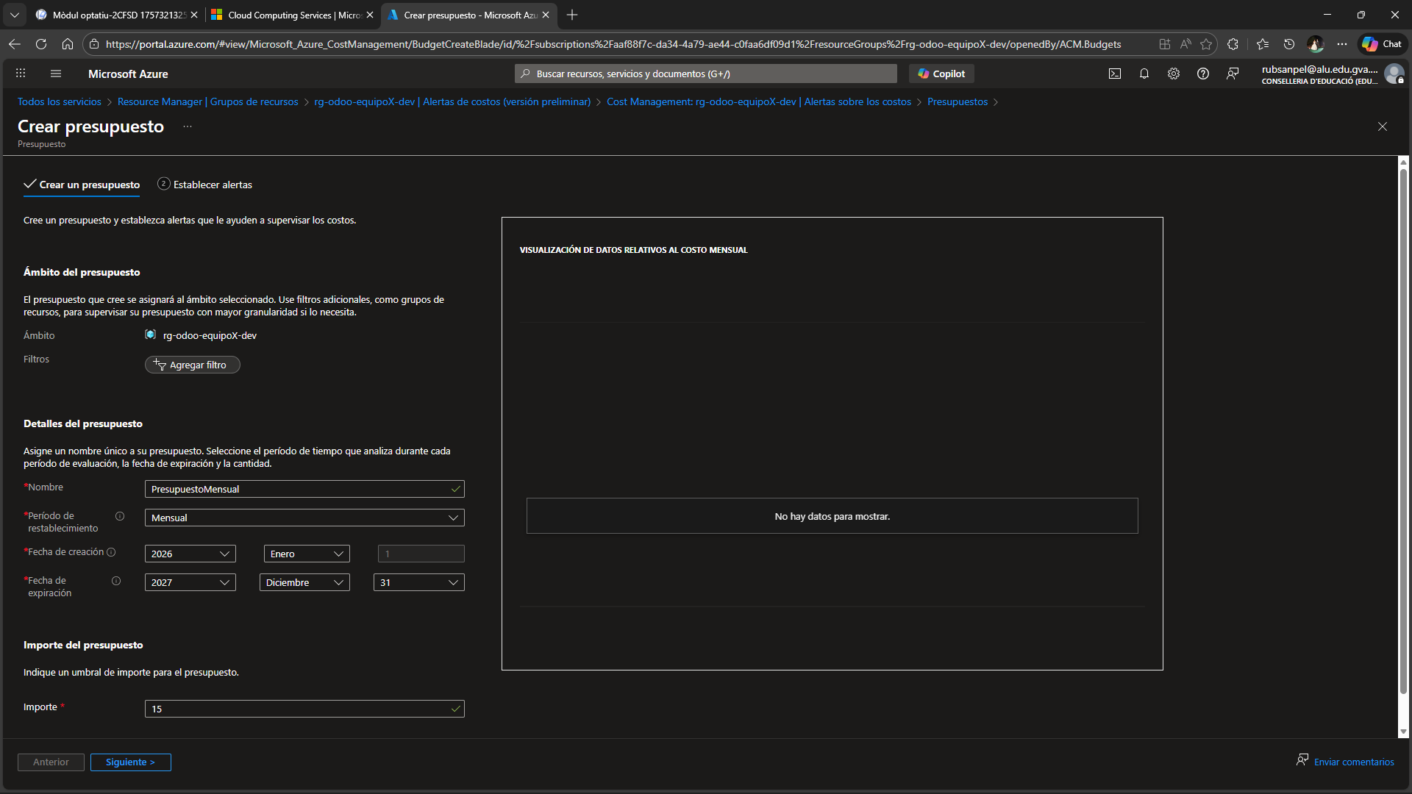

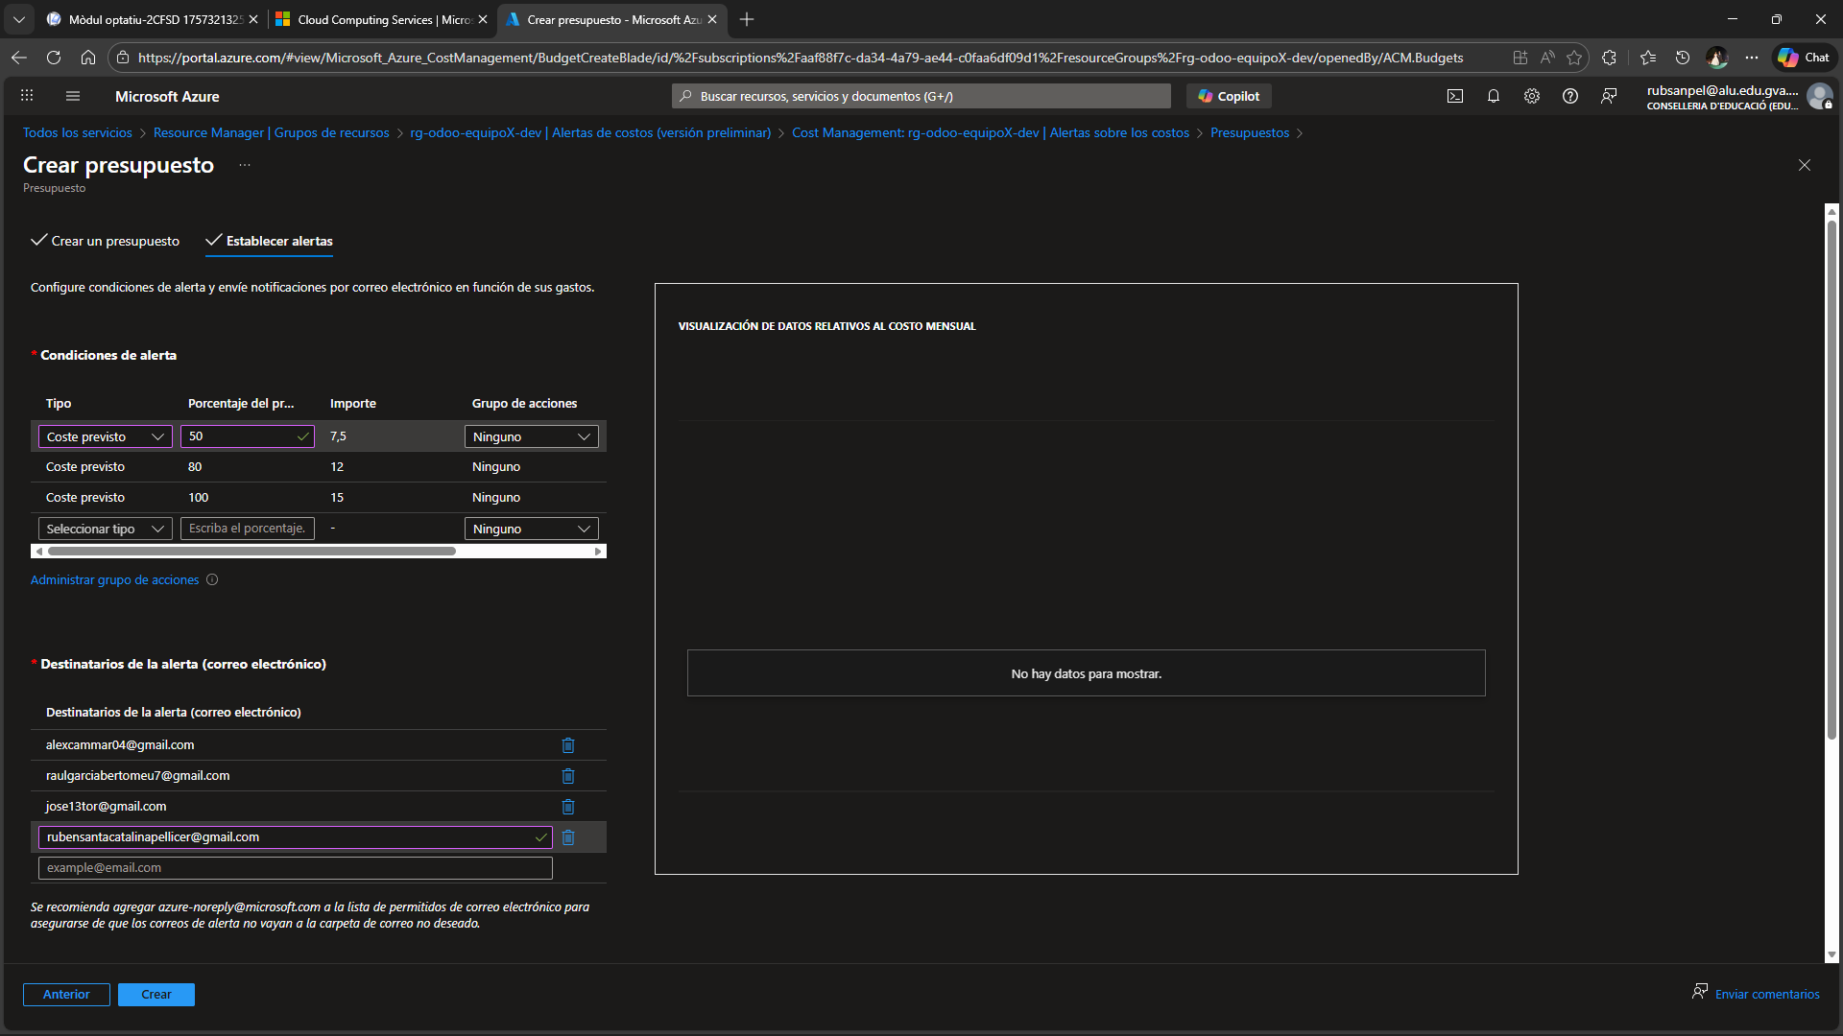

Mitjançant Azure Calculator Mostre els presupostos tant de una part com de l’altra que es demana.
Microsoft Azure Estimate
Your Estimate
Service category | Service type | Custom name | Region | Description | Estimated monthly cost
Compute | Azure Container Instances |  | East US | 1 Container group(s) x 10 Second(s), Linux OS, Pay as you go, 1 GB Memory, 1 vCPU(s) | $0,00
Databases | Azure Database for PostgreSQL |  | Spain Central | Flexible Server Deployment, General Purpose Tier, 1 D2ds v5 (2 vCores) (1 year reserved), Storage - Premium SSD, 5 GiB Storage, 0 Provisioned IOPS, 0 GiB Additional Backup storage - LRS redundancy, without High Availability | $62,57
Storage | Azure Files |  | Spain Central | HDD (Standard) Media tier, LRS Redundancy, Provisioned v2 Billing model, Provisioned capacity – 256 GiB Provisioned storage, 1,052 Provisioned IOPS, 66 MiB/sec Provisioned throughput, Used capacity - 0 GiB Overflow used snapshot storage, 0 GiB Used soft-deleted storage, 0 File sync servers | $62,88
Support |  |  | Support |  | $0,00
 |  |  | Licensing Program | Microsoft Customer Agreement (MCA)
 |  |  | Billing Account
 |  |  | Billing Profile
 |  |  | Total |  | $125,45

Microsoft Azure Estimate
Your Estimate
Service category | Service type | Custom name | Region | Description | Estimated monthly cost
Compute | Virtual Machines |  | Spain Central | 1 B1s (1 Core, 1 GB RAM) (3 year savings plan), Linux, (Pay as you go); 0 managed disks – S4; Inter Region transfer type, 5 GB outbound data transfer from Spain Central to East Asia | $4,58
Storage | Azure Files |  | Spain Central | HDD (Standard) Media tier, LRS Redundancy, Provisioned v2 Billing model, Provisioned capacity – 256 GiB Provisioned storage, 1,052 Provisioned IOPS, 66 MiB/sec Provisioned throughput, Used capacity - 0 GiB Overflow used snapshot storage, 0 GiB Used soft-deleted storage, 0 File sync servers | $62,88
Support |  |  | Support |  | $0,00
 |  |  | Licensing Program | Microsoft Customer Agreement (MCA)
 |  |  | Billing Account
 |  |  | Billing Profile
 |  |  | Total |  | $67,45

Comprobar el cost del grup que haviem creat anteriorment i veure si es pot buscar per etiqueta.

