K. J. Somaiya College of Engineering, Mumbai-77
(Autonomous College Affiliated to University of Mumbai)
Semester: January 2017- April 2017
Max. Marks: 30 Duration: 1hr.15 min.

Class: L Y B Tech Semester: VIII

Branch: COMP Course Code: UCEE801

Test 2 Name of the Course: Machine Learning

Question No. |  | Max.  Marks | *CO  Mapped | Bloom’s Taxonomy
1 | For above Naïve Bayes problem, Test the instance:  <medium ,red, circle> find the probability. | 10 | 2 | Knowledge, Analysis, Application
  Probability | positive | negative
  P(Y) | 0.5 | 0.5
  P(small | Y) | 0.4 | 0.4
  P(medium | Y) | 0.1 | 0.2
  P(large | Y) | 0.5 | 0.4
  P(red | Y) | 0.9 | 0.3
  P(blue | Y) | 0.05 | 0.3
  P(green | Y) | 0.05 | 0.4
  P(square | Y) | 0.05 | 0.4
  P(triangle | Y) | 0.05 | 0.3
  P(circle | Y) | 0.9 | 0.3
2 | 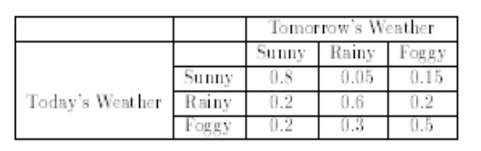  - Given that today is sunny, what is the probability that tomorrow is sunny and the day after is rainy?  - Given that today is foggy, what is the probability that it will be rainy two days from now? | 5 | 02 | Knowledge, Application
3 | What is Support vector machine technique? Where are they used? Explain Kernel trick in SVM. | 5 | 02 | Knowledge
4 | Explain Principal Component analysis Technique.  Why dimensionality reduction is required in machine learning algorithms ? | 10 | 4 | Knowledge, Analysis

