Changes made to file
K. J. Somaiya College of Engineering, Mumbai-77
(Autonomous College Affiliated to University of Mumbai)
Semester: January-April 2016
Max. Marks: 30 Duration: 1hr.15 min.

Class: B E Semester: VIII

Branch: COMP

Test 2 Name of the Course: Machine Learning

Question No. |  | Max.  Marks | CO Mapped | Bloom’s Taxonomy Level
1  1 | Given the network below, calculate marginal and conditional probabilities  Pr(¬p3), Pr(p2|¬p3)  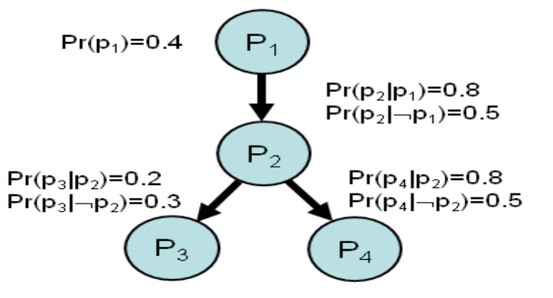  OR  What are neural networks? What is perceptron? Explain how backpropagation algorithm works. | 10 | CO2 | Analysis
2 | Solve the problem by k-means clustering algorithm. | 10 | CO3 | Analysis
  Suppose we have 4 objects as your training data point and each object have 2 attributes.
  Object Attribute 1 Attribute 2
  Medicine A 1 1
  Medicine B 2 1
  Medicine C 4 3
  Medicine D 5 4
  Take K =2.
3 | What do you mean by Reinforcement learning? Discuss elements of Reinforcement learning. Differentiate between Passive and Active Learning with an example. | 10 | CO5 | Knowledge

