Multi-Threading

Process running application which got its own memory.(JVM, Browser etc..)
Thread Unit of execution. Thread will share the memory.
Task actual work

HelloWorld JVM(Jvm created one thread and that thread will execute your program.)
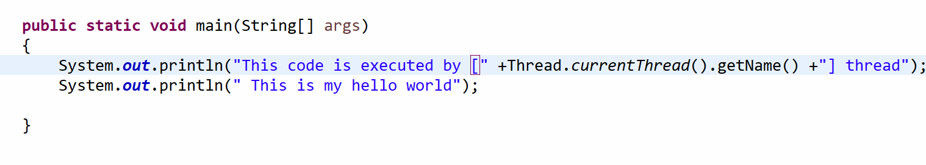
JVM(it will create one thread(main) and assign the responsibility.)

How do we create our own thread.
- Using Thread class
- Using Runnable Interface

- Create a class which extends Thread class
- Override/implement run
- Write the code inside run method.
- Create the thread object and start it.

Thread(t1) Thread Schedular CPU

Music(T10) + Game(T11) + Internet bowser(T12) + Youtube(T13)

T1 T2 T3

