List Duplicate and ordered
- ArrayList Dynamically growing and index based. Best Random Access/Read
- Arraylist Capacity 150%
- LinkedList Best random insertion and read not suitable

Set Unique elements and unordered.
- HashSet Unique elements and unordered.
- LinkedListHashSet Unique elements and ordered.
- TreeSet Unique elements and sorted. Comparable( compareTo() ) O(log N)

Set it internally using Map

Karnataka(K) Bangalore(V)
Gujrat Gandhi Nagar
Maharastra Mumbai
Nagaland Kohima
Tamilnadu Chennai
Rajasthan Jaipur
Punjab Chandigarh
Haryan Chandigarh

Map Key(Unique) and value store.

HashSet HashMap.

- How does HashMap works?
- How doest put() method works in hashmap
- How goes get() method works in hashmap
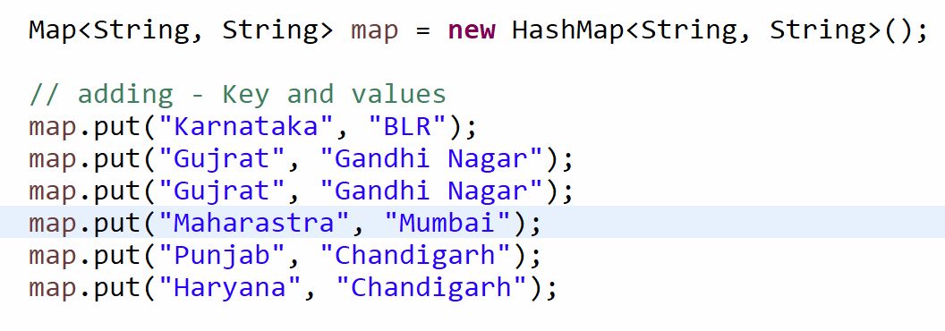

HashSet(Key, PRESENT) HashMap(Key , Value)
LinkedHashSet LinkedHashMap
TreeSet TreeMap

