HashMap Product and Price
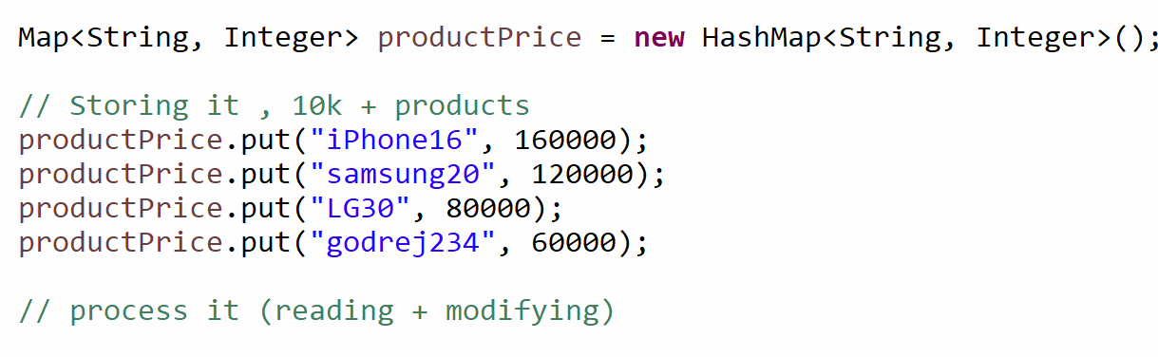

- Use HashTable OR Synchronize the Map

CAS Compare and Swap

