INSTRUMENTATION & ELECTRICAL FIELD SPECIALIST
WEEK 1 TASK: ELECTRICAL CIRCUIT DESIGN
Small-Scale Industrial Plant – Electrical Distribution Design
Candidate | GAURAV RAWAT
Internship | Instrumentation & Electrical Field Specialist
Task | Week 1 – Electrical Circuit Design
Internship Period | 14 September 2026 – 12 October 2026
Design Basis | Educational/academic design using assumed plant loads

1. Objective
The objective of this task is to develop an electrical circuit design for a small-scale industrial plant. The design includes the incoming supply, transformer, circuit protection, relay protection, distribution board, outgoing feeders, and industrial loads. The design considers estimated load demand, basic electrical safety, protection, reliability and efficient distribution. The circuit is presented as a single-line diagram because a single-line representation is a standard way to communicate the main power path and protection arrangement without drawing every conductor separately.

2. Design Assumptions and Load Requirements
For academic design purposes, a three-phase 415 V, 50 Hz low-voltage plant distribution system is assumed. The plant is supplied from an 11 kV utility network through an 11/0.415 kV transformer. The connected loads are assumed to total approximately 30 kW. A design power factor of 0.85 is used for sizing the transformer and incoming protection. These values are assumptions for this internship exercise and are not intended for direct construction or field energization.
Load | Rated Power | Qty. | Total | Approx. Current*
Motor loads | 20 kW | 1 group | 20 kW | ≈35 A
Industrial lighting | 5 kW | 1 group | 5 kW | ≈8 A
Control panel | 2 kW | 1 | 2 kW | ≈3.5 A
Auxiliary loads | 3 kW | 1 group | 3 kW | ≈5 A
Total |  |  | 30 kW | ≈52 A diversified
*Approximate branch currents are indicative values only. Actual feeder and protective-device sizing must be based on the real equipment nameplates, starting currents, cable ampacity, installation method, fault level and applicable electrical standards.

3. Circuit / Single-Line Design
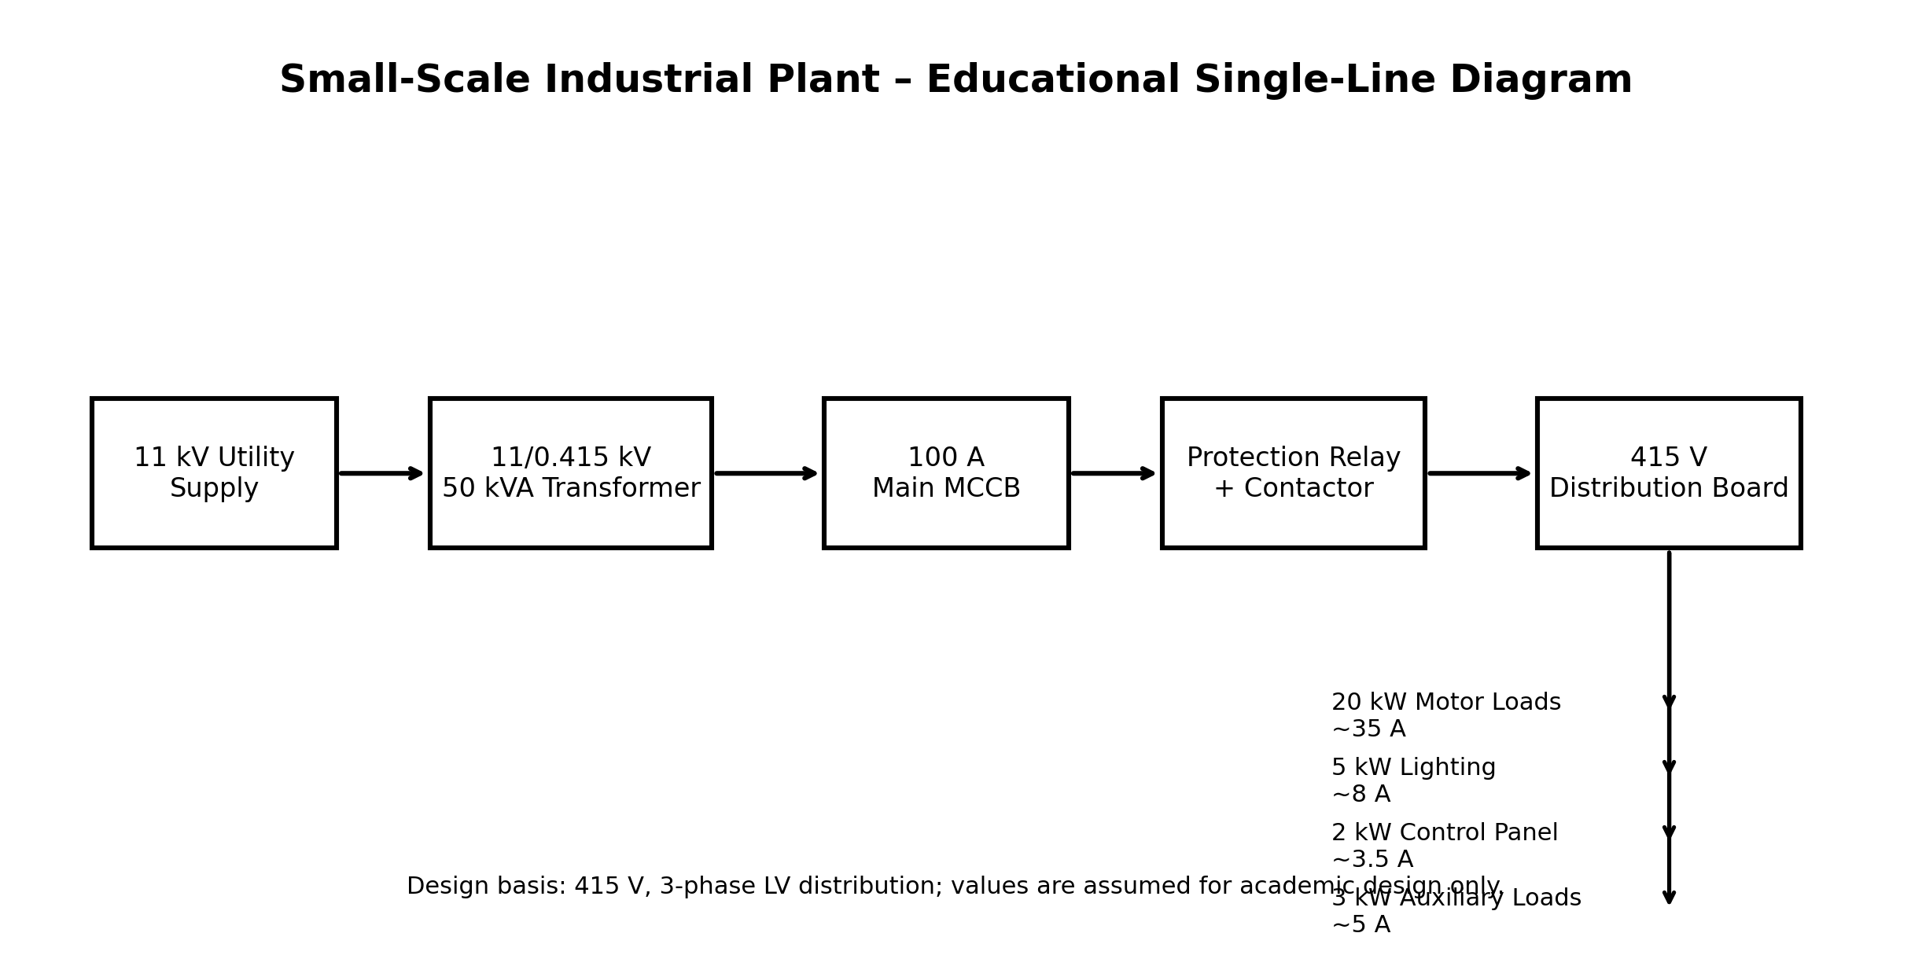
The proposed power path is: 11 kV utility supply → 11/0.415 kV transformer → 100 A main MCCB → protection relay/contactor arrangement → 415 V distribution board → individual protected feeders. The distribution board separates the motor, lighting, control and auxiliary circuits so that a fault on one feeder can be isolated without unnecessarily disconnecting the complete plant.

4. Basic Electrical Calculations
Total active load, P = 20 + 5 + 2 + 3 = 30 kW. Using a design power factor of 0.85, the estimated apparent power is S = P / pf = 30/0.85 ≈ 35.3 kVA. A 50 kVA transformer is therefore selected for this academic design, providing reserve capacity for reasonable future or starting-load variation.
For a three-phase 415 V system, the transformer secondary full-load current is approximately I = S/(√3 × V) = 50,000/(1.732 × 415) ≈ 69.6 A. A 100 A main MCCB is therefore shown in the conceptual design. The final protective-device rating and breaking capacity must be verified against the actual short-circuit level and cable rating before any real installation.

5. Component List and Specifications
Component | Proposed Specification | Function | Selection Note
Transformer | 11/0.415 kV, 50 kVA, 3-phase, 50 Hz | Voltage step-down | Provides LV supply with spare capacity
Main MCCB | 415 V, 100 A, 3/4-pole as required | Overload/short-circuit isolation | Final breaking capacity to be verified
Protection relay | Overcurrent/earth-fault protection | Fault detection/tripping | Settings require coordination study
Contactor | AC-3 rated for motor duty | Motor switching | Select from actual motor FLC
Overload relay | Adjustable to motor full-load current | Motor overload protection | Set to manufacturer data
Distribution board | 415 V, 3-phase, suitable incomer/outgoings | Feeder distribution | Segregate circuits
Cables | Copper/Al, size by current & installation method | Power/control wiring | Voltage drop and thermal rating required
Earthing system | Protective earth/earth bar | Shock protection | Must comply with applicable standards

6. Protection and Safety Measures
Safety is incorporated through isolation, overcurrent protection, motor overload protection, protective earthing and appropriate separation of feeders. The main MCCB provides a means of isolating the LV distribution system and protecting against overload and short-circuit conditions. Motor feeders should use appropriately rated contactors and overload relays. The plant should have a proper protective earth conductor and an accessible earth bar. Cable sizes must be selected according to current-carrying capacity, voltage drop, short-circuit withstand and installation conditions. Lockout/tagout procedures should be followed before maintenance, and only qualified personnel should work on energized or potentially energized electrical equipment.

7. Efficiency and Reliability Considerations
The design keeps the main distribution simple and separates major load groups. This helps fault isolation and maintenance. The transformer is not intentionally operated at its maximum rating, which provides a practical reserve in this academic model. Good power factor, appropriately sized conductors, balanced three-phase loading, efficient motors and routine preventive maintenance can reduce losses. In an actual plant, measured demand and power-quality data should be used to refine transformer, feeder and protection selection.

8. Design Procedure / Key Steps Completed
- Defined an assumed small-scale industrial plant and its major electrical loads.
- Calculated approximate total active power and apparent power.
- Selected a conceptual transformer rating with reserve capacity.
- Calculated approximate transformer secondary full-load current.
- Provided an incoming MCCB and protection arrangement.
- Separated motor, lighting, control and auxiliary feeders.
- Prepared a single-line circuit representation.
- Listed components and indicative specifications.
- Included electrical safety, protection and efficiency considerations.

9. Conclusion
This Week 1 design demonstrates a structured approach to planning a small industrial electrical distribution system. The proposed arrangement provides a clear path from the medium-voltage source through the transformer and main protection to the low-voltage distribution board and individual loads. The design also demonstrates the importance of load estimation, protective devices, earthing, safe isolation and equipment selection. Because this is an academic exercise based on assumed values, the circuit must not be used as a construction drawing. A real installation requires site data, equipment nameplates, fault-level calculations, cable calculations, protection coordination and verification by a competent electrical professional in accordance with applicable standards.

10. References / Study Basis
- Basic principles of three-phase power systems, transformers and LV distribution.
- Standard electrical protection concepts: MCCB, overload, overcurrent and earth-fault protection.
- Manufacturer datasheets should be consulted for final selection of transformers, breakers, relays and contactors.

Prepared as an academic internship task document

