第1次作业

危国锐 120034910021

（上海交通大学海洋学院，上海 200030）

摘要：移动控制体是一种不必追随流体运动的区域. 关于移动控制体的Reynolds输运定理（RTT）是关于含参变量积分的Leibniz定理在高维情形下的推广.包括随体导数公式在内的一些流体力学基本结果可视作RTT的直接推论. 由RTT可以统一对描述流体运动的两种方法——Lagrangian描述和Eulerian描述的理解. 不可压缩流体的连续方程是流速的散度为0. 海水的状态方程是非线性的. TEOS-10基于Gibbs函数公式，海水的所有热力学特性（密度、焓、熵声速等）都可以热力学一致的方式推导出来. 使用TEOS-10计算位温、密度等海水状态参量，首先要遵循TEOS-10规范将海水现场温度和以实用盐标定义的盐度转换为“绝对盐度”（*Absolute Salinity*）和“保守温度”（*Conservative Temperature*）. 本文使用的程序和文档发布于https://grwei.github.io/SJTU_2021-2022-1-MS8402/.

关键词：雷诺输运定理，流体运动学，连续方程，状态方程，TEOS-10

Homework 1

Guorui Wei 120034910021

(*School of Oceanography*, *Shanghai Jiao Tong University*, *Shanghai* 200030, *China*)

**Abstract**：A moving control volume is a region that does not have to follow the motion of the fluid. The Reynolds transport theorem (RTT) for a moving control volume is an extension of Leibniz's theorem for integrals with parameters in high-dimensional cases. The basic results of fluid mechanics including the volume derivative formula. RTT can unify the understanding of the two methods of describing fluid motion - Lagrangian description and Eulerian description. The continuity equation of an incompressible fluid is that the divergence of the flow velocity is 0. The state of seawater The equation is nonlinear. TEOS-10 is based on the Gibbs function formula, and all thermodynamic properties of seawater (density, enthalpy, entropy sound velocity, etc.) can be derived in a thermodynamically consistent way. Using TEOS-10 to calculate seawater state parameters such as potential temperature and density, First, the field temperature of seawater and the salinity defined by the practical salt scale are converted into "*Absolute Salinity*" and "*Conservative Temperature*" according to the TEOS-10 specification. The programs and documents used in this article are published at https://grwei.github.io/SJTU_2021-2022-1-MS8402/.

**Keywords**：Reynolds Transport Theorem, Fluid Kinematics, Continuity Equation, Equation of State, TEOS-10

**目 录**

摘要 i

Abstract i

1 流体运动学基础 1

2 第1题 3

2.1 问题描述 3

2.2 解决方案 3

3 第2题 3

3.1 问题描述 3

3.2 解决方案 4

4 第3题 4

4.1 问题描述 5

4.2 解决方案 5

References 7

附录A 本作业使用的MATLAB程序源代码 8

# 流体运动学基础

本节简要回顾流体运动学中一些基本且重要的结果.

描述流体运动的两种方法——Lagrangian描述（流体质点的观点）和Eulerian描述（场的观点）的联系被定义为 (Kundu et al., 2016, p. 82)



其中是任意标量，向量或张量. 由此定义随体导数 (*material*, *substantial*, or *particle* *derivative*)，它是Lagrangian描述下对时间的全导数，并可导出其Eulerian描述下的表达式 (p. 83)：



上式给出了两种描述方法的联系.

Kundu et al. (2016) 引入移动控制体 (Control Volume, CV) 的概念，推导了雷诺输运定理 (Reynolds transport theorem, RTT). 由此可统一对两种描述方法的理解.

RTT描述的是移动控制体（不必追随流体质点）所包含的物理量对时间的变化率. 从数学上，就是建立了被积函数和积分区域都含参变量的积分对这参变量的导数. 事实上，我们在数学分析课程 (陈纪修 et al., 2019, p. 315) 中已证过一维RTT，那就是下面的积分号下求导定理

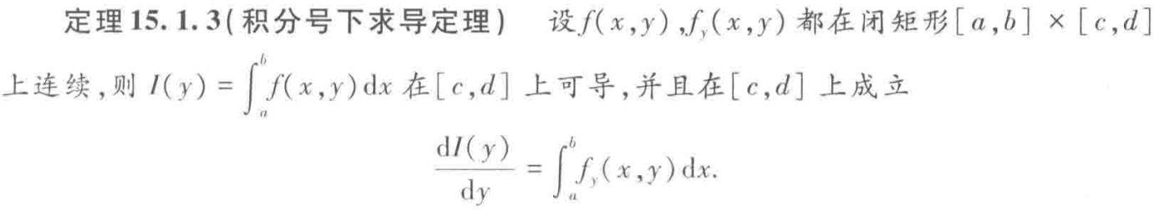

和Leibniz定理

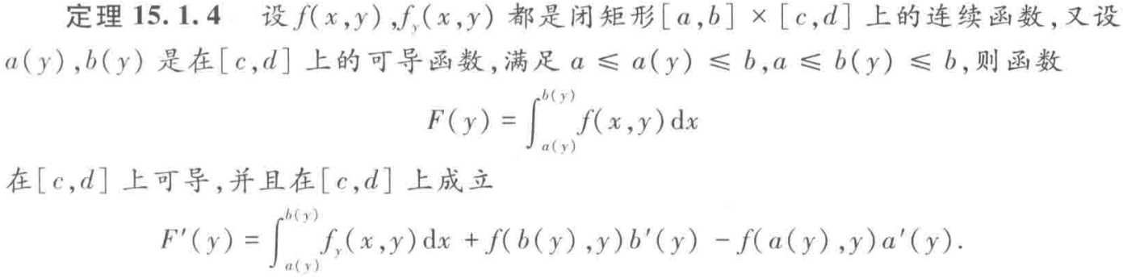

Leibniz定理在二维、三维情形下的推广，便是著名的雷诺输运定理 (Reynolds transport theorem, RTT). Kundu et al. (2016) 从数学上不很严格地给出了推导 (pp. 99-103)，其结果是



式中各字母的含义示于下图 (Fig 3.20). 这样，Lagrangian描述和Eulerian描述，就分别对应于（3.35）中的情形. 如此，两种描述方法不仅是联系的，而且是统一的.

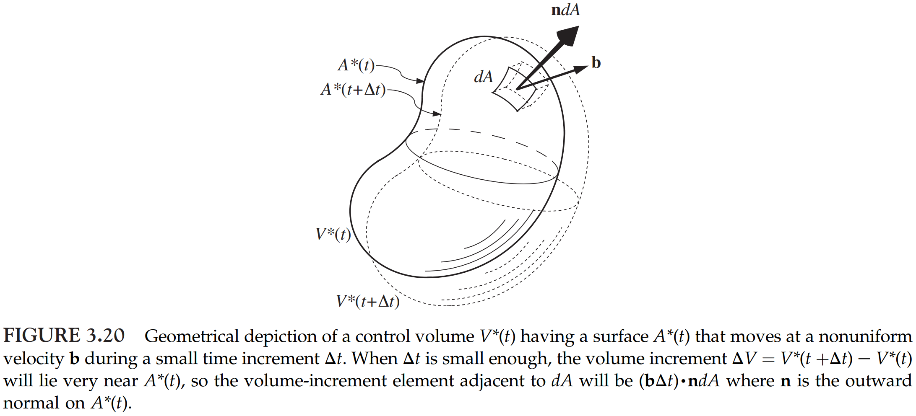

从RTT (3.35) 出发，可获得一些重要推论. 例如，在 (3.35) 中取就得到

利用（1），在（3.35）中取就得到RTT的微分形式：

在（1）中取便得到人们熟悉的速度散度的物理意义（相对体积膨胀率）. 在（2）中取便得到随体导数公式，它是“the *Eulerian representation of the Lagrangian derivative as applied to a field*.”(Vallis, 2017, p. 5)

另外，吴望一（1982）从定义出发，推导了线、面、体元的随体导数 (1982a, pp. 135-138) 和体、面、线积分的随体导数 (1982b, pp. 479-484). 这些结果可视为一维RTT及其微分形式在曲线曲面情形下的推广，正如Green, Gauss, Stokes公式是Newton-Leibniz公式在高维情形下的推广.

关于RTT (3.35)，受Vallis (2017, pp. 3-7) 和[吴望一 (1982a, pp. 135-138)](#_ENREF_6" \o "吴望一, 1982 #5) 的启发，现重新推导如下：

在推导中利用了（1）（2）. 这种推导方法在数学上不严格，然而物理意义较清晰，便于记忆. 应该指出，这种方法不是我的原创.

# 第1题

## 问题描述



## 解决方案

在RTT（3.35）中取 立得

此时，积分区域是空间位置固定的控制体 (Control Volume, CV). 事实上，上式就是积分号下求导定理在三维情形下的推广.

# 第2题

## 问题描述

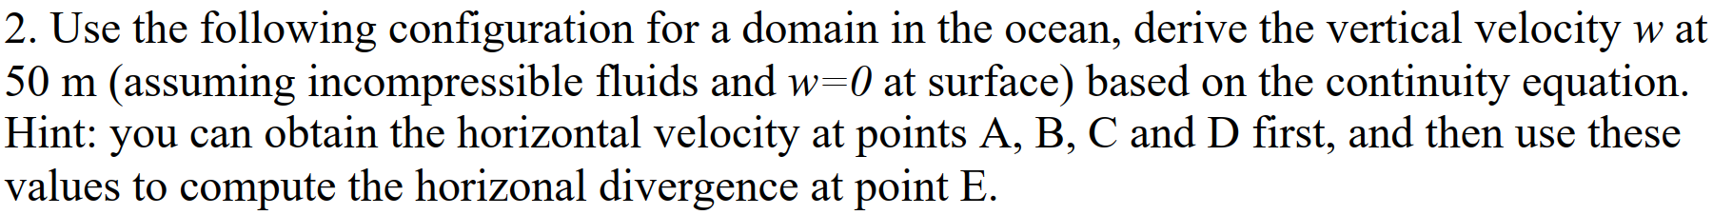

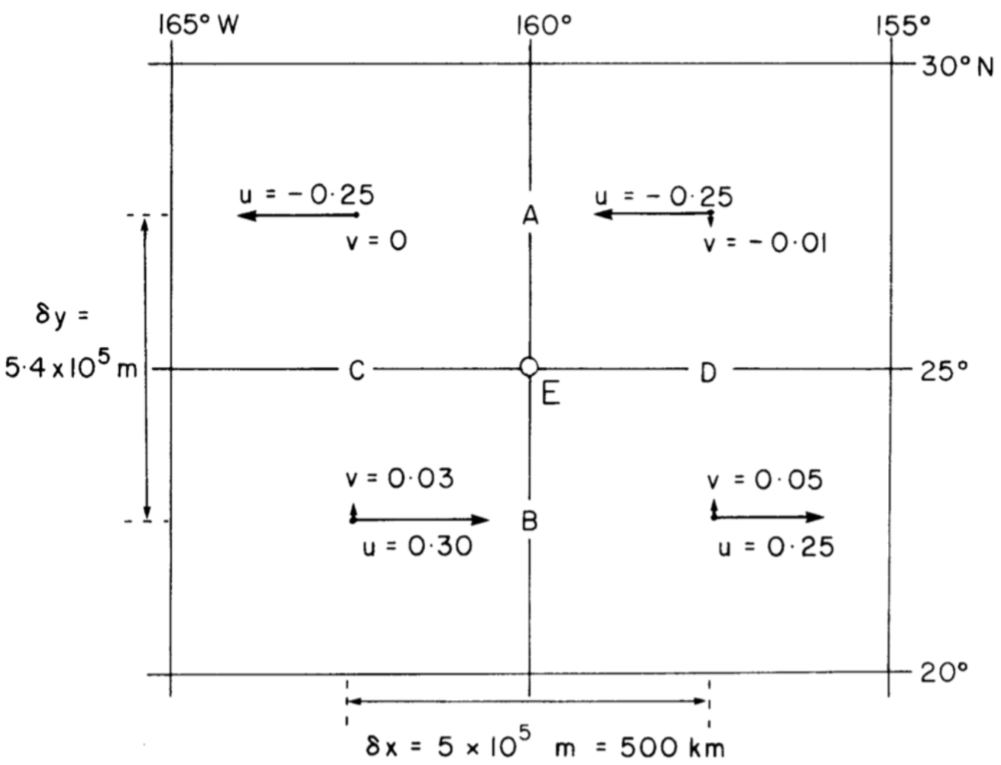

## 解决方案

从左上象限起，按逆时针方向，为四个数据点依次编号1至4.

首先，用线性插值估计A至D点的水平流速梯度：

然后，用线性插值估计E点的水平流速梯度：

假定：1）流体为不可压缩的，从而有连续方程

2）水平流速在方向上不变，即

从而，E点上方垂直流速

代入数据，得E点50米深处垂直流速 (m/s).

# 第3题

“TEOS-10 is based on a Gibbs function formulation from which all thermodynamic properties of seawater (density, enthalpy, entropy sound speed, etc.) can be derived in a thermodynamically consistent manner. TEOS-10 was adopted by the Intergovernmental Oceanographic Commission at its 25th Assembly in June 2009 to replace EOS-80 as the official description of seawater and ice properties in marine science.”(http://www.teos-10.org/index.htm)

## 问题描述

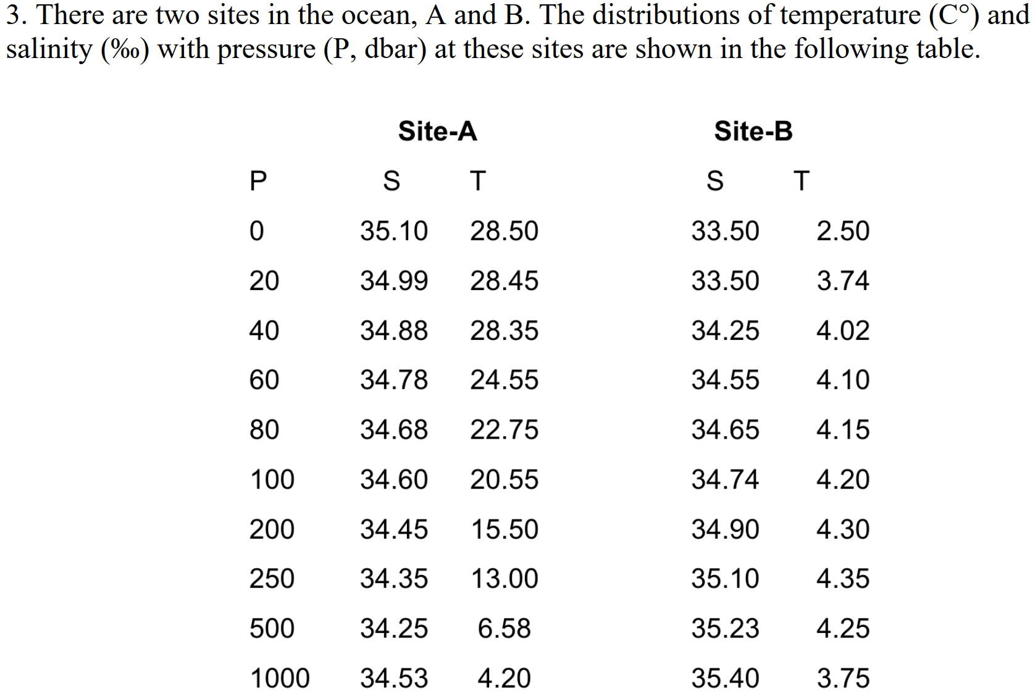

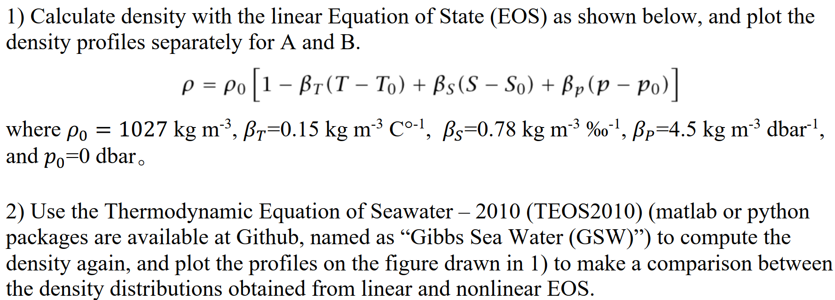

## 解决方案

题目未明确指出原始数据中“温度”和“盐度”两词的定义. 若“温度”是指现场（in-situ）温度，而“盐度”的单位是实用盐标（psu），则当使用TEOS-10 (McDougall et al., 2011) 时，需要先转换为*Absolute Salinity* (TEOS-10) 和*Conservative Temperature* (TEOS-10)，这需要使用A, B两地的位置，然而题目并未提供. 鉴此，我暂且将原始数据的“温度”和“盐度”理解为*Absolute Salinity* (TEOS-10) 和*Conservative Temperature* (TEOS-10).

题中给出的线性EOS公式似乎有小笔误. 我擅自将其更改为

图4.1展现了使用线性与非线性EOS的计算结果的巨大差异.



图4.1 Site A和Site B处的海水密度剖面. 蓝点、橙圈分别是TEOS-10、Linear EOS的计算结果，蓝实线、橙虚线分别是TEOS-10、线性EOS数据的插值结果. 注意，下横轴（相应于TEOS-10数据）和上横轴（相应于线性EOS数据）刻度值有显著差异. 该图可用于说明使用线性与非线性EOS的密度计算结果的巨大差异

References

<http://www.teos-10.org/index.htm>. Retrieved 2022-02-28 from <http://www.teos-10.org/index.htm>

Kundu, P. K., Cohen, I. M., & Dowling, D. R. (2016). Chapter 3 - Kinematics. In P. K. Kundu, I. M. Cohen, & D. R. Dowling (Eds.), *Fluid Mechanics (Sixth Edition)* (pp. 77-108). Academic Press. <https://doi.org/10.1016/B978-0-12-405935-1.00003-4>

McDougall, Barker, T. J., & M, P. (2011). Getting started with TEOS-10 and the Gibbs Seawater (GSW) oceanographic toolbox. *Scor/Iapso WG*, *127*, 1-28.

Vallis, G. K. (2017). *Atmospheric and Oceanic Fluid Dynamics: Fundamentals and Large-Scale Circulation* (2 ed.). Cambridge University Press. <https://doi.org/10.1017/9781107588417>

陈纪修, 於崇华, & 金路. (2019). *数学分析(下册)* (3 ed.). 高等教育出版社.

吴望一. (1982a). *流体力学(上册)*. 北京大学出版社.

吴望一. (1982b). *流体力学(下册)*. 北京大学出版社.

1. 本作业使用的MATLAB程序源代码

|  |  |
| --- | --- |
| 1 | %% hw1.m |
| 2 | % Description: MATLAB code used in homework 1 (MS8402, 2022 Spring) |
| 3 | % Author: Guorui Wei (危国锐) (313017602@qq.com; weiguorui@sjtu.edu.cn) |
| 4 | % Student ID: 120034910021 |
| 5 | % Created: 2022-02-27 |
| 6 | % Last modified: 2022-02-28 |
| 7 |  |
| 8 | %% Initialize project |
| 9 |  |
| 10 | clc; clear; close all |
| 11 | init_env(); |
| 12 |  |
| 13 | %% Question 2 |
| 14 |  |
| 15 | % |
| 16 | u = [-.25,-.25,.05,.03]; % [m/s] |
| 17 | v = [0,-.01,.25,.30]; % [m/s] |
| 18 | delta_x = 5e5; % [m] |
| 19 | delta_y = 5.4e5; % [m] |
| 20 | % |
| 21 | u_wrt_x = (u(2)-u(1)+u(3)-u(4))/(2*delta_x); % [1/s] |
| 22 | v_wrt_y = (v(1)-v(4)+v(2)-v(3))/(2*delta_y); % [1/s] |
| 23 | w = @(z) -(u_wrt_x+v_wrt_y)*z; % [m/s] |
| 24 | fprintf("w(-50) = %.2d cm/s\n",w(-50)*100); |
| 25 |  |
| 26 | %% Question 3 |
| 27 |  |
| 28 | % |
| 29 | site_A.p = [0,20,40,60,80,100,200,250,500,1000].'; % [dbar] |
| 30 | site_A.SA = [35.10,34.99,34.88,34.78,34.68,34.60,34.45,34.35,34.25,34.53].'; % [g/kg] |
| 31 | site_A.CT = [28.50,28.45,28.35,24.55,22.75,20.55,15.50,13.00,6.58,4.20].'; % [deg C] |
| 32 | site_B.p = site_A.p; % [dbar] |
| 33 | site_B.SA = [33.50,33.50,34.25,34.55,34.65,34.74,34.90,35.10,35.23,35.40].'; % [g/kg] |
| 34 | site_B.CT = [2.50,3.74,4.02,4.10,4.15,4.20,4.30,4.35,4.25,3.75].'; % [deg C] |
| 35 | p_i = (site_A.p(1):1:site_A.p(end)).'; % specific query points at which the interpolated SA_i and CT_i are required [ dbar ] |
| 36 |  |
| 37 | %% Figure. |
| 38 |  |
| 39 | t_TCL = tiledlayout(1,2,"TileSpacing","tight","Padding","tight"); |
| 40 | % |
| 41 | site_A = hw1_3(site_A,p_i,t_TCL,1,"\bf Site A"); |
| 42 | site_B = hw1_3(site_B,p_i,t_TCL,2,"\bf Site B"); |
| 43 | % |
| 44 | xlabel(t_TCL,"density (kg/$\rm{m}^3$)","Interpreter",'latex'); |
| 45 | ylabel(t_TCL,"pressure (dbar)","Interpreter",'latex'); |
| 46 | [t_title_t,t_title_s] = title(t_TCL,"\bf 2022 Spring MS8402 Hw1 Q3","Guorui Wei 120034910021","Interpreter",'latex'); |
| 47 | set(t_title_s,'FontSize',8) |
| 48 | % |
| 49 | exportgraphics(t_TCL,"..\\doc\\fig\\hw1_Q3.emf",'Resolution',800,'ContentType','auto','BackgroundColor','none','Colorspace','rgb') |
| 50 | exportgraphics(t_TCL,"..\\doc\\fig\\hw1_Q3.png",'Resolution',800,'ContentType','auto','BackgroundColor','none','Colorspace','rgb') |
| 51 |  |
| 52 | %% local functions |
| 53 |  |
| 54 | %% Initialize environment |
| 55 |  |
| 56 | function [] = init_env() |
| 57 | % set up project directory |
| 58 | if ~isfolder("../doc/fig/") |
| 59 | mkdir ../doc/fig/ |
| 60 | end |
| 61 | % configure searching path |
| 62 | mfile_fullpath = mfilename('fullpath'); % the full path and name of the file in which the call occurs, not including the filename extension. |
| 63 | mfile_fullpath_without_fname = mfile_fullpath(1:end-strlength(mfilename)); |
| 64 | addpath(genpath(mfile_fullpath_without_fname + "../data"), ... |
| 65 | genpath(mfile_fullpath_without_fname + "../inc")); % adds the specified folders to the top of the search path for the current MATLAB® session. |
| 66 | end |
| 67 |  |
| 68 | %% Question 3 |
| 69 |  |
| 70 | function [site_struct] = hw1_3(site_struct,p_i,t_TCL,num_Tile,textbox_string) |
| 71 | %% hw1_3 |
| 72 | % Description. |
| 73 | arguments |
| 74 | site_struct |
| 75 | p_i |
| 76 | t_TCL |
| 77 | num_Tile = 1 |
| 78 | textbox_string = "\bf Site" |
| 79 | end |
| 80 |  |
| 81 | site_struct.p_i = p_i; % specific query points at which the interpolated SA_i and CT_i are required [ dbar ] |
| 82 | [site_struct.SA_i,site_struct.CT_i] = gsw_SA_CT_interp(site_struct.SA,site_struct.CT,site_struct.p,p_i); % SA and CT interpolation to p_i on a cast |
| 83 |  |
| 84 | %%% 1. Calculate density with the linear Equations of State (EOS). |
| 85 |  |
| 86 | rho_0 = 1027; % [kg/m^3] |
| 87 | beta_T = 0.15; % [kg/m^3/(deg C)] |
| 88 | beta_S = 0.78; % [kg/m^3/(g/kg)] |
| 89 | beta_p = 4.5;  % [kg/m^3/dbar] |
| 90 |  |
| 91 | func_rho_linear = @(T,S,p) rho_0 * (1 - beta_T*(T-T(1)) + beta_S*(S-S(1)) + beta_p*(p-p(1))); |
| 92 | site_struct.rho_linear = func_rho_linear(site_struct.CT, site_struct.SA, site_struct.p); |
| 93 | site_struct.rho_i_linear = func_rho_linear(site_struct.CT_i,site_struct.SA_i,site_struct.p_i); |
| 94 |  |
| 95 | %%% 2. Use TEOS-10 to compute the density. |
| 96 | % NOTE: Since the location of site A & B is not provided, I have to let SA, CT |
| 97 | % (TEOS-10) be SP, t, and therefore the results here should not be correct. |
| 98 |  |
| 99 | site_struct.rho_TEOS_10 = gsw_rho_CT_exact(site_struct.SA,site_struct.CT,site_struct.p); % Calculates in-situ density from Absolute Salinity and Conservative Temperature. |
| 100 | site_struct.rho_i_TEOS_10 = gsw_rho_CT_exact(site_struct.SA_i,site_struct.CT_i,site_struct.p_i); |
| 101 |  |
| 102 | %%% plot |
| 103 |  |
| 104 | % |
| 105 | t_Axes_TEOS = nexttile(t_TCL,num_Tile); |
| 106 | t_plot_1 = plot(t_Axes_TEOS,site_struct.rho_i_TEOS_10,site_struct.p_i,'-',"color",'#0072BD',"DisplayName",'TEOS-10'); |
| 107 | hold on |
| 108 | t_plot_2 = plot(site_struct.rho_TEOS_10,site_struct.p,'.',"color",'#0072BD',"MarkerSize",10,"DisplayName",''); |
| 109 | set(t_Axes_TEOS,"YDir",'reverse',"TickLabelInterpreter",'latex',"FontSize",10,'Box','off',"XColor",'#0072BD',"YColor",'#0072BD'); |
| 110 | % |
| 111 | t_Axes_linear = axes(t_TCL); |
| 112 | t_Axes_linear.Layout.Tile = num_Tile; |
| 113 | t_plot_3 = plot(t_Axes_linear,site_struct.rho_i_linear,site_struct.p_i,'--','Color','#D95319',"DisplayName",'LEOS'); |
| 114 | hold on |
| 115 | t_plot_4 = plot(site_struct.rho_linear,site_struct.p,'o',"MarkerSize",4,'Color','#D95319',"DisplayName",''); |
| 116 | set(t_Axes_linear,'YDir','reverse','FontSize',10,'TickLabelInterpreter','latex','XAxisLocation','top','YAxisLocation','right','YTickLabel',{},'Box','off','Color','none','XColor','#D95319','YColor','#D95319','YLimitMethod','tight') |
| 117 | % |
| 118 | linkaxes([t_Axes_TEOS,t_Axes_linear],'y'); |
| 119 | legend([t_plot_2,t_plot_4],["TEOS-10","Linear EOS"],"Location",'southwest','Interpreter','latex',"Box","off"); |
| 120 | annotation('textbox',[0.36+0.5*(num_Tile-1) 0.68 0.10 0.06],'String',textbox_string,'LineStyle','none','FontWeight','bold','Interpreter','latex'); |
| 121 |  |
| 122 | end |
| 123 |  |