第1次作业

危国锐 120034910021

（上海交通大学海洋学院，上海 200030）

摘要：使用有限差分法，数值求解了一个具有解析解的一维对流（平流，输运）方程. 对于时间偏导项，采取两层显式差分平流方案. 对于空间偏导项，分别采取前（左）向和后（右）向差分作近似. 选取两个不同的时间与空间步长之比，分别执行计算. 在四个求解尝试中，仅有当取0.9时的两层显式前向差分平流方案可接近解析解. 在另外三个求解尝试中，当取2.0时的两层显式前向差分平流方案能体现特征线的方向（物理意义为平流方向），但其数值结果显示出不稳定的外观；两个两层显式后向差分平流方案的尝试均不能正确体现特征线的方向，且数值结果显示出不稳定的外观. 由数值实验可以看出，即使要求解的问题相对简单，采取前向和后向差分格式得到的数值结果可能大不相同，且数值格式的稳定性可能对网格剖分方式高度敏感. 本文所使用的计算机程序和文档发布于<https://github.com/grwei/SJTU_2021-2022-2-MATH6008>.

关键词：有限差分法，输运方程，两层格式，显式格式

Homework 1

Guorui Wei 120034910021

(*School of Oceanography*, *Shanghai Jiao Tong University*, *Shanghai* 200030, *China*)

**Abstract**：Using the finite difference method, a one-dimensional advection (convection, transport) equation with an analytical solution is numerically solved. For the temporal partial derivatives, a two-layer explicit differential advection scheme is adopted. For the spatial partial derivatives, forward (left) and backward (right) is approximated to the difference. Two different ratios of time and space steps, *τ* , are selected to perform the calculation separately. Among the four solution attempts, only the two-layer explicit forward differential advection scheme when *τ* is 0.9 can be approximated. Analytical solution. In the other three solution attempts, the two-layer explicit forward differential advection scheme when *τ* takes 2.0 can reflect the direction of the characteristic line (the physical meaning is the direction of advection), but its numerical results show an unstable appearance ; both attempts at the two-layer explicit backward differential advection scheme fail to correctly reflect the orientation of the feature lines, and the numerical results show an unstable appearance. It can be seen from the numerical experiments that even if the solution required The problem is relatively simple, the numerical results obtained with the forward and backward differencing schemes can be quite different, and the stability of the numerical scheme can be highly sensitive to the meshing method. The computer programs and documents used in this article are published at <https://github.com/grwei/SJTU_2021-2022-2-MATH6008>.

**Keywords**：finite difference method, advection equation, two-level scheme, explicit scheme

**目 录**

摘要 i

Abstract i

1 问题描述 1

2 格式设计 1

2.1 两层显式前向差分平流方案 1

2.2 两层显式后向差分平流方案 2

3 计算结果 2

4 讨论 3

References 4

附录A 本作业使用的MATLAB程序源代码 5

A.1 主程序 5

A.2 子程序 8

# 问题描述

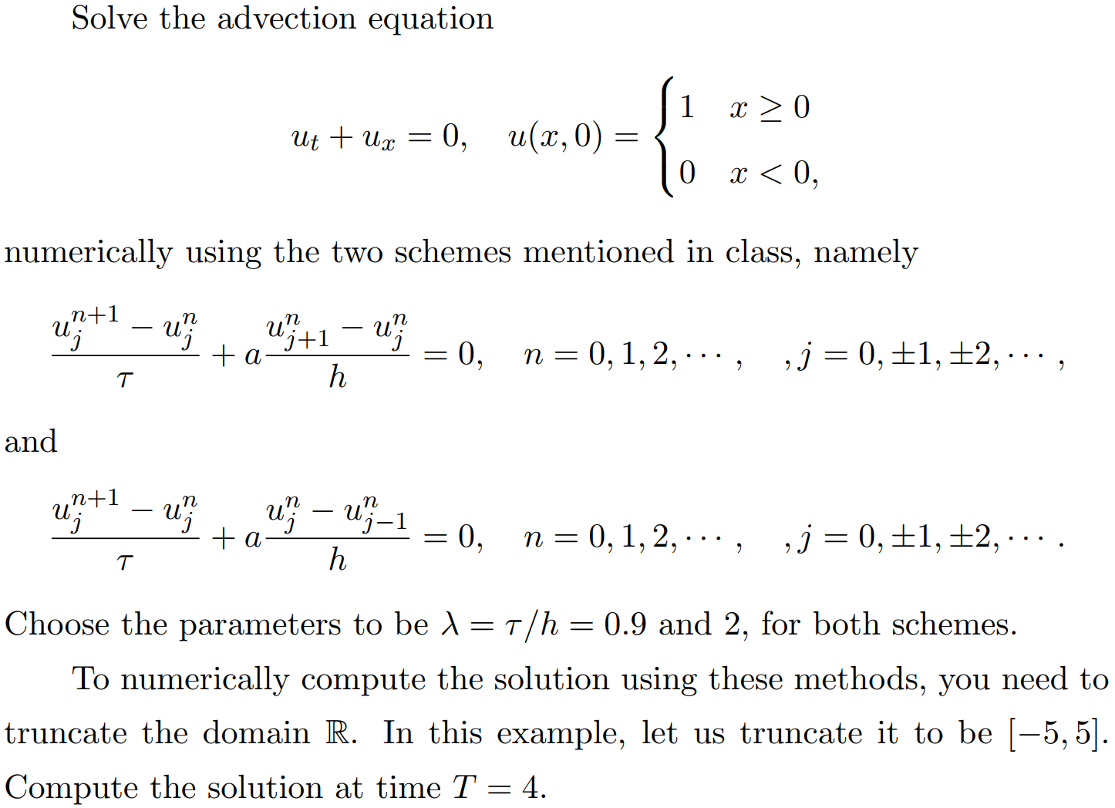

# 格式设计

待求解的问题是一个一维的一阶常系数线性齐次发展方程，该问题具有解析解，为

可见，在问题区域中，恒有故将数值求解区域截断为并添加边界条件

采用两层显式有限差分方法进行数值求解. 对于空间偏导项，分别采取前（右）向差分和后（左）向差分方案进行计算. 下文采取以下符号约定：

其中

## 两层显式前向差分平流方案

时间偏导采取前向差分，空间偏导采取前（右）向差分. 有限差分方程为

初始条件为

边界条件为

## 两层显式后向差分平流方案

时间偏导采取前向差分，空间偏导采取后（左）向差分. 有限差分方程为

初始条件和边界条件同（4）（5）.

# 计算结果

分别采取有限差分格式（3）（6），分别取为0.9, 2.0进行数值求解，计算结果示于图3.1. 可见，在四个求解尝试中，仅有当取0.9时的两层显式前向差分平流方案可接近解析解（1）. 在另外三个求解尝试中，当取2.0时的两层显式前向差分平流方案能体现特征线的方向（物理意义为平流方向），但其数值结果显示出不稳定的外观；两个两层显式后向差分平流方案的尝试均不能正确体现特征线的方向，且数值结果显示出不稳定的外观.

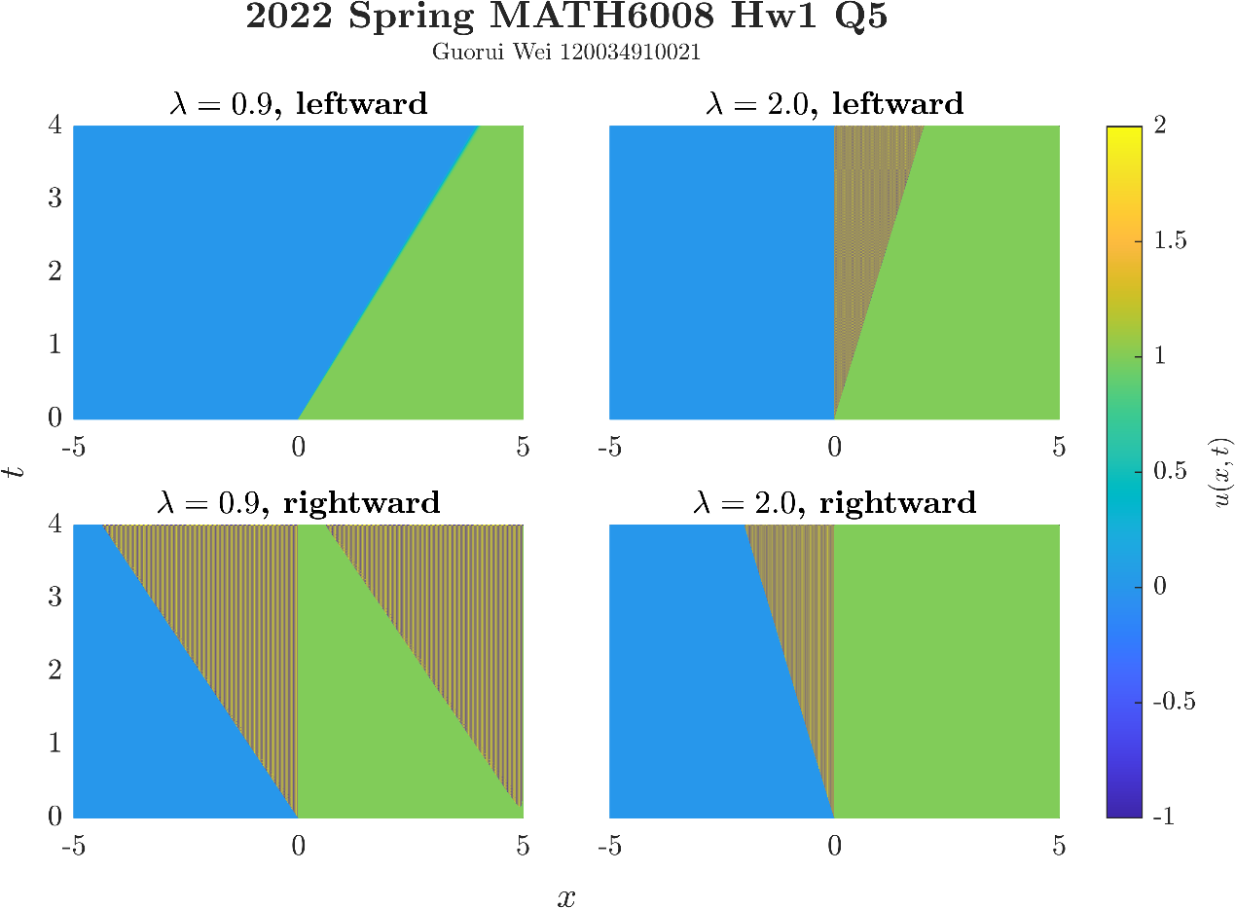

图. 分别采取有限差分格式（3）（6），分别取为0.9, 2.0进行数值求解的计算结果. 可见，在四个求解尝试中，仅有当取0.9时的两层显式前向差分平流方案可接近解析解（1）. 在另外三个求解尝试中，当取2.0时的两层显式前向差分平流方案能体现特征线的方向（物理意义为平流方向），但其数值结果显示出不稳定的外观；两个两层显式后向差分平流方案的尝试均不能正确体现特征线的方向，且数值结果显示出不稳定的外观. 由本次数值实验可以看出，即使要求解的问题相对简单，采取前向和后向差分格式得到的数值结果可能大不相同，且数值格式的稳定性可能对网格剖分方式高度敏感.

# 讨论

分别采取有限差分格式（3）（6），分别取为0.9, 2.0进行数值求解，计算结果示于图3.1. 可见，在四个求解尝试中，仅有当取0.9时的两层显式前向差分平流方案可接近解析解（1）. 另外三个求解尝试的数值结果都显示出不稳定的外观；其中，当取2.0时的两层显式前向差分平流方案能体现特征线的方向（物理意义为平流方向），而两个两层显式后向差分平流方案的尝试均不能正确体现特征线的方向.

由本次数值实验可以看出，即使要求解的问题相对简单，采取前向和后向差分格式得到的数值结果可能大不相同，且数值格式的稳定性可能对网格剖分方式高度敏感.

References

1. 本作业使用的MATLAB程序源代码

本附录提供的计算机程序源代码可能不是最新的. 本文所使用的计算机程序和文档的最新版本发布于<https://github.com/grwei/SJTU_2021-2022-2-MATH6008>.

* 1. 主程序

|  |  |
| --- | --- |
| 1 | %% hw1.m |
| 2 | % Matlab code for 2022 Spring MATH6008-M01 Homework 1 |
| 3 | % Author: Guorui Wei (危国锐) (weiguorui@sjtu.edu.cn; 313017602@qq.com) |
| 4 | % Student ID: 120034910021 |
| 5 | % Created: 2022-02-28 |
| 6 | % Last modified: 2022-03-01 |
| 7 |  |
| 8 | %% Initialize project |
| 9 |  |
| 10 | clc; clear; close all |
| 11 | init_env(); |
| 12 |  |
| 13 | %% FDM for the advection equation (two-level explicit scheme) |
| 14 |  |
| 15 | %%% Parameters definition. |
| 16 | hw1_tau = 4e-3; % time step |
| 17 |  |
| 18 | %%% |
| 19 | t_TCL = tiledlayout(2,2,"TileSpacing","compact","Padding","tight"); |
| 20 | xlabel(t_TCL,"$x$","Interpreter",'latex'); |
| 21 | ylabel(t_TCL,"$t$","Interpreter",'latex'); |
| 22 | [t_title_t,t_title_s] = title(t_TCL,"\bf 2022 Spring MATH6008 Hw1 Q5","Guorui Wei 120034910021","Interpreter",'latex'); |
| 23 | set(t_title_s,'FontSize',8) |
| 24 |  |
| 25 | %%% Two-level explicit scheme for the advection equation. |
| 26 | % Backward (left-) one-sided difference for space. |
| 27 | hw1_results_09_left = hw1_FDM(hw1_tau,0.9,"leftward",t_TCL,1,"\bf $\lambda = 0.9$, leftward"); |
| 28 | hw1_results_20_left = hw1_FDM(hw1_tau,2.0,"leftward",t_TCL,2,"\bf $\lambda = 2.0$, leftward"); |
| 29 | % Forward (right-) one-sided difference for space. |
| 30 | hw1_results_09_right = hw1_FDM(hw1_tau,0.9,"rightward",t_TCL,3,"\bf $\lambda = 0.9$, rightward"); |
| 31 | hw1_results_20_right = hw1_FDM(hw1_tau,2.0,"rightward",t_TCL,4,"\bf $\lambda = 2.0$, rightward"); |
| 32 |  |
| 33 | %% Figure. |
| 34 |  |
| 35 | % |
| 36 | exportgraphics(t_TCL,"..\\doc\\fig\\hw1_Q3.png",'Resolution',800,'ContentType','auto','BackgroundColor','none','Colorspace','rgb') |
| 37 |  |
| 38 | %% local functions |
| 39 |  |
| 40 | function [hw1_results] = hw1_FDM(hw1_tau,hw1_lambda,space_diff_type,t_TCL,tile_num,tile_title) |
| 41 | %% hw1_FDM |
| 42 | %%% two-level explicit scheme for the advection equation |
| 43 | % hw1_tau: time step |
| 44 | % hw1_lambda: time step/space step |
| 45 | % space_diff_type: direction of one-sided difference for space |
| 46 | arguments |
| 47 | hw1_tau |
| 48 | hw1_lambda |
| 49 | space_diff_type |
| 50 | t_TCL |
| 51 | tile_num |
| 52 | tile_title |
| 53 | end |
| 54 |  |
| 55 | %%% parameters definition |
| 56 | hw1_N_t = floor(4/hw1_tau); |
| 57 | hw1_h = hw1_tau / hw1_lambda; |
| 58 | hw1_N_x = floor(5/hw1_h); |
| 59 | if 4/hw1_tau ~= hw1_N_t |
| 60 | warndlg("N_t should be positive integer!","invalid parameters"); |
| 61 | end |
| 62 |  |
| 63 | %%% two-level explicit scheme for the advection equation |
| 64 | hw1_x_val_vector = linspace(-5,5,2*hw1_N_x+1); % x-value vector of the solving region |
| 65 | hw1_t_val_vector = linspace(0,4,hw1_N_t+1); % t-value vector of the solving region |
| 66 | [hw1_x_grid,hw1_t_grid] = meshgrid(hw1_x_val_vector,hw1_t_val_vector); |
| 67 | hw1_results = zeros(size(hw1_t_grid)); % numerical results |
| 68 | % Assign the initial and boundary conditions. |
| 69 | hw1_results(1,:) = hw1_x_val_vector >= 0; % Initial conditions. |
| 70 | hw1_results(:,1) = 0; % Boundary conditions. |
| 71 | hw1_results(:,end) = 1; % Boundary conditions. |
| 72 | % Solve level by level. |
| 73 | for n = 1:(hw1_N_t) |
| 74 | for j = 2:(2*hw1_N_x) |
| 75 | if space_diff_type == "leftward" |
| 76 | % backward (left-) one-sided difference for space |
| 77 | hw1_results(n+1,j) = (1-hw1_lambda)*hw1_results(n,j) + hw1_lambda*hw1_results(n,j-1); |
| 78 | else |
| 79 | % forward (right-) one-sided difference for space |
| 80 | hw1_results(n+1,j) = (1+hw1_lambda)*hw1_results(n,j) - hw1_lambda*hw1_results(n,j+1); |
| 81 | end |
| 82 | end |
| 83 | end |
| 84 |  |
| 85 | %%% Figure. |
| 86 | % |
| 87 | t_Axes = nexttile(t_TCL,tile_num); |
| 88 | s = pcolor(t_Axes,hw1_x_grid,hw1_t_grid,hw1_results); |
| 89 | set(s,'EdgeColor','flat','FaceColor','flat','EdgeColor','interp','FaceColor','interp') |
| 90 | title(t_Axes,tile_title,'Interpreter','latex') |
| 91 | caxis(t_Axes,[-1 2]); % Hold Color Limits for Multiple Plots |
| 92 | colormap(t_Axes,"parula") |
| 93 | set(t_Axes,'YDir',"normal",'TickLabelInterpreter','latex','FontSize',10) |
| 94 | if ~mod(tile_num,2) |
| 95 | set(t_Axes,'YTickLabel',{}); |
| 96 | end |
| 97 | % share colorbar |
| 98 | if tile_num == 1 |
| 99 | cb = colorbar; |
| 100 | set(cb,"TickLabelInterpreter",'latex'); |
| 101 | set(cb.Label,'Interpreter','latex','String','$u(x,t)$'); |
| 102 | cb.Layout.Tile = 'east'; |
| 103 | end |
| 104 |  |
| 105 | end % end of function definition |
| 106 |  |
| 107 | %% Initialize environment |
| 108 | function [] = init_env() |
| 109 | %% init_env |
| 110 | % Description. |
| 111 | arguments |
| 112 |  |
| 113 | end |
| 114 | % set up project directory |
| 115 | if ~isfolder("../doc/fig/") |
| 116 | mkdir ../doc/fig/ |
| 117 | end |
| 118 | % configure searching path |
| 119 | mfile_fullpath = mfilename('fullpath'); % the full path and name of the file in which the call occurs, not including the filename extension. |
| 120 | mfile_fullpath_without_fname = mfile_fullpath(1:end-strlength(mfilename)); |
| 121 | addpath(genpath(mfile_fullpath_without_fname + "../data"), ... |
| 122 | genpath(mfile_fullpath_without_fname + "../inc")); % adds the specified folders to the top of the search path for the current MATLAB® session. |
| 123 | end |
| 124 |  |

* 1. 子程序

本文所使用的计算机程序和文档发布于<https://github.com/grwei/SJTU_2021-2022-2-MATH6008>.