第3次作业

危国锐 120034910021

（上海交通大学海洋学院，上海 200030）

摘要：. 本文使用的程序和文档发布于<https://grwei.github.io/SJTU_2021-2022-2_MS8401/>.

关键词：词1，词2

Homework 3

Guorui Wei 120034910021

(*School of Oceanography*, *Shanghai Jiao Tong University*, *Shanghai* 200030, *China*)

**Abstract****:** The computer programs and documents used in this article are published at <https://grwei.github.io/SJTU_2021-2022-2_MS8401/>.

**Keywords:** keyword 1, keyword 2

**目 录**

摘要 i

Abstract i

1 Data and Methods 1

2 Results 1

References 4

附录A 本文使用的MATLAB程序源代码 5

A.1 主程序 5

A.2 子程序 8

# Data and Methods

使用NOAA Extended Reconstructed Sea Surface Temperature (SST) V5[1]数据集（ersst v5）的Monthly Mean数据，选取Nino3.4区（170°W - 120°W, 5°S - 5°N）从1900年1月至2020年12月的SST数据. 去除线性趋势和季节变化，求出区域平均SST的时间序列，即Nino3.4 index 假定采样是等间隔年的.

计算的离散Fourier变换（discrete Fourier transform, DFT）

其中

按文献 [1] 的方法作显著性检验，其中原假设是 [1, eq.(17)].

用程序 [2] 对上述作小波分析.

# Results

“Figure 2.2b shows the normalized wavelet power spectrum, |*Wn*(*s*)|2/*σ*2, for the Niño3 SST time series. The normalization by 1/*σ*2 gives a measure of the power *relative to* white noise. In Figure 2.2b, most of the power is concentrated within the ENSO band of 2–8 yr, although there is appreciable power at longer periods. The 2–8-yr band for ENSO agrees with other studies and is also seen in the Fourier spectrum in Figure 2.1. With wavelet analysis, one can see variations in the frequency of occurrence and amplitude of El Niño (warm) and La Niña (cold) events. During 1875–1920 and 1960–90 there were many warm and cold events of large amplitude, while during 1920–60 there were few events. From 1875–1910, there was a slight shift from a period near 4 yr to a period closer to 2 yr, while from 1960–90 the shift is from shorter to longer periods.” [1]

“The COI is indicated in Figs. 1b by the crosshatched regions. The peaks within these regions have presumably been reduced in magnitude due to the zero padding. Thus, it is unclear whether the decrease in 2–8-yr power after 1990 is a true decrease in variance or an artifact of the padding.” [1]



Figure . Nino3.4指数及其离散Fourier变换（DFT）. 可见显著的2-5年周期成分. Fourier power spectrum of Niño3.4 SST (solid). The lower dashed line is the mean red noise spectrum from [1, eq.(16)] assuming a lag-1 of . The upper dashed line is the 95% confidence spectrum. [1, Fig.3]

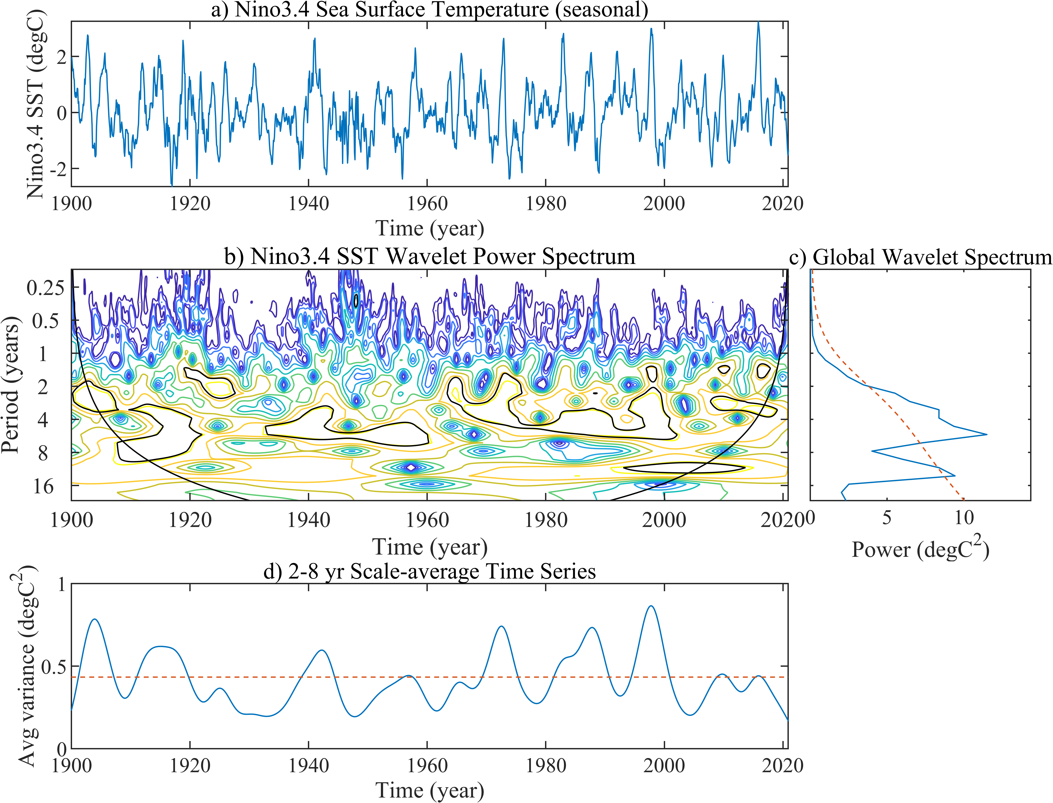

Figure . Nino3.4指数的小波变换. (a) The Niño3.4 SST time series used for the wavelet analysis. (b) The local wavelet power spectrum of (a) using the Morlet wavelet, normalized by 1/*σ*2 (*σ*2 = 0.75°C2). The left axis is the Fourier period (in yr) corresponding to the wavelet scale. The bottom axis is time (yr). The shaded contours are at normalized variances of 0.0625, 0.125, 0.25, 0.5, 1, 2, 4, 8, 16. The thick contour encloses regions of greater than 95% confidence for a red-noise process with a lag-1 coefficient of 0.93. Cross-hatched regions on either end indicate the “cone of influence,” where edge effects become important. [1, Fig.1]

References

[] Torrence, Christopher, and Gilbert P. Compo. "A Practical Guide to Wavelet Analysis", *Bulletin of the American Meteorological Society* 79, 1 (1998): 61-78, accessed Jun 21, 2022, [https://doi.org/10.1175/1520-0477(1998)079<0061:APGTWA>2.0.CO;2](https://doi.org/10.1175/1520-0477(1998)079%3C0061:APGTWA%3E2.0.CO;2)

[2] Wavelet software was provided by C. Torrence and G. Compo, and is available at URL: <http://atoc.colorado.edu/research/wavelets/>.

1. 本文使用的MATLAB程序源代码

本文使用的程序和文档发布于<https://grwei.github.io/SJTU_2021-2022-2_MS8401/>.

* 1. 主程序

|  |  |
| --- | --- |
| 1 | %% hw3.m |
| 2 | % Description: MATLAB code for Homework 3 (MS8401, 2022 Spring) |
| 3 | % Author: Guorui Wei (危国锐) (313017602@qq.com; weiguorui@sjtu.edu.cn) |
| 4 | % Student ID: 120034910021 |
| 5 | % Created: 2022-06-18 |
| 6 | % Last modified: 2022-06-21 |
| 7 | % References: [1] [A Practical Guide to WaveletAnalysis](https://paos.colorado.edu/research/wavelets/) |
| 8 | % Toolbox:    [T2] [Climate Data Tools for Matlab](https://github.com/chadagreene/CDT) |
| 9 | %             [T3] [Wavelet Software](https://github.com/chris-torrence/wavelets) |
| 10 | % Data:       [D1] [NOAA Extended Reconstructed Sea Surface Temperature (SST) V5](https://psl.noaa.gov/data/gridded/data.noaa.ersst.v5.html) |
| 11 |  |
| 12 | %% Initialize project |
| 13 |  |
| 14 | clc; clear; close all |
| 15 | init_env(); |
| 16 |  |
| 17 | %% Read data |
| 18 |  |
| 19 | nc_path = "..\data\sst.mnmean.nc"; |
| 20 | nc_info = ncinfo(nc_path); |
| 21 | sst = double(ncread(nc_path,'sst')); % [deg C] sst(lon,lat,time_month) |
| 22 | sst(sst == ncreadatt(nc_path,'/sst','missing_value')) = NaN; % Monthly Means of Sea Surface Temperature (SST) |
| 23 | lon = double(ncread(nc_path,'lon')); % [deg E] |
| 24 | lat = double(ncread(nc_path,'lat')); % [deg N] |
| 25 | time_month = (datetime(1854,1,15) + calmonths(0:size(sst,3)-1)).'; |
| 26 |  |
| 27 | %% pre-processing |
| 28 |  |
| 29 | sst_dtr = detrend3(sst,'omitnan'); % Remove the global warming signal (detrended) |
| 30 | sst_var = deseason(sst_dtr,time_month); % Remove seasonal cycles (detrended and seasonal cycle removed -> variability) |
| 31 |  |
| 32 | %%% Nino3.4: 170°W - 120°W, 5°S - 5°N |
| 33 | % Niño3.4 SST anomaly index: SST anomalies averaged in the box 170°W - 120°W, 5°S - 5°N |
| 34 |  |
| 35 | TF_lon_range = lon >= 190 & lon <= 240; |
| 36 | TF_lat_range = lat >= -5 & lat <= 5; |
| 37 | TF_time_range = datetime(1900,1,1) < time_month & time_month < datetime(2020,12,30); |
| 38 |  |
| 39 | T_s = 1/12; % [year] |
| 40 | Nino3_4_index = squeeze(mean(sst_var(TF_lon_range,TF_lat_range,TF_time_range),[1 2],"omitnan")); |
| 41 |  |
| 42 | %% 0. |
| 43 |  |
| 44 | var_Nino3_4_index = var(Nino3_4_index); |
| 45 | [ac,lags] = xcorr(Nino3_4_index,Nino3_4_index,2,"normalized"); |
| 46 | alpha_ = (ac(lags == 1) + sqrt(ac(lags == 2)))/2; |
| 47 | % alpha_ = 0.72; |
| 48 | P_k = (1-alpha_^2)./(1+alpha_^2-2*alpha_*cos(2*pi*(0:length(Nino3_4_index)-1).'/length(Nino3_4_index))); % [1,eq.(16)] |
| 49 |  |
| 50 | %% 1. Perform spectrum analysis on the Niño3.4 SST anomaly index |
| 51 |  |
| 52 | Nino3_4_DFT = fft(Nino3_4_index)/length(Nino3_4_index); |
| 53 | Nino3_4_freq = (0:length(Nino3_4_DFT)-1)/length(Nino3_4_DFT)/T_s; % [1/year] |
| 54 | Nino3_4_cycle = 1./Nino3_4_freq; |
| 55 | TF_freq_avail = Nino3_4_cycle > -Inf; |
| 56 |  |
| 57 | %%% create figure |
| 58 |  |
| 59 | figure('Name',"Fig.1 Nino3.4 index and its DFT"); |
| 60 | t_TCL = tiledlayout(2,1,"TileSpacing","tight","Padding","tight"); |
| 61 |  |
| 62 | % Nino3.4 index |
| 63 |  |
| 64 | t_axes = nexttile(t_TCL,1); |
| 65 | plot(t_axes,time_month(TF_time_range),Nino3_4_index,'-',"DisplayName",'Nino3.4 index'); |
| 66 | set(t_axes,"YDir",'normal',"TickLabelInterpreter",'latex',"FontSize",10,'Box','off','TickDir','out','XLimitMethod','tight'); |
| 67 | xticks(t_axes,datetime(1900,1,15) + calyears(0:20:120)) |
| 68 | xtickformat(t_axes,'yyyy') |
| 69 | xlabel(t_axes,"$t$ (year)",FontSize=10,Interpreter="latex"); |
| 70 | ylabel(t_axes,"SST anomaly ($^{\circ}\rm{C}$)","FontSize",10,"Interpreter","latex"); |
| 71 | title(t_axes,sprintf("\\bf Nino3.4 index"),"Interpreter","latex"); |
| 72 |  |
| 73 | % DFT of Nino3.4 index |
| 74 |  |
| 75 | xtick_cycle = [50,10,7:-1:1]; |
| 76 | t_axes = nexttile(t_TCL,2); |
| 77 | plot(t_axes,Nino3_4_freq(TF_freq_avail),abs(Nino3_4_DFT(TF_freq_avail)).^2, ... |
| 78 | '-',"DisplayName",'$|\hat{x}(k)|^2$'); |
| 79 | hold on |
| 80 | plot(t_axes,Nino3_4_freq(TF_freq_avail),P_k*var_Nino3_4_index/length(Nino3_4_index), ... |
| 81 | '--',"DisplayName",sprintf("$\\sigma^2 P_k/N, \\, \\alpha = %.2g$",alpha_)) |
| 82 | yl = ylim(t_axes); |
| 83 | plot(t_axes,Nino3_4_freq(TF_freq_avail),P_k*var_Nino3_4_index/length(Nino3_4_index)/2*chi2inv(0.95,2), ... |
| 84 | '--',"DisplayName",sprintf("$\\sigma^2 \\chi^2_2(0.95) P_k/(2N)$")) |
| 85 | hold off |
| 86 | set(t_axes,"YDir",'normal',"TickLabelInterpreter",'latex',"FontSize",10,'Box','off','TickDir','out','XLimitMethod','tight') |
| 87 | xlim(t_axes,[-Inf,1/0.9]); |
| 88 | ylim(t_axes,yl); |
| 89 | xticks(t_axes,1./xtick_cycle); |
| 90 | xticklabels(t_axes,string(xtick_cycle)); |
| 91 | xlabel(t_axes,"period (years)",FontSize=10,Interpreter="latex"); |
| 92 | ylabel(t_axes,"magnitude","FontSize",10,"Interpreter","latex"); |
| 93 | legend(t_axes,"Interpreter","latex","Box","off",'Location','best'); |
| 94 | title(t_axes,sprintf("\\bf DFT of Nino3.4 index"),"Interpreter","latex"); |
| 95 |  |
| 96 | % |
| 97 | exportgraphics(t_TCL,sprintf("..\\doc\\fig\\hw3\\hw3_DFT_Nino3_4.png"),'Resolution',1000,'ContentType','auto','BackgroundColor','none','Colorspace','rgb') |
| 98 | exportgraphics(t_TCL,sprintf("..\\doc\\fig\\hw3\\hw3_DFT_Nino3_4.emf"),'Resolution',1000,'ContentType','auto','BackgroundColor','none','Colorspace','rgb') |
| 99 |  |
| 100 | %% 2. Perform wavelet analysis on the Niño3.4 SST anomaly index |
| 101 |  |
| 102 | t_fig = figure('Name',"Fig.2 wavelet analysis of the Niño3.4 SST anomaly index"); |
| 103 | hw3_wavetest; |
| 104 | % |
| 105 | exportgraphics(t_fig,sprintf("..\\doc\\fig\\hw3\\hw3_wavelet_Nino3_4.png"),'Resolution',1000,'ContentType','auto','BackgroundColor','none','Colorspace','rgb') |
| 106 | exportgraphics(t_fig,sprintf("..\\doc\\fig\\hw3\\hw3_wavelet_Nino3_4.emf"),'Resolution',1000,'ContentType','auto','BackgroundColor','none','Colorspace','rgb') |
| 107 |  |
| 108 | %% local functions |
| 109 |  |
| 110 | %% Initialize environment |
| 111 |  |
| 112 | function [] = init_env() |
| 113 | % Initialize environment |
| 114 | % |
| 115 | % set up project directory |
| 116 | if ~isfolder("../doc/fig/hw3") |
| 117 | mkdir ../doc/fig/hw3 |
| 118 | end |
| 119 | % configure searching path |
| 120 | mfile_fullpath = mfilename('fullpath'); % the full path and name of the file in which the call occurs, not including the filename extension. |
| 121 | mfile_fullpath_without_fname = mfile_fullpath(1:end-strlength(mfilename)); |
| 122 | addpath(genpath(mfile_fullpath_without_fname + "../data"), ... |
| 123 | genpath(mfile_fullpath_without_fname + "../inc")); % adds the specified folders to the top of the search path for the current MATLAB® session. |
| 124 |  |
| 125 | return; |
| 126 | end |
| 127 |  |

* 1. 子程序

本文使用的程序和文档发布于<https://grwei.github.io/SJTU_2021-2022-2_MS8401/>.

1. https://psl.noaa.gov/data/gridded/data.noaa.ersst.v5.html