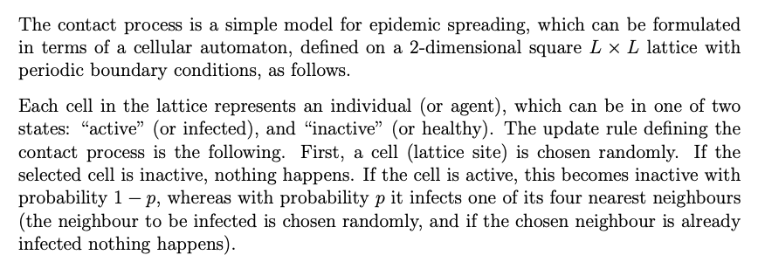
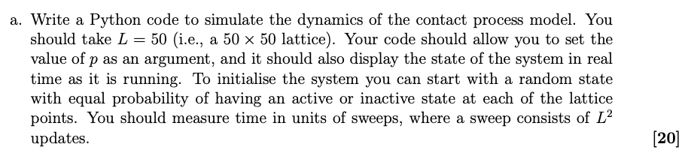
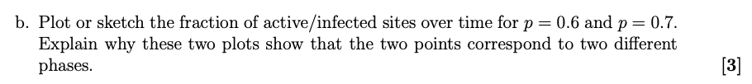
P=0.6 is in the absorbing phase, where the number of active sites dies out and the lattice reaches a fully inactive absorbing state.
P=0.7 is in the active phase, where the number of active sites persists indefinitely and the fraction of active sites fluctuates around a non-zero steady-state value.
These represent two different phases.
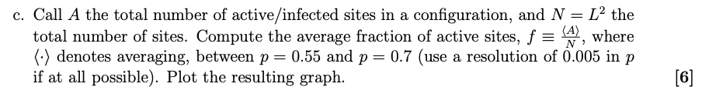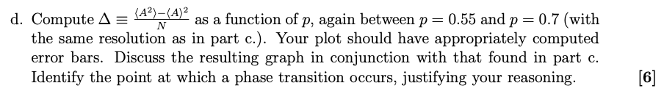The average active sites fraction starts off at 0 and begins to increase after p~0.60. It is at this point that the equilibrium state is not an absorbing state where there are no active cells but an oscillating state where there are some active cells. The average active sites fraction increases with increasing p.
It is also seen in the normalised variance vs infection probability that the normalised variance is ~0 up until p~0.60 and then it starts to increase and become non-zero. There is a peak at p=0.63. It is this point which marks the phase transition which shows it is a second-order continuous phase transition. There is also noisy variance behaviour above p~0.62 because some simulations die out (become absorbing states) while others survive.
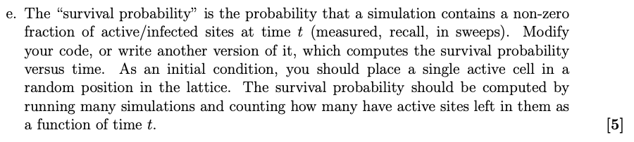
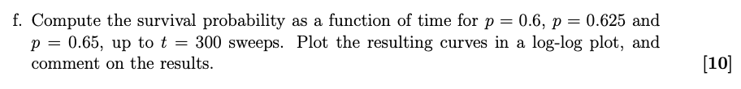
For p = 0.6, log(P) steadily decreases, curving downward and the epidemic always dies out. This is an absorbing state where below the critical point, P decreases monotonically to zero, with all simulations eventually dying out. The decay is faster than a power law, consistent with exponential decay at long times, indicating that active sites cannot sustain itself from one single cell at this infection probability.
For p = 0.625, log(P) also decreases but more slowly, with a roughly linear log-log relationship at intermediate times. This is near the critical point and consistent with a power-law decay. This is the expected behaviour and shows a continuous second-order phase transition. The slight curvature and eventual steepening suggest p=0.625 is close to but not exactly at the critical point or reflects the finite size effects on the lattice.
For p = 0.65, log(P) decreases initially but then flattens to a plateau around log(P) ~ 1.3, meaning a constant fraction of simulations survive indefinitely. This is an active phase where the plateau indicates that a finite fraction of simulations sustains active sites indefinitely and that active sites can survive permanently from a single active site.
The contrast between these three behaviours confirms that the critical density lies between p=0.6 and p-0.65, consistent with the phase transition identified from the previous variance plot.

