Data Science project
Visualization, Analysis and predictive modeling
of a Graduate Admissions dataset
Grzegorz Rypeść

1. Introduction
The dataset we chose comes from: https://www.kaggle.com/mohansacharya/graduate-admissions
It contains several parameters which are considered important during the application for Masters Programs. It is is inspired by the UCLA Graduate Dataset. It estimates a chance for a student for admission to master studies. We will mainly use Python programming language (numPy, pandas, matplotlib, seaborn libraries), GeoDa and Power-BI visualization tools to make the research.
We hope that by creating this analysis we can help students to estimate their chances when applying for master degrees.

2. Dataset preparation
The parameters included in the dataset are :
1. Serial No. (1 to 400), int 64
2. GRE Scores (290 to 340), int64
3. TOEFL Scores (92 to 120), int64
4. University Rating (1 to 5), int64
5. Statement of Purpose (1 to 5), int64
6. Letter of Recommendation Strength (1 to 5), int64
7. Undergraduate GPA (6.8 to 9.92), float64
8. Research Experience ( either 0 or 1 ), float64
9. Chance of Admit (0.34 to 0.97), float64
There are no invalid or null records. There are 400 records in total and 9 columns. We changed some of the labels to remove spaces at the end of the text as it may be misleading. The dataset weighs 16,2 kB.

3. Correlation between columns
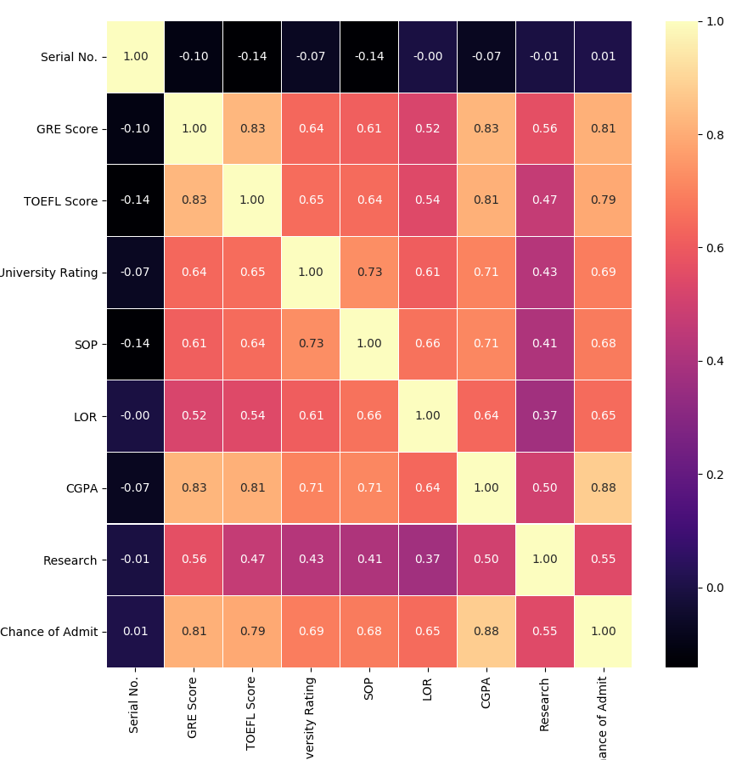

With use of Python programming language we managed to get a correlation table visible above. We can see that LOR, SOP, and Research have the lowest correlation with probability of admission. On the contrary, the highest influence on the admission have: CGPA, GRE score and TOEFL score.

4. Importance of parameters
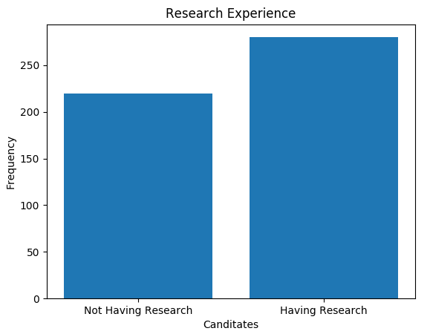

Although research has the lowest correlation out of all of the parameters we don’t think it can be skipped. 56% of candidates have a research.
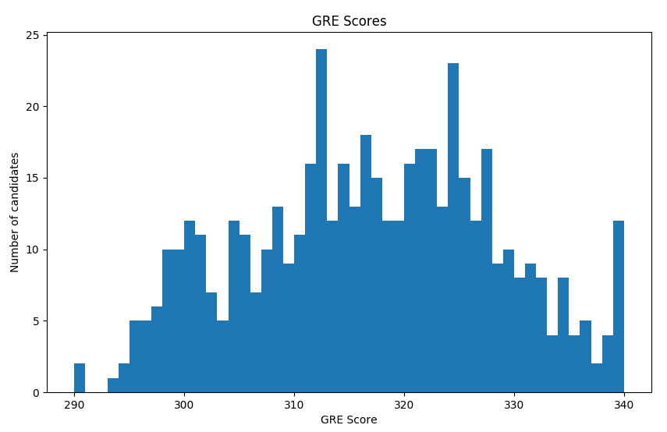
Above histogram shows the frequency for GRE scores. There is a density between 310 and 330. Surely having more than 330 points is a good aiming spot for a candidate.
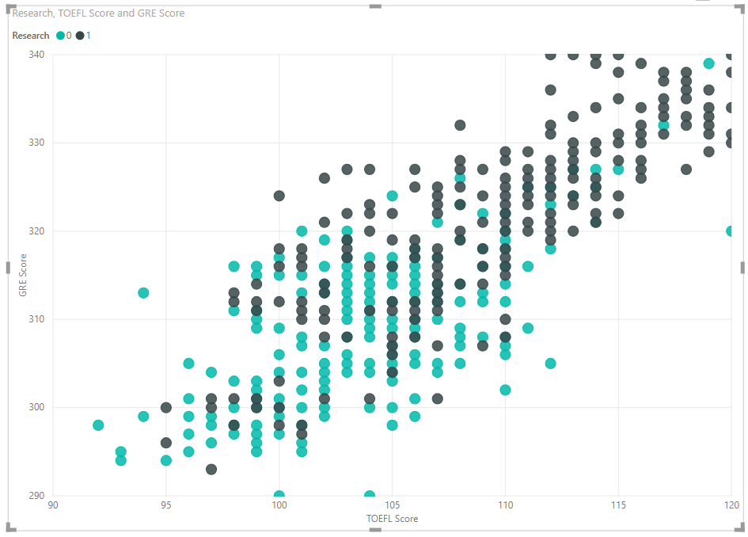
This chart shows a strong correlation between TOEFL score and GRE score. It is logical that on average a good student succeeded in both. We can also see that people with higher scores made a research.
