The World Report

Us

April 26, 2019

The project…

#PART 1: Read csv, merge, clean.  
library(readr)  
library(readxl)  
library(dplyr)  
library(countrycode)  
  
source('Read_Clean.R')  
cleaned <- Read_Clean()

# PART 2: PCA  
library(pryr)  
library(ggbiplot) #if the library is not present use the code below  
#library(devtools)  
#install_github("vqv/ggbiplot")  
source('PCA.R')  
(PrinCompPlot <- PCA(cleaned))

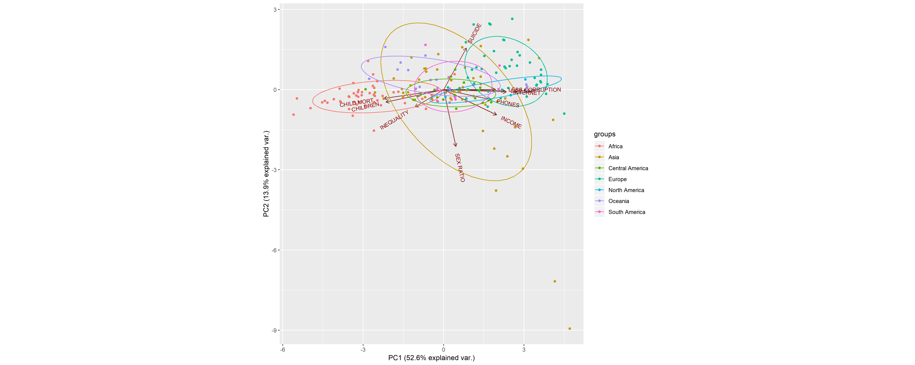

# PART 3: Hierarchical Clustering between Continents  
library(ape)  
source('cluster_continents.R')  
(Cl_continents <- cluster_continents(cleaned))

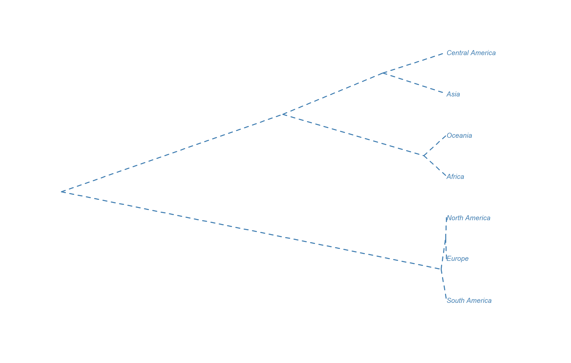

## $type  
## [1] "cladogram"  
##   
## $use.edge.length  
## [1] TRUE  
##   
## $node.pos  
## [1] 1  
##   
## $node.depth  
## [1] 1  
##   
## $show.tip.label  
## [1] TRUE  
##   
## $show.node.label  
## [1] FALSE  
##   
## $font  
## [1] 3  
##   
## $cex  
## [1] 0.8  
##   
## $adj  
## [1] 0  
##   
## $srt  
## [1] 0  
##   
## $no.margin  
## [1] FALSE  
##   
## $label.offset  
## [1] 0  
##   
## $x.lim  
## [1] 0.000000000 0.007834986  
##   
## $y.lim  
## [1] 1 7  
##   
## $direction  
## [1] "rightwards"  
##   
## $tip.color  
## [1] "steelblue"  
##   
## $Ntip  
## [1] 7  
##   
## $Nnode  
## [1] 6  
##   
## $root.time  
## NULL  
##   
## $align.tip.label  
## [1] FALSE

# PART 4: K-means Clustering between Countries  
library(maptools)  
source('clusters_countries.R')  
(Cl_countries <- clusters_countries(cleaned))

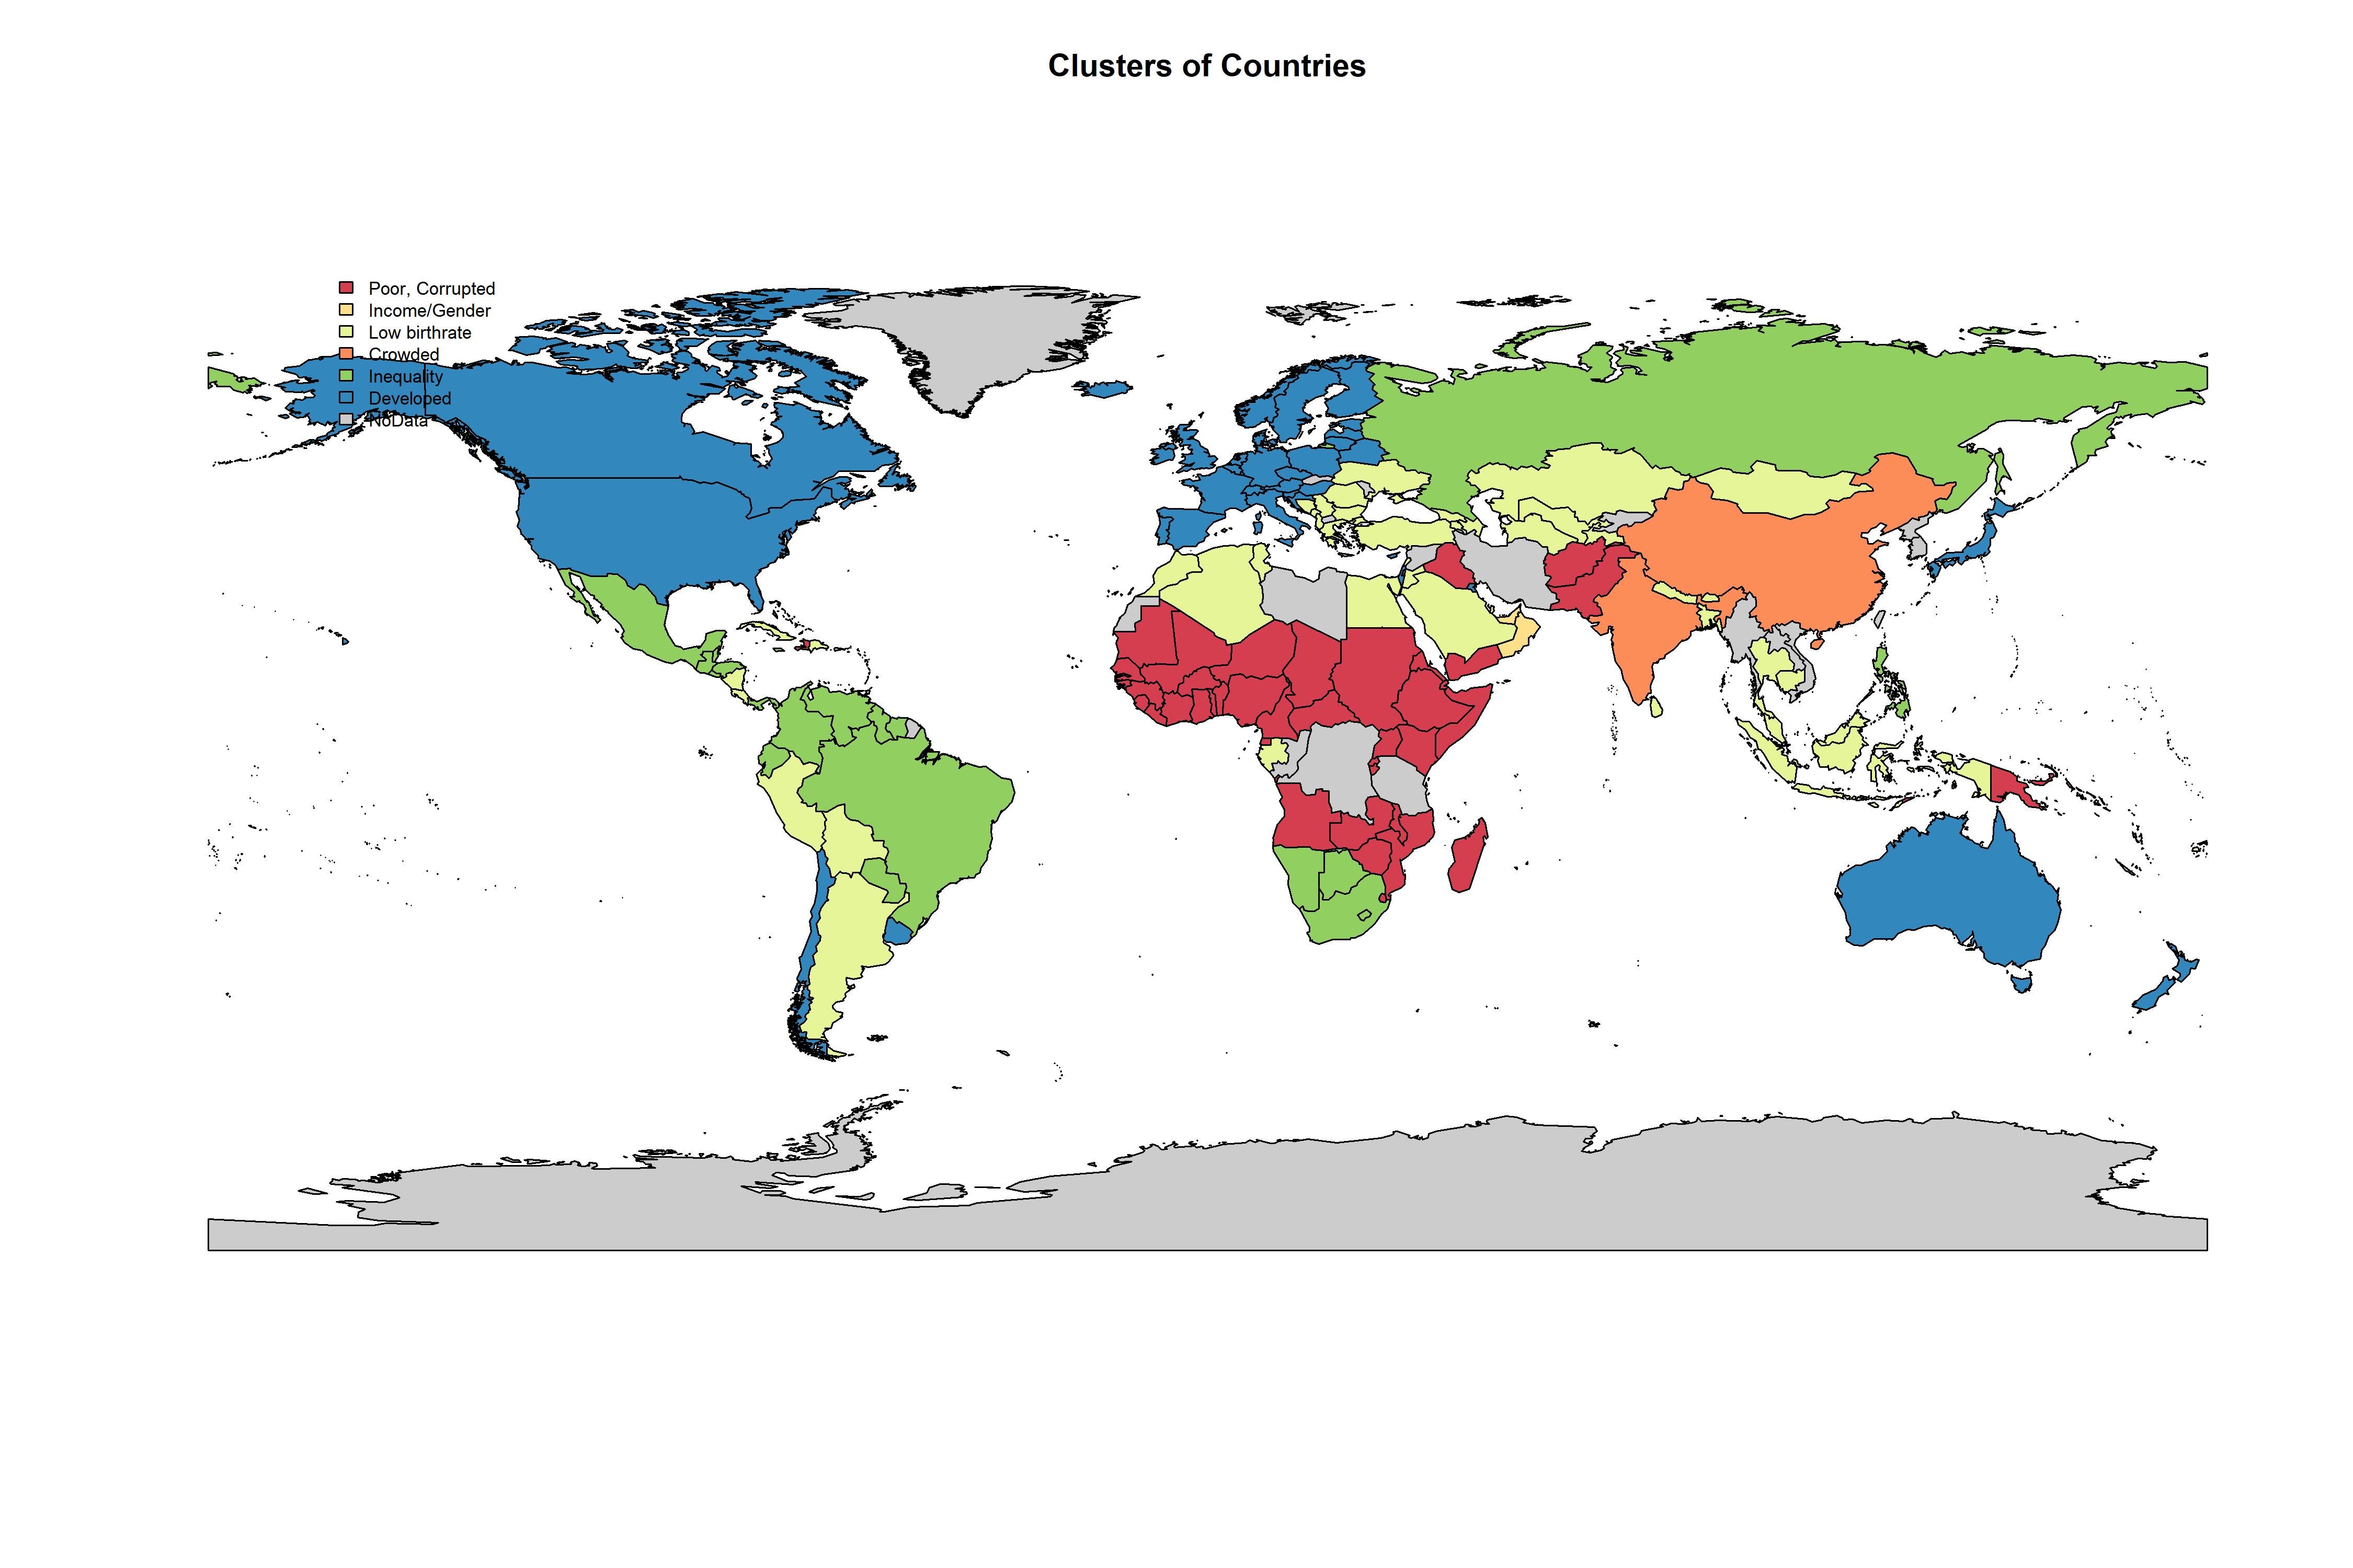

## [[1]]  
## [[1]]$rect  
## [[1]]$rect$w  
## [1] 32.67785  
##   
## [[1]]$rect$h  
## [1] 35.5463  
##   
## [[1]]$rect$left  
## [1] -159.408  
##   
## [[1]]$rect$top  
## [1] 91.16901  
##   
##   
## [[1]]$text  
## [[1]]$text$x  
## [1] -151.1008 -151.1008 -151.1008 -151.1008 -151.1008 -151.1008 -151.1008  
##   
## [[1]]$text$y  
## [1] 83.26984 79.32025 75.37066 71.42107 67.47148 63.52189 59.57230  
##   
##   
##   
## [[2]]  
## pop_total murder_pp armed_pp phones_p100 children_p_woman  
## 1 -0.09673427 -0.1630504 -0.2720038 -1.0167330 1.3860231  
## 2 -0.23643898 -0.6300806 0.6922626 2.0641305 -0.5225604  
## 3 -0.11214911 -0.2601146 0.1863580 0.2715601 -0.3886788  
## 4 9.29505170 -0.4669487 -0.5055657 -0.3708733 -0.6103552  
## 5 -0.04461503 2.1005559 -0.2025836 0.2219853 -0.3442223  
## 6 -0.08781200 -0.5286097 0.1174541 0.5199152 -0.8165710  
## life_exp_yrs suicide_pp urban_pop_tot sex_ratio_p100 corruption_CPI  
## 1 -1.23681561 -0.4001203 -0.163854329 -0.07323727 -0.73025697  
## 2 0.77296430 -0.7271698 -0.240609900 6.00607625 0.63325580  
## 3 0.25248575 -0.1892355 -0.122016017 -0.10605896 -0.28506544  
## 4 0.04680461 0.5178095 8.465034696 0.24447490 -0.11795186  
## 5 -0.05396296 0.2039223 0.037334597 -0.18504319 -0.08954255  
## 6 1.08246056 0.7174278 0.001869159 -0.20450210 1.34952357  
## internet_%of_pop child_mort_p1000 income_per_person  
## 1 -1.19786906 1.3328363 -0.7560933  
## 2 1.43349881 -0.7180198 2.6031046  
## 3 0.08199237 -0.3723325 -0.2445600  
## 4 -0.29508764 -0.1253641 -0.3827777  
## 5 0.01258829 -0.2053602 -0.2781054  
## 6 1.21983842 -0.8619745 1.2560185  
## investments_per_ofGDP gini  
## 1 -0.1654316 0.2837025  
## 2 0.8115888 0.1504132  
## 3 0.1170223 -0.2169881  
## 4 1.5781607 -0.2367667  
## 5 0.1460954 1.3138547  
## 6 -0.2149932 -0.7733844

#Show Centers  
Cl_countries[2]

## [[1]]  
## pop_total murder_pp armed_pp phones_p100 children_p_woman  
## 1 -0.09673427 -0.1630504 -0.2720038 -1.0167330 1.3860231  
## 2 -0.23643898 -0.6300806 0.6922626 2.0641305 -0.5225604  
## 3 -0.11214911 -0.2601146 0.1863580 0.2715601 -0.3886788  
## 4 9.29505170 -0.4669487 -0.5055657 -0.3708733 -0.6103552  
## 5 -0.04461503 2.1005559 -0.2025836 0.2219853 -0.3442223  
## 6 -0.08781200 -0.5286097 0.1174541 0.5199152 -0.8165710  
## life_exp_yrs suicide_pp urban_pop_tot sex_ratio_p100 corruption_CPI  
## 1 -1.23681561 -0.4001203 -0.163854329 -0.07323727 -0.73025697  
## 2 0.77296430 -0.7271698 -0.240609900 6.00607625 0.63325580  
## 3 0.25248575 -0.1892355 -0.122016017 -0.10605896 -0.28506544  
## 4 0.04680461 0.5178095 8.465034696 0.24447490 -0.11795186  
## 5 -0.05396296 0.2039223 0.037334597 -0.18504319 -0.08954255  
## 6 1.08246056 0.7174278 0.001869159 -0.20450210 1.34952357  
## internet_%of_pop child_mort_p1000 income_per_person  
## 1 -1.19786906 1.3328363 -0.7560933  
## 2 1.43349881 -0.7180198 2.6031046  
## 3 0.08199237 -0.3723325 -0.2445600  
## 4 -0.29508764 -0.1253641 -0.3827777  
## 5 0.01258829 -0.2053602 -0.2781054  
## 6 1.21983842 -0.8619745 1.2560185  
## investments_per_ofGDP gini  
## 1 -0.1654316 0.2837025  
## 2 0.8115888 0.1504132  
## 3 0.1170223 -0.2169881  
## 4 1.5781607 -0.2367667  
## 5 0.1460954 1.3138547  
## 6 -0.2149932 -0.7733844