From Text Wishes to Sound: A Real-Time Granular Synth VST with a Text‑to‑Audio Generative Companion
Grzegorz Samson
Faculty of Composition, Theory of Music and Sound Engineering, The Feliks Nowowiejski Academy of Music in Bydgoszcz, ul. Profesora Jerzego Godziszewskiego 1, 85-008 Bydgoszcz, Poland;
Research Poster Presented at the 10th Audio Developer Conference
10-12 November 2025 Bristol, UK & Online
_____________________________________________________________________________________

Abstract
This poster presents a custom-built granular synthesizer VST created with JUCE, designed for real-time, interactive sound design. The plugin supports on-the-fly buffering and replacement of user-supplied audio while rendering evolving, multi-layer soundscapes suitable for ambient textures and installation contexts. It is paired with a Python companion application that turns the user’s text “wishes” into structured, multi-layered sound ideas. Large language model (text-to-text) act as an assistant to translate natural-language prompts into sound prompts for a text-to-audio models, which generates artificially synthesised audio material. Together, the VST and companion app form an interactive pipeline. The poster focuses on the system’s architecture, text transformation, and strategies for safely hot-swapping audio during playback. The contribution is educational and non-commercial, it shares practical fine-tuning tips that other audio developers can adapt to their own interactive or installation-based projects.
Keywords: granular synthesis; JUCE; text-to-audio; generative audio; installation; real-time audio; LLM prompting

Introduction
This work presents an end-to-end workflow that translates natural-language wishes into generative soundscapes suitable for live performance. The workflow is composed of a Python companion application that structures user input into audio text prompts, a text-to-audio (TTA) pre-trained generative transformer that produces short audio stems, and a JUCE-based granular synthesizer VST that renders the stems into soundscape with support for real-time hot-swapping of source audio. Work targets immersive installations and studio setting. Contributions of this project are:
- a reproducible wish to sound pipeline with custom Python app;
- a granular VST with safe buffer management;
- a JSON schema and prompt guidelines;

Origins
The project was designed to create an interactive system capable of converting text wishes into a soundscape using recent technologies, including pre-trained transformer networks. To support this work, an in-depth study was conducted and reported in the article Perspectives on Generative Sound Design: A Generative Soundscapes Showcase. In that paper the historical context of generative music, stochastic processes, and analog and digital sound-generation techniques was reviewed. Paper also defined the concept of the soundscape with reference to R. Murray Schafer’s acoustic ecology and mentioned related work.

Text‑to‑Audio Generative Companion

Use of Language Models
Large language models (LLMs) can make user experience more natural. LLMs can imitate human reasoning and work on the semantic level. Unlike older interfaces based on fixed “if... then...” rules, this systems can hold conversations with the user without much preprogramming.
The application further reffered as Wishing Well uses the idea of an assistant that helps the user give clear instructions and refine their wishes. The assistant also takes on a small creative role — it speaks as the voice of the well, guiding the user through the sound-generation process. Model used for the assistant was OpenAI’s ChatGPT gpt-4o-2024-08-06.

External Model Handling
Current machine learning technologies, including transformer architectures, are developed in two main environments:
- Academic and open-source – these models are open and free to use, and can be run on local machines. They are valuable for research and education, but they often provide lower quality, have limited training data, and require manual setup of the computing environment.
- Commercial – these systems provide access to large-scale models (with billions of parameters) trained on extensive datasets. They run on the provider’s infrastructure, and users interact with them through an API (Application Programming Interface), which allows communication between the local application and the external model.
High-accuracy transformer models require large amounts of computing power, including advanced GPUs arranged in large computing clusters. Such resources are usually unavailable to individual users or small institutions. A practical solution is to outsource computation by using the provider’s infrastructure, which allows fast query processing at relatively low cost.
However, using external models introduces several limitations:
- constant internet access is required — loss of connection prevents interaction;
- transmission delays — sending and receiving queries can cause short response delays;
- server load or downtime — during high traffic, queries may be delayed or temporarily stopped.

Graphical User Interface
The main parts of the interface of Text‑to‑Audio Generative Companion (as shown in Figure 1) are:
- a text input box for entering user wishes or prompts;
- a response area showing messages and feedback from the system;
- status messages that show what the app is doing (for example, “generating sounds”);
- buttons for basic actions such as Send and Reset.

Components
This assistant reasoning and information processing is divided into three main components:
- Conversational message – a response that maintains dialogue with the user;
- Data for the transformer – semantic content prepared for further sound event generation;
- Control message – an instruction that triggers or stops the audio-generation modules.
To handle these three components correctly, the LLM session is initialized with a control instruction that defines the model’s behavior and the required response format.
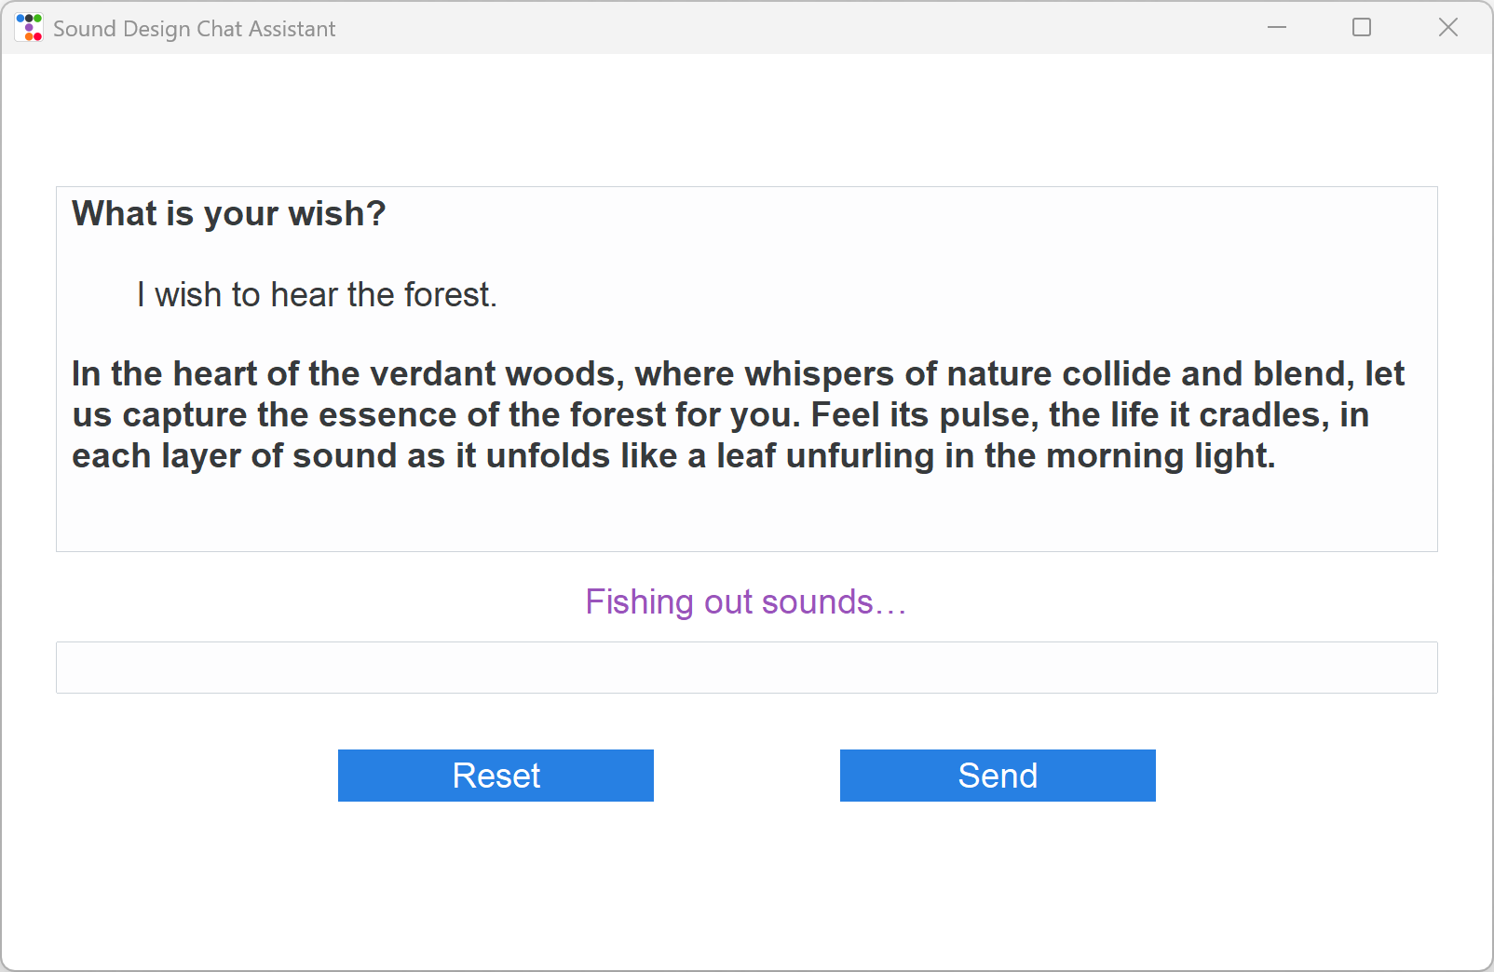
Figure 1 The graphical interface of the granular synthesizer implemented in the JUCE framework [G. S.]

Formatting
The instructions sent to the LLM are written in YAML (YAML Ain’t Markup Language).
For programmatic handling, the model’s responses are formatted in JSON, which makes them easy to process by scripts and ensures a clear separation between the three components of each response. This structure also defines consistent data formatting rules within the system.

Methodology for Instruction Design
The process of creating control instructions was based on:
- the technical documentation of OpenAI, describing recommended interaction formats and styles;
- best practices from prompt engineering;
- empirical testing, involving iterative trials, analysis of model outputs, and gradual refinement of prompts.
This approach led to stable and repeatable patterns of interaction between the model and the user.

Implementing Control Instructions

Assistant role
The first line of the YAML system prompt sets the model’s role using the assistant metaphor for a sound designer. After that, the prompt defines each response component and how the LLM formats it.

„system_message: |
You are a sound design assistant that holds an interactive conversation with the user.”
For every response, you must include three parts:
1. A conversational reply. This reply must be enclosed in a MESSAGE block, i.e.:
```message
Your conversational reply goes here.
```
[…]
2. A JSON block that describes sound effect layers. This block must be enclosed in triple backticks with the language identifier "json".
Describe appropriate sound effects for the concept '{concept}' in JSON format, in english. Describe them very simply, with ideas easy for sonification. Don't use metaphors.
Make sound prompts short, basic and simple.
[…]
3. A SYSTEM block that instructs the user interface what to do next. This must also be enclosed in triple backticks using the `system` identifier.
[…]
Do not mix the three outputs. The MESSAGE block should be returned first followed by the JSON block and SYSTEM BLOCK.
Don't ask follow up questions when you generate audio.

MESSAGE component
Message component specifies the tone and function of the assistant’s reply. The application aims to have an unique character, so the assistant speaks in a poetic “voice of the well,” manner. This prepares users for non-literal sonifications and sets expectations for variability in outcomes.
Excerpt from the instruction:
„1. A conversational reply. This reply must be enclosed in a MESSAGE block, i.e.:
```message
Your conversational reply goes here.
```
You are a sound design assistant that holds an interactive conversation with the user. Be aware, thoughtful but also have some poetic, and mysteriousness, like a prophet. Speak in Polish. Be aware that your GENERATE messages result in real sound output—compose with intention, knowing the user will hear it. Always stay attuned to what the user might be hearing (you get the list of generated files from user), and guide the unfolding world of sound as if you were building a living dream.”

JSON Component
The JSON block is the machine-readable plan for the text-to-audio model. From the user’s concept, the LLM produces a small set of clear, non-metaphorical sound layers. Language must be simple and unambiguous to make sonification easy. Musical elements are excluded unless the user explicitly requests them.
Excerpt from the instruction:
“2. A JSON block that describes sound effect layers. This block must be enclosed in triple backticks with the language identifier "json".
Describe appropriate sound effects for the concept '{concept}' in JSON format, in english. Describe them very simply, with ideas easy for sonification. Don't use metaphors.
Make sound prompts short, basic and simple.
Follow these steps:
1. Break down the concept into key sound elements (e.g., natural sounds, ambiance, human activity, etc.). Don't make any musical elements.
2. Make around 3-4 sound layers.
3. Write a detailed description for each sound layer that fits the concept. Don't use poetic description. Stick to basic, clear ideas without double meaning. Make the sound description simple for sonification. When generating musical content specify instrument that should be playing.”

Audio prompts
The ElevenLabs SFX model was used as the text-to-sound transformer. The structure of the sonification prompts was adapted to this system and extended with additional metadata to improve the management of the installation.
Core parameters (per layer)
- prompt — a simple English text description of the desired sound.
- duration — was fixed at 10 seconds (the transformer’s maximum limit is 22 seconds).
- number_of_generations — was fixed at 1 per prompt.
- prompt_influence — was set within the 0.3–0.5 range, controlling how closely the output follows the prompt (as recommended by ElevenLabs).
Because the sound generation process is relatively long, each layer was generated only once, and its duration was limited to 10 second (sample layer pack is shown in Figure 2).
To support archiving, additional parameters were introduced:
- filename — a descriptor of the file content, written in snake_case (using underscores between words).
- category — a general sound category used in the folder structure for archiving (expressed with a forward slash between category and subcategory).
„
4. Use the following metadata for each sound layer:
- 'prompt': A vivid and detailed description of the sound. Every description should be specific, simple and provide a context. Don't use any musical terms (don't use words like rhythmically, melodically...) and words describing sound genres (don't use word ambient) unless users clearly asks to generate music
- 'category': Define a folder structure for all of the sound layers from the concept, using a general tag followed by the concept name (e.g., 'Concept_Name', 'Emotion\\Fatigue', 'Nature\\Forest').
- 'filename': A descriptive name for the sound layer, in snake_case format.
- 'duration': Set to 10 seconds for each layer.
- 'num_generations': Set to 1.
- 'prompt_influence': Set a value between 0.3 and 0.5.
The JSON must have the following structure:
```json { "sounds": [ {
"prompt": "A simple description of the sound",
"category": "Concept_Name",
"filename": "descriptive_filename",
"duration": 10,
"num_generations": 1,
"prompt_influence": 0.4
}, ... ] } ```”

SYSTEM Component
The third and final element of the response generated by the LLM is the system component, which serves as the control layer of the application. The assistant decides which actions should be taken based on the context of the conversation. As a result, the operational process is hidden from the user, allowing interaction to feel more natural and continuous.

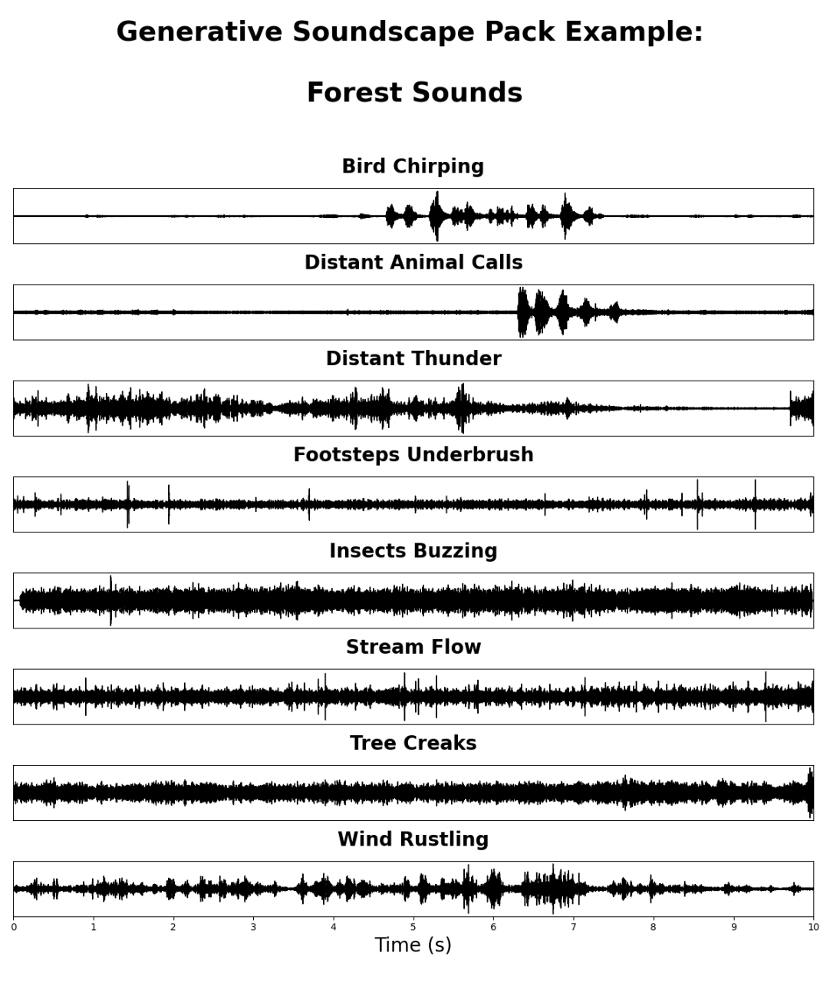
Figure 2 Sample layer pack generated by TTA ElevenLabs SFX model.
Depending on the dialogue context, the model can execute one of the following actions:
- GENERATE — new sound layers are created; if an existing sound aura is already present, previous files are deleted;
- EXTEND — new sound layers are added without deleting the existing ones;
- DELETE — selected sounds, or all sounds, are removed based on filenames provided in the files list;
- HOLD — all actions are paused, for example, when the user’s request requires clarification.
Within the SYSTEM block, the assistant also receives information about the files stored in the Generated Audio folder. This allows the LLM to remain aware of which sound files are currently being played to the user and to make decisions with full contextual awareness.
„3. A SYSTEM block that instructs the user interface what to do next. This must also be enclosed in triple backticks using the `system` identifier. The SYSTEM block must include a key `"action"` with one of the following values:
- `"GENERATE"` – to generate new audio based on the assistant's response.
- `"EXTEND"` – to add more sounds to an existing set.
- `"DELETE"` – to delete specific files (you must include a `"files"` list).
- `"HOLD"` – to do nothing.
The user will send you a SYSTEM block with every message containing the current list of audio files. Use that context to make your decision.
Format:
```json {
"action": "GENERATE" | "EXTEND" | "DELETE" | "HOLD",
"files": ["existing_file_1.wav", "existing_file_2.wav"] // Only required for DELETE } ```”

Final Instructions
At the end of the configuration, the model was instructed not to mix the contents of the three components and not to ask unnecessary questions.
„Do not mix the three outputs. The MESSAGE block should be returned first followed by the JSON block and SYSTEM BLOCK. Don't ask follow up questions when you generate audio.”

Archiving
Because every query sent to the transformer results in the generation of new sound files, a comprehensive archiving system was implemented. The purpose of this system was both to preserve a complete record of the creative process and to enable the re-use of generated materials in future sessions.
File Structure
- Active Folder – “Generated Audio”
All sound files created during a session were immediately saved in the working directory Generated Audio. This allowed the system to maintain real-time access to the current set of sounds used in playback.
- Archive Folder – Categorization and Timestamping
In parallel, every file was duplicated into a categorized directory structure.
Parent folders were organized according to two parameters:
  - category — the semantic category of the first sound in the set (e.g., Emotion/Fatigue, Nature/Forest);
  - timestamp — a time marker identifying the exact moment when the file was created.
- File Naming
Each file was given a unique name stored in the filename field. Unlike random alphanumeric identifiers, these filenames reflected the semantic content of the material. As a result, files could be easily searched and reused without the need to listen through the entire library.
Each generated sound file was accompanied by a metadata record saved as sound_archive.json, which contained all relevant parameters used for its creation — including input prompts, category, and filename.
The conversation history between the user and the assistant was also archived in a plain text file (.txt). This made it possible to document the creative process, review past interactions, and perform analytical or artistic reinterpretations of earlier sessions.

Real-Time Granular Synth VST
A system for automatic playback of newly generated sound files was developed to provide an organic, time-varying listening experience.

Granular synthesizer concept
Granular synthesis is based on dividing the source material into short segments called grains, typically a few to several dozen milliseconds long. Grains may be played in a random order, and their parameters (such as amplitude, pitch, or duration) may be modified to create a continuous, non-deterministic texture. In this project, the generated sounds were treated as source material for macrograins with a length of about 3 seconds.

JUCE framework
The JUCE framework was chosen for implementation, because it supports efficient audio processing and is compatible with common plugin formats, including the Steinberg VST standard, which allowed direct integration with external DAWs (e.g., REAPER). Using JUCE, builds were produced from a single codebase, either as a standalone application for quick testing or as a VST plugin for DAW hosting. The typical code structure was organized into two main classes:
- PluginEditor — was used to handle the graphical user interface;
- PluginProcessor — was used to handle application logic, real-time audio processing, and background tasks.

Implementation in JUCE
The granular synthesizer implemented in JUCE was based on code by Anthony Brigante, which was made available under open access. The original program provided a simple granular synthesizer; the grain logic was encapsulated in a Grain class.
The source code was substantially extended and adapted (GUI shown in Figure 3). In particular, the following additions and changes were made:
- a VST-ready version was developed. The original source was designed as a standalone application with GUI and logic combined in a single file; this was refactored to follow better software practices and to separate components;
- a serialization mechanism using ValueTree was introduced so that parameters could be preserved after the application was closed and the plugin could run stably in the background;
- multichannel audio projection was supported and tested (from mono and stereo up to a 12-channel, 7.1.4 layout);
- additional control parameters were added, including duration_deviation — the maximum variation in grain duration;
- folder-level buffering and per-file additive loading were implemented, together with support for simultaneous projection of many loaded files; waveform visualizations and a collapsible file list were provided for file management and monitoring;
- a watch-folder feature was implemented so that files placed in the monitored folder could be added to or removed from the buffer dynamically, allowing the buffer to reflect the folder’s current contents.
The watch-folder functionality proved especially important for the performative capability of this virtual instrument. It allowed new recordings to be added to the granulator in real time, eliminating playback gaps and ensuring continuity of the soundscape. Such a live, folder-driven workflow is uncommon in commercial granular synths, which typically operate on static sample sets. The adapted source code has been made available on the Open Science Framework.
Integration with the Python user application was achieved by designating the Generated Audio folder (into which audio files are written) as the source material for the granular synthesizer.
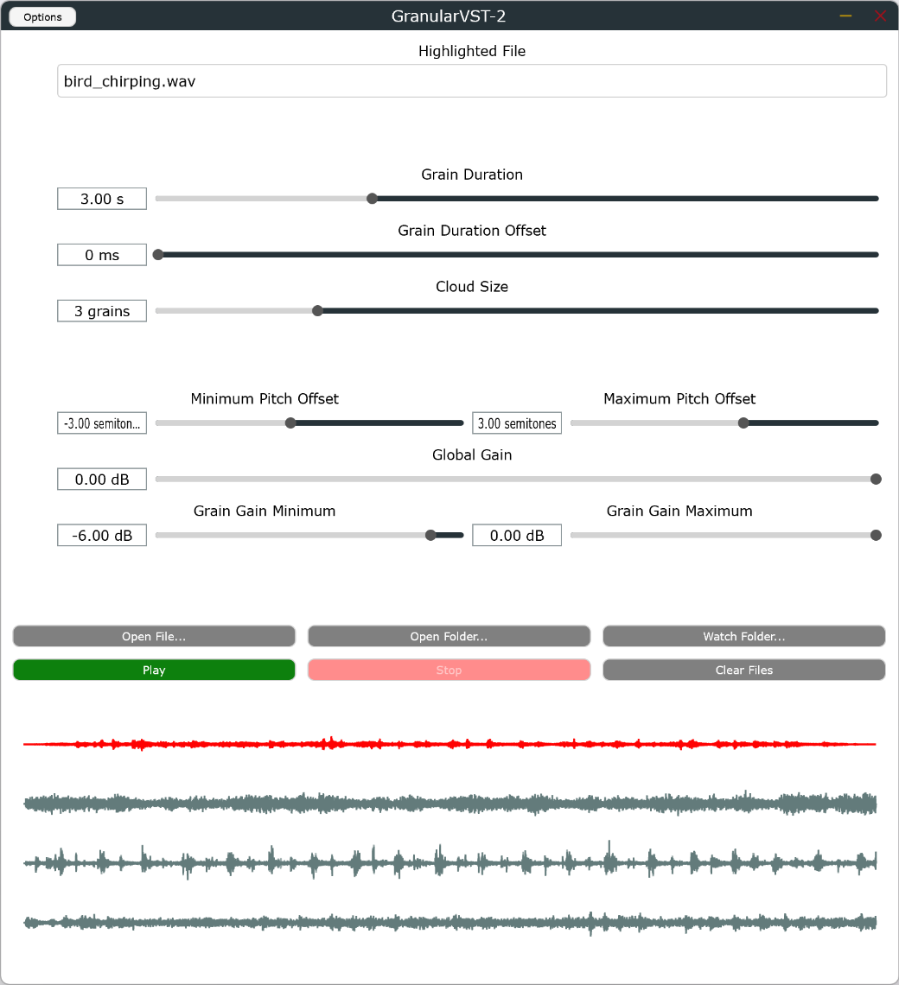
Figure 3 The graphical interface of the granular synthesizer implemented in the JUCE framework [G. S.] .

Difficulties
Several technical problems were encountered during the implementation and were addressed with additional measures.
- Sudden truncation of grain envelopes occurred when grains were played from audio located near file ends. A fade-out mechanism for very short samples was implemented to prevent clicks.
- Instability was observed when many files were deleted from the watched folder while they were being played. Synchronization and safe-removal safeguards were introduced to avoid crashes and race conditions.

DAW parameterization
The granular synthesizer was prepared as a VST so that an effects chain could be applied in the host DAW to refine the final sound. Playback conditions were oriented toward surround presentation and were adapted for the Dolby Atmos standard. Tests were carried out using a 7.1.4 setup, and the DAW effects chain was configured accordingly.
The following effects were used in the chain:
- Surround reverb supporting the Dolby Atmos 7.1.4 format — was used to spatialize the sound and diffuse signal energy across additional channels.
- Compressor — was used to reduce the amplitude differences between very loud and very quiet sounds.

Limitations
This work remains a prototype tailored to ambient/installation contexts and is constrained by dependence on commercial APIs (internet stability, latency, rate limits, changing upstream behavior), occasional prompt/semantic drift that can yield speech-like or musical artifacts, and audio generation choices that fix stems to 10s and one candidate per layer (limiting diversity and selection).
Although crossfades and safe buffer removal were implemented, rare real-time edge cases (e.g., file replacements during reads, very short tails) can still introduce artifacts. Finally, API usage entails monetary and energy costs, legal/licensing constraints apply to upstream services.

Conclusion
Author presented a practical pipeline translating text wishes into soundscapes via structured prompting, and at granular VST.
The project has clear limitations. Dependence on external commercial models introduced latency, a requirement for stable internet, and variability due to provider load. The current evaluation was informal and qualitative.
Future work should address limitations of the project. Directions for future work include: integrating lightweight classifiers to filter speech or strong musical content; enabling local or hybrid TTA inference to reduce latency; exploring stem-separation techniques to control spectral roles more precisely; implementing multi-candidate generation with automated selection heuristics; and conducting controlled listening tests to quantify perceived quality and user experience. Further UX work could refine the assistant’s dialogue style and investigate how different personas affect user expectation and satisfaction.
Overall, the system and the implementation details documented here are intended as a practical, reproducible blueprint for developers and researchers working on interactive generative sound projects. Implementation artifacts, metadata schemes, and session templates were produced to support reuse and further study; these materials may be used as a basis for more extensive evaluations and artistic applications.

Acknowledgments
Author thanks colleagues and workshop participants for feedback and the audio developer community for shared insights.

References
Brigante, Anthony. GranularSynth. C++. 17 December 2018, released 19 December 2024. https://github.com/abrigante1/GranularSynth.
‘Overview - OpenAI API’. Accessed 19 August 2025. https://platform.openai.com.
Samson, Grzegorz. ‘Exploring Process for Interjoined Procedurally Generated Visual and Audial Content’. Journal of The Audio Engineering Society, no. 333 (August 2025).
———. ‘Perspectives on Generative Sound Design: A Generative Soundscapes Showcase’. Arts 14, no. 3 (June 2025): 67. https://doi.org/10.3390/arts14030067.
———. Procedurally Generated Visual and Audial Content Granular VST. OSF, 27 April 2025. https://osf.io/9m5dh/.
‘Sound Effects | ElevenLabs Documentation’. Accessed 27 April 2025. https://elevenlabs.io/docs/capabilities/sound-effects.

grzegorzsamson218@hotmail.com
Grzegorz Samson, ‘Perspectives on Generative Sound Design: A Generative Soundscapes Showcase’, Arts 14, no. 3 (June 2025): 67, https://doi.org/10.3390/arts14030067.
‘Overview - OpenAI API’, accessed 19 August 2025, https://platform.openai.com.
‘Sound Effects | ElevenLabs Documentation’, accessed 27 April 2025, https://elevenlabs.io/docs/capabilities/sound-effects.
Samson, ‘Perspectives on Generative Sound Design’.
Anthony Brigante, GranularSynth, C++, 17 December 2018, released 19 December 2024, https://github.com/abrigante1/GranularSynth.
Grzegorz Samson, Procedurally Generated Visual and Audial Content Granular VST, OSF, 27 April 2025, https://osf.io/9m5dh/.
Grzegorz Samson, ‘Exploring Process for Interjoined Procedurally Generated Visual and Audial Content’, Journal of The Audio Engineering Society, no. 333 (August 2025).

