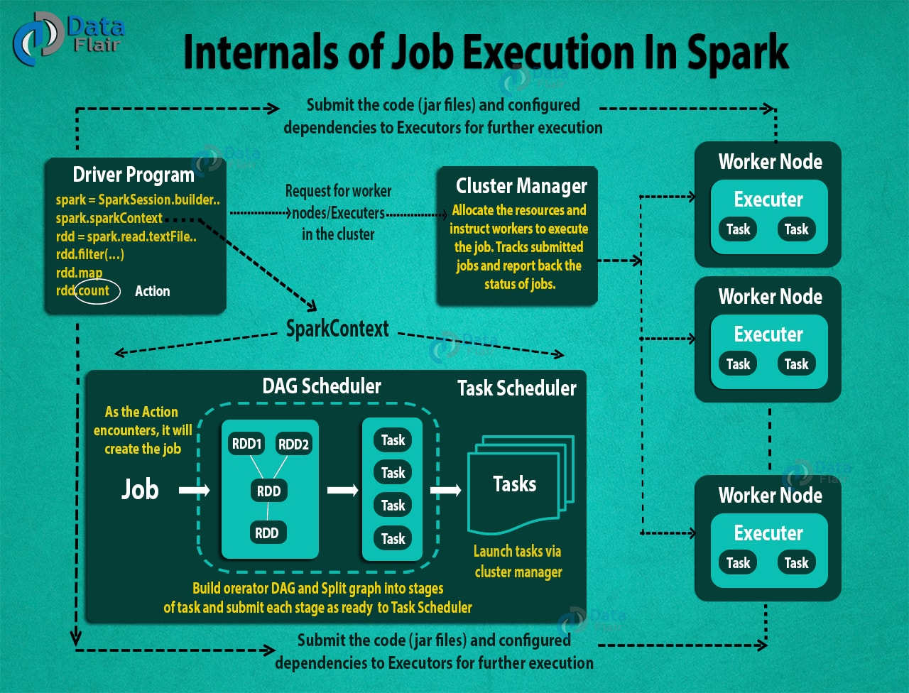

* Using spark-submit, the user submits an application.
* In spark-submit, we invoke the main() method that the user specifies. It also launches the driver program.
* The driver program asks for the resources to the cluster manager that we need to launch executors.
* The cluster manager launches executors on behalf of the driver program.
* The driver process runs with the help of user application. Based on the [**actions and transformation on RDDs**](https://data-flair.training/blogs/spark-rdd-operations-transformations-actions/), the driver sends work to executors in the form of tasks.
* The executors process the task and the result sends back to the driver through the cluster manager.