|  |  |
| --- | --- |
| **Architetture dei Sistemi**  **Di Elaborazione** | Delivery date:  9th December 2022 |
| **Laboratory**  **8** | Expected delivery of lab_08.zip must include:   * zipped project folder * this lab track completed and converted to pdf format. |

Download the template project for Keil µVision “*ABI_C+ASM*” from the course material.

NB: Deliver a single Keil project including Exercise 1 and Exercise 2.

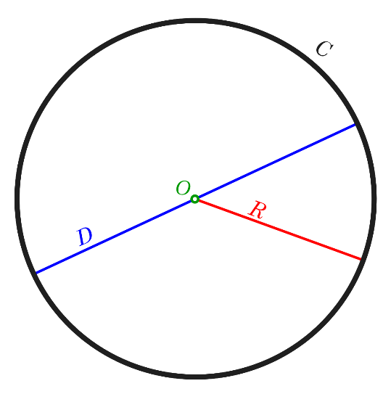**Exercise 1) – Compute the value of π using the circle method.**

Pythagoreans called a set of points equally spaced from a given origin *Monad* (from Ancient Greek μονάς *(monas)* 'unity', and μόνος *(monos)* 'alone'). As originally conceived by the Pythagoreans, the *Monad* is the Supreme Being, divinity, the totality of all things, or the unreachable perfection by human beings (but we can at least try😊). The *Monad* (aka circle) in geometry is strongly intertwined with π (a mathematical transcendental irrational constant), commonly defined as the ratio between a circle’s circumference and diameter.

$$π=\frac{C}{D}$$

An irrational number cannot be expressed exactly as a ratio of two integers.

Consequently, its decimal representation never ends!

**3.14159265358979323846264338327950288419716939937510…**

However, **mathematical operations in computers are finite**! In the literature, some interesting methods and algorithms to compute an approximated value of $π$ have been developed.

One of the most intuitive methods is the circle method (not the best in terms of performance). It is based on the following observations.

* The area of the circle is:
$$A=πr^{2} (Eq. 1)$$

* Where π can be computed as:
$$π=A/{r^{2}}(Eq. 2)$$

* The assumption is to have a circle of radius **r centered in the origin (0,0).**

Therefore, the Pythagoras theorem states that the distance from the origin is:

$d^{2}=x^{2}+y^{2}(Eq. 3)$

The cartesian plane can be built thinking of unitary squares centered in every (x, y) point, where x and y are the integers between -r and r.

Squares whose center belongs within or on the circumference contribute to the final area. They must satisfy the following:

$x^{2}+y^{2}≤ r^{2}(Eq. 4)$

The number of points that satisfy the above condition (Eq. 4) approximates the area of the circle.

Therefore, the final formula is (where the double sums are the Area):

$$π≈\frac{1}{r^{2}}\sum_{x=-r}^{r}{\sum_{y=-r}^{r}{check_square\left(x,y,r\right)}} \left(Eq. 5\right)$$

$$where check_square\left(x,y,r\right)=\left\{\begin{aligned}1, &x^{2}+y^{2}≤r^{2} \\ 0, &x^{2}+y^{2}>r^{2}\end{aligned}\right.$$

The graphical idea is the following:

It **does not** contribute to the Area

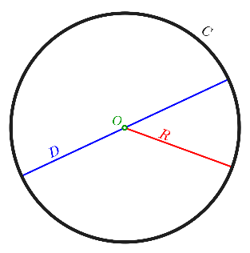

It contributes to the Area

x3,y3

x1,y1

Declare the coordinates as couples of (x,y) (signed integer) into a read-only memory region 2-byte aligned (into an assembly file) as follows:

Matrix_Coordinates DCD −5,5,−4,5,-3,5,−2,5,−1,5,0,5,1,5,2,5,3,5,4,5,5,5

DCD −5,4,−4,4,−3,4,−2,4,−1,4,0,4,1,4,2,4,3,4,4,4,5,4

DCD −5,3,−4,3,−3,3,−2,3,−1,3,0,3,1,3,2,3,3,3,4,3,5,3

DCD −5,2,−4,2,−3,2,−2,2,−1,2,0,2,1,2,2,2,3,2,4,2,5,2

DCD −5,1,−4,1,−3,1,−2,1,−1,1,0,1,1,1,2,1,3,1,4,1,5,1

DCD −5,0,−4,0,−3,0,−2,0,−1,0,0,0,1,0,2,0,3,0,4,0,5,0

DCD −5,−1,−4,−1,−3,−1,−2,−1, −1,−1 ,0,−1,1,−1,2,−1,3,−1,4,−1,5,−1

DCD −5,−2,−4,−2,−3,−2,−2,−2,−1,−2,0,−2,1,−2,2,−2,3,−2,4,−2,5,−2

DCD −5,−3,−4,−3,−3,−3,−2,−3,−1,−3,0,−3,1,−3,2,−3,3,−3,4,−3,5,−3

DCD −5,−4,−4,−4,−3,−4,−2,−4,−1,−4,0,−4,1,−4,2,−4,3,−4,4,−4,5,−4

DCD −5,−5,−4,−5,−3,−5,−2,−5,−1,−5,0,−5,1,−5,2,−5,3,−5,4,−5,5,−5

ROWS DCB 11

COLUMNS DCB 22

The parsing of Matrix_Coordinates must be done in C. Remember that the extern keyword must be used for referencing assembly data structures:

extern <datatype> _Matrix_Coordinates;

extern <datatype> _ROWS;

extern <datatype> _COLUMNS;

In the loop body of Eq. 4, check_square(x,y,r)is called using an assembly function with the following prototype:

int check_square(int x, int y, int r)

which implements:

* 1. Moreover, the Arm Cortex-M3 does not provide hardware floating point support.

Therefore, we can resort to software emulated floating-point algorithms, including the type float. As an example, Arm FPlib has the following EABI-compliant function for float division:

float __aeabi_fdiv (float a ,float b) /* return a/b */

<https://developer.arm.com/documentation/dui0475/m/floating-point-support/the-software-floating-point-library--fplib/calling-fplib-routines?lang=en>

You are required to compute the division with r2 in (Eq. 5) by calling a second assembly function with the following prototype:

float my_division(float* a, float* b)

The function body to implement is:

my_division:

/*save R4,R5,R6,R7,LR,PC*/

/*obtain value of a and b and prepare for next function call*/

/*call __eabi_fdiv*/

/*results has to be returned!*/

/*restore R4,R5,R6,R7,LR,PC*/

* 1. Compute the value of π using a radius of 2,3,5 and store it into a variable.

|  |  |  |  |
| --- | --- | --- | --- |
| Radius (r) | Area | Approximated value of π (3 decimal units) | Clock Cycle  (xtal = 18 MHz) |
| 2 | 13 | 3.250 | 10534 |
| 3 | 29 | 3.222 | 11423 |
| 5 | 81 | 3.240 | 14299 |

Converter from hex to FP (and viceversa): <https://gregstoll.com/~gregstoll/floattohex/>

**Exercise 2) – SuperVisorCall (SVC)**

Enhance the program developed in Exercise 1 by using the **SVC** instruction after the computation of π. Copy part of the template project for Keil µVision “*SVC*”.

You must set the control to user mode(unprivileged)and use the Process Stack Pointer.

2.1) Starting from Exercise 1, write a code to compute a **signature** by calling the SVC with ***0xCA***.

In safety-critical domains, such as the automotive one, functional test programs based on CPU instructions are developed to verify the correct in-field behavior of microprocessor-based systems. This safety process is also known as online testing. A possible way to assess if a functional test program has executed its computations correctly is to introduce a signature computation to be checked at the end of the test program.

A signature typically accumulates into one register the others’ values by means of an arithmetic operation. For example, suppose you have R0, R1, R2, R3, R4, R5, and you want to compute the signature into R0.

XOR R0, R0, R1

XOR R0, R0, R2

XOR R0, R0, R3

XOR R0, R0, R4

XOR R0, R0, R5

Implement an SVC call to compute the signature between Registers from 0 to 12, the LR and XPSR with the XOR instruction.

This must be done by calling the SVC at the end of Exercise 1.

__asm__(“svc 0xca”);

The computed signature value must be accumulated into R0 and returned from the SVC through the PSP stack (as shown in the figure below).

2.2) Starting from Exercise 1, write a code for **memory compaction** by calling the SVC with ***0xFE***.

Compute the memory footprint of *Matrix_Coordinates* in bytes in Exercise 1.

|  |  |
| --- | --- |
| Data | Size [bytes] |
| *Matrix_Coordinates* | 968 |

In this case, it can be safely assumed that points are always in the range [-128,127].

Therefore, data can be compacted (4 values for each word).

Implement a SVC call to compact *Matrix_Coordinates* and store its compacted version into an empty optimized data structure called *Opt_M_Coordinates* (declared into an assembly file as Read/Write region), you have to calculate the required size!

This must be done by calling the SVC at the end of Exercise 1.

__asm__(“svc 0xfe”);

The idea is:



Then compute the memory footprint.

|  |  |  |
| --- | --- | --- |
| Data | Size [bytes] | Memory saved [bytes] |
| *Matrix_Coordinates* | 968 | 0 |
| *Opt_M_Coordinates* | 242 | 726 |