INDIAN STARTUP FUNDING TRACKER
An Interactive Excel Dashboard
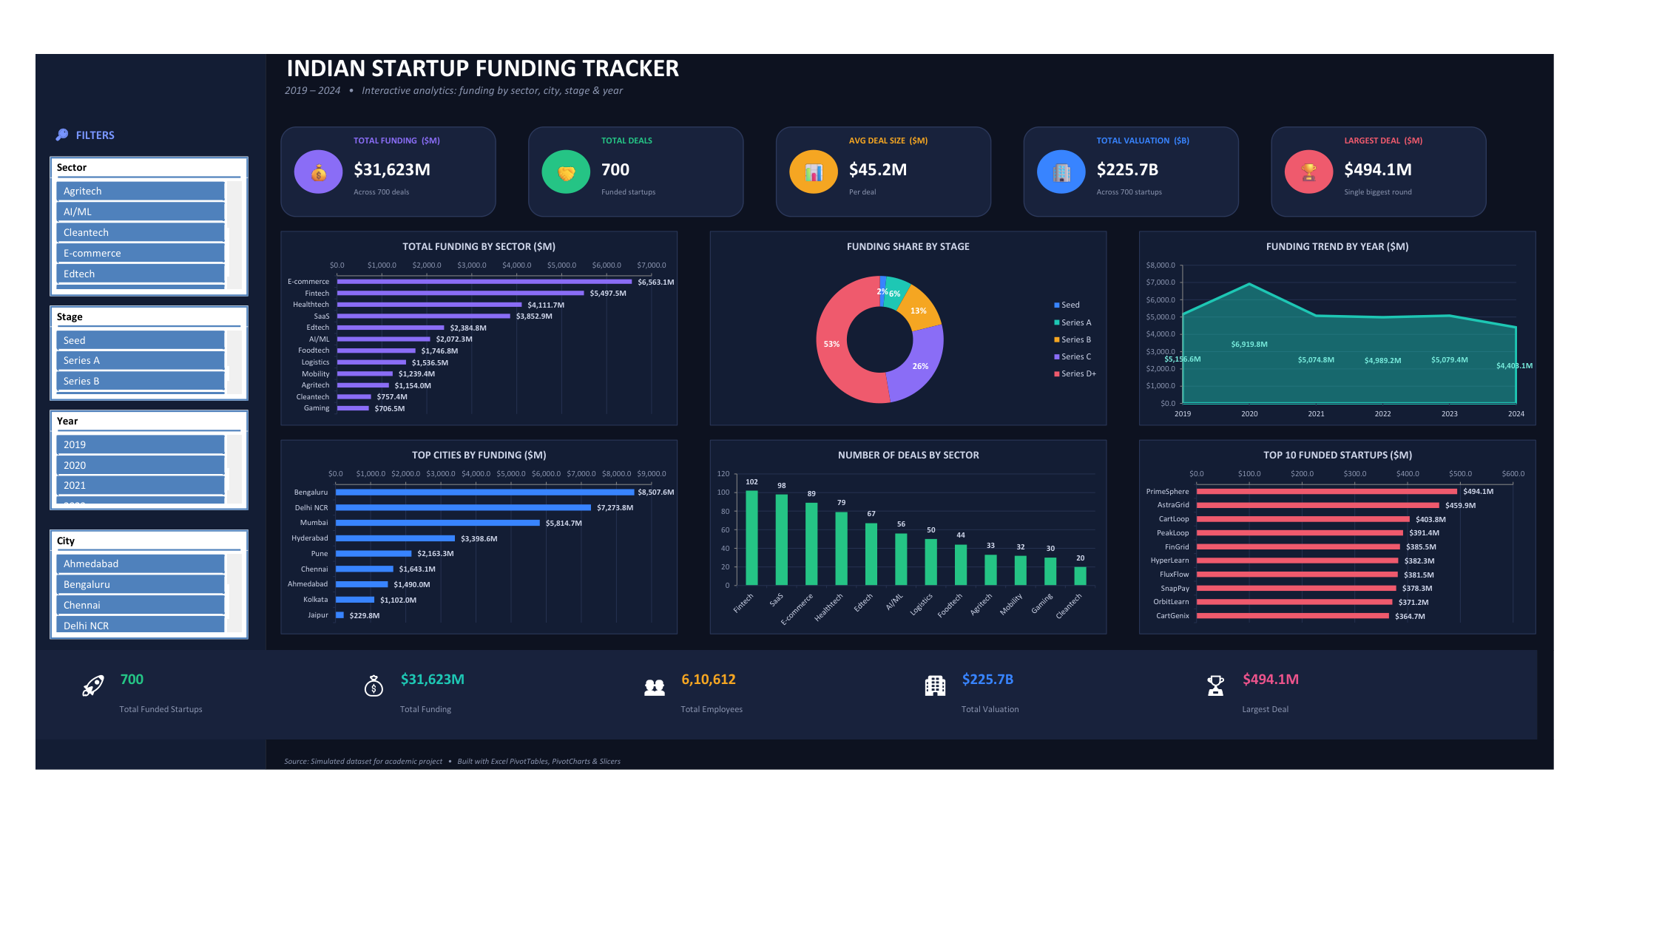

Submitted by: Chaitanya Khurana
Batch : PGA12

Contents
Contents 2
1. Project Objective 3
2. Dataset Description 3
3. Tools & Techniques Used 3
4. Dashboard Components 4
4.1 KPI Cards 4
4.2 Charts 4
4.3 Slicers & Interactivity 4
5. Key Insights 4
6. How to Use the Dashboard 4
7. Conclusion 5

1. Project Objective
The goal of this project is to design an interactive Microsoft Excel dashboard that analyses the Indian startup funding landscape between 2019 and 2024. The dashboard turns a raw table of 520 funding deals into a single, easy-to-read screen that answers business questions such as:
- Which sectors and cities attract the most capital?
- How has total funding changed year on year?
- How is funding distributed across investment stages (Seed to Series D+)?
- Which individual startups raised the largest rounds?
Every visual is fully interactive: a single click on a slicer filters the entire dashboard at once, allowing the viewer to drill into any sector, stage, year, or city.

2. Dataset Description
The dataset contains 700 records of startup funding rounds. Each row represents one funding deal with the following 11 fields:
Field | Type | Description
Company | Text | Startup / company name
Sector | Text | Industry (Fintech, Edtech, SaaS, …) — 12 sectors
City | Text | HQ location — 9 Indian cities
Funding Stage | Text | Seed, Series A / B / C / D+
Funding Amount ($M) | Number | Capital raised in the round (US$ millions)
Funding Date | Date | Date the round closed (2019–2024)
Funding Year | Number | Year extracted from Funding Date
Lead Investor | Text | Primary investor in the round
Founded Year | Number | Year the startup was founded
Valuation ($M) | Number | Post-money valuation (US$ millions)
Employees | Number | Approximate headcount
Note: the dataset is a realistic, simulated sample created for this academic project; company names are fictional. The structure and value ranges mirror real Indian startup-funding data so the analysis techniques are identical to those used on live data.

3. Tools & Techniques Used
- Excel Table – the raw data table with filters and consistent number formatting.
- PivotTables – 11 PivotTables summarise the data by Sector, City, Stage, Year, deal count, and top companies.
- PivotCharts – six charts (column, bar, line and doughnut) are bound directly to the PivotTables.
- Slicers – four slicers (Sector, Stage, Year, City) in a left filter rail, connected to every PivotTable, so one click filters the whole dashboard.
- KPI cards – five headline metrics (Total Funding, Total Deals, Avg Deal Size, Total Valuation, Largest Deal) built on summary PivotTables that also respond to the slicers.
- Formulas & functions – SUM, COUNT, AVERAGE and MAX aggregations inside the PivotTables, plus a Top-10 value filter for the leading startups.

4. Dashboard Components

4.1 KPI Cards
Five colour-coded cards across the top give an instant summary of the filtered data. Because they are built on PivotTables, they recalculate the moment a slicer is clicked.

4.2 Charts
- Total Funding by Sector (column) — ranks sectors by capital raised.
- Funding Share by Stage (doughnut) — share of funding across Seed to Series D+.
- Funding Trend by Year (line) — total funding for each year, 2019–2024.
- Top Cities by Funding (bar) — leading startup hubs.
- Number of Deals by Sector (column) — deal volume vs. deal value.
- Top 10 Funded Startups (bar) — the largest individual rounds.

4.3 Slicers & Interactivity
A left-hand filter rail holds the Sector, Stage, Year and City slicers, all shared across every PivotTable. Selecting, for example, “Fintech” and “2023” instantly filters all six charts and all five KPI cards to that segment. The dashboard uses a dark theme with rounded KPI cards for a modern, app-style look.

5. Key Insights
Reading the dashboard for the full 2019–2024 period reveals several findings:
- Market size: Total funding across the period reached about $31.6 billion over 700 deals, at an average of $45.2M per deal.
- Top sectors: E-commerce ($6.6B), Fintech ($5.5B) and Healthtech ($4.1B) attracted the most capital.
- Deal volume: Fintech (102 deals) and SaaS (98 deals) recorded the highest deal volumes, showing strong activity even where individual rounds are smaller.
- Funding hubs: Bengaluru ($8.5B) and Delhi NCR ($7.3B) dominate, together accounting for roughly half of all funding.
- Stage mix: Late-stage rounds (Series C and D+) make up about 79% of total capital, while Seed rounds are only ~2% by value.
- Yearly trend: Funding peaked in 2020 (~$6.9B), then eased to a $4.4–5.1B range across the following years.

6. How to Use the Dashboard
- Open the workbook — it opens on the Dashboard sheet.
- Click any tile in a slicer (e.g. a sector or year) to filter every chart and KPI at once.
- Hold Ctrl to select several tiles; use the clear-filter icon (top-right of a slicer) to reset.
- The Data sheet holds the raw 700 rows; the Pivots sheet holds the underlying PivotTables.
- If a chart looks empty on first open, press Ctrl+Alt+F9 to recalculate.

7. Conclusion
This project demonstrates a complete Excel analytics workflow — from a structured data table, through PivotTables and PivotCharts, to a polished, slicer-driven dashboard. The result communicates the Indian startup-funding story clearly and lets any viewer explore it interactively, without needing to touch the underlying data.

