**File Creation Task**

1. AWS account has been created successfully.

2. gitbash software install and working fine in local machine.

3. GitHub repositorie has been created.

**Task Description:**

Create a directory called ""my_folder"", navigate into it, and create a file named ""my_file.txt"" with some text. Then, create another file named ""another_file.txt"" with some text. Concatenate the content of ""another_file.txt"" to ""my_file.txt"" and display the updated content. Finally, list all files and directories in the current directory.

1. EC2 machine created on AWS:

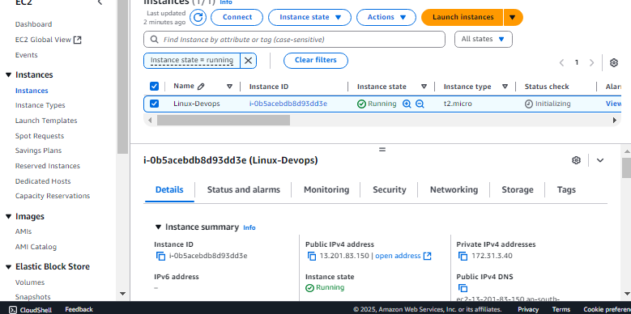

1. Login to the server:

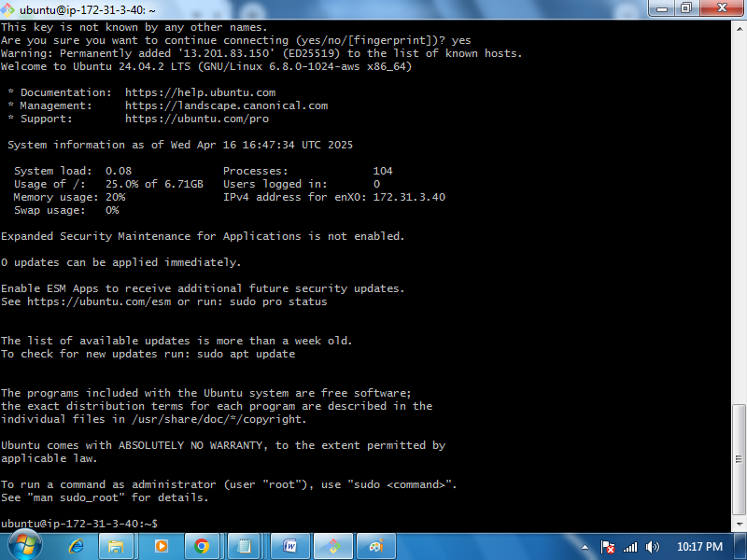

1. Below find the first task details:

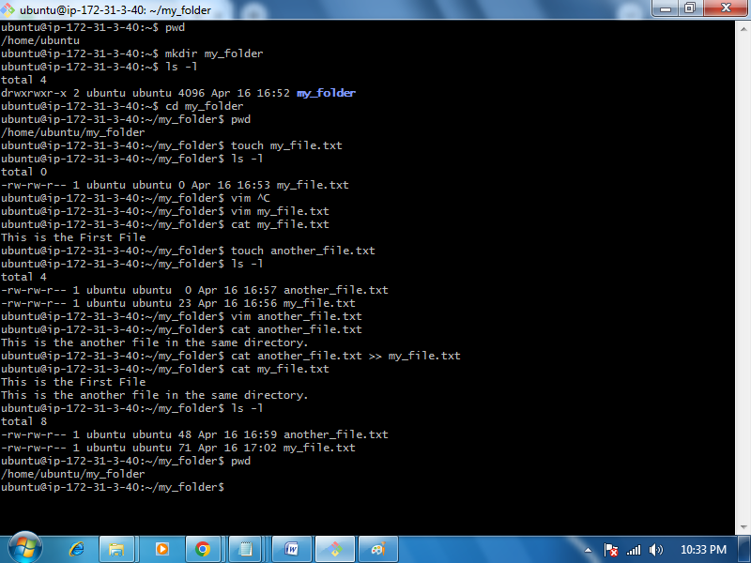

Create 20 files with .txt extensions and rename the first 5 files to .yml extension and Print the latest created top 5 files among the total no of files".

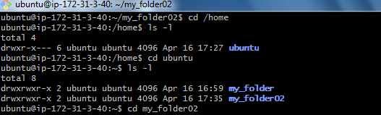

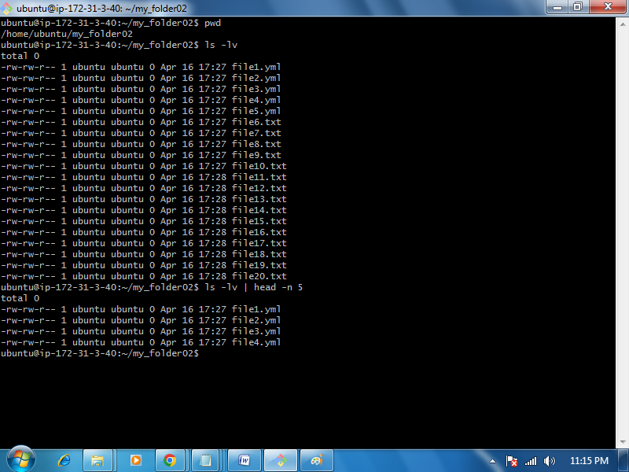

**Techstacks needs to be used :**

Shell (AWS, Gitbash, WSL, Vbox)

**How do I submit my work?**

Push all your work files to GitHub (O/P screenshot images must).

Submit your URLs in the portal.

**Terms and Conditions?**

You agree to not share this confidential document with anyone.

You agree to open-source your code (it may even look good on your profile!). Do not mention our company’s name anywhere in the code.

We will never use your source code under any circumstances for any commercial purposes; this is just a basic assessment task.

**NOTE:** Any violation of Terms and conditions is strictly prohibited. You are bound to adhere to it.