AWS Task-2
Task Description:
Set up a VPC with an Internet gateway, create a public subnet with 256 IP addresses, a private subnet with 256 IP addresses, make a route table connecting the Internet gateway and the subnets, and launch a Linux EC2 instance by using the above VPC and public subnet.
VPC created: CIDR 256 IP address:
My CIDR range: 172.86.8.0/24
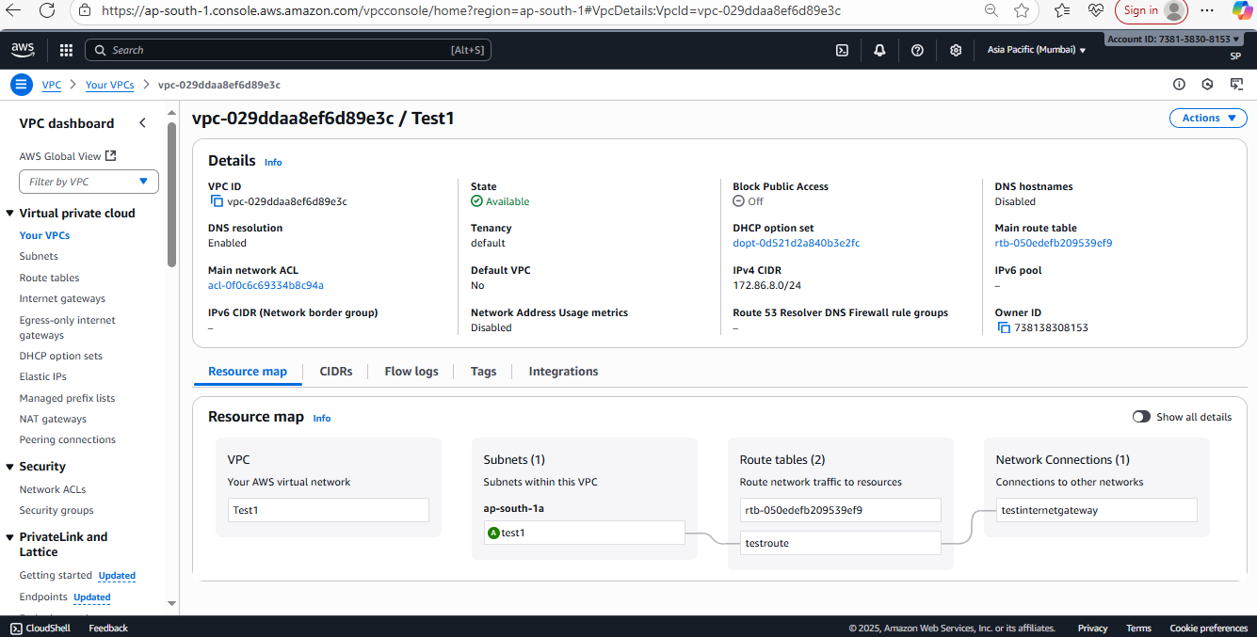
Subnet created:
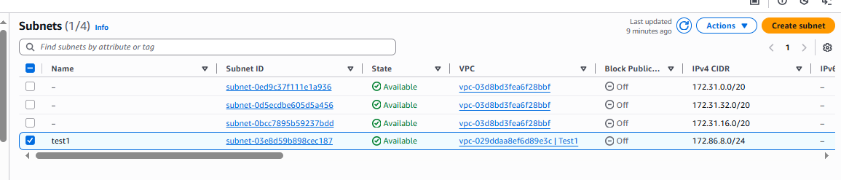
Route table created and associated with subnet:
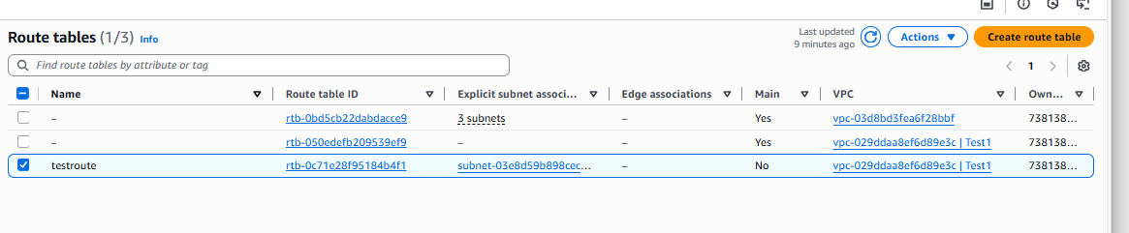
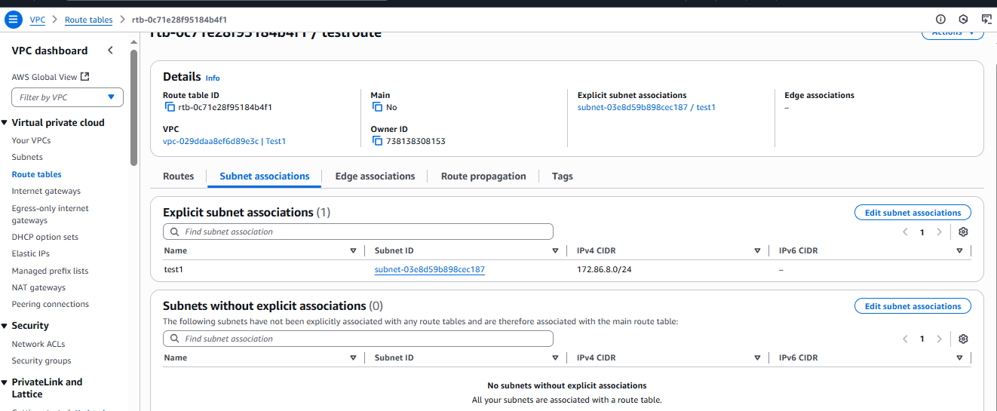

Attached with internet gateway which created newly:
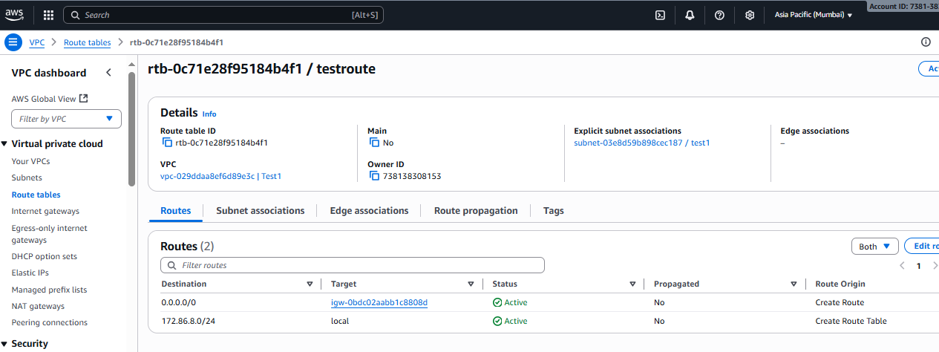

Internet Gateway created and attached with VPC:
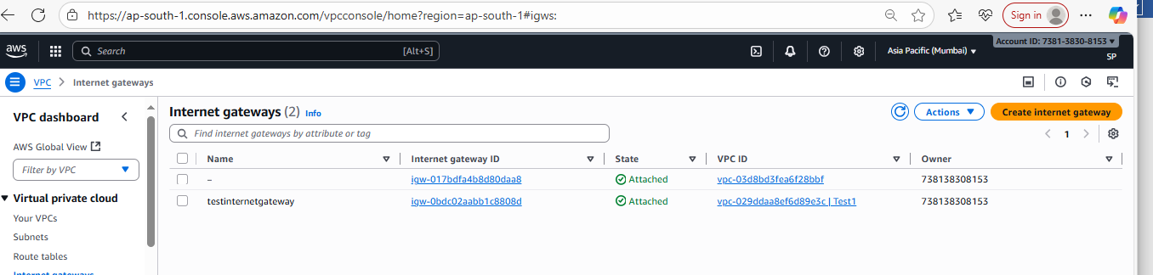
Launched instance with new 256 public subnet:
